WaveCast
System Architecture & Complexity Report
A Transparent, AI-Powered Surf Forecasting Platform

Tomer Atia
Vibe Coding Course | 2026

This document describes the architecture and engineering complexity of Wavecast -a production-deployed, full-stack web application combining real-time marine data aggregation, a transparent scoring algorithm, JWT authentication, and an AI-powered conversational assistant.

1. Project Overview 1
2. High-Level Architecture 2
System Layers 2
Request Flow 3
3. Backend -Layered Architecture 3
Data Pipeline & Caching 3
4. Authentication & Security 4
5. Transparent Scoring Algorithm 4
6. AI Surf Assistant 5
System Prompt 5
Available Tools 5
Agentic Loop 6
7. Deployment & Infrastructure 6
8. Complexity Summary 6

1. Project Overview
Wavecast is a free, open-source surf forecasting platform designed as a transparent alternative to commercial services such as Surfline. Surfers can browse real-time wave conditions across 60 global spots, save favorites, configure score-based email alerts, and converse with an AI assistant that fetches live data before answering.

The key differentiator is transparency: the scoring algorithm's weights are publicly documented, so users understand exactly why a spot receives a given rating -unlike closed commercial tools.

Live at: https://wavecast-tomeratia.netlify.app

2. High-Level Architecture
The system is a monorepo with three npm workspaces: a React frontend (Netlify), a Node.js/Express backend (Railway), and a shared TypeScript types package. A PostgreSQL database (Supabase) provides persistence.

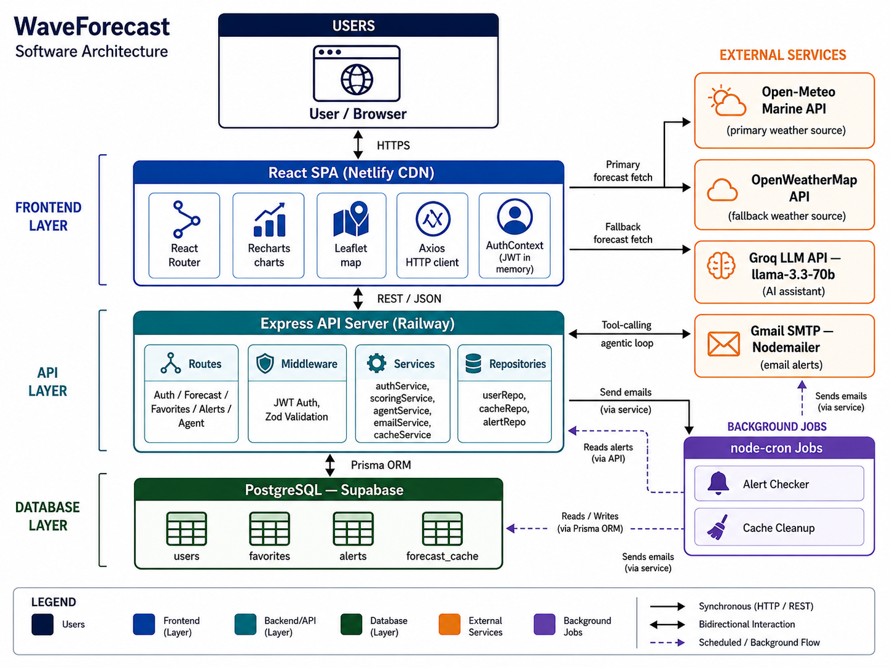
Figure 1: Wavecast System Architecture

System Layers
Layer | Technology | Responsibility
Frontend | React 18, Vite, Tailwind CSS | SPA: charts, maps, auth UI, AI chat
API Server | Express + TypeScript (Railway) | Routes, JWT auth middleware, validation, orchestration
Business Logic | Service classes | Scoring, caching, email, agentic AI loop
Data Access | Repository layer + Prisma ORM | All database queries abstracted from business logic
Database | PostgreSQL on Supabase | users, favorites, alerts, forecast_cache
AI / LLM | Groq API -llama-3.3-70b | Conversational assistant with live tool use

Request Flow
Browser → React SPA → Express API (JWT auth) → Service layer → DB cache check → External APIs (if cache miss) → Score → Response → React renders charts & labels.

3. Backend -Layered Architecture
The backend enforces a strict separation of concerns across four layers. No layer skips its neighbor.

Layer | Role
Routes | HTTP binding, input validation (Zod), delegates to service
Services | All business logic -scoring, caching, AI loop, email dispatch
Repositories | Pure DB queries via Prisma -no logic, no HTTP concepts
Prisma / PostgreSQL | Type-safe ORM, migrations, four core tables

Data Pipeline & Caching
Every forecast request first checks a PostgreSQL cache table (3-hour TTL). On a cache miss, the server queries Open-Meteo Marine API (primary, no key needed) and OpenWeatherMap (fallback) in parallel via Promise.allSettled. Each provider has a dedicated adapter that normalizes its response to a shared NormalizedForecast interface. The result is scored, cached, and returned. A node-cron job periodically purges expired cache rows.

Provider | Role | Rate Limit
Open-Meteo Marine | Primary -swell height, period, direction | 10,000 req/day, no API key
OpenWeatherMap | Fallback -wind speed & direction | 60 req/min, API key required

4. Authentication & Security
Authentication uses a dual-token JWT pattern that follows current security best practices:

- Access Token (15 min): short-lived JWT kept in memory on the client -never in localStorage, so it cannot be stolen via XSS.
- Refresh Token (7 days): stored in an httpOnly, Secure, SameSite=Strict cookie -inaccessible to JavaScript.
- On 401, an Axios interceptor automatically calls POST /api/auth/refresh and retries the original request.

Threat | Mitigation
XSS token theft | Access token in memory; refresh token in httpOnly cookie
SQL injection | Prisma ORM -all queries are parameterized, no raw SQL
Weak passwords | bcrypt at 12 salt rounds; minimum 8-character validation (Zod)
Secrets exposure | All keys in environment variables; .env never committed

5. Transparent Scoring Algorithm
The scoring algorithm is the core product differentiator. Each factor is normalized to [0, 1] using domain-specific logic, then combined into a weighted sum producing an integer score from 0 to 100.

Factor | Weight | Ideal Value
Swell Height | 35% | 1.5 – 3.0 m (primary wave quality driver)
Swell Period | 30% | >= 12 seconds (longer = more powerful, better-formed)
Wind Speed | 15% | < 10 km/h (light wind = clean, glassy surface)
Wind Direction | 10% | Offshore (grooms wave faces)
Tide | 10% | Mid-tide (safe neutral default)

Score | Label | Meaning
0 – 19 | Flat | No rideable waves
20 – 39 | Poor | Barely surfable
40 – 59 | Fair | Decent; worth going
60 – 79 | Good | Solid session
80 – 100 | Epic | Go now

The API response includes a full per-factor breakdown so the UI can display exactly how each component contributed to the final score -reinforcing the platform's transparency commitment.

6. AI Surf Assistant
The AI assistant is an agentic system, not a simple chatbot. It uses the Groq API (llama-3.3-70b-versatile) with OpenAI-compatible function calling to fetch live forecast data and reason over it before answering the user.

System Prompt
The following system prompt defines the assistant's behavior:

You are a friendly surf forecasting assistant for WaveCast,
a free surf forecasting app.

Always use the provided tools to fetch live data before
answering questions about conditions.

Respond in the same language the user writes in.

Score labels: flat (<20), poor (20-39), fair (40-59),
good (60-79), epic (80+).

Keep answers concise, practical, and surf-focused.
When recommending spots, always mention the score and key
conditions (wave height, period, wind).

IMPORTANT: When calling tools, always use valid JSON for
arguments. Never use any other format.

Key design decisions: (1) The instruction to always use tools before answering prevents hallucination of forecast data. (2) Mirroring the user's language requires zero routing logic in the application. (3) The explicit JSON format rule reduces malformed tool calls that would break the loop.

Available Tools
Tool | Parameters | Returns
search_spots() | none | All 25 known spots (id, name, country, region)
get_forecast(spot_name) | spot_name: string | Current forecast + score for a fuzzy-matched spot
get_best_spots(top_n) | top_n: number | Top N spots ranked by current score

Agentic Loop
Each user message triggers a server-side loop (max 10 iterations): call LLM → if tool calls returned, execute them and append results to history → call LLM again → repeat until the model produces a stop signal. A fallback handles malformed JSON by retrying without tools, allowing a plain-text response rather than crashing.

Example multi-step query: "Best waves in Europe this week?" -the assistant internally calls search_spots(), then get_forecast() for each European spot, then synthesizes a ranked recommendation -all in one user interaction.

7. Deployment & Infrastructure
Platform | Hosts | Why
Netlify | React SPA | CDN edge delivery, free SSL, SPA redirect rules, git-triggered deploys
Railway | Express API | Persistent container -required for cron jobs; env-var management
Supabase | PostgreSQL | Managed Postgres, connection pooling, free tier

All secrets (JWT_SECRET, Groq API key, Brevo API key, DATABASE_URL) are managed as environment variables across Railway and Netlify -never committed to source control. The monorepo uses npm workspaces so both client and server share the same lock file and type definitions.

8. Complexity Summary
Wavecast integrates a wide range of distinct engineering concerns into a single cohesive production application:

Dimension | What Makes It Non-Trivial
Layered backend | Routes → Services → Repositories → ORM; no cross-layer shortcuts
Dual-token auth | Access token in memory + httpOnly refresh cookie; auto-refresh on 401
Multi-provider pipeline | Primary + fallback APIs, adapters, parallel querying, retry with backoff
DB caching | PostgreSQL TTL cache; cron cleanup prevents stale accumulation
Transparent scoring | 5 weighted factors with domain normalization; per-factor breakdown returned
Agentic AI | LLM + 3 live tools + multi-step loop + graceful fallback on parse failure
Background jobs | 2 cron jobs (alert checker + cache cleanup) inside persistent container
Production deploy | 3 cloud platforms, CI/CD on git push, env-based config

The email alert system is architecturally complete (cron job, DB tracking, Brevo API transport) and active in production, sending alerts via the Brevo HTTP API.

