# Exercises for Chapter 4 – The C# Classes

## Exercise 1

* Create a class **Rectangle**.
  + The Rectangle object should have the following attributes:
    - X and Y coordinates of rectangle’s bottom-left corner.
    - Width and Height
* Assumptions:
  + A rectangle object is parallel to the x,y coordinates.
  + The width attribute represents the side that is parallel to the **x** coordinate.
  + The height attribute represents the side that is parallel to the **y** coordinate.

width

height

(x,y)

* Attributes’ values should be provided on a Rectangle object’s initialization, and can be changed by resizing and moving the rectangle
* The Rectangle should provide the following properties and methods:
  + Get for its different attributes.
  + Area
    - Provides rectangle’s area.
  + Resize()
    - Receives new width and height and resize the rectangle accordingly.
  + Move()
    - Receives new x and y coordinates and move the rectangle accordingly.
  + Assign()
    - Receives a rectangle as a parameter, and copies its attributes.
  + IsSizeEqual()
    - Receives a rectangle as parameter.  
      Returns whether or not rectangles’ area is equal.
  + GetUnion()
    - Receives a Rectangle object as parameter.   
      Returns the minimum bounding rectangle.
  + Minimum()
    - Gets a rectangle as parameter.  
      Returns the smaller of the two rectangles.
  + A print method that prints rectangle details to the console.
* In your **Main()** method (which should be defined in a separate class and file), do the following:
  + Get from the user an initial values for a rectangle attributes.
  + Print user rectangle details.
  + Create application rectangle (using hard coded initial values) and print its details.
  + Find out:
    - Is rectangles size equal?
    - Which is the minimal one?
    - Can you get their union?
  + Set your rectangle with the values of the user’s one.
  + Try to compare them using the (==) operator.
    - Are they equal?
  + Assign user’s rectangle into yours, using the (=) operator.
    - Are they equal (==) now?

## Exercise 2

Implement a **LinkedList** class that contains strings.

* Advanced students may implement **LinkedList<T>**
* **LinkedList** should have the following methods:

**Add(string item);  
string GetAt(int index);  
string RemoveAt(int index);**

* **LinkedList** should have a **Count** property:
  + Implement **Count** as an auto-property
* Implementation notes:
  + **LinkedList** should have a private inner class: **Node**
  + **Node** contains two elements: **Next** and **Item**
  + When you create a new **Node**, initialize it with object initializer
  + It is much easier to implement a cyclic list
    - Create a **private static readonly _emptyNode** node
    - Create a private **Node** reference (**_last**)
    - At the beginning:

**_last = _EmptyNode;  
_last.Next = EmptyNode;  
Count = 0;**

* + - Create a private **First** property that refer to the **_emptyNode.Next**
* At **Main()**, create a new list, and copy all command line arguments to the list.
* Test your **GetAt** and **Remove** method
  + To print the list after each change add a utility static class with **PrintList()** method, that get the list and print all elements
  + Call this method after each **Add** and **RemoveAt()** method call
  + Convert this method to be an extension method, call it **Print()**
* Add a **Log** partial method to the **LinkedList**

**static partial void Log(string message, T item, int count);**

* + Remember to change the **LinkedList** to be partial class
  + Add calls to the **Log** method in **Add()** and **RemoveAt()**
* Create a second partial class and implement the **Log** method
  + Test your code
* The **ListUtil.Print()** extension method is very inefficient
  + Create an efficient **Print** method in the **LinkedList** class that override the extension method.

# Exercise 3

In the exercise you will see how much easier it is to work with optional parameters. You will implement a spell checking application that uses the Microsoft Word component.

* Create a new Console Application in Visual Studio 2008
* Add a reference to "Microsoft.Office.Interop.Word"

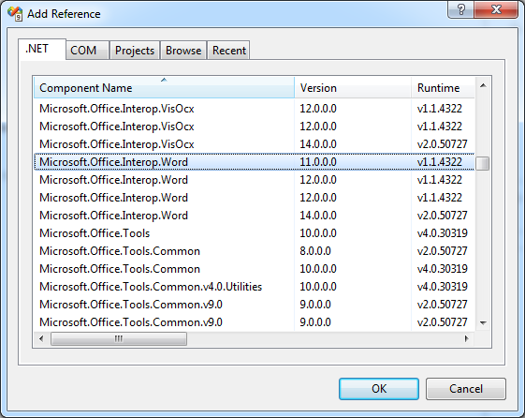

* Use the following code in your application to obtain spelling suggestions for a certain word
  + Note that the **Application** object originates from the Microsoft Word interop assembly.

Application word = new Application();

object missing = Missing.Value;

word.Documents.Add(ref missing, ref missing,

ref missing, ref missing);

SpellingSuggestions suggestions =

word.GetSpellingSuggestions("placa",

ref missing, ref missing, ref missing,

ref missing, ref missing,

ref missing, ref missing, ref missing,

ref missing,

ref missing, ref missing,

ref missing, ref missing);

foreach (SpellingSuggestion item in suggestions)

{

Console.WriteLine(item.Name);

}

* Repeat the same steps using Visual Studio 2010
  + Note that you don’t need to use **System.Reflection.Missing.Value**, because the **Add** and **GetSpellingSuggestions** methods now accept optional parameters.