**2 Modes of operation :**

1. **LIST OF CHANGES**

Inputs : From TAG, To TAG

Output : List of changes between TAGs.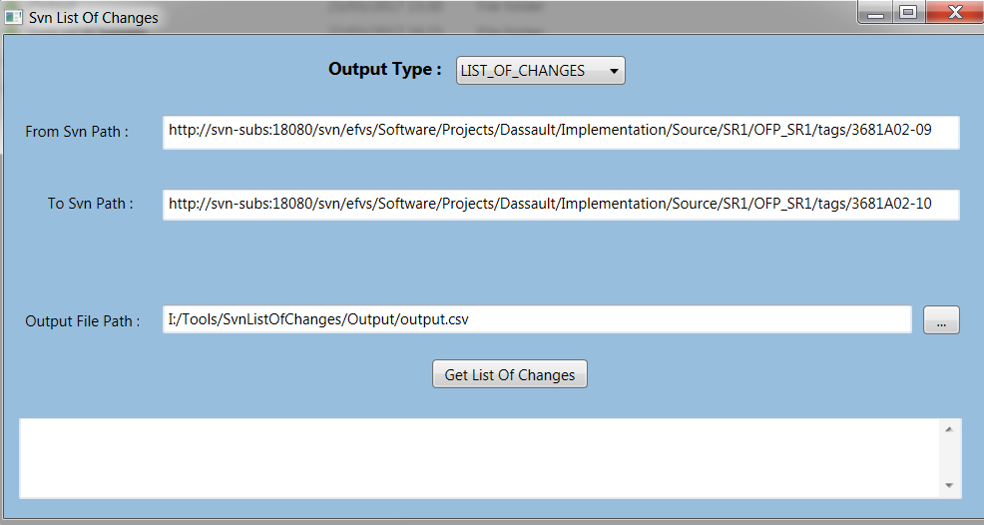

1. **HISTORY**

Inputs : TRUNK SVN path, TAGs SVN Path, TAG to start from (Generates only changes made after this TAG. In case field is left empty – generates all history)

Output : List of all files on TRUNK, for each file last modification information is displayed, and last TAG which contains the changed file - This TAG should be reviewed for the file – can be compared against completeness to verify that change was reviewed. (In case TAG on completeness is greater or equal to the tag on output file -> the file was reviewed. )

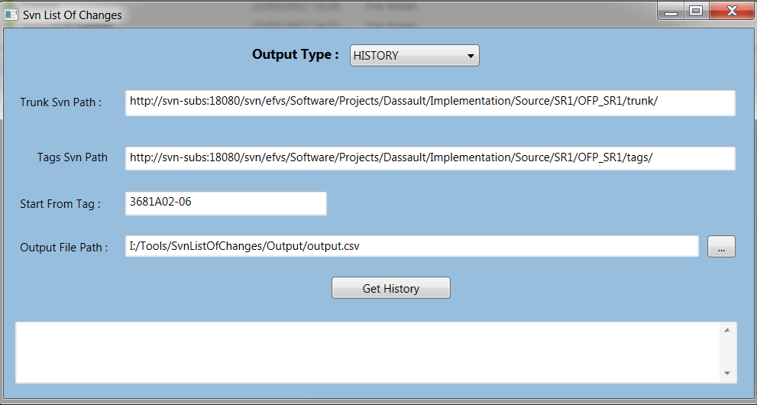

**Tool can be also executed from command line :**

Examples :

