
Memphis Primary Materials
Volume 1, Number 4 April

Research on Environmental Economics
The Harvard Environmental Economics Program (HEEP) conducts research on the impact of environmental issues on local economies and on a global scale. The program brings together “faculty and graduate students engaged in research, teaching, and outreach in environmental and natural resource economics and related public policy.”
Harvard Faculty Fellows collaborate with a broad range of experts in industry, universities, government, and private think tanks to provide up-to-date research on topics in environmental economics.
Research topics include global climate change, costs and benefits of environmental protection, political implications of environmental policy, corporate social responsibility, natural resource economics, environmental employment, and energy policy. Many of these issues are directly related to the businesses in and around the Memphis metropolitan area. Additional information can be found on the United States Environmental Protection Agency website.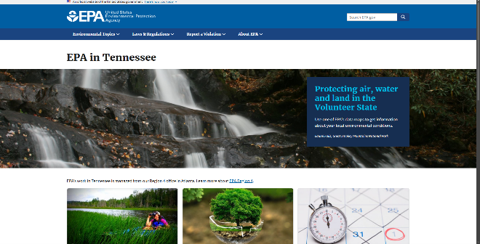
The Hard Costs of Pollution
A University of Maine Researcher has determined that the annual cost in Maine of childhood diseases caused by pollutants is $380.9 million. Maine has already adopted policies to combat the effects of pollution, such as screening children for lead, which have lowered disease rates and lowered costs.
“It is clear that reducing childhood exposure to environmental pollutants would provide a sizeable economic benefit to the state,” the report concludes. Conditions reported to be caused by pollution include lead poisoning, cancer, and asthma. Lead poisoning accounts for $268 million in annual costs.
Environmental Economics Conference
Memphis Primary Materials is a cosponsor of the upcoming Memphis Environmental Economics Conference, which will be held in the Civic Auditorium on September 23-24. The conference will focus on the anticipated rapid growth of “green jobs” during the coming decade, and the impact that these jobs are likely to have on worldwide environmental economics. For additional information about environmental economics, see the attached white paper entitled Environmental Economics and Business.
For more information about the conference sessions, along with an online registration form, go to:
www.memphisprimarymaterials.com/MEEC

James Jaworski
Thomas Freeman
Research and Development
May 23, 2021
Environmental Economics and Business
Environmental economics is the field of economics that studies environmental issues and their effect on the larger economy. Environmental economists attempt to assess the value of the environment and the tangible benefits of natural resources and the ecosystem. They study the economic effects of environmental regulations, pollution, environmental-based tax policies, and property rights. Environmental economics differs from ecologic economics in that environmental economists are generally trained as economists and study the environmental effects on markets, particularly where there is market failure. Ecologic economists, on the other hand, are generally trained as ecologists who have expanded their field of study to include the effects of humans and industry on ecological systems.
Environmental economists have a role in the business of the economy. Investors are now trying to make profits from growing environmental awareness by investing in financial instruments such as energy commodities and businesses such as wind power companies. In Europe, for example, investors can trade in carbon permits—essentially, buying and selling the right to pollute. Since 2005, the European Union has required major polluters to either cut the amount of carbon dioxide they emit, or buy pollution credits on the open market. The United States may soon set up a similar system for the buying and trading of greenhouse gas emissions. Environmental economists help to determine the current price and the future price and value of these rights (Abboud A1).
Environmental economics also studies the effects of environmental regulation, such as the Kyoto Protocol, on innovation and business. For example, Agence Francaise De Developpement published a study showing that the Kyoto Protocol has exerted significant influence on innovations in, and the quantity of, new climate change technology.
In the United States, environmental economics is studied at a branch of the Environmental Protection Agency called the National Center for Environmental Economics. The NCEE analyzes the impacts on health and the environment of regulations and policies, provides input on policy decisions, and manages the EPA’s research on environmental matters. Studies of the effects of policies are important to determine their fairness—a policy justifiable on efficiency grounds may be impractical if it imposes a disproportionate burden on a certain group. For example, political opposition to higher fuel taxes, carbon taxes, or other emissions taxes in the U.S. is frequently based on the claim that such taxes fall most heavily on low-income groups (Tietenberg and Folmer 1).

Works Cited
Abboud, Leila S. "Economist Strikes Gold." The Wall Street Journal 13 March 2008: A1. Print.
Tietenberg, Tom and Henk, Editors Folmer. The International Yearbook of Environmental Resource Economics, 2006/2007. Northampton, MA: Edward Elgar Publishers, 2006. Print.

The Kyoto Protocol is an international agreement that aims to reduce carbon dioxide emissions.

