SummaryPlot

Xiang Ji

December 29, 2014

This R script is used for generating summary plot for the Geneconv project

1, Read in tables

rm(list=ls()) # clean up workspace  
#path <- "/Users/xji3/Genconv/NewClusterPackRun/NewPackageNewRun/OldResults01152015/"  
path <- "/Users/xji3/Genconv/NewClusterPackRun/NewPackageNewRun/"  
#path <- "G:/Geneconv/NewClusterPackRun/NewPackageNewRun/"  
#HKY_clock_summary <- "HKY_clock_summary"  
summary.list <- c( "HKY_nonclock_summary",  
 "HKY_clock_summary",  
 "MG94_clock_summary",  
 "MG94_nonclock_summary",   
 "Force_HKY_clock_summary",   
 "Force_HKY_nonclock_summary",  
 "Force_MG94_clock_summary",   
 "Force_MG94_nonclock_summary"  
 )  
#summary.list <- c("Force_MG94_clock_summary")  
for (target.summary in summary.list){  
 summary_file <- paste(path, target.summary, '.txt', sep = '')  
 all <- readLines(summary_file, n = -1)  
 col.names <- strsplit(all[1], ' ')[[1]][-1]  
 row.names <- strsplit(all[length(all)], ' ')[[1]][-1]  
 summary_mat <- as.matrix(read.table(summary_file,   
 row.names = row.names,   
 col.names = col.names))  
 assign(target.summary, summary_mat)  
}

Now generate summary file of only pairs that have all cases finished in HKY or MG94 models.

# HKY  
HKY.pair.names <- intersect(intersect(intersect(colnames(HKY_clock_summary),   
 colnames(HKY_nonclock_summary)),  
 colnames(Force_HKY_clock_summary)),  
 colnames(Force_HKY_nonclock_summary))  
HKY.clock.filtered <- HKY_clock_summary[, HKY.pair.names]  
HKY.nonclock.filtered <- HKY_nonclock_summary[, HKY.pair.names]  
HKY.Force.clock.filtered <- Force_HKY_clock_summary[, HKY.pair.names]  
HKY.Force.nonclock.filtered <- Force_HKY_nonclock_summary[, HKY.pair.names]  
  
write.table(HKY.clock.filtered, paste( path, "HKY_clock_filtered", sep = ""))  
write.table(HKY.nonclock.filtered, paste( path, "HKY_nonclock_filtered", sep = ""))  
write.table(HKY.Force.clock.filtered, paste( path, "HKY_Force_clock_filtered", sep = ""))  
write.table(HKY.Force.nonclock.filtered, paste( path, "HKY_Force_nonclock_filtered", sep = ""))  
  
  
  
# MG94  
MG94.pair.names <- intersect(intersect(intersect(colnames(MG94_clock_summary),   
 colnames(MG94_nonclock_summary)),  
 colnames(Force_MG94_clock_summary)),  
 colnames(Force_MG94_nonclock_summary))  
MG94.clock.filtered <- MG94_clock_summary[, MG94.pair.names]  
MG94.nonclock.filtered <- MG94_nonclock_summary[, MG94.pair.names]  
MG94.Force.clock.filtered <- Force_MG94_clock_summary[, MG94.pair.names]  
MG94.Force.nonclock.filtered <- Force_MG94_nonclock_summary[, MG94.pair.names]  
  
write.table(MG94.clock.filtered, paste( path, "MG94_clock_filtered", sep = ""))  
write.table(MG94.nonclock.filtered, paste( path, "MG94_nonclock_filtered", sep = ""))  
write.table(MG94.Force.clock.filtered, paste( path, "MG94_Force_clock_filtered", sep = ""))  
write.table(MG94.Force.nonclock.filtered, paste( path, "MG94_Force_nonclock_filtered", sep = ""))

Now analyze the results

First, show the loglikelihood improvement for each model with/without tau

# HKY nonclock  
(HKY.nonclock.filtered - HKY.Force.nonclock.filtered)[2,]

## YLR406C_YDL075W YER131W_YGL189C YDR502C_YLR180W YHR106W_YDR353W   
## 45.32 84.73 361.25 165.28   
## YIL057C_YER067W YPL087W_YBR183W YNL069C_YIL133C YDR518W_YCL043C   
## 42.03 46.49 90.04 42.93   
## YGR043C_YLR354C YPR157W_YGR141W YDR099W_YER177W YBR024W_YBR037C   
## 60.11 73.59 156.46 44.68   
## YPL037C_YDR252W YPR159W_YGR143W YGL133W_YPL216W YBR191W_YPL079W   
## 13.36 230.93 27.77 120.41   
## YNL049C_YIL109C YPL232W_YMR183C YLR284C_YOR180C YIR033W_YKL020C   
## 158.20 109.92 16.80 94.99   
## YMR243C_YOR316C YER102W_YBL072C YAL056W_YOR371C YDR438W_YML018C   
## 85.48 232.13 22.94 17.39

# HKY clock  
(HKY.clock.filtered - HKY.Force.clock.filtered)[2,]

## YLR406C_YDL075W YER131W_YGL189C YDR502C_YLR180W YHR106W_YDR353W   
## 45.671 47.253 169.574 145.207   
## YIL057C_YER067W YPL087W_YBR183W YNL069C_YIL133C YDR518W_YCL043C   
## 41.107 39.588 77.690 34.149   
## YGR043C_YLR354C YPR157W_YGR141W YDR099W_YER177W YBR024W_YBR037C   
## 40.567 63.727 152.259 32.103   
## YPL037C_YDR252W YPR159W_YGR143W YGL133W_YPL216W YBR191W_YPL079W   
## 15.203 231.875 11.503 119.181   
## YNL049C_YIL109C YPL232W_YMR183C YLR284C_YOR180C YIR033W_YKL020C   
## 121.540 92.364 17.778 76.723   
## YMR243C_YOR316C YER102W_YBL072C YAL056W_YOR371C YDR438W_YML018C   
## 66.710 36569.553 26.628 7.088

# MG94 nonclock  
(MG94.nonclock.filtered - MG94.Force.nonclock.filtered)[2,]

## YLR406C_YDL075W YER131W_YGL189C YDR502C_YLR180W YHR106W_YDR353W   
## 16.9829 15.6925 45.7337 22.2515   
## YIL057C_YER067W YNL069C_YIL133C YDR518W_YCL043C YGR043C_YLR354C   
## 16.4041 58.6072 33.7744 5.5141   
## YDR099W_YER177W YMR143W_YDL083C YJR048W_YEL039C YBR191W_YPL079W   
## 14.2549 37.2294 21.5963 66.1023   
## YDR418W_YEL054C YPL232W_YMR183C YLR284C_YOR180C YBL087C_YER117W   
## 32.0401 30.0242 0.8918 47.6112   
## YGL062W_YBR218C YIR033W_YKL020C YER102W_YBL072C YAL056W_YOR371C   
## 442.2758 30.9337 137.7021 14.6457   
## YDR438W_YML018C   
## 3.2045

# MG94 clock  
(MG94.clock.filtered - MG94.Force.clock.filtered)[2,]

## YLR406C_YDL075W YER131W_YGL189C YDR502C_YLR180W YHR106W_YDR353W   
## 17.42 16.95 245.34 520.78   
## YIL057C_YER067W YNL069C_YIL133C YDR518W_YCL043C YGR043C_YLR354C   
## 579.66 53.30 85.02 715.54   
## YDR099W_YER177W YMR143W_YDL083C YJR048W_YEL039C YBR191W_YPL079W   
## 213.01 45.36 179.97 71.69   
## YDR418W_YEL054C YPL232W_YMR183C YLR284C_YOR180C YBL087C_YER117W   
## 34.90 876.14 41.58 49.55   
## YGL062W_YBR218C YIR033W_YKL020C YER102W_YBL072C YAL056W_YOR371C   
## 2027.02 150.79 149.31 132.01   
## YDR438W_YML018C   
## -96.55

Then, show the edge specific tau estimates (posterior expected number of geneconv events / posterior expected time in heterogeneous states of each branch)

HKY.nonclock.filtered[21:32, ]

## YLR406C_YDL075W YER131W_YGL189C YDR502C_YLR180W  
## (N0,N1,tau) 8.019 7.160 2.941  
## (N0,kluyveri,tau) 0.000 0.000 0.000  
## (N1,N2,tau) 10.018 8.121 3.115  
## (N1,castellii,tau) 9.963 7.194 3.168  
## (N2,N3,tau) 5.498 8.104 2.829  
## (N2,bayanus,tau) 8.313 8.056 3.167  
## (N3,N4,tau) 5.518 6.568 3.246  
## (N3,kudriavzevii,tau) 4.164 7.661 3.551  
## (N4,N5,tau) 12.541 6.631 3.241  
## (N4,mikatae,tau) 7.695 8.282 3.045  
## (N5,cerevisiae,tau) 6.502 11.615 3.402  
## (N5,paradoxus,tau) 8.498 4.075 2.919  
## YHR106W_YDR353W YIL057C_YER067W YPL087W_YBR183W  
## (N0,N1,tau) 1.802 0.9864 0.4710  
## (N0,kluyveri,tau) 0.000 0.0000 0.0000  
## (N1,N2,tau) 1.573 0.9380 0.4247  
## (N1,castellii,tau) 2.227 1.1657 0.5067  
## (N2,N3,tau) 1.652 0.9198 0.3093  
## (N2,bayanus,tau) 1.820 0.7903 0.4961  
## (N3,N4,tau) 1.744 0.7104 0.4495  
## (N3,kudriavzevii,tau) 1.682 0.9511 0.4387  
## (N4,N5,tau) 1.677 0.6356 0.4750  
## (N4,mikatae,tau) 1.791 1.1071 0.4834  
## (N5,cerevisiae,tau) 2.122 0.7710 0.5486  
## (N5,paradoxus,tau) 1.706 1.1633 0.4166  
## YNL069C_YIL133C YDR518W_YCL043C YGR043C_YLR354C  
## (N0,N1,tau) 5.099 0.2832 0.7236  
## (N0,kluyveri,tau) 0.000 0.0000 0.0000  
## (N1,N2,tau) 5.060 0.2610 0.6623  
## (N1,castellii,tau) 6.307 0.3078 0.7191  
## (N2,N3,tau) 6.178 0.2117 0.6607  
## (N2,bayanus,tau) 5.876 0.2639 0.7236  
## (N3,N4,tau) 6.453 0.3089 0.7185  
## (N3,kudriavzevii,tau) 3.808 0.3053 0.6703  
## (N4,N5,tau) 4.843 0.2913 0.6791  
## (N4,mikatae,tau) 3.037 0.2730 0.8822  
## (N5,cerevisiae,tau) 4.258 0.3071 0.8880  
## (N5,paradoxus,tau) 4.388 0.2862 0.7330  
## YPR157W_YGR141W YDR099W_YER177W YBR024W_YBR037C  
## (N0,N1,tau) 0.5579 3.854 0.4734  
## (N0,kluyveri,tau) 0.0000 0.000 0.0000  
## (N1,N2,tau) 0.5160 3.264 0.4649  
## (N1,castellii,tau) 0.5424 4.822 0.4982  
## (N2,N3,tau) 0.4070 3.452 0.4402  
## (N2,bayanus,tau) 0.5768 3.334 0.3923  
## (N3,N4,tau) 0.6953 3.518 0.6368  
## (N3,kudriavzevii,tau) 0.6129 4.400 0.4858  
## (N4,N5,tau) 0.6484 3.198 0.3822  
## (N4,mikatae,tau) 0.5480 4.732 0.4951  
## (N5,cerevisiae,tau) 0.6488 3.504 0.4750  
## (N5,paradoxus,tau) 0.5630 3.693 0.4281  
## YPL037C_YDR252W YPR159W_YGR143W YGL133W_YPL216W  
## (N0,N1,tau) 0.3711 1.1321 0.1253  
## (N0,kluyveri,tau) 0.0000 0.0000 0.0000  
## (N1,N2,tau) 0.3195 1.1458 0.1281  
## (N1,castellii,tau) 0.5589 1.1930 0.1322  
## (N2,N3,tau) 0.3056 0.9359 0.1207  
## (N2,bayanus,tau) 0.3524 1.1857 0.1056  
## (N3,N4,tau) 0.4999 0.9415 0.1245  
## (N3,kudriavzevii,tau) 0.3871 1.0777 0.1234  
## (N4,N5,tau) 0.4005 1.1148 0.1329  
## (N4,mikatae,tau) 0.4121 1.1804 0.1224  
## (N5,cerevisiae,tau) 0.3479 0.9478 0.1248  
## (N5,paradoxus,tau) 0.3072 1.2585 0.1080  
## YBR191W_YPL079W YNL049C_YIL109C YPL232W_YMR183C  
## (N0,N1,tau) 14.46 0.6129 1.190  
## (N0,kluyveri,tau) 0.00 0.0000 0.000  
## (N1,N2,tau) 14.12 0.6323 1.230  
## (N1,castellii,tau) 15.50 0.6125 1.207  
## (N2,N3,tau) 16.26 0.5488 1.040  
## (N2,bayanus,tau) 20.45 0.6395 1.259  
## (N3,N4,tau) 17.97 0.5647 1.225  
## (N3,kudriavzevii,tau) 12.28 0.5624 1.107  
## (N4,N5,tau) 15.62 0.5543 1.268  
## (N4,mikatae,tau) 20.28 0.6171 1.021  
## (N5,cerevisiae,tau) 11.88 0.6070 1.231  
## (N5,paradoxus,tau) 20.00 0.6765 1.354  
## YLR284C_YOR180C YIR033W_YKL020C YMR243C_YOR316C  
## (N0,N1,tau) 0.2077 0.3406 0.6861  
## (N0,kluyveri,tau) 0.0000 0.0000 0.0000  
## (N1,N2,tau) 0.2003 0.3493 0.7023  
## (N1,castellii,tau) 0.1952 0.3533 0.8132  
## (N2,N3,tau) 0.2096 0.3381 0.5935  
## (N2,bayanus,tau) 0.1937 0.3502 0.6734  
## (N3,N4,tau) 0.1925 0.2873 0.6197  
## (N3,kudriavzevii,tau) 0.2322 0.3304 0.6138  
## (N4,N5,tau) 0.2711 0.3050 0.5942  
## (N4,mikatae,tau) 0.2282 0.2909 0.6334  
## (N5,cerevisiae,tau) 0.2044 0.3200 0.6758  
## (N5,paradoxus,tau) 0.2048 0.3400 0.5868  
## YER102W_YBL072C YAL056W_YOR371C YDR438W_YML018C  
## (N0,N1,tau) 13.838 0.1457 0.2115  
## (N0,kluyveri,tau) 0.000 0.0000 0.0000  
## (N1,N2,tau) 15.688 0.1431 0.2220  
## (N1,castellii,tau) 15.348 0.1410 0.2395  
## (N2,N3,tau) 16.279 0.1332 0.1775  
## (N2,bayanus,tau) 19.523 0.1338 0.2195  
## (N3,N4,tau) 23.216 0.1437 0.1697  
## (N3,kudriavzevii,tau) 9.835 0.1365 0.1661  
## (N4,N5,tau) 32.514 0.1559 0.1884  
## (N4,mikatae,tau) 15.832 0.1472 0.1991  
## (N5,cerevisiae,tau) 48.916 0.2036 0.1565  
## (N5,paradoxus,tau) 23.212 0.1532 0.1921

Now plot Total blen v.s. Tau into different groups (differ by color)

HKY nonclock case

plot(colSums(HKY.Force.nonclock.filtered[9:20, ]), HKY.nonclock.filtered[8, ],  
 type = "n", xlab = "Total branch length", ylab = "Tau" )  
col.color <- rep("black", dim(HKY.nonclock.filtered)[2])  
col.color[(HKY.nonclock.filtered - HKY.Force.nonclock.filtered)[2,] < 50] <- "red"  
points(x = colSums(HKY.Force.nonclock.filtered[9:20, ]), y = HKY.nonclock.filtered[8, ],  
 type = "p", col = col.color, bg = col.color)  
legend("topright", c("lnL improvement > 50", "lnL improvement < 50"),  
 lty = c(1, 1),   
 lwd = c(2.5, 2.5),  
 col = c("black", "red"))  
title("HKY nonclock")

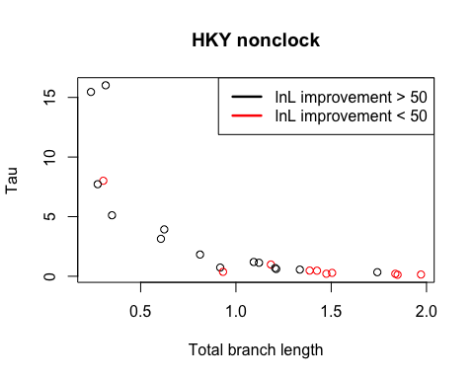

HKY clock case

plot(colSums(HKY.Force.clock.filtered[9:20, ]), HKY.clock.filtered[8, ],  
 type = "n", xlab = "Total branch length", ylab = "Tau" )  
col.color <- rep("black", dim(HKY.clock.filtered)[2])  
col.color[(HKY.clock.filtered - HKY.Force.clock.filtered)[2,] < 50] <- "red"  
points(x = colSums(HKY.Force.clock.filtered[9:20, ]), y = HKY.clock.filtered[8, ],  
 type = "p", col = col.color, bg = col.color)  
legend("topright", c("lnL improvement > 50", "lnL improvement < 50"),  
 lty = c(1, 1),   
 lwd = c(2.5, 2.5),  
 col = c("black", "red"))  
title("HKY clock")

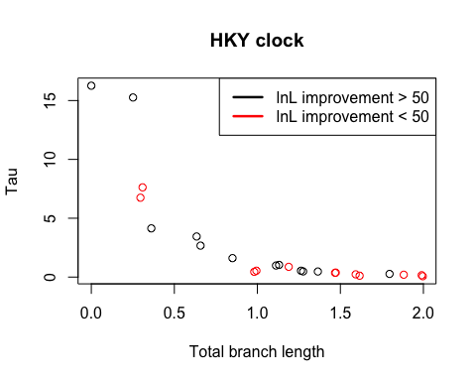

MG94 nonclock case

improvement.lmt <- 20  
plot(colSums(MG94.Force.nonclock.filtered[10:21, ]), MG94.nonclock.filtered[8, ],  
 type = "n", xlab = "Total branch length", ylab = "Tau" )  
col.color <- rep("black", dim(MG94.nonclock.filtered)[2])  
col.color[(MG94.nonclock.filtered - MG94.Force.nonclock.filtered)[2,] < improvement.lmt] <- "red"  
points(x = colSums(MG94.Force.nonclock.filtered[10:21, ]), y = MG94.nonclock.filtered[8, ],  
 type = "p", col = col.color, bg = col.color)  
legend("topright",   
 c(paste("lnL improvement > ", toString(improvement.lmt), sep = ""),  
 paste("lnL improvement < ", toString(improvement.lmt), sep = "")),  
 lty = c(1, 1),   
 lwd = c(2.5, 2.5),  
 col = c("black", "red"))  
title("MG94 nonclock")

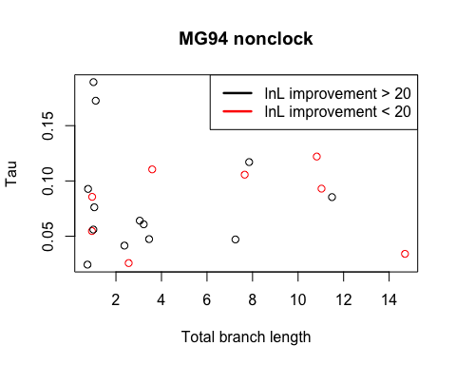

MG94 clock case

improvement.lmt <- 20  
plot(colSums(MG94.Force.clock.filtered[10:21, ]), MG94.clock.filtered[8, ],  
 type = "n", xlab = "Total branch length", ylab = "Tau" )  
col.color <- rep("black", dim(MG94.clock.filtered)[2])  
col.color[(MG94.clock.filtered - MG94.Force.clock.filtered)[2,] < improvement.lmt] <- "red"  
points(x = colSums(MG94.Force.clock.filtered[10:21, ]), y = MG94.clock.filtered[8, ],  
 type = "p", col = col.color, bg = col.color)  
legend("topright",   
 c(paste("lnL improvement > ", toString(improvement.lmt), sep = ""),  
 paste("lnL improvement < ", toString(improvement.lmt), sep = "")),  
 lty = c(1, 1),   
 lwd = c(2.5, 2.5),  
 col = c("black", "red"))  
title("MG94 clock")

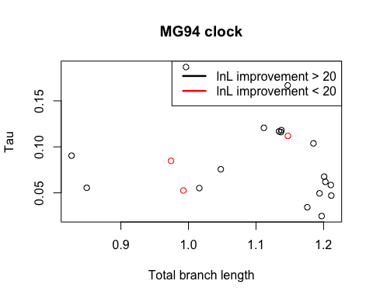

Now see if the pairs red in HKY are also red in MG94

nonclock case

HKY.pair.names[(HKY.nonclock.filtered - HKY.Force.nonclock.filtered)[2,] < 50]

## [1] "YLR406C_YDL075W" "YIL057C_YER067W" "YPL087W_YBR183W"  
## [4] "YDR518W_YCL043C" "YBR024W_YBR037C" "YPL037C_YDR252W"  
## [7] "YGL133W_YPL216W" "YLR284C_YOR180C" "YAL056W_YOR371C"  
## [10] "YDR438W_YML018C"

MG94.pair.names[(MG94.nonclock.filtered - MG94.Force.nonclock.filtered)[2,] < improvement.lmt]

## [1] "YLR406C_YDL075W" "YER131W_YGL189C" "YIL057C_YER067W" "YGR043C_YLR354C"  
## [5] "YDR099W_YER177W" "YLR284C_YOR180C" "YAL056W_YOR371C" "YDR438W_YML018C"

Only 3 pairs show up in both: YLR406C_YDL075W, YIL057C_YER067W, YDR438W_YML018C.

clock case

HKY.pair.names[(HKY.clock.filtered - HKY.Force.clock.filtered)[2,] < 50]

## [1] "YLR406C_YDL075W" "YER131W_YGL189C" "YIL057C_YER067W"  
## [4] "YPL087W_YBR183W" "YDR518W_YCL043C" "YGR043C_YLR354C"  
## [7] "YBR024W_YBR037C" "YPL037C_YDR252W" "YGL133W_YPL216W"  
## [10] "YLR284C_YOR180C" "YAL056W_YOR371C" "YDR438W_YML018C"

MG94.pair.names[(MG94.clock.filtered - MG94.Force.clock.filtered)[2,] < improvement.lmt]

## [1] "YLR406C_YDL075W" "YER131W_YGL189C" "YDR438W_YML018C"

2 pairs show up in both: YLR406C_YDL075W, YDR438W_YML018C

=========================================

Now plot Total blen v.s. Tau into different groups (differ by lnL improvement per site)

HKY nonclock case

plot(colSums(HKY.Force.nonclock.filtered[9:20, ]), HKY.nonclock.filtered[8, ],  
 type = "n", xlab = "Total branch length", ylab = "Tau" )  
col.color <- rep("black", dim(HKY.nonclock.filtered)[2])  
col.color[((HKY.nonclock.filtered - HKY.Force.nonclock.filtered)[2,] / HKY.nonclock.filtered[1, ]) < 0.06] <- "red"  
points(x = colSums(HKY.Force.nonclock.filtered[9:20, ]), y = HKY.nonclock.filtered[8, ],  
 type = "p", col = col.color, bg = col.color)  
legend("topright", c("lnL improvement per site > 0.06",  
 "lnL improvement per site < 0.06"),  
 lty = c(1, 1),   
 lwd = c(2.5, 2.5),  
 col = c("black", "red"))  
title("HKY nonclock")

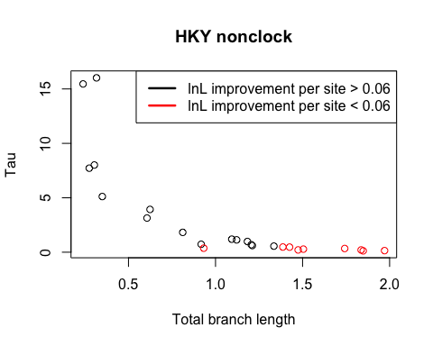

# lnL improvement per site  
((HKY.nonclock.filtered - HKY.Force.nonclock.filtered)[2,] / HKY.nonclock.filtered[1, ])

## YLR406C_YDL075W YER131W_YGL189C YDR502C_YLR180W YHR106W_YDR353W   
## 0.134895 0.239360 0.316054 0.173246   
## YIL057C_YER067W YPL087W_YBR183W YNL069C_YIL133C YDR518W_YCL043C   
## 0.090389 0.050645 0.152353 0.028735   
## YGR043C_YLR354C YPR157W_YGR141W YDR099W_YER177W YBR024W_YBR037C   
## 0.060532 0.060868 0.210301 0.053765   
## YPL037C_YDR252W YPR159W_YGR143W YGL133W_YPL216W YBR191W_YPL079W   
## 0.031368 0.115064 0.009705 0.252429   
## YNL049C_YIL109C YPL232W_YMR183C YLR284C_YOR180C YIR033W_YKL020C   
## 0.063228 0.127221 0.020901 0.037829   
## YMR243C_YOR316C YER102W_YBL072C YAL056W_YOR371C YDR438W_YML018C   
## 0.076393 0.390796 0.011672 0.017508

HKY clock case

plot(colSums(HKY.Force.clock.filtered[9:20, ]), HKY.clock.filtered[8, ],  
 type = "n", xlab = "Total branch length", ylab = "Tau" )  
col.color <- rep("black", dim(HKY.clock.filtered)[2])  
col.color[((HKY.clock.filtered - HKY.Force.clock.filtered)[2,] / HKY.clock.filtered[1, ]) < 0.06] <- "red"  
points(x = colSums(HKY.Force.clock.filtered[9:20, ]), y = HKY.clock.filtered[8, ],  
 type = "p", col = col.color, bg = col.color)  
legend("topright", c("lnL improvement per site > 0.06",  
 "lnL improvement per site < 0.06"),  
 lty = c(1, 1),   
 lwd = c(2.5, 2.5),  
 col = c("black", "red"))  
title("HKY clock")

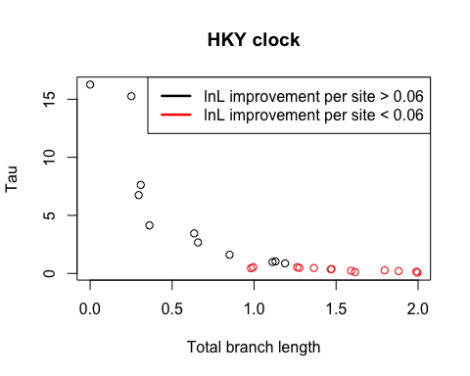

# lnL improvement per site  
((HKY.clock.filtered - HKY.Force.clock.filtered)[2,] / HKY.clock.filtered[1, ])

## YLR406C_YDL075W YER131W_YGL189C YDR502C_YLR180W YHR106W_YDR353W   
## 0.135924 0.133484 0.148359 0.152208   
## YIL057C_YER067W YPL087W_YBR183W YNL069C_YIL133C YDR518W_YCL043C   
## 0.088402 0.043125 0.131456 0.022857   
## YGR043C_YLR354C YPR157W_YGR141W YDR099W_YER177W YBR024W_YBR037C   
## 0.040853 0.052711 0.204649 0.038632   
## YPL037C_YDR252W YPR159W_YGR143W YGL133W_YPL216W YBR191W_YPL079W   
## 0.035687 0.115533 0.004019 0.249856   
## YNL049C_YIL109C YPL232W_YMR183C YLR284C_YOR180C YIR033W_YKL020C   
## 0.048577 0.106903 0.022112 0.030555   
## YMR243C_YOR316C YER102W_YBL072C YAL056W_YOR371C YDR438W_YML018C   
## 0.059616 61.564903 0.013551 0.007138

MG94 nonclock case

improvement.lmt <- 0.16  
plot(colSums(MG94.Force.nonclock.filtered[10:21, ]), MG94.nonclock.filtered[8, ],  
 type = "n", xlab = "Total branch length", ylab = "Tau" )  
col.color <- rep("black", dim(MG94.nonclock.filtered)[2])  
col.color[((MG94.nonclock.filtered - MG94.Force.nonclock.filtered)[2,] / MG94.nonclock.filtered[1]) < improvement.lmt] <- "red"  
points(x = colSums(MG94.Force.nonclock.filtered[10:21, ]), y = MG94.nonclock.filtered[8, ],  
 type = "p", col = col.color, bg = col.color)  
legend("topright",   
 c(paste("lnL improvement per site > ", toString(improvement.lmt), sep = ""),  
 paste("lnL improvement per site < ", toString(improvement.lmt), sep = "")),  
 lty = c(1, 1),   
 lwd = c(2.5, 2.5),  
 col = c("black", "red"))  
title("MG94 nonclock")

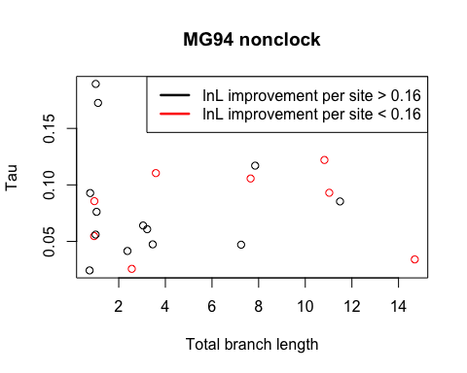

# lnL improvement per site  
((MG94.nonclock.filtered - MG94.Force.nonclock.filtered)[2,] / MG94.nonclock.filtered[1])

## YLR406C_YDL075W YER131W_YGL189C YDR502C_YLR180W YHR106W_YDR353W   
## 0.151633 0.140111 0.408336 0.198674   
## YIL057C_YER067W YNL069C_YIL133C YDR518W_YCL043C YGR043C_YLR354C   
## 0.146466 0.523279 0.301557 0.049233   
## YDR099W_YER177W YMR143W_YDL083C YJR048W_YEL039C YBR191W_YPL079W   
## 0.127276 0.332405 0.192824 0.590199   
## YDR418W_YEL054C YPL232W_YMR183C YLR284C_YOR180C YBL087C_YER117W   
## 0.286073 0.268073 0.007963 0.425100   
## YGL062W_YBR218C YIR033W_YKL020C YER102W_YBL072C YAL056W_YOR371C   
## 3.948891 0.276194 1.229483 0.130766   
## YDR438W_YML018C   
## 0.028612

MG94 clock case

improvement.lmt <- 0.4  
plot(colSums(MG94.Force.clock.filtered[10:21, ]), MG94.clock.filtered[8, ],  
 type = "n", xlab = "Total branch length", ylab = "Tau" )  
col.color <- rep("black", dim(MG94.clock.filtered)[2])  
col.color[((MG94.clock.filtered - MG94.Force.clock.filtered)[2,] / MG94.clock.filtered[1]) < improvement.lmt] <- "red"  
points(x = colSums(MG94.Force.clock.filtered[10:21, ]), y = MG94.clock.filtered[8, ],  
 type = "p", col = col.color, bg = col.color)  
legend("topright",   
 c(paste("lnL improvement per site > ", toString(improvement.lmt), sep = ""),  
 paste("lnL improvement per site < ", toString(improvement.lmt), sep = "")),  
 lty = c(1, 1),   
 lwd = c(2.5, 2.5),  
 col = c("black", "red"))  
title("MG94 clock")

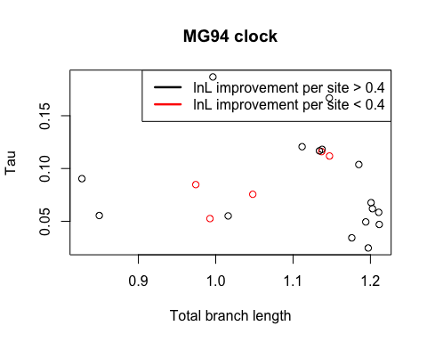

# lnL improvement per site  
((MG94.clock.filtered - MG94.Force.clock.filtered)[2,] / MG94.clock.filtered[1])

## YLR406C_YDL075W YER131W_YGL189C YDR502C_YLR180W YHR106W_YDR353W   
## 0.1556 0.1513 2.1905 4.6498   
## YIL057C_YER067W YNL069C_YIL133C YDR518W_YCL043C YGR043C_YLR354C   
## 5.1756 0.4759 0.7591 6.3887   
## YDR099W_YER177W YMR143W_YDL083C YJR048W_YEL039C YBR191W_YPL079W   
## 1.9019 0.4050 1.6068 0.6401   
## YDR418W_YEL054C YPL232W_YMR183C YLR284C_YOR180C YBL087C_YER117W   
## 0.3116 7.8226 0.3712 0.4424   
## YGL062W_YBR218C YIR033W_YKL020C YER102W_YBL072C YAL056W_YOR371C   
## 18.0984 1.3464 1.3331 1.1786   
## YDR438W_YML018C   
## -0.8621

OK, the MG94 nonclock long branch lengths are suspecious. It seems that the first four branches carry most of the total length. What if plot without those branches?

MG94 nonclock case without first four branches: (N0, N1), (N0,kluyveri), (N1,N2), (N1,castellii) are excluded

improvement.lmt <- 0.16  
plot(colSums(MG94.Force.nonclock.filtered[14:21, ]), MG94.nonclock.filtered[8, ],  
 type = "n", xlab = "Partial branch length", ylab = "Tau" )  
col.color <- rep("black", dim(MG94.nonclock.filtered)[2])  
col.color[((MG94.nonclock.filtered - MG94.Force.nonclock.filtered)[2,] / MG94.nonclock.filtered[1]) < improvement.lmt] <- "red"  
points(x = colSums(MG94.Force.nonclock.filtered[14:21, ]), y = MG94.nonclock.filtered[8, ],  
 type = "p", col = col.color, bg = col.color)  
legend("topright",   
 c(paste("lnL improvement per site > ", toString(improvement.lmt), sep = ""),  
 paste("lnL improvement per site < ", toString(improvement.lmt), sep = "")),  
 lty = c(1, 1),   
 lwd = c(2.5, 2.5),  
 col = c("black", "red"))  
title("MG94 nonclock 4 branches removed")

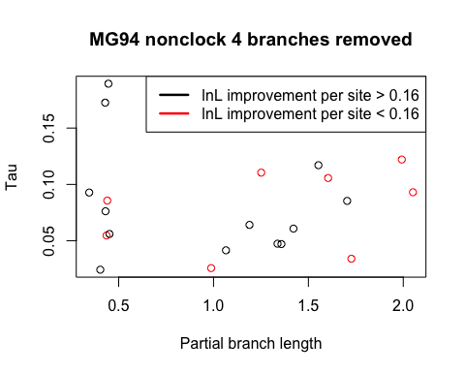

# lnL improvement per site  
((MG94.nonclock.filtered - MG94.Force.nonclock.filtered)[2,] / MG94.nonclock.filtered[1])

## YLR406C_YDL075W YER131W_YGL189C YDR502C_YLR180W YHR106W_YDR353W   
## 0.151633 0.140111 0.408336 0.198674   
## YIL057C_YER067W YNL069C_YIL133C YDR518W_YCL043C YGR043C_YLR354C   
## 0.146466 0.523279 0.301557 0.049233   
## YDR099W_YER177W YMR143W_YDL083C YJR048W_YEL039C YBR191W_YPL079W   
## 0.127276 0.332405 0.192824 0.590199   
## YDR418W_YEL054C YPL232W_YMR183C YLR284C_YOR180C YBL087C_YER117W   
## 0.286073 0.268073 0.007963 0.425100   
## YGL062W_YBR218C YIR033W_YKL020C YER102W_YBL072C YAL056W_YOR371C   
## 3.948891 0.276194 1.229483 0.130766   
## YDR438W_YML018C   
## 0.028612