INTRODUCTION TO COMPUTER HARDWARE

1. **MOTHERBOARD**

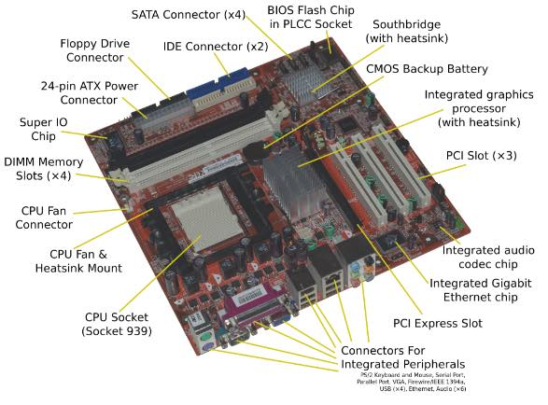

# Computer Motherboard And Its Components

The **computer motherboard** connects all the parts(components) of a computer together.  
Mainboard, baseboard, mobo (abbreviation), system board,  MB (abbreviation), logic board are the synonyms of computer’s motherboard .  
The motherboard is the most important component in the PC. All the component such as RAM stick, hard disk drive, optical drives, processor, processor fan and external card are plugin into motherboard.  
***Computer motherboard*** is single platform to connect all of the parts (components) of a computer together,Hence it considered as the backbone of a computer.

**Some of popular manufacturers of the motherboard.**  
**Intel**  
**ASUS**  
**AOpen**  
**ABIT**  
**Biostar**  
**Gigabyte**  
**MSI**

# The motherboard may be characterized by the

### i) form factor ii) chipset iii) type of processor socket used

**i) Form factor** refers to the motherboard’s geometry, dimensions, arrangement and electrical  
requirements. Advanced Technology Extended (ATX) is the most common design of motherboard for desktop computers.

**ii) Chipset** is a circuit, which is used to controls the of resources such as the bus interface with the processor, cache memory and RAM, expansion  
cards, etc. It used to coordinate data transfers between the various components of the computer.

**iii) The processor socket** is a connector into which the processor is mounted. The Basic Input Output System (BIOS) and Complementary Metal-Oxide Semiconductor (CMOS) are present on the motherboard.

# Components of Motherboard

The important components of a Motherboard are given below:

[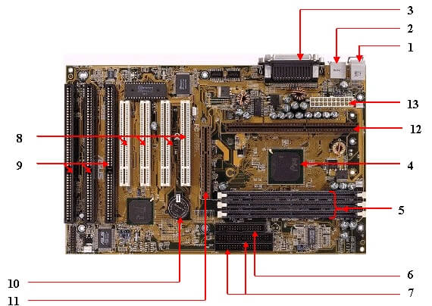](https://www.kencorner.com/wp-content/uploads/2018/03/Kencorner_Mother_Board1.jpg)

**1. Mouse & keyboard :**  
There are two types of keyboard and mouse  connectors.First type is called PS/2 and second one is called USB.

[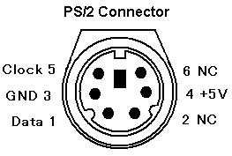](https://www.kencorner.com/wp-content/uploads/2018/03/Kencorner_ps2Connector.jpg)

**2. USB (Universal serial bus) :**  
USB is **Universal serial bus.** It is used for connection for PC. There are  different devices which is used to connect with USB port such as mouse, keyboards, scanners, cameras, and even printers.USB connector is used to connect computer motherboard and a peripheral device. You can insert or remove peripheral device connect by USB connector without restarting your system.

**3. Parallel port  :**  
Most of old  printers are used to connect by  parallel port. Parallel port used more than one wire for sending or receiving multiple bits of data at once, while serial port uses only one wire. Parallel ports use a 25-pin female DB connector.

**4. CPU Chip  :**  
CPU refers to a processor, the central processing unit, also called the microprocessor performs all the task that take place inside a computer system.It is also know as brain of computer.

**5. RAM slots :**  
RAM slots is for attaching RAM on it in general desktop we can see two slot of RAM but in server motherboard we can see 4+ slot of RAM.RAM comes in different size(memory).

**6. Floppy controller :**  
In old motherboard the floppy drive connects to the computer via a 34-pin ribbon cable, one end of ribbon cable is connect to floppy drive and other is connected to the motherboard.

**7. IDE controller :**  
IDE that is **Integrated Drive Electronics**,also called as **ATA** or Parallel **ATA (PATA)**.IDE controller is responsible for controlling the hard drive. Today’s computers no longer come with a IDE controller.

**8. PCI slot :**  
PCI stands for Peripheral Component Interface, PCI slot allows you to insert expansion cards into your computer. PCI used to connect additional PCI device like network cards, sound cards,modems,video cards.Some of today’s computers no longer come with a PCI expansion slot.Its connect audio, video and graphics.

**9. ISA slot :**  
ISA stands for Industry Standard Architecture, It is the standard architecture of the Expansion bus.Its connect modem and input devices.

**10. CMOS Battery :**  
CMOS is complementary metal-oxide-semiconductor is used to store BIOS setting in computer motherboard. CMOS Battery also store date and time.

**11. AGP slot :**  
The Accelerated Graphics Port (**AGP**) is a high-speed point-to-point channel for attaching a video card to a computer system, If you have a modern motherboard, you will almost certainly notice a single connector that looks like a PCI slot.A fast port for a graphics card

**12. CPU slot :**  
The processor socket (also called a CPU socket) is the connector on the motherboard that connect a CPU.

**13. Power supply plug in :**  
The Power supply provides the necessary electrical power to make the computer system operate. The power supply takes standard 110-V AC power and converts into  +/-12-Volt, +/-5-Volt, and 3.3-Volt DC power.  
The power supply connector has 20-pins, and the connector can go in only one direction.

[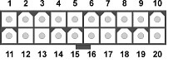](https://www.kencorner.com/wp-content/uploads/2018/03/Kencorner_Power_Connector.jpg)

# Connector Side of Motherboard

[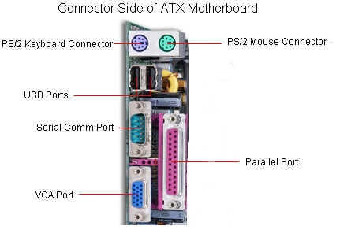](https://www.kencorner.com/wp-content/uploads/2018/03/Kencorner_Connector_Motherboard.jpg)

|  |  |
| --- | --- |
| [component of motherboard Keyboard port](https://www.kencorner.com/wp-content/uploads/2018/03/Keyboard.jpg) | **Keyboard & Mouse :** This Port is used to connect keyboard and mouse , now a day we use USB connector for keyboard and mouse |
| [component of motherboard serial port](https://www.kencorner.com/wp-content/uploads/2018/03/serialport.jpg) | **Serial or COM :**  It used to connect some types of modem, scanner, or digital camera |
| [component of motherboard parallel Port](https://www.kencorner.com/wp-content/uploads/2018/03/parallelPort.jpg) | **Parallel or Printer** : You plug your printer into the parallel, or printer, port. But now printers may use a USB port |
| [component of motherboard USB port](https://www.kencorner.com/wp-content/uploads/2018/03/USBport.jpg) | **USB :** Designed to replace older Serial and Parallel ports, the USB (Universal Serial Bus) can connect computers with a number of devices, such as printers, keyboards, mice, scanners, digital cameras, PDAs, and more |
|  |  |
| [component of motherboard monitor Port](https://www.kencorner.com/wp-content/uploads/2018/03/monitorPort.jpg) | **Video or Monitor** : It used to connect your monitor into the video port |
| [component of motherboard Line Out](https://www.kencorner.com/wp-content/uploads/2018/03/LineOut.jpg) | **Line Out** : It used to connect speakers or headphone into the Line Out jack |
| [component of motherboard line IN](https://www.kencorner.com/wp-content/uploads/2018/03/lineIN.jpg) | **Line In** : The Line In jack allows you to listen to your computer using a stereo system |
| [component of motherboard microphone port](https://www.kencorner.com/wp-content/uploads/2018/03/microPhonePort.jpg) | **Microphone** : It used to connect a microphone into this jack to record sounds on your computer |
| [component of motherboard JoyStick](https://www.kencorner.com/wp-content/uploads/2018/03/JoyStick.jpg) | **Joystick or Game** : If you have a joystick, musical (MIDI) keyboard, or other gaming device, this is where you plug it in |
| [component of motherboard Phone or Modem port](https://www.kencorner.com/wp-content/uploads/2018/03/PhoneORModem.jpg) | **Phone or Modem** : The phone or modem jack is where you plug your computer into a phone line |
| [component of motherboard LAN port](https://www.kencorner.com/wp-content/uploads/2018/03/LANport.jpg) | **Network or Ethernet** : You can connect your computer to a network by plugging in an Ethernet cable in this port |
| [component of motherboard Printer Port](https://www.kencorner.com/wp-content/uploads/2018/03/PrinterPort.jpg) | **SCSI** : It used to connect a hard drive, CD-ROM drive, or other device to a computer |

# Below Diagram show component of motherboard

Here we are using Asus H110M-cs motherboard

[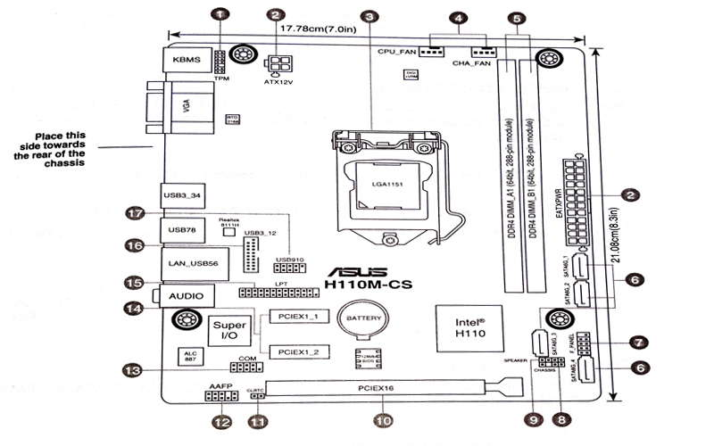](https://www.kencorner.com/wp-content/uploads/2018/03/Part-of-motherBoard.jpg)

**(1)  TPM connector (14-1 pin TPM)**

[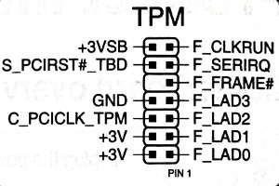](https://www.kencorner.com/wp-content/uploads/2018/03/tpm.jpg)

**(2 ) ATX power connector    (3) CPU socket    (4) CPU and chassis fan connector   (5) DDR4 DIMM slots   (6) Serial ATA connector**

**(7) System Front panel connector**

[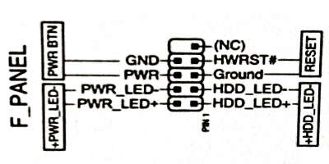](https://www.kencorner.com/wp-content/uploads/2018/03/frontPannel.jpg)

**(8) Chassis instrusion head   (9) Speaker Connector   (10) PCI Express  (11) Clear RTC RAM  (12) Front panel audio connector  (13) Serial port connector  (14) PCI Express slots  (15) LPT connector  (16) USB 3.0 connector  (17) USB 2.0 connector**

# ****Installing components of motherboard****

[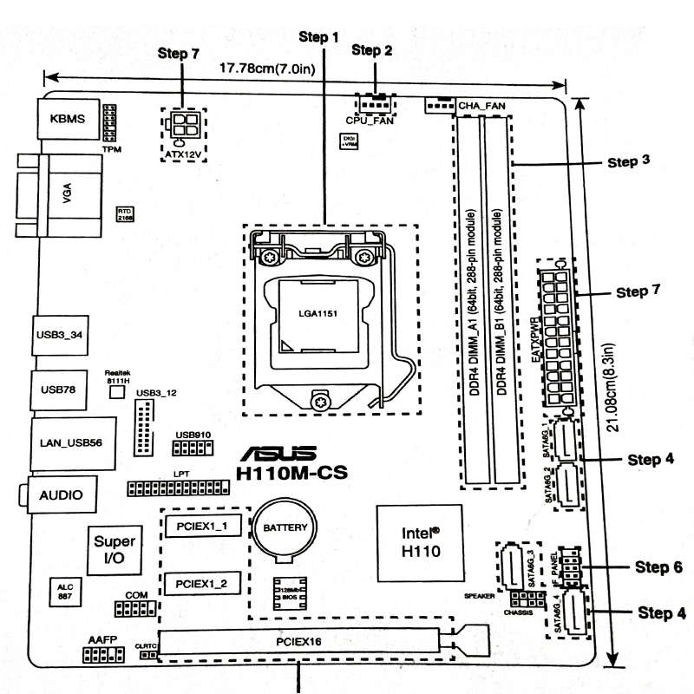](https://www.kencorner.com/wp-content/uploads/2018/03/Steps-in-Installing-motherboard.jpg)

### Step 1 ) Install CPU

[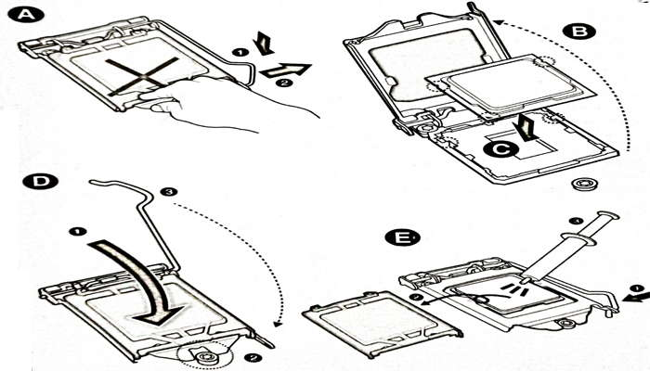](https://www.kencorner.com/wp-content/uploads/2018/03/Step-installing-Cpu.jpg)

### Step 2 ) Installing CPU Fan

[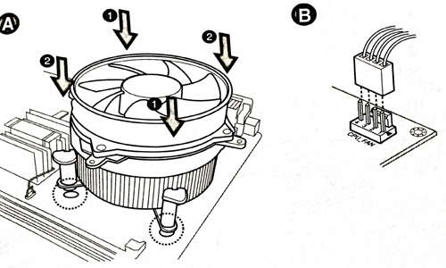](https://www.kencorner.com/wp-content/uploads/2018/03/Installing-cpu-fan.jpg)

### Step 3 ) Install RAM

[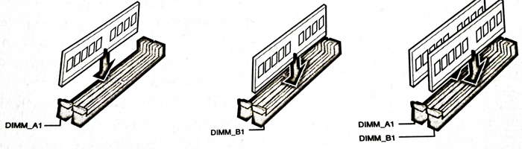](https://www.kencorner.com/wp-content/uploads/2018/03/installing-RAM.jpg)

### Step 4 ) Install SATA devices

### Step 5 ) Install Expansion cards

### Step 6 ) Install system panel connector

### Step 7 ) Install ATX power connector

[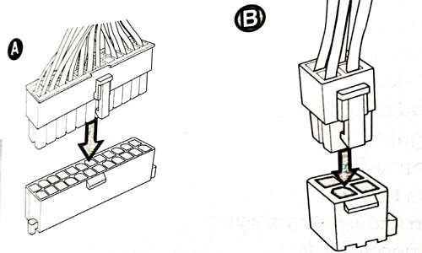](https://www.kencorner.com/wp-content/uploads/2018/03/power-connection-mothereboard.jpg)

### Step 8 ) Connecting input/output devices

### Step 9 ) Power On the system and install Operating System

1. **RAM MODULES**

## Memory module a narrow printed circuit board that holds memory chips (RAM chips). The common architecture

## for desktop computers is the dual inline memory module (DIMM), which transfers 64 bits at a time. Because of space limitations, laptops use small outline DIMMs (SODIMMs). The modules are keyed with notches in different places so they cannot be inserted into the wrong slots.

**Error Detection and Correction**  
Most desktop and laptop computers use RAM chips that hold eight bits per byte, while highend

servers and workstations typically have nine bits. The ninth bit is a parity bit for detecting errors.

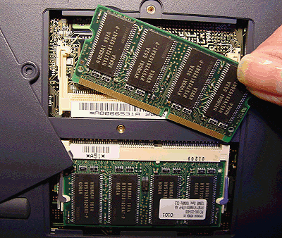

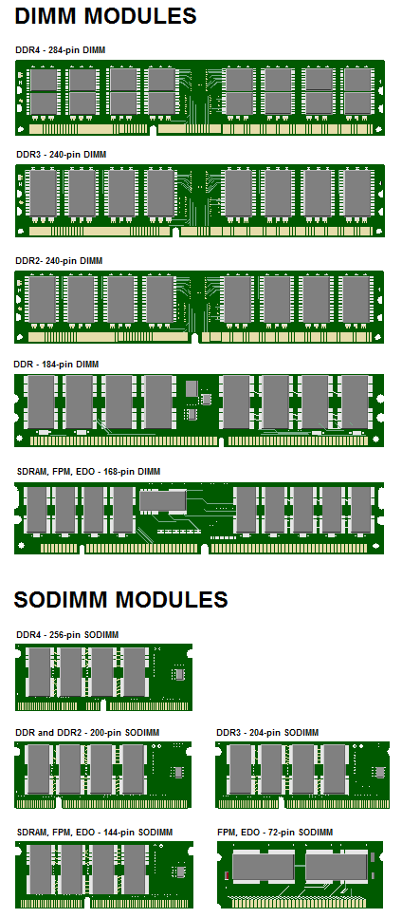

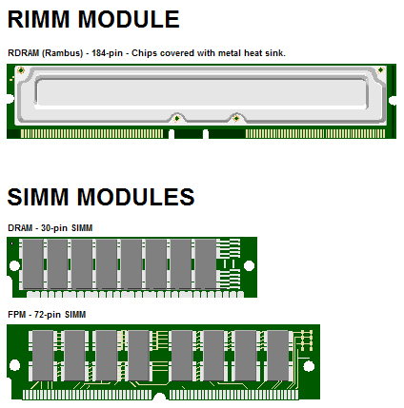

1. **DAUGHTER CARDS**

A daughter card or daughterboard is a type of circuit board that gets added to an existing one. Its name is appropriate for its use, since it is connected to a “motherboard” or “main board.” The motherboard is the primary circuit board for a device. It is usually in the device as it is shipped from the factory

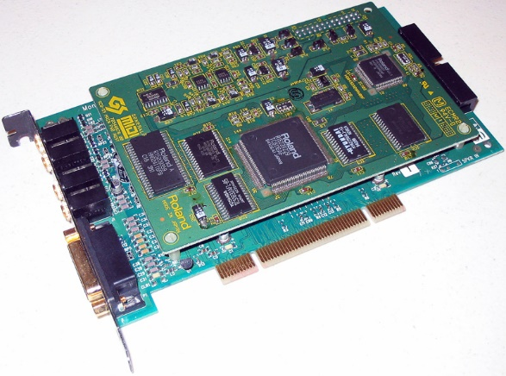

1. **BUS SLOT**

Alternatively known as a bus slot or expansion port, an expansion slot is a connection or port inside a computer on the motherboard or riser card. It provides an installation point for a hardware expansion card to be connected.

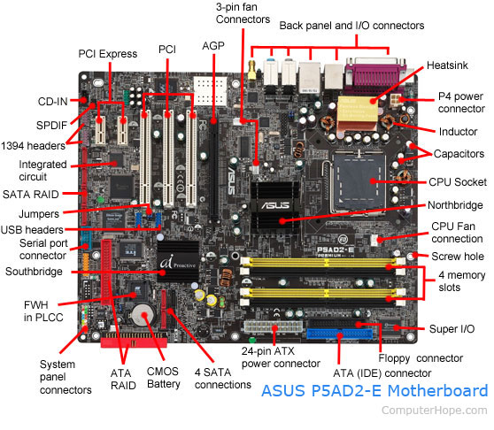

1. **SMPS**

The full form of SMPS is **Switched Mode Power Supply** also known as **Switching Mode Power Supply**. SMPS is an electronic power supply system that makes use of a switching regulator to transfer electrical power effectively. It is a PSU (power supply unit) and is usually used in computers to change the voltage to the appropriate range for the computer.

An SMPS adjusts output voltage and current between different electrical configurations by switching the basics of typically lossless storage such as capacitors and inductors. Ideal switching concepts determined by transistors controlled outside of their active state that have no resistance when ‘on’ and carry no current when ‘off.’ It is the idea why switches with an ideal function will operate with 100 per cent output, that is, all input energy is provided to the load; no power is wasted as dissipated heating. In fact, such ideal systems do not exist, which is why a switching power source can not be 100 per cent proficient, but it is still a vital improvement in effectiveness over a linear regulator.

## **Working principles of SMPS**

In the SMPS device, the switching regulators are used which switches on and off the load current to maintain and regulate the voltage output. Suitable power generation for a system is the mean voltage between off and on. Unlike the linear power supply, the SMPS carry transistor switches among low dissipation, full-on and full-off phase, and spend much less time in high dissipation cycles, which decreases depleted strength.

### **Benefits of SMPS**

* The switch-mode power source is small in scale.
* The SMPS is very lightweight.
* SMPS power consumption is typically 60 to 70 per cent, which is ideal for use.
* SMPS is strongly anti-interference.
* The SMPS production range is large.

### **Limitations of SMPS**

* The complexity of SMPS is very large.
* The production reflection is high and its control is weak in the case of SMPS.
* Use of SMPS can only be a step-down regulator.
* In SMPS, the voltage output is just one.

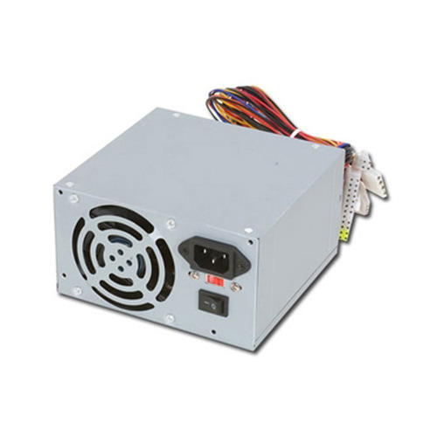

## **Internal Storage Devices**

Some storage devices are classed as 'internal' which means they are inside the computer case.

Most computers have some form of internal storage. The most common type of internal storage is the hard disk.

At the most basic level, internal storage is needed to hold the operating system so that the computer is able to access the input and output devices.

It will also be used to store the applications software that you use and more than likely, the original copies of your data files.

Internal storage allows the data and applications to be loaded very rapidly into memory, ready for use. The data can be accessed much faster than data which is stored on an external storage device. This is because internal storage devices are connected directly to the motherboard and its data bus whereas external devices are connected through a hardware interface such as USB, which means they are considerably slower to access.

Internal storage also means that if the computer is moved around, it will still retain its most commonly used data.

The main disadvantage of internal storage is that when the hard disk fails (and it will), all the data and applications may be lost.

This can be avoided to some extent by using more than one hard disk within the machine. Each hard disk has a copy of all the data, so if one fails the other can carry on. This is called a RAID array. An alternative is to use external drives for backup

© www.teach-ict.com

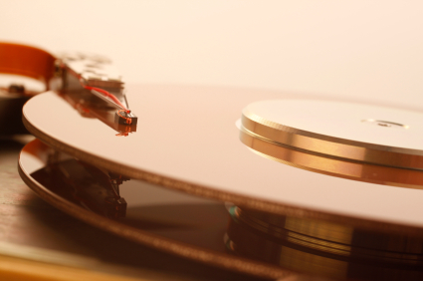

1. **INTERFACING PORT**

A **port** is basically a physical docking point which is basically used to connect the external devices to the computer, or we can say that A port act as an interface between the computer and the external devices, e.g., we can connect hard drives, printers to the computer with the help of ports.

**Features of Computer ports:**

* We can connect external devices to the computer with the help of ports and cables.
* These are basically slots on motherboard where we connect external devices, or we can plug in external devices through cables.
* Mouse, keyboards, printers, speakers are some examples of external devices that connected to the computer through ports.

**Types of ports:**

**1. Serial ports –**  
A serial port is basically a serial communication interface through which information transforms one bit at a time. It is one of the oldest type of interfaces.

* + These are basically used for external modems.
  + These are basically available in two versions in market these are 9 pins, 25 pin models.
  + Data travels at a speed of 115 kilo-bits per second.

**2. Parallel ports –**  
A parallel port is basically a parallel communication interface through which information transforms multiple bits at a time.

* + These are basically used to connect peripherals such as scanners or printers.
  + These are also known as printer ports.
  + These are available in a 25 pin model.
  + Data travels at a speed of 150 kilo bits per second.

**3. PS/2 ports –**  
These are basically 6 pin mini Din connector used to connect keyboard, mice to a PC compatible computers.

* + These are basically used by old computers for connecting mouse or keyboard.
  + These are called mouse ports.
  + These ports are still favoured in organisation for security reason.
  + These ports provides no restriction on key rollover.

**4. Universal serial bus port –**  
It is basically a standard cable connection interface between computer and external device. USB is an industrial standard for short-distance digital data communication.

* + Basically it can connect all types of external devices to the computer such as mouse, keyboard, printers, speakers etc.
  + These ports were introduced in 1997.
  + Minimum 2 ports are there in every computer system.
  + Data basically travels at a speed of 14mb/s which is much faster than serial port.
  + The devices that uses USB port gets power from a USB port.

**5. VGA Ports –**  
VGA connector stands for Video Graphic Array connector, these are basically 15 pin connector available in many video-cards, computer, projectors etc.

* + It is used to connect monitor to computer’s video card.
  + It is 15 pin connector.
  + These were introduced by IBM in 1987.
  + VGA basically utilizes analog signal hence it can only be used to lower resolution or we can say VGA is only capable of lowering the resolution.

These are some of the common ports available in computer system. Except these there are many more ports available in computer. These are as follows:

**Modem Port:**  
These are basically used to connect PC’s modem to telephone networks.

**Ethernet Port:**  
These are basically used to connect Ethernet cables to the computer. In this data may travel with a speed of 10mb/s to 100 mb/s based on the network bandwidth.

**Game Port:**  
These ports are available in computer to connect joysticks which are now replaced by USB.

Digital Video Interface or we can say DVI Port these are basically used to connect flat panel LCD Monitor to the computer’s high end video graphics.

**Sockets:**  
Sockets are basically used to connect microphone or speakers to the sound card of the computer.

1. **DESKTOP AND SERVER CLASS COMPUTERS**

A [desktop computer](https://www.webopedia.com/definitions/desktop-computer/) system typically runs a user-friendly operating system and desktop applications to facilitate desktop-oriented tasks. In contrast, a [server](https://www.webopedia.com/definitions/server/) manages all network resources. Servers are often [dedicated](https://www.webopedia.com/definitions/dedicated/) (meaning it performs no other task besides server tasks). Because a server is engineered to manage, store, send and process data 24-hours a day it has to be more reliable than a desktop computer and offers a variety of features and hardware not typically used in the average desktop computer.

## SERVER HARDWARE

One of the best choices for a small business is a [dedicated server](https://www.webopedia.com/definitions/dedicated-server/) built from the ground up as a file server to provide features and expansion options that a [desktop computer](https://www.webopedia.com/definitions/desktop-computer/) lacks. Some server hardware decisions you will need to make include the following:

1. [**Form Factor**](https://www.webopedia.com/definitions/form-factor/)**:** For small businesses, the best choice is a dedicated entry-level server in a tower configuration.
2. [**Processor**](https://www.webopedia.com/definitions/microprocessor/)**:**Choose a server-specific processor to boost performance and data throughput.
3. [**Memory**](https://www.webopedia.com/definitions/memory/)**:** Buy as much memory as you can afford and look for expansion slots for future upgrades.
4. [**Storage**](https://www.webopedia.com/definitions/mass-storage/)**:** Look for SATA or SCSI hard disks, not IDE.

## **Install the operating system**

To install the computer's operating system using a CD or DVD, you need to configure your computer to boot from the CD/DVD drive. You can change the [boot sequence](https://www.computerhope.com/jargon/b/bootsequ.htm) in your BIOS setup, and setting the CD/DVD drive to be the first boot device. Some computers may also allow you to access the boot sequence directly at computer start up, without entering the BIOS, by pressing a specific key on the keyboard. The key to press differs for each computer, but is often the Delete key or one of the [function keys](https://www.computerhope.com/jargon/f/funckeys.htm).

If the operating system software came on a USB flash drive, you need to configure the computer to boot to a USB device as the first boot device.

Once the computer is configured to boot to the proper device, the computer should load the operating system installation program and guide you through the install process. You will be asked questions along the way for configuration of basic settings, like date and time, user account name, and if you want to enable automatic operating system updates. Go through the installation steps, answering questions and selecting the preferred options.

## Running the operating system

After the operating system has been installed, the computer should load into the operating system. You may then proceed with installing software that you want on the computer and updating any settings you want.