TASK 1. Use Cases
GPT answer | Selected scenario
Here are three clear RBAC use cases, written in a clean, practical way (good for documentation, reports, or coursework):  1. Admin Assigning Roles to Users  Scenario:  An administrator manages user access within the system.  Flow:  - The admin logs into the system with administrative privileges.  - The admin selects a user account.  - The admin assigns a role (e.g., Editor or Viewer) to the user.  - The system updates the user’s role-to-permission mapping.  Outcome:  The user automatically gains all permissions associated with the assigned role without manual permission configuration.  2. User Accessing a Protected Resource  Scenario:  A user attempts to access a resource that requires specific permissions.  Flow:  - The user logs into the system.  - The user requests access to a protected resource (e.g., editing a document).  - The system checks the user’s assigned role(s).  - The system verifies whether the role includes the required permission.  Outcome:  Access is granted, and the user can successfully perform the requested action.  3. User Being Denied Access to a Protected Resource  Scenario:  A user attempts to perform an action beyond their role’s permissions.  Flow:  - The user logs into the system.  - The user attempts to access a restricted resource (e.g., deleting data).  - The system checks the user’s role and associated permissions.  - The required permission is not found.  Outcome:  Access is denied, and the system returns an authorization error or warning message.  If you want, I can also:  - rewrite these in UML use-case format,  - make them more academic (for a paper or report),  - or adapt them to a real system (cloud app, database, n8n, etc.). | 1. Admin Assigning Roles to Users  Scenario:  An administrator manages user access within the system.  Flow:  - The admin logs into the system with administrative privileges.  - The admin selects a user account.  - The admin assigns a role (e.g., Editor or Viewer) to the user.  - The system updates the user’s role-to-permission mapping.  Outcome:  The user automatically gains all permissions associated with the assigned role without manual permission configuration.

TASK 2. User Stories
Prompt 1: Create 5 user stories for RBAC in format: As a [role], I want [action], so that [benefit]
GPT answer 1:
- As an administrator, I want to assign roles to users, so that access permissions are managed centrally and consistently.
- As an administrator, I want to modify or revoke user roles, so that access rights can be updated when responsibilities change.
- As a registered user, I want to access resources allowed by my role, so that I can perform my assigned tasks efficiently.
- As a registered user, I want to be prevented from accessing unauthorized resources, so that system security and data integrity are maintained.
- As a system auditor, I want to review user roles and permissions, so that compliance and access control policies can be verified.
Prompt 2: which of them covering admin, manager, and developer needs
GPT answer 2:
✅ Final mapping summary
Role | Covered by User Story # | Coverage
Admin | 1, 2 | ✅ Fully
Manager | 5 (rename to Manager) | ⚠️ Partial
Developer | 3 | ✅ Yes
Security | 4 | ➕ Supporting

Prompt 3: create use case where manager needs are covered fully in a format: : As a [role], I want [action], so that [benefit]
GPT answer 3:
User story:
As a manager, I want to review and approve team members’ role assignments, so that access permissions align with their responsibilities and compliance requirements.

FINAL ANSWER TASK 2:
- As an administrator, I want to assign roles to users, so that access permissions are managed centrally and consistently.
- As a manager, I want to review and approve team members’ role assignments, so that access permissions align with their responsibilities and compliance requirements.
- As a registered user, I want to access resources allowed by my role, so that I can perform my assigned tasks efficiently.

TASK 3. Task List
GPT VERSION
Task | Category | Priority | Estimate
Design RBAC data model (users, roles, permissions) | Backend (API, database) | High | 4h
Create database tables for roles and permissions | Backend (API, database) | High | 3h
Implement user–role mapping table | Backend (API, database) | High | 2h
Implement role–permission mapping table | Backend (API, database) | High | 2h
Develop API endpoint to assign roles to users | Backend (API, database) | High | 3h
Develop API endpoint to revoke or update roles | Backend (API, database) | High | 3h
Implement permission-check middleware | Backend (API, database) | High | 4h
Create API to fetch user roles and permissions | Backend (API, database) | Medium | 2h
Build admin UI for role management | Frontend (UI) | High | 5h
Build UI for assigning roles to users | Frontend (UI) | High | 4h
Build manager UI for reviewing role assignments | Frontend (UI) | Medium | 4h
Display access-denied messages in UI | Frontend (UI) | Medium | 2h
Implement role-based UI element visibility | Frontend (UI) | Medium | 3h
Write unit tests for RBAC permission logic | Testing | High | 4h
Write API integration tests for RBAC endpoints | Testing | High | 4h
Write frontend tests for role-based UI behavior | Testing | Medium | 3h
Validate least-privilege role definitions | Security | High | 2h
Implement audit logging for role changes | Security | High | 3h
Secure RBAC APIs with authentication checks | Security | High | 3h
Perform access control security review | Security | Medium | 3h

ADJUSTED PRIORITY VERSION
Task | Category | Priority | Estimate
Design RBAC data model (users, roles, permissions) | Backend (API, database) | High | 4h
Create database tables for roles and permissions | Backend (API, database) | High | 3h
Implement user–role mapping table | Backend (API, database) | High | 2h
Implement role–permission mapping table | Backend (API, database) | High | 2h
Develop API endpoint to assign roles to users | Backend (API, database) | High | 3h
Develop API endpoint to revoke or update roles | Backend (API, database) | High | 3h
Implement permission-check middleware | Backend (API, database) | High | 4h
Create API to fetch user roles and permissions | Backend (API, database) | High | 2h
Build admin UI for role management | Frontend (UI) | Medium | 5h
Build UI for assigning roles to users | Frontend (UI) | Medium | 4h
Build manager UI for reviewing role assignments | Frontend (UI) | Medium | 4h
Display access-denied messages in UI | Frontend (UI) | Medium | 2h
Implement role-based UI element visibility | Frontend (UI) | High | 3h
Write unit tests for RBAC permission logic | Testing | High | 4h
Write API integration tests for RBAC endpoints | Testing | High | 4h
Write frontend tests for role-based UI behavior | Testing | Medium | 3h
Validate least-privilege role definitions | Security | High | 2h
Implement audit logging for role changes | Security | High | 3h
Secure RBAC APIs with authentication checks | Security | High | 3h
Perform access control security review | Security | High | 3h

TASK 4. Workflow Diagram
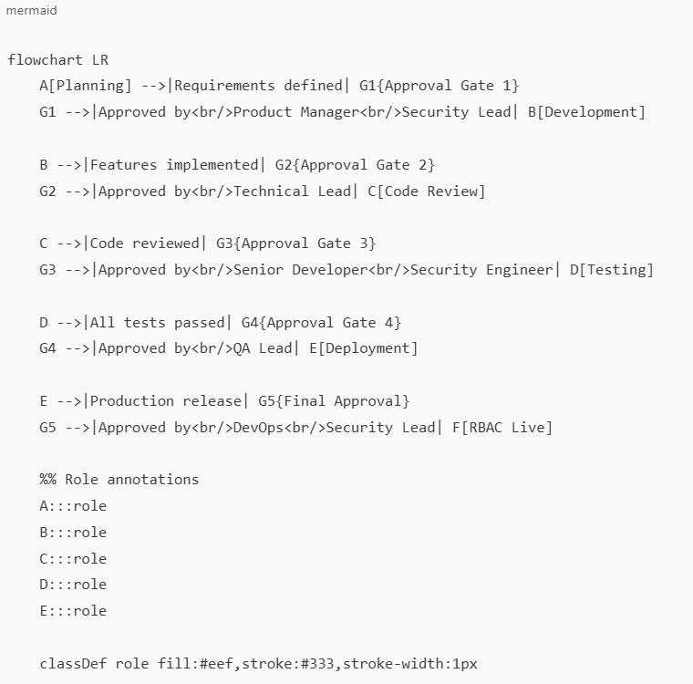
Mermaid diagram (above code was copied and pasted to mermaid diagram creating app):
TASK 5. Validation Notes
1. Scalability Review (≈10,000 users)
What’s good already ✅
- Role–permission mapping (not per-user permissions)
- Middleware-based permission checks
- API-based access control (centralized enforcement)
These scale well to 10k users.
Gaps / Risks ⚠️
- No caching of roles/permissions
- No indexing strategy mentioned
- No rate limiting or performance testing
- No consideration for concurrent access
Improvements to add
Suggested tasks:
- Cache user roles and permissions (e.g., Redis or in-memory cache)
- Add database indexes on user_id, role_id, permission_id
- Implement API rate limiting
- Load-test RBAC authorization checks (10k+ users)
Why:
Without caching, every request may hit the database, which becomes a bottleneck at scale.

2. Security Review (OWASP Compliance)
What’s good already ✅
- Permission-check middleware
- Secure RBAC APIs with authentication
- Audit logging for role changes
- Security review before deployment
These align well with OWASP Top 10.
Gaps / Risks ⚠️
- No explicit protection against:
  - Broken Access Control (OWASP A01)
  - Privilege escalation
  - Insecure direct object references (IDOR)
- No separation between authentication and authorization logic
- No security regression testing
Improvements to add
Suggested tasks:
- Enforce server-side authorization on every protected endpoint
- Add explicit checks against role escalation (admin-only actions)
- Implement security tests for OWASP A01 (Broken Access Control)
- Log and alert on repeated authorization failures
Why:
RBAC failures are one of the most common real-world security breaches.

3. Maintainability Review
What’s good already ✅
- Clear separation: backend, frontend, testing, security
- Middleware-based permission checks
- Dedicated testing tasks
Gaps / Risks ⚠️
- No versioning strategy for roles/permissions
- No documentation tasks
- No migration or rollback plan
- No configuration-based role definitions
Improvements to add
Suggested tasks:
- Define roles and permissions via configuration (YAML/JSON)
- Document RBAC roles, permissions, and flows
- Add database migration and rollback scripts
- Version roles and permissions for backward compatibility
Why:
RBAC systems tend to evolve; without versioning and documentation, they become fragile.

4. Suggested Additional Tasks (Summary)
Improvement Area | New Task
Scalability | Cache roles/permissions
Scalability | Index RBAC database tables
Scalability | Load test RBAC authorization
Security | OWASP Broken Access Control tests
Security | Privilege escalation prevention
Security | Authorization failure monitoring
Maintainability | Config-based role definitions
Maintainability | RBAC documentation
Maintainability | Migration & rollback strategy
Maintainability | Version roles and permissions

Final Assessment
Overall quality: ⭐⭐⭐⭐☆ (strong foundation)
With improvements: ⭐⭐⭐⭐⭐ (production-ready for 10k+ users)

