Name:
Student ID:

Data Exploration and Multiple Linear Regression (MLR) using SAS.

The “College” data set contains the statistics for many US Colleges from 1995
issue of US News and World Report. It has 777 observations on 18 variables. The colleges want
to predict the enrollment of the student for the next semester based on the past data available.
For a description of the data see “College.txt” in Canvas which contains college data and
attribute information. The main task is to check if the number of enrollments is dependent on the
characteristics of the university.
“Private” is the dummy variable. Do the dummy coding accordingly (See the “Regression with
Dummy Variables in SAS.docx in Canvas)
1. Generate boxplots of the accept (Number of applications accepted), top10perc (% of
new students from top 10% of High School class) attributes and the dependent variable enroll
(Number of new students enrolled) and identify/remove the cutoff values for outliers.
2. Try to fit an MLR to this dataset, with ENROLL as the dependent variable.
P_UNDERGRAD has somewhat longish tail, so we will take a log transform, (use
LP_UNDERGRAD= log(P_UNDERGRAD)) and then use LP_UNDERGRAD as one of
predictor. Keep the first 544 records as a training set (call it ENROLLTRAIN) which you will
use to fit the model; the remaining 233 will be used as a test set (ENROLLTEST).
3. Use only the following variables in your model:
ENROLL=ACCEPT+TOP10PERC+F_UNDERGRAD+LP_UNDERGRADE+ROOM_BOARD +GRADE_RATE +PRIVATEDUMMY
(a) Report the coefficients obtained by your model. Would you drop any of the variables
used in your model (based on the t-scores or p-values)?
(b) Report the MSE obtained on ENROLLTRAIN. How much does this increase when you
score your model on ENROLLTEST?
(c) (Bonus 2 points). Do you think your MLR model is reasonable for this problem? You
may look at the distribution of residuals to provide an informed answer.

SAS Code:
Kindly paste your SAS code here

proc import datafile="C:\Users\ianko\Desktop\sas\SMPL DATA\College.csv"
DBMS= csv out= college replace;

proc print data=College; run;

data college2;
set College;
if (private='Yes') then P_1 = 1; else P_1= 0;
run;

proc print data= college2; run;

proc univariate data=college2 normal plot;
var apps accept enroll top10perc top25perc f_undergrad p_undergrad outstate room_board books personal phd terminal s_f_ratio perc_alumni expend grad_rate P_1;
run;

proc import datafile="C:\Users\ianko\Desktop\sas\SMPL DATA\college.csv"
DBMS= csv out= college replace;

data college3;
set college2;
if (accept>5154) then delete;
if (enroll>1892) then delete;
if (top10perc>65) then delete;
run;

proc print data=college3; run;

data MODcollege3;
set college3(firstobs=1 obs=544);
Lp_undergrad = log(p_undergrad);
run;

proc print data=MODcollege3; run;

proc reg data=MODcollege3;
model enroll = accept top10perc room_board f_undergrad grad_rate P_1 Lp_undergrad / tol vif collin;
run;

data Model_MODcollege3;
set MODcollege3;
y_bar= 183.10230 + (0.16968*accept) + (0.58053*top10perc) + (-0.03350*room_board) + (0.09463*f_undergrad) + (0.16653*grad_rate) + (-11.69977*P_1);
predicted_err=((enroll-y_bar)**2); run;

proc print data=Model_MODcollege3; run;

data TESTcollege3;
set college3(firstobs=545 obs=657);
Lp_undergrad = log(p_undergrad);
run;

proc print data=TESTcollege3;

proc reg data=TESTcollege3;
model enroll = accept top10perc room_board f_undergrad grad_rate P_1 Lp_undergrad / tol vif collin;
run;

proc univariate data=TESTcollege3;
var apps accept enroll top10perc top25perc f_undergrad p_undergrad outstate room_board books personal phd terminal s_f_ratio perc_alumni expend grad_rate P_1 Lp_undergrad;
run;

proc reg data=MODcollege3;
model enroll = accept top10perc room_board f_undergrad P_1 Lp_undergrad / tol vif collin;
run;

proc reg data=MODcollege3;
model enroll = accept top10perc room_board f_undergrad Lp_undergrad / tol vif collin;
run;

Answers:
Kindly paste screenshots of the output for answering the questions.
There is no restriction on how many pages you use and how much you can interpret the output, the space given for each answer is just a format.

1. Generate boxplots of the accept (Number of applications accepted), top10perc (% of
new students from the top 10% of High School classes) attributes and the dependent variable enroll
(Number of new students enrolled) and identify/remove the cutoff values for outliers.

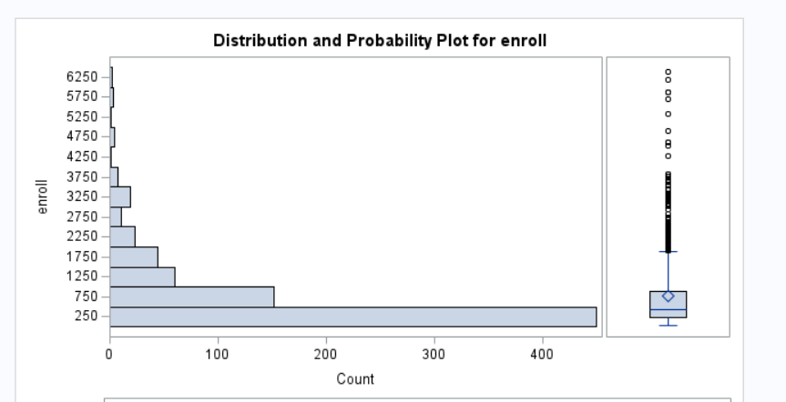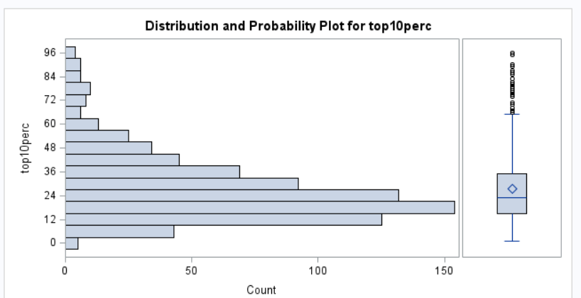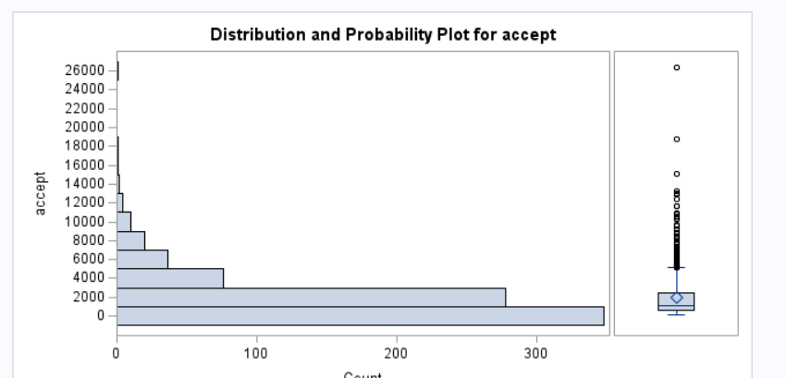

2. Try to fit an MLR to this dataset, with ENROLL as the dependent variable.
P_UNDERGRAD has a somewhat longish tail, so we will take a log transform, (use
LP_UNDERGRAD= log(P_UNDERGRAD)) and then use LP_UNDERGRAD as one of
predictor. Keep the first 544 records as a training set (call it ENROLLTRAIN) which you will
use to fit the model; the remaining 233 will be used as a test set (ENROLLTEST).

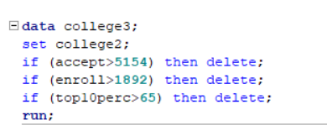

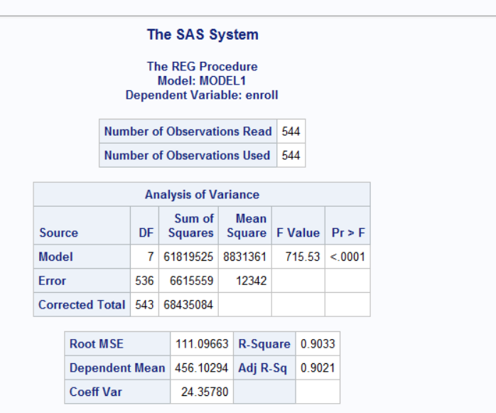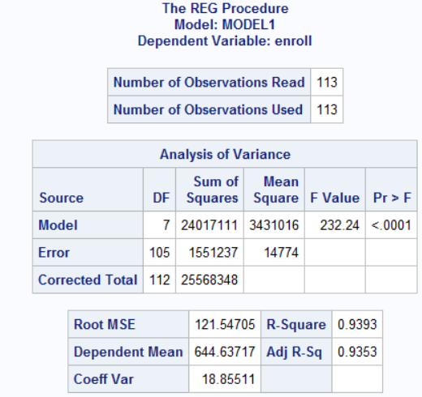

Removed outliers and created a train and test dataset.
3. Use only the following variables in your model:
ENROLL=ACCEPT+TOP10PERC+F_UNDERGRAD+LP_UNDERGRADE+ROOM_BOARD +GRADE_RATE +PRIVATEDUMMY

(a) Report the coefficients obtained by your model. Would you drop any of the variables
used in your model (based on the t-scores or p-values)?

The coefficients for the variables seen in the chart above in their respective order is .169, .580 -.0335, .094, .16653, and-11.69. Looking the p-values, it is preferred that the numbers stay under .05. However, top10perc, grad_rate and P_1 all contain p values that are above the .05 threshold and can be removed as a variable based on those numbers. I removed grad rate, Since P_1 is the dummy variable I I left it alone and found that top10perc fell under the .05 threshold. So, I kept the variable moving forward.

(b) Report the MSE obtained on ENROLLTRAIN. How much does this increase when you
score your model on ENROLLTEST?

The MSE of my ENROLLTRAIN named, “MODcolleg3”: was 12326, however the MSE on the test data set was found to be 14774, which is a 2467 difference.

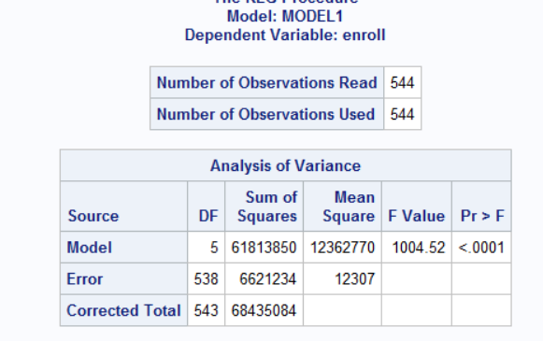
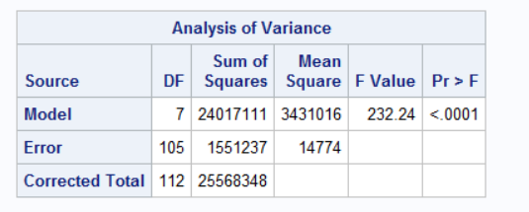

(c) (Bonus 2 points). Do you think your MLR model is reasonable for this problem? You
may look at the distribution of residuals to provide an informed answer.

I do believe that this model is a good fit. Looking at the residual plots, the plots are evenly distributed along the zero line, the bell curve is uniform and bell shaped, none of the VIF values are over 5, and the coefficients are small which indicated little to no effect on the dependent variable After removing grad rate a variable.

