MBAD 6211
HW3-Text Mining
Data description
A fuel company has 250+ gas stations in the US. It captures customers’ comments via phone, which are merged with numeric variables by matching them with the company’s royalty card number. All data were provided in the Gas_text_numeric_data file. Some of the text comments, variable names, and descriptions were disguised to protect the identity of the client company.
- The target variable is identified by the column name.
- Cust_ID, and Loyal_Status are nominal variables, and all other variables are binary.
- Comment column contains the text information.
Variable and model naming requirements:
- Please include your name initials to the data frame names as well as model names in your R coding.
- Please instance, in my coding, I would name the data frames as dfKZ, dfKZ.train, and dfKZ.valid. I would also name the models as treeKZ, etc.
Canvas submission. You need to submit two separate documents via the Canvas HW1 submission link:
- Word document: please provide your answers in the Word document, and copy/paste your R codes at the end of the document.
- R coding file.
Grading Criteria:
- 5 pts for minor errors
- 10 pts for major errors
Questions:
- Provide the word cloud after all necessary pre-processing. (15pts)

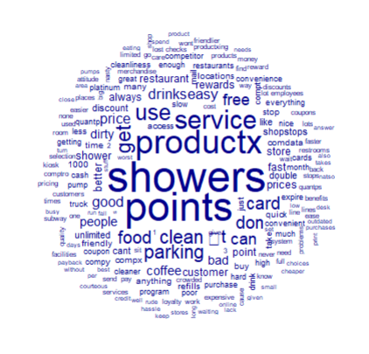
- What are the top 5 terms that are most related to “price”? Please specify your similarity measurement method and detailed results. (10 pts)
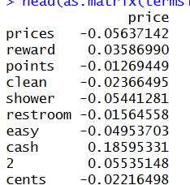

these are the top 10 terms that are most related to price. To achieve these results I had to separate each term individualy and list them out based on frequency. Afterwards I had used the term “price” and used a command to find the top ten terms that correlated with price. That means every time price is listed another term “cash” will be seen in the same sentence 18% of the time.

- What are the top 5 terms that are most related to “service”? Please specify your similarity measurement method and detailed results. (10 pts)
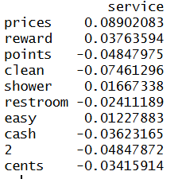
these are the top 10 terms that are most related to service. To achieve these results I had to separate each term individually and list them out based on frequency. Afterwards I had used the term “service” and used a command to find the top ten terms that correlated with price. That means every time price is listed another term “prices” will be seen in the same sentence 8% of the time.

- Perform topic modeling with 4 topics
  - Further remove some common words, such as “shower” & “point”
  - You might encounter the issue with all zero rows, and you need to remove those all zero rows. Here are some sample codes for your reference
myDfm <- dfm_remove(myDfm, c('shower','point'))
myDfm <- as.matrix(myDfm)
myDfm <-myDfm[which(rowSums(myDfm)>0),]
myDfm <- as.dfm(myDfm)
  - Provide the term/beat plots for four topics. (10 pts)
  - Please summarize those four topics based on your best effort (10 pts)
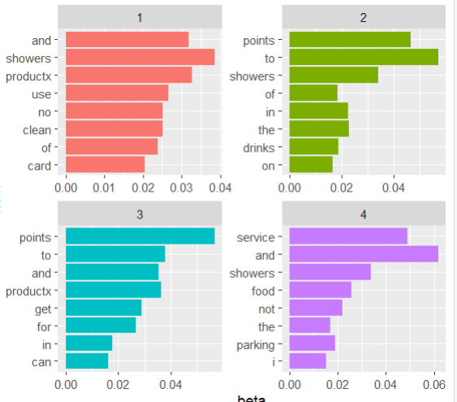
These four plots show the main themes that appear, based on an LDA topic model. Each topic groups together words that tend to appear in the same kinds of sentences. The significance of this data is that it helps you quickly understand what customers talk about most. One topic focuses on cleanliness and showers, another on amenities like showers and drinks, another on points and products, and the last on service, food, parking, and overall experience. Instead of reading all comments manually, these topics highlight the key issues customers care about, making it easier to identify what’s working well and what needs improvement.

- Please run two decision tree models
  - Do we need to remove any column from predictive modeling? (5 pts)
Yes there must be columns removed.
  - Model 1 only uses non-text information (i.e., all other columns except the Comment column)
    - Please show the tree plot (10 pts)
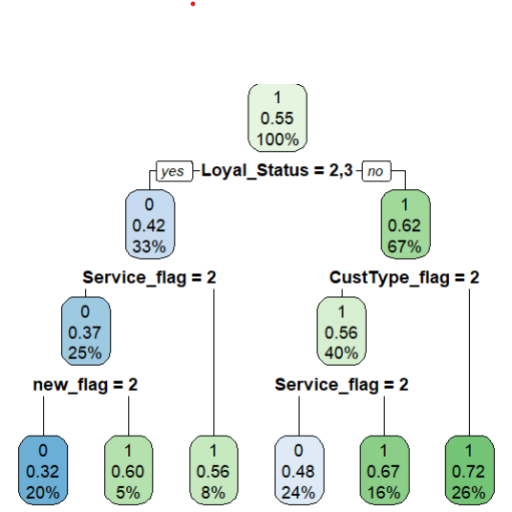
  - Model 2 combines both non-text and text information
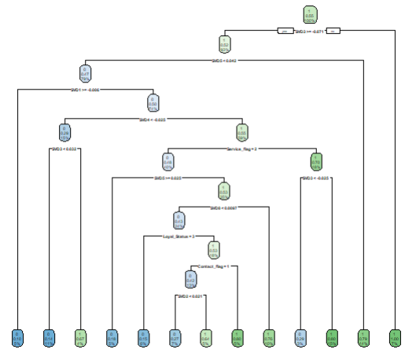
    - Text mine the Comment column
    - Apply SVD to extract text information from the Comment column
    - Keep the number of SVD as 8
    - Combine 8 SVD with all other columns except the Comment column
    - Please show the tree plot (20 pts)
  - Please compare the model performance of two models based on the confusion matrix of the validation dataset (5 pts)
Tree1 contained non text information only, while Tree2 used both. Overall, Tree1 performed better, with higher accuracy and metrics like precision.. Tree2 made more mistakes, showing that more information and values sometimes skew accuracy, suggesting that there should be efficient cleaning of data prior to creating the trees. In summary, Tree1 is more accurate and reliable, while Tree2 contains more data but less effective.

- Please copy and paste your R codes in your WORD submission. (5 pts)
Hints:
install.packages('quanteda')
install.packages('quanteda.textmodels')
install.packages('quanteda.textstats')
install.packages('quanteda.textplots')

library(quanteda)
library(quanteda.textmodels)
library(quanteda.textstats)
library(quanteda.textplots)

text <- read.csv('gastext.csv',stringsAsFactors = F)
MyCorpus <- corpus(text$Comment)
summary(MyCorpus)

MyTokens <- tokens(MyCorpus)

bigram <- tokens_ngrams(MyTokens,n=1:2)
mydfm <- dfm(bigram)
topfeatures(mydfm)
head(mydfm)

Edfm <- dfm(tokens(MyCorpus,
remove_punct = T))
topfeatures(Edfm)
Edfm@Dimnames

install.packages('stopwords')
library(stopwords)

Edfm <- dfm_remove(Edfm,stopwords('english'))

Edfm@Dimnames

dim(Edfm)
Edfmtfidf <-dfm_tfidf(Edfm)

head(Edfmtfidf)

Edfm

MySvd <- textmodel_lsa(Edfmtfidf)

MySvd$docs[]

install.packages('topicmodels')
install.packages('tidytext')

library(topicmodels)
library(tidytext)

myLDA <- LDA(Edfm, k=4,control=list(seed=101))

myLDA

myLDATD <- tidy(myLDA)

myLDATD

library(ggplot2)
library(dplyr)

topterms <- myLDATD %>%
group_by(topic) %>%
top_n(8,beta) %>%
ungroup() %>%
arrange(topic,beta)
topterms %>%
mutate(term=reorder(term,beta)) %>%
ggplot(aes(term,beta,fill = factor(topic)))+
geom_bar(stat= 'identity', show.legend = FALSE)+
facet_wrap(~topic,scales='free')+
coord_flip()

opdocs <- tidy(myLDA,matrix='gamma')

textsim <- textstat_simil(Edfm,
selection = 'text1',
margin ='documents',
method= 'correlation')
head(as.matrix(textsim),6)

docdist <- textstat_dist(Edfm)

clust <- hclust(as.dist(docdist))
plot(clust,xlab='Distance',ylab = NULL)

textsim

termsim <- textstat_simil(Edfm,
selection ='price',
margin='feature',
method= 'correlation')
head(as.matrix(termsim),10)

teamsim <- textstat_simil(Edfm,
selection ='service',
margin='feature',
method= 'correlation')

head(as.matrix(teamsim),10)

tstatFreq <- textstat_frequency(Edfm)

head(tstatFreq,20)
textplot_wordcloud(Edfm,max_words = 500)

Edfm <- dfm_remove(Edfm,stopwords('english'))

Edfm <- dfm_wordstem(Edfm)

dim(Edfm)
topfeatures(Edfm,30)

stopwords1 <- c('shower','point','productx','service','use','price')

Edfm <- dfm_remove(Edfm,stopwords1)

dim(Edfm)

Edfm <- dfm_trim(Edfm,min_termfreq = 4, min_docfreq = 2)
dim(Edfm)

textplot_wordcloud(Edfm,max_words = 500)
topfeatures(Edfm,10)

stopword2 <-c('servic','get','park','card','clean','�','t','don','food','drink')

Edfm <-dfm_remove(Edfm,stopword2)
dim(Edfm)

topterms <- Edfm %>%
group_by(topic) %>%
top_n(8,beta) %>%
ungroup() %>%
arrange(topic,beta)
topterms %>%
mutate(term=reorder(term,beta)) %>%
ggplot(aes(term,beta,fill = factor(topic)))+
geom_bar(stat= 'identity', show.legend = FALSE)+
facet_wrap(~topic,scales='free')+
coord_flip()

library(rpart)
library(rpart.plot)

data1 <- text
data1$Comment <- NULL

data1$Score <- factor(data1$Score)
tree1 <- rpart(Score ~ ., data=train1, method="class")t
set.seed(123)
idx <- sample(1:nrow(data1), 0.7*nrow(data1))
train1 <- data1[idx,]
valid1 <- data1[-idx,]

tree1 <- rpart(Rating ~ ., data=train1, method="class")

rpart.plot(tree1)

