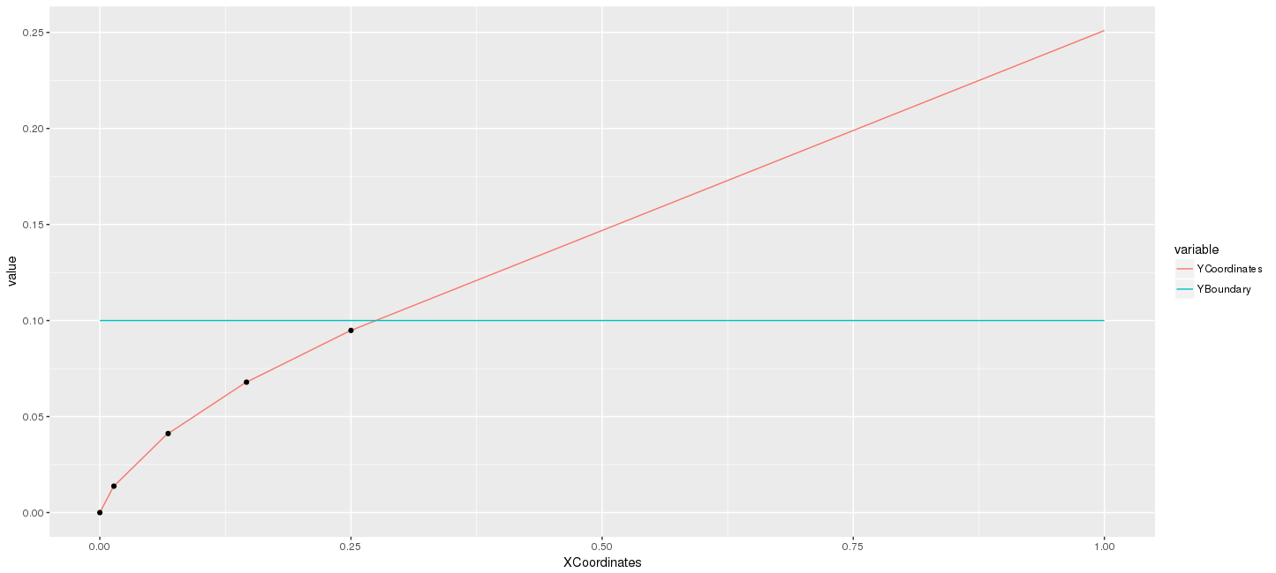
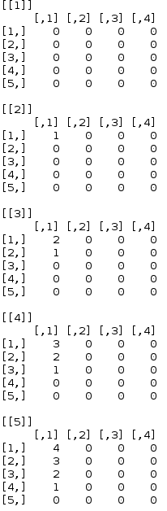

Cost=1
Lambda=0.1
Uniform 0 to 3.7

