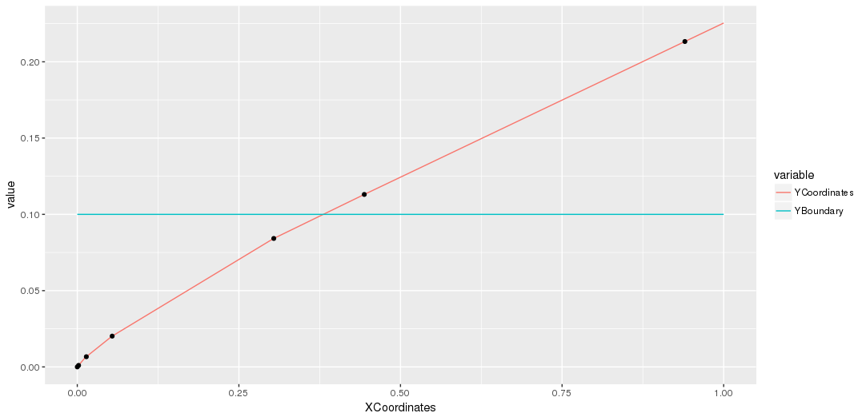

Cost=1
Lambda=0.1
1.7 prob 0.2 , 3.2 prob 0.8

[[1]]
[,1] [,2] [,3] [,4]
[1,] 0 0 0 0
[2,] 0 0 0 0
[3,] 0 0 0 0
[4,] 0 0 0 0
[5,] 0 0 0 0

[[2]]
[,1] [,2] [,3] [,4]
[1,] 1 1 1 1
[2,] 0 0 0 0
[3,] 0 0 0 0
[4,] 0 0 0 0
[5,] 0 0 0 0

[[3]]
[,1] [,2] [,3] [,4]
[1,] 2 1 1 1
[2,] 1 0 0 0
[3,] 0 0 0 0
[4,] 0 0 0 0
[5,] 0 0 0 0

[[4]]
[,1] [,2] [,3] [,4]
[1,] 3 1 1 1
[2,] 2 0 0 0
[3,] 1 1 1 1
[4,] 0 0 0 0
[5,] 0 0 0 0

[[5]]
[,1] [,2] [,3] [,4]
[1,] 4 1 1 1
[2,] 3 0 0 0
[3,] 2 1 1 1
[4,] 1 0 0 0
[5,] 0 0 0 0

[[6]]
[,1] [,2] [,3] [,4]
[1,] 4 3 1 1
[2,] 3 2 0 0
[3,] 2 1 1 1
[4,] 1 0 0 0
[5,] 0 0 0 0

[[7]]
[,1] [,2] [,3] [,4]
[1,] 4 3 3 1
[2,] 3 2 2 0
[3,] 2 1 1 1
[4,] 1 0 0 0
[5,] 0 0 0 0

