Multigrid with Jacobi or Gouss Siedel smoother for 2D Poisson problem

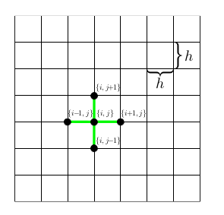

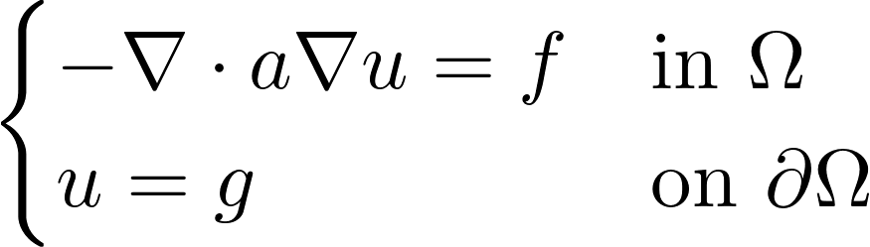

Objectives:

Write a parallel code for solving the Poisson equation on a rectangular domain and Dirichlet boundary conditions, following the indications of the bibliography provided (or the notes of the course by Prof. Antonietti.)

1. Write a scalar version first assuming a Cartesian grid uniform in x and y, using simple finite differences, and test it on simple cases.
2. Write a parallel version using MPI or OpenMP (your choice) and verify
3. Extend to non constant coefficient  (maybe you want to assume non constant coefficient from the start).

More challenging stuff (may lead to an exam project)

1. Extend to general triangular grids using linear finite elements instead of finite differences.
2. Extend to more general boundary conditions
3. Make the code generic so that the smoother can be changed easily.
4. Implement a general Algebraic Multigrid [2]

[1] multigrid_poisson_slides.pdf
[2] BoomerAMG.pdf

