TraceFP

User Guide

**User Guide**

* Introduction
* Basic interface
  + How to open a floor plan file (.fp)
  + How to open a wall sample file (.dq)
  + How to save modified floor plan file
  + Clear all data on screen
* Graphics rendering
  + Display wall samples, control points, and rooms
  + Refresh
* Basic floor plan manipulation
  + Basic point manipulation
  + Basic room manipulation
  + Undo / Redo
* Advanced floor plan manipulation
  + Points
    - Merge multiple points into one point
    - Clustering points
  + Lines
    - Align points to a linear line
    - Align points to a pair of orthogonal lines
  + Rooms
    - Add a point to a room and extend room borders
    - Split a triangle into multiple triangle along a point
    - Reduce number of triangles without changing coverage of rooms
  + Axis control
    - Align all lines to direction

**Introduction**

TraceFP is an application to manipulate floor plan files.

Floor plan files (.fp) uses triangles as basic building blocks of rooms. Each room is consisted of one or more triangles. Each triangle is assigned a room id. Different triangle can have the same room id, so that they can together represent an area that the particular room occupies. Each triangle must have its points based on control points, which is displayed as pink points on the screen.

The application also supports the use of wall samples files (.dq). Wall samples are displayed as blue points on the screen, as opposed to control points, which are pink.

**Basic interface**

**How to open a floor plan file (.fp)**

Click on the “open fp file” button. Select the corresponding .fp format floor plan file. It might take a while for the floor plan file to be read and rendered.

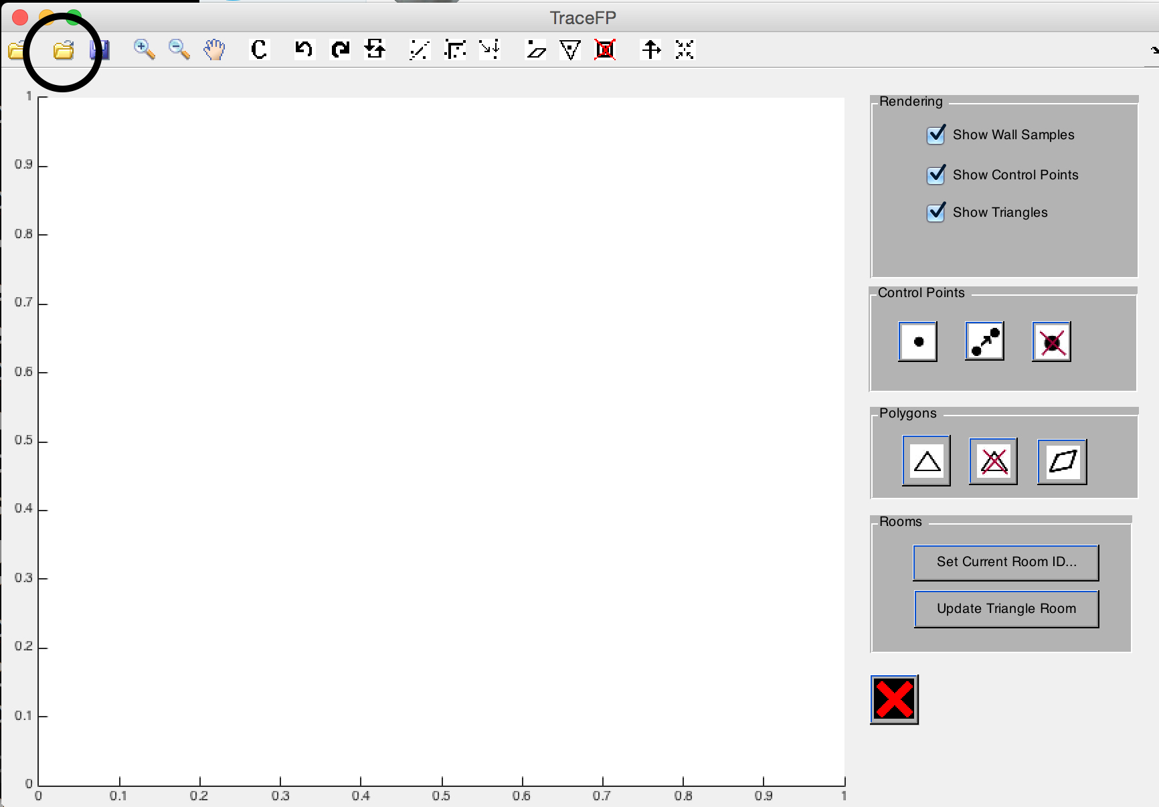

**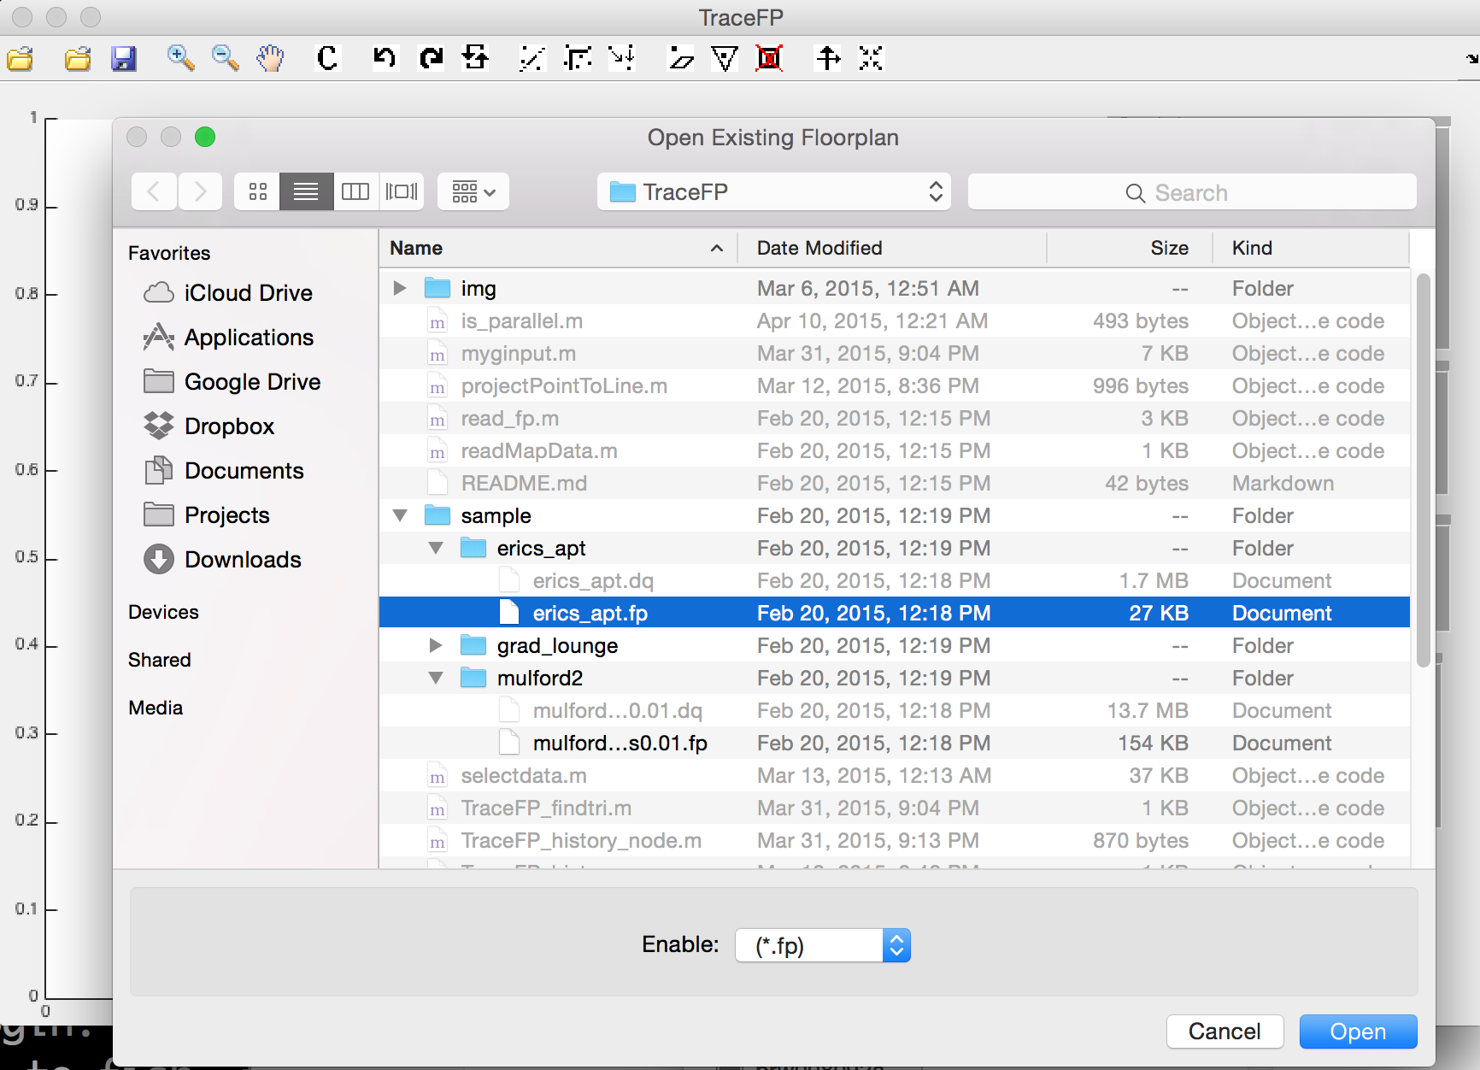****How to open a wall sample file (.dq)**

Click on the “open dq file” button. Select the corresponding .dq format wall sample file. It might take a while for the wall sample file to be read and rendered.

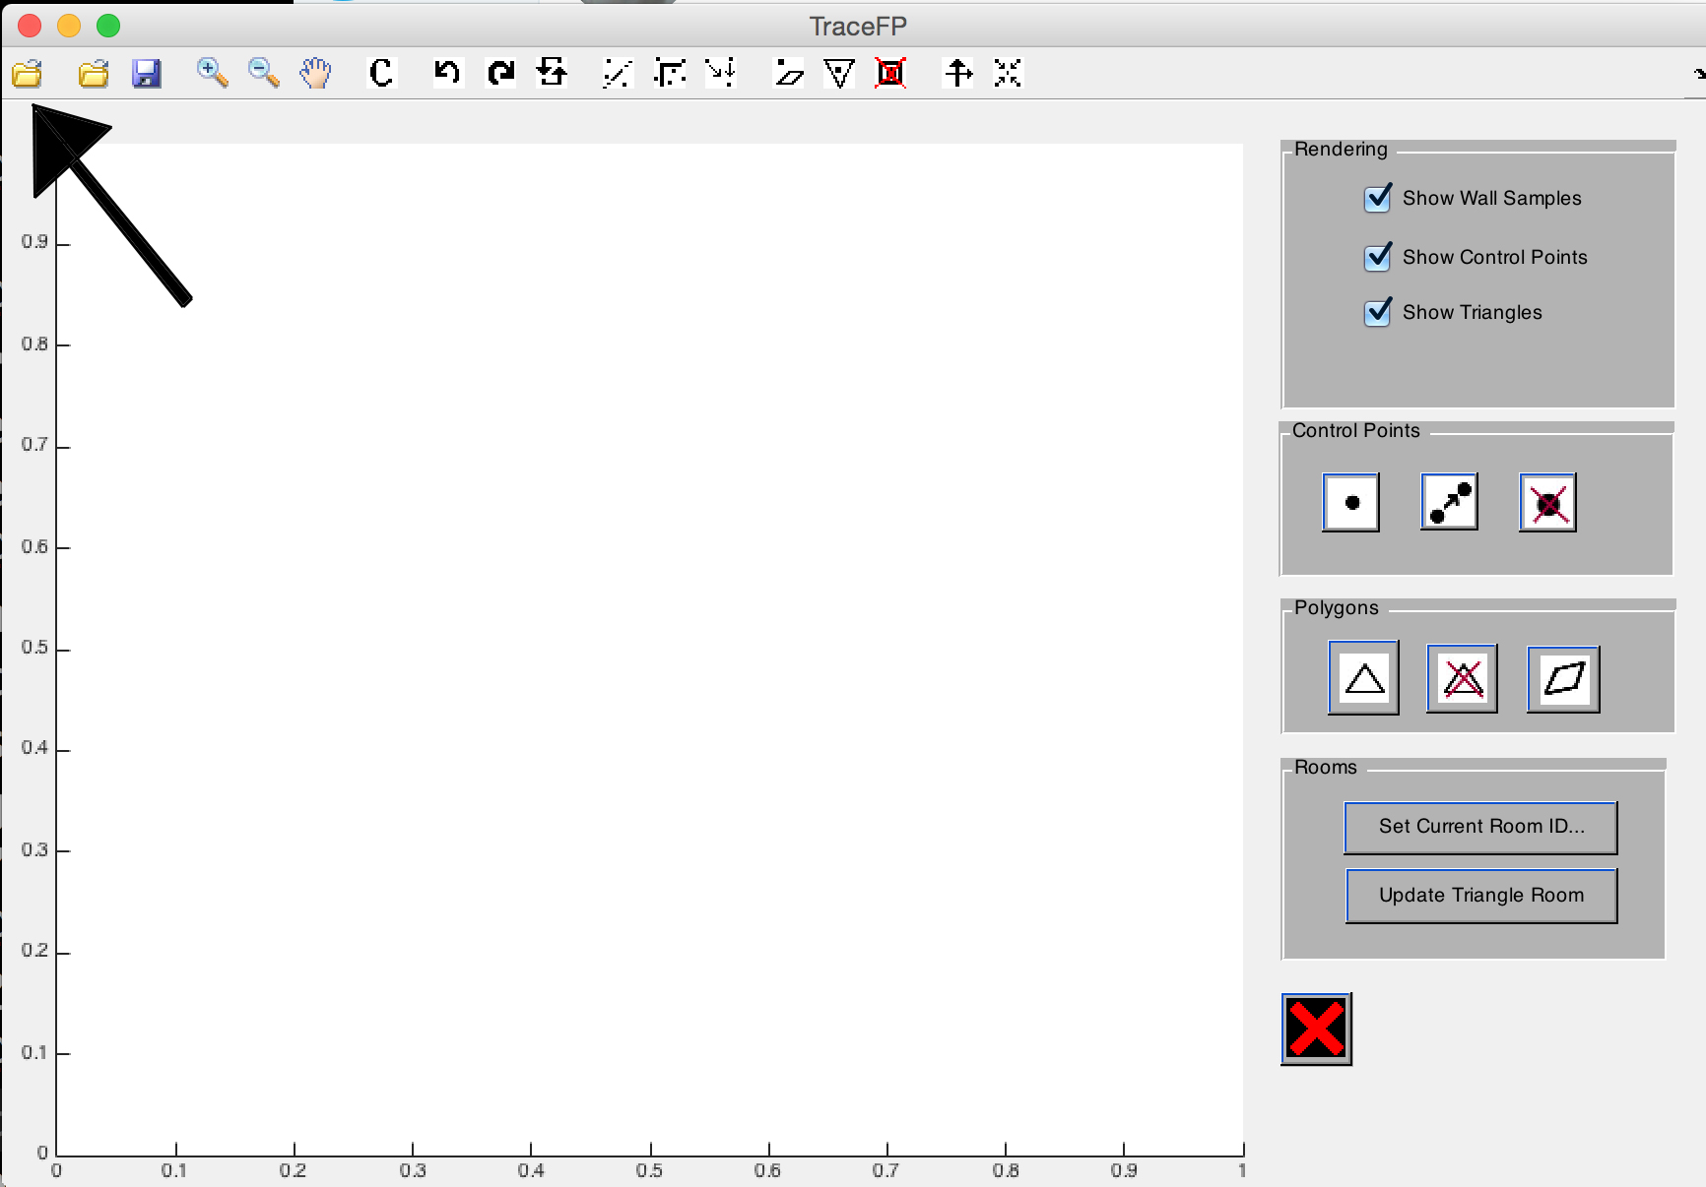

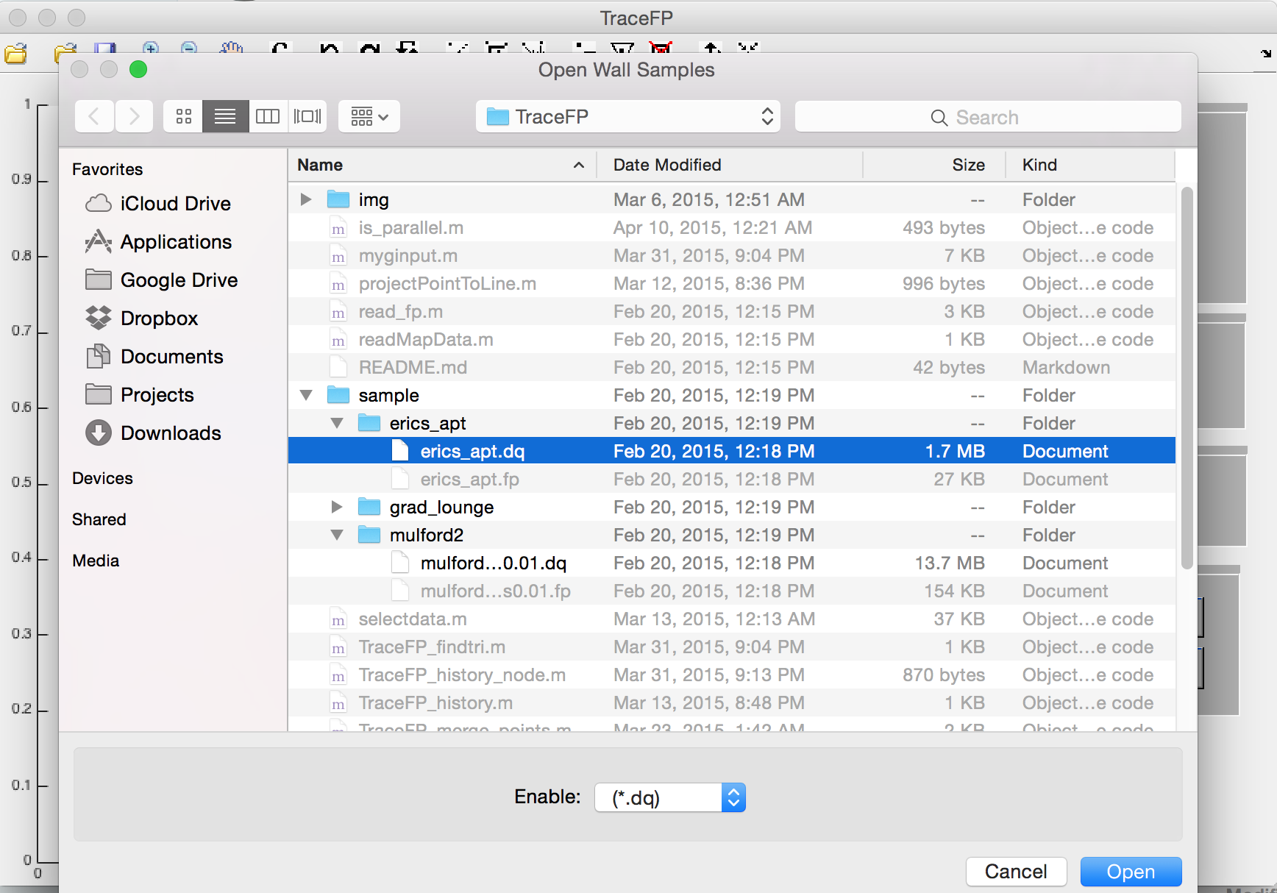

**How to save modified floor plan file**

Click on the “save fp file” button. If the file is newly created, the application will prompt you for path to create the file. Otherwise, the file is automatically saved to the original opened file.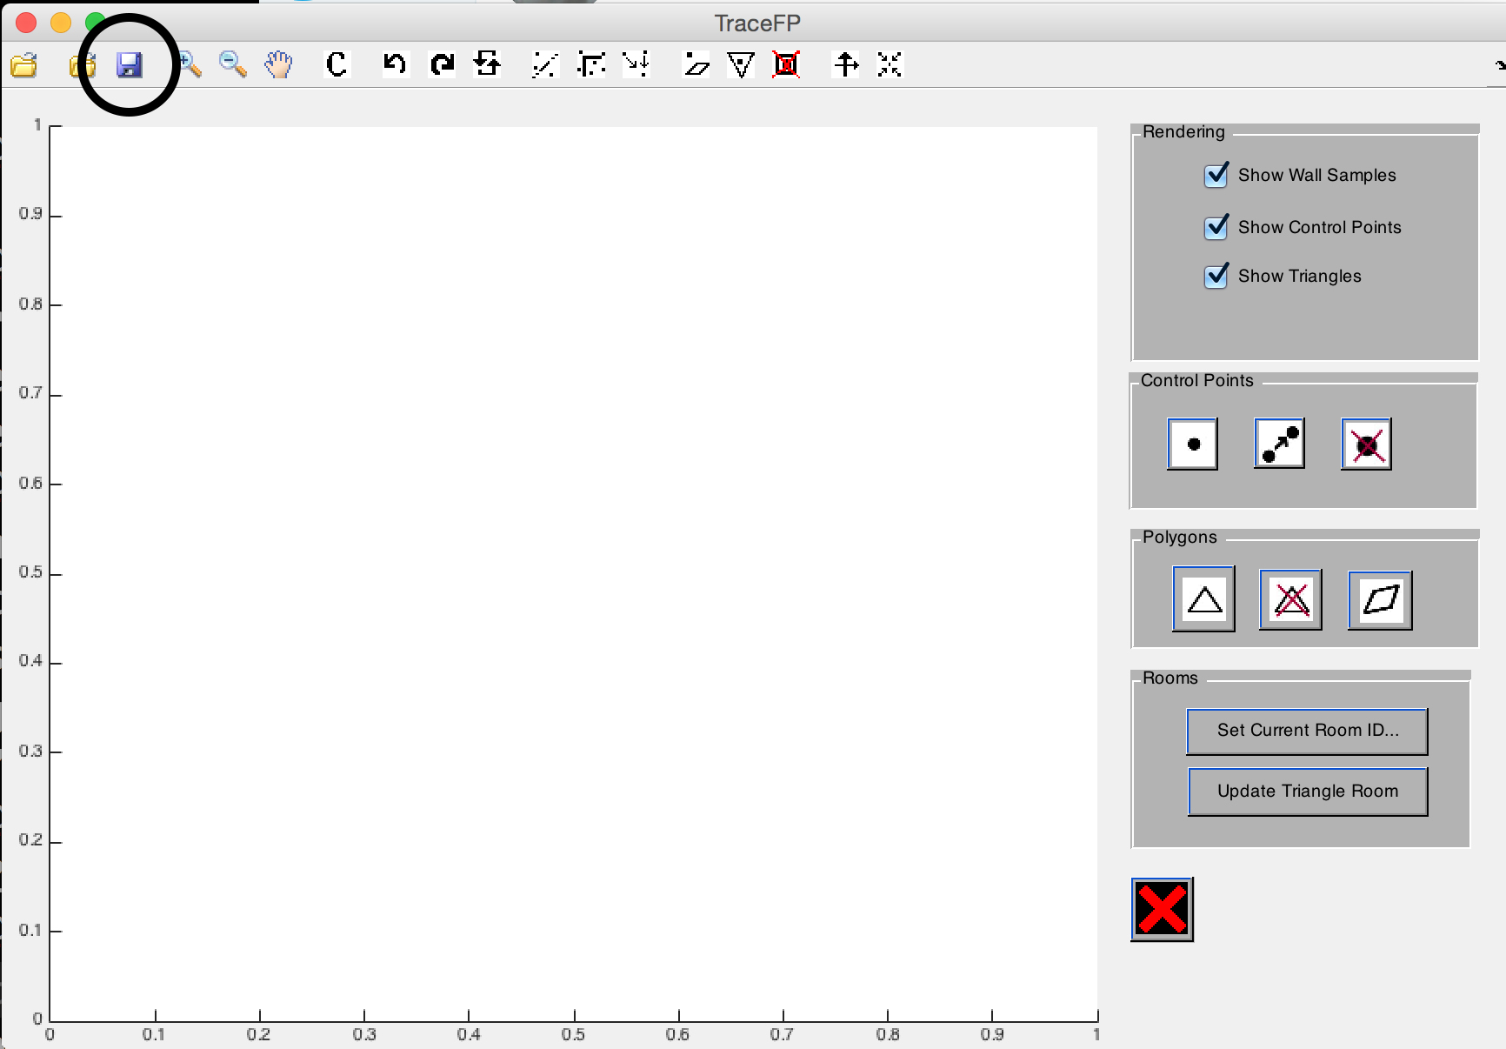

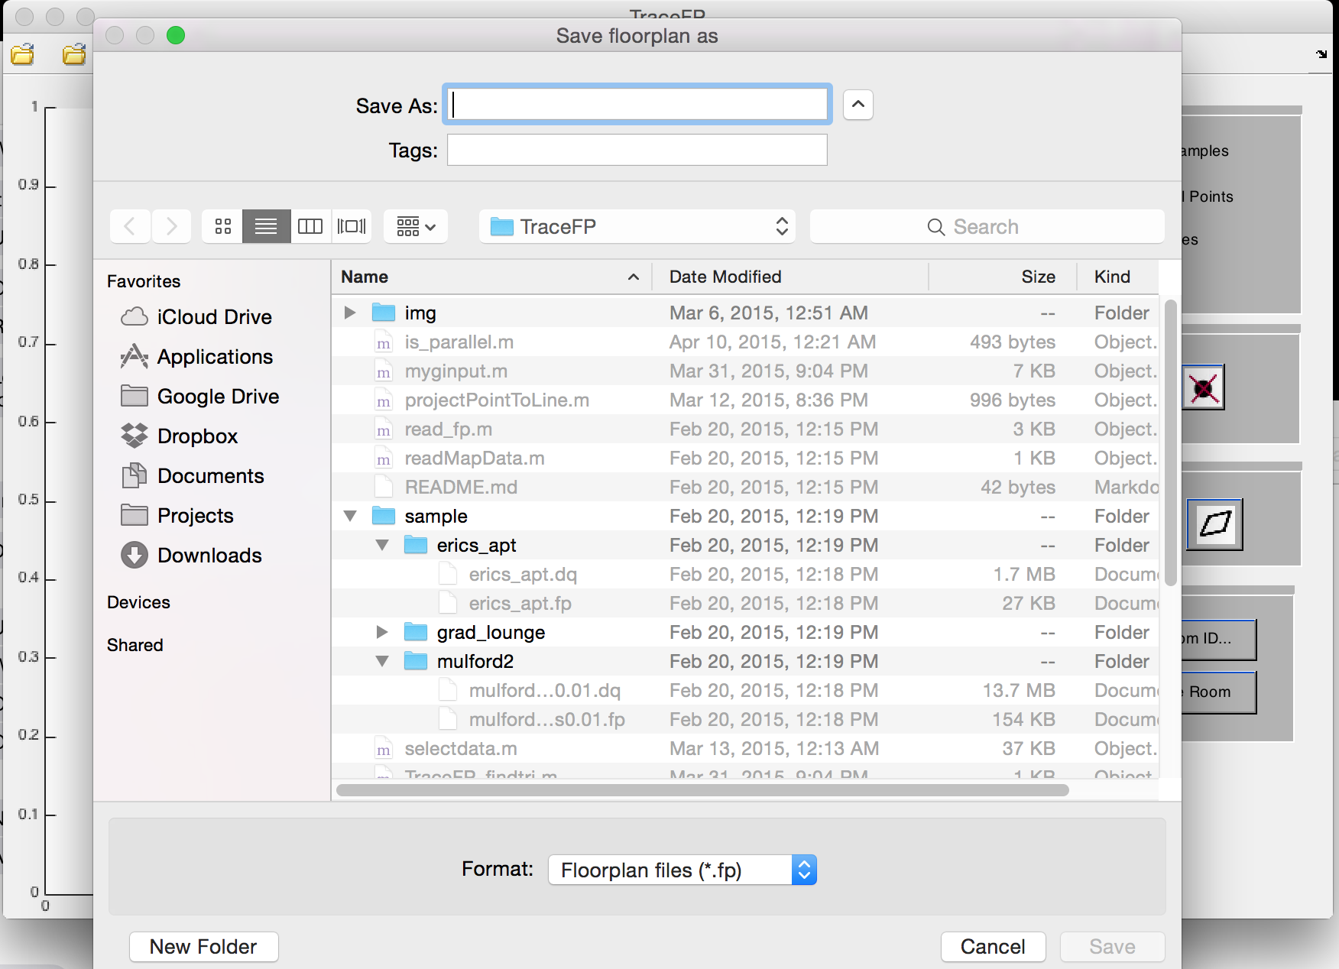

**Clear all data on screen**

Click on the “clear” button. Everything currently loaded on the screen will be cleared, including triangles, control points and wall samples.

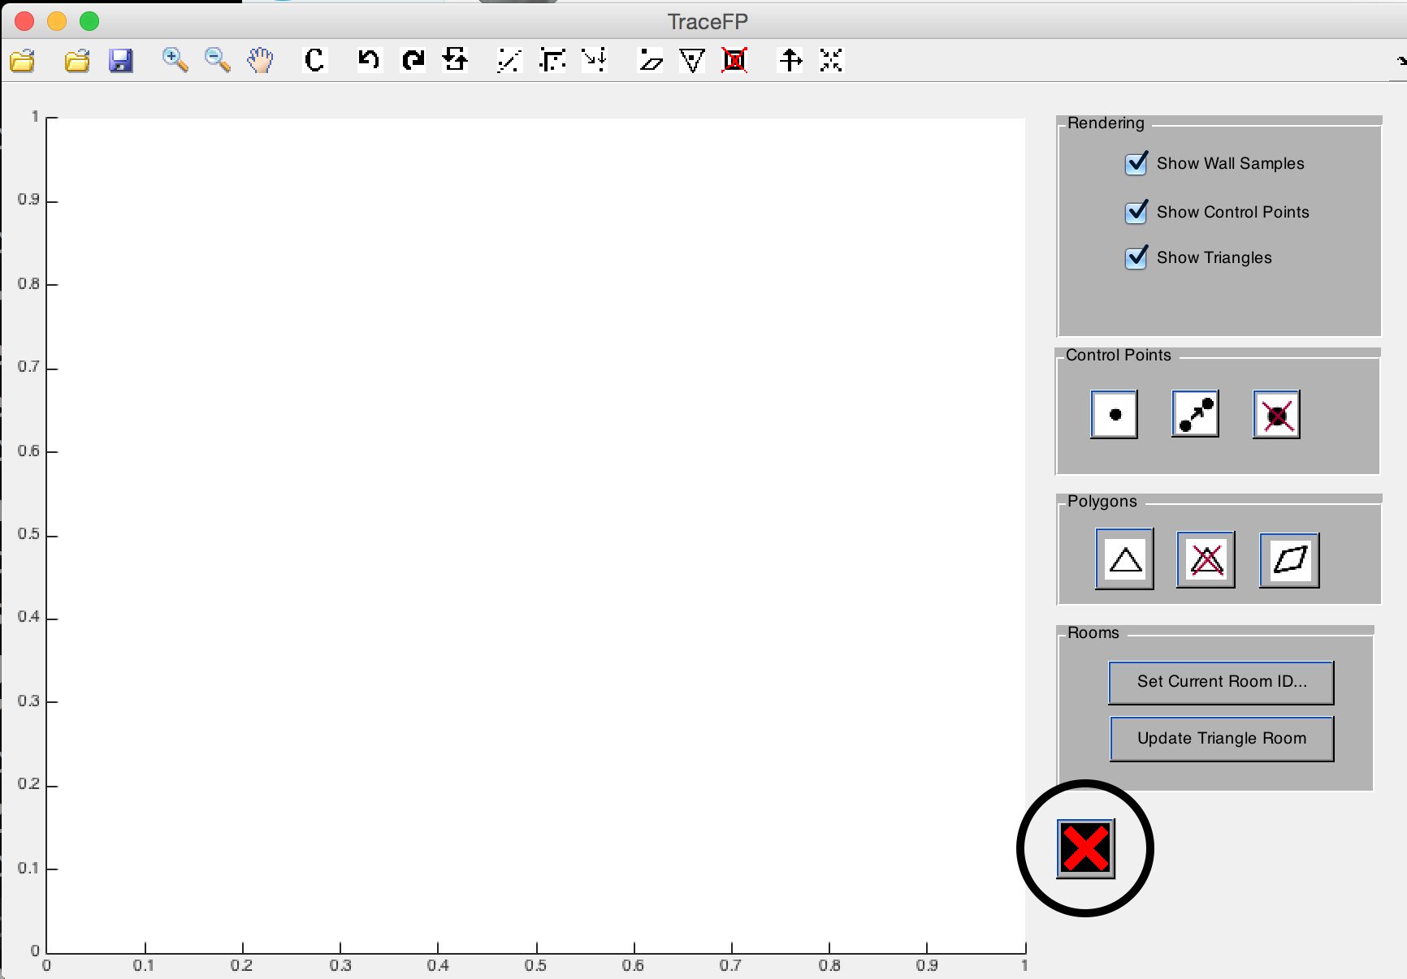

**Graphics rendering**

**Display wall samples, control points, and rooms**

The three checkboxes on the top right of the screen control whether to display wall samples / control points / triangles.

**Basic floor plan manipulation**

**Advanced floor plan manipulation**