U.S. Consulate General Ho Chi Minh City

Immigration Visa Unit

04 Le Duan Street, District 1, Ho Chi Minh City, Vietnam.

Case Number: HCM2017630011

Petitioner: Tommy Dang

Applicant: Ngan Thi Tran

**EXPLANATION ABOUT EX-MARRIAGE**

My name is Tommy Dang, born on December 18th, 1983 in Quy Nhon City, Binh Dinh province, Vietnam.

On June 30th, 2017, we (I and my fiancé) took an interview for immigration visa (K-1 visa). The consulate officer required us to submit an explanation about my ex-wife.

I hereby present the requested information below:

1. My ex-wife: Amy Pham, born on September 27th, 1986 in Pleiku, Gia Lai province, Vietnam. Amy’s cellphone number is (+1) 312-662-3174. Amy’s family does not use the landline telephone number.
2. Amy is currently residing at 5483 N. Parkside Ave, Chicago IL, 60630. She is living with our son (Charlie Dang, born on July 20th, 2012 in Chicago), her parents, and her younger brother. The following image shows the graduation invitation letter from Care-A-Lot Early Learning Center, where my ex-wife is sending our son to for the preschool. Care-A-Lot Early Learning Center is 10-minute walk from 5483 N. Parkside Ave.

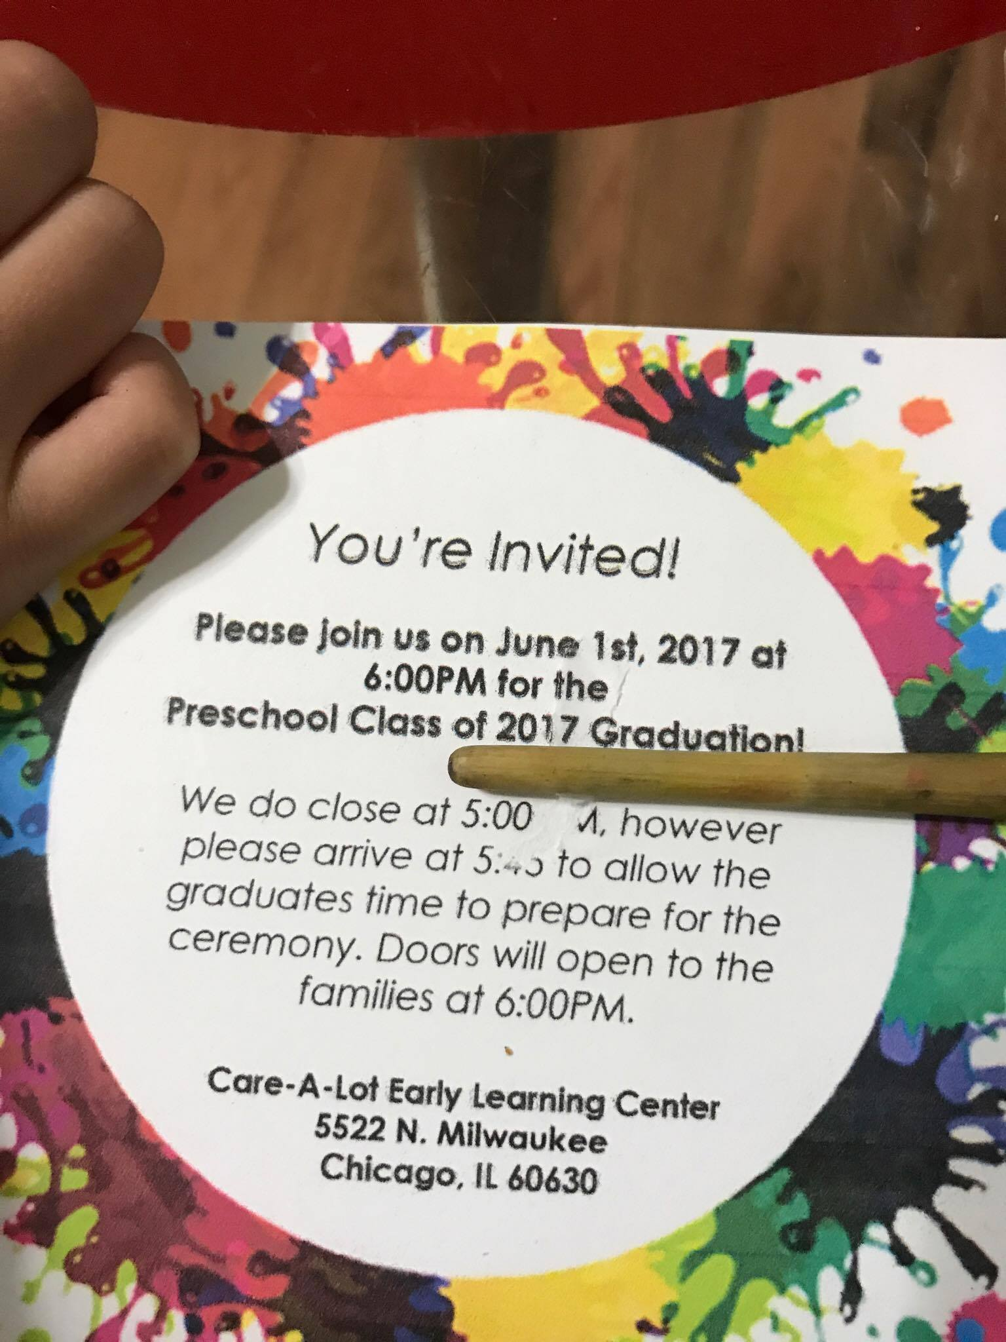

Care-A-Lot Early Learning Center

Address: 5522 N Milwaukee Ave, Chicago, IL 60630, USA

Phone: (+1) 773-763-0888

1. Amy did **NOT** immigrated with me. She came to Chicago, IL, USA in 2005 with her family (parents, 2 brothers, and 1 younger sister). Her grand-parents (mother-side) sponsored her family. Her grand-father name is Ngoc Ho. Her grand-mother name is Thuy T Truong.

I hereby undertake the above declaration is true. I shall take full legal responsibility under the law for any fraudulent information.

Thanks,

Tommy Dang

Quy Nhon city, Binh Dinh, Vietnam

July 3rd, 2017