NYCU Pattern Recognition, Homework 1

**Deadline: Mar. 22, 23:59**

**Part. 1, Coding (70%)**:

In this coding assignment, you are required to implement linear regression using only NumPy. Then, train your implemented model using **Gradient Descent** by the provided dataset, and test the performance with testing data.

Please note that only NumPy can be used to implement your model. Therefore, you will get no points by simply calling sklearn.linear_model.LinearRegression. Moreover, please train your linear model using Gradient Descent, not the closed-form solution.

**Allowed packages: numpy, pandas, matplotlib.**

**(25%) Linear Regression Model - Single Feature**

**Requirements:**

* Use the single feature (BMI) to train your linear regression model.
* Use MSE ([Mean Square Error](https://zh.wikipedia.org/zh-tw/%E5%9D%87%E6%96%B9%E8%AF%AF%E5%B7%AE)) as your loss function.
* Please use Gradient Descent. (Not the mini-batch GD nor SGD)
* Tune the learning rate and epoch to get the same result provided on slide page 9.

**Criteria:**

1. (0%) Show the learning rate and epoch you choose.
2. (5%) Show the weights and intercepts of your linear model.
3. (5%) What’s your final training loss (MSE)?
4. (5%) What’s the MSE of your validation prediction and validation ground truth?
5. (5%) Plot the training curve. (x-axis=epoch, y-axis=loss)
6. (5%) Plot the line (using red) you find with the training data (using blue) and validation data (using orange).

**(45%) Linear Regression Model - Multiple Features**

**Requirements:**

* Use all the 6 features to train your linear regression model.
* Use MSE ([Mean Square Error](https://zh.wikipedia.org/zh-tw/%E5%9D%87%E6%96%B9%E8%AF%AF%E5%B7%AE)) as your loss function.
* Please use Gradient Descent. (Not the mini-batch GD nor SGD)
* Tune the learning rate and epoch to get the same result provided on slide page 10.

**Criteria:**

1. (0%) Show the learning rate and epoch you choose.
2. (10%) Show the weights and intercepts of your linear model.
3. (5%) What’s your final training loss (MSE)?
4. (5%) What’s the MSE of your validation prediction and validation ground truth?
5. (5%) Plot the training curve. (x-axis=epoch, y-axis=loss)
6. (20%) Train your own model and save your final testing predictions in the csv file. Try different learning rates, epochs, batch_size, and do some data analysis to choose the feature you want to use).

| **Points** | **Test MSE** |
| --- | --- |
| **20** | **< 30000000** |
| **15** | **< 40000000** |
| **10** | **< 50000000** |
| **5** | **50000000 ~ 100000000** |
| **0** | **> 100000000** |

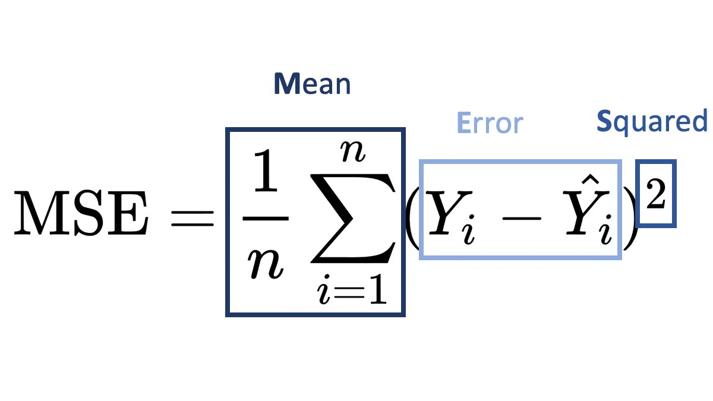

**Part. 2, Questions (30%):**

(7%) 1. What’s the difference between Gradient Descent, Mini-Batch Gradient Descent, and Stochastic Gradient Descent?

(7%) 2. How do different values of learning rate (too large, too small…) affect the convergence of optimization? Please explain in detail.

(8%) 3. Suppose you are given a dataset with two variables, X and Y, and you want to perform linear regression to determine the relationship between these variables. You plot the data and notice that there is a strong nonlinear relationship between X and Y. Can you still use linear regression to analyze this data? Why or why not? Please explain in detail.

(8%) 4. In the coding part of this homework, we can notice that when we use more features in the data, we can usually achieve a lower training loss. Consider two sets of features, A and B, where B is a subset of A. (1) Prove that we can achieve a non-greater training loss when we use the features of set A rather than the features of set B. (2) In what situation will the two training losses be equal?