MINOR PROJECT

**Osteoarthritis Detection and Report Generation**

Group ID - 3

Mentor: - Dr. Trilok Chand

Group Members: -

Aditya (SID 18103075)

Saarisht Thaman (SID 18103063)

Gaurav Sharma (SID 18103050)

Aditya Kumar (SID 18103010)

**Aim: -**

An application where medicine practitioners can upload their technical images and the system provides them with a correct and short caption and analysis of the image to get the severity level of the X-ray Scan. We’ll be using Hierarchical RNN (Recurrent Neural Networks) to generate paragraph for the final accurate report generation. System needs to generate a professional radiology report for a given patient with claims supported by visual evidence, highlighting the area where the problem seems to be in the technical image.

**Motivation: -**

Nowadays, Medical Imaging in the sector of Pathology, Radiology etc. generate and capture enormous amounts of data containing extremely valuable signals and information this data is being generated at a pace far surpassing what “traditional” methods of analysis can process. Machine learning therefore quickly enters the picture, as it is one of the best ways to integrate, analyze and make predictions based on large, heterogeneous data sets. The techniques namely Magnetic Resonance Imaging, X-ray radiography, Ultrasound etc. are being widely used by Medicine Practitioners, that usually involves diagnosis by them and then further treatment depending upon the severity level of the reports.

The reading of the images is usually conducted by expert Medical Professionals. However, reading every report and then diagnosing can be a challenging task especially in rural and highly populated regions, this is usually because in these sectors writing medical reports and maintain them is a very challenging task as it requires skills, hours and a surplus number of supporting staff which is highly unlikely for the task case under consideration. Also, in these areas where there are a significant number of patients and the task of reading, writing and maintain that many reports by a few health professionals can be tedious and time-consuming.

A study by National bureau of Economics Research shows increment in human life expectancy with incremental use of medical imaging. To the point that Deep learning rose to its prominent position in Medical Industry when neural networks started outperforming other methods on several high-profile image analysis benchmarks. Most famously on the ImageNet Large-Scale Visual Recognition Challenge (ILSVRC) in 2012 when a deep learning model (*a Convolutional Neural Network*) halved the second best error rate on the image classification task, it has been 8 years since then and by now Convolutional Neural Network have surpassed even human performance on the ILSVRC, and reached a level where the ILSVRC classification task is essentially solved (i.e. with error rate close to the Bayes rate).

As evident from recent statistics, inculcating these technologies with already implemented system and infrastructure helps in saving a lot of time, resources and work force involved for the overall procedures. The rising cost of healthcare and shortage of healthcare professionals are just some of the reasons which increase the use of Artificial Intelligence and Machine Learning in Medicine and diagnostic industry. Classification and Segmentation are the main applications of Convolutional Neural Networks in healthcare through Deep Learning.

**Design: -**

Design of the System essentially sums up to just generating medical image reports that can be further analyzed to give adequate treatment to the patient. The initial requirements for construction of the project would be datasets that comprise of images. The main steps that would be involved would be preprocessing of the images and then passing these images through a convolutional artificial neural network to get the desired output. One of our primary areas of focus would be on Knee X-Ray images. System can use the outputs and plug them into different RNN frameworks and look for probable solutions.

**Sample**:

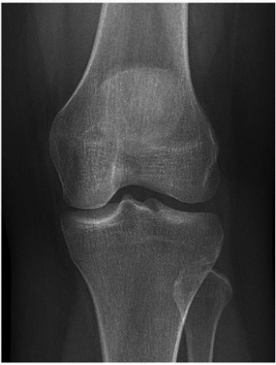 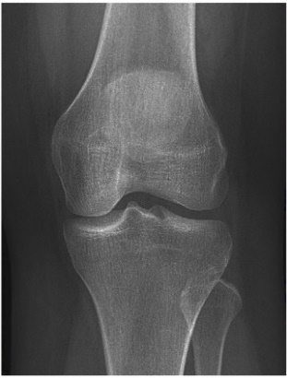 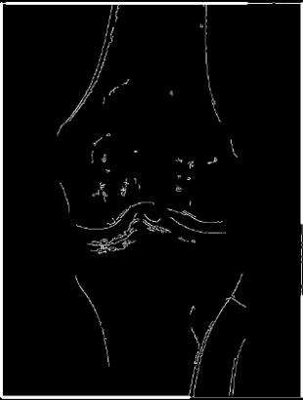

Osteoarthritis Grade Detection

Original Image Contrast and Brightness Edge Detection

Corrected

**SAMPLE REPORT HERE**

**Expected Outcome: -**

A Web Application where medicine practitioners can upload their technical images and we provide them with a correct and short caption and analysis of the image to get the severity level of the diagnosis. System will most likely utilize the MERN (MongoDB, Express, React, Node) stack since data can be large to handle and process; incorporating that with either java or python to use the hierarchical RNN from TensorFlow {this will be accomplished by using Deep Learning algorithms for image classification and RNN for natural language processing}.

**Repository Link: -** <https://github.com/Gauravsharma-20/Minor-Project>