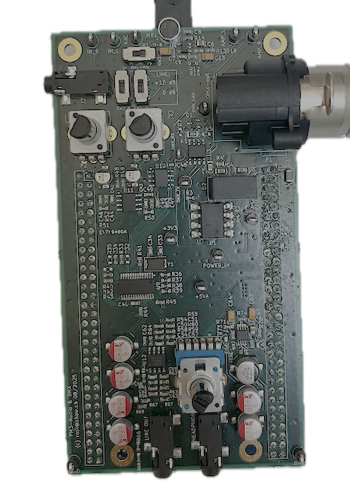

Hardware Test Report
  - Electronics Projects

Abstract
This document serves the purpose of planning, testing and documenting the developed hardware in the project module 3.
Table of Content
1. Test procedure 2
2. Safety 2
3. Test Plan 3
4. Test Analysis 5

Test procedure
After the hardware has been completely soldered and assembled, it is of utmost importance to carefully inspect the solder joints under a microscope. This pre-testing step can help prevent potential damage to the electronics caused by shorts or misplaced components.
Next, the “life signs” test can begin, where the board is powered on for the first time. During this step, all safety considerations mentioned in the safety chapter must be observed. All internal voltages and current draws should be documented and compared against the expected values. In case of a failure, a structured debugging approach must be followed. If the life signs test passes, it is permissible to proceed to the basic hardware functionality tests.
The basic hardware functionality test aims to verify the operation of sub-circuits groups. It follows a systematic approach, starting from the audio input connectors, through the analog input circuitry, codec, analog output circuitry, and ending at the output connectors.
After verifying the basic hardware functionality, an additional test will be performed to determine the corner frequency of the board’s input/output filter. A frequency sweep across the human-audible spectrum will be applied to the board’s input, and a Fourier transform of the output signal will be used to generate an amplitude response plot.

Safety
Although not part of the testing, care must be taken when soldering and handling the soldering iron. Soldering temperatures range from 300 °C to 400 °C and can cause serious burns if not handled properly.
When powering the board for the first time, it is good practice to use a laboratory power supply with a current-limit feature to prevent severe damage in case of a short circuit. Even better results can be achieved by powering the board at a slightly lower voltage initially to further limit power in case of a fault.
If abnormal behavior such as smoke, overheating, or excessive current draw is observed, disconnect power immediately and inspect the hardware before continuing.
Work on a ESD protected surface to prevent ESD damage to components.

Test Plan
Test item, Description | Test conditions | Expected, Tolerance | Measured | Comparison, verdict | Remarks, Discussion
General setup for all the following tests (unless stated otherwise):
- Power in by laboratory power supply, 5V
- +3V0 (P2, Pin 1) connected to +3V3
Voltage at +3V3 ESP supply | No input signal | $$3.32\text{V} | 33.2\text{k}\text{Ω} \left(±1\%\right)⋅100\text{μ}\text{A} \left(±1\%\right)=3.25\text{V}…3.39\text{V}$$ | $$3.29\text{V}$$ | In range → passed
Voltage at +3V3 digital supply (VD) | No input signal | $$3.32\text{V} | 33.2\text{k}\text{Ω} \left(±1\%\right)⋅100\text{μ}\text{A} \left(±1\%\right)=3.25\text{V}…3.39\text{V}$$ | $$3.29\text{V}$$ | In range → passed
Voltage at +5V analog supply (VA) | No input signal | $$4.99\text{V} | 49.9\text{k}\text{Ω} \left(±1\%\right)⋅100\text{μ}\text{A} \left(±1\%\right)=4.89\text{V}…5.09\text{V}$$ | $$4.99\text{V}$$ | In range → passed
Voltage at DMX output (DMX_+5V) | No input signal | $$5.4\text{V} | 270\text{Ω} \left(±1\%\right)⋅20\text{mA} \left(±1\%\right)=5.29\text{V}…5.51\text{V}$$ | $$5.24\text{V}$$ | Out of range, considered acceptable^{*)} → passed | *) Taking into account the tolerance envelope
Voltage at Boost output | No input signal | $$5.51\text{V} | \left(\frac{301\text{k}\text{Ω} \left(±1\%\right)}{30\text{k}\text{Ω} \left(±1\%\right)}+1\right)⋅500\text{mV} \left(±15\text{mV}\right)=5.25\text{V}…5.78\text{V}$$ | $$5.67\text{V}$$ | In range → passed
Ripple on +3V3 ESP supply | No input signal | $$0.8{\text{μV}}_{\text{RMS}}+1\text{mV}⋅{10}^{-\frac{50\text{dB}}{20}}→ <0.80\text{μV}$$ | $$4.0{\text{mV}}_{\text{PP}}$$ | Out of range, considered acceptable^{*)} → passed | *) Oscilloscope has not enough accuracy, measures above the expected value even when no signal is connected
Ripple on +3V3 digital supply (VD) | No input signal | $$0.8{\text{μV}}_{\text{RMS}}+1\text{mV}⋅{10}^{-\frac{50\text{dB}}{20}}→ <0.80\text{μV}$$ | $$4.4{\text{mV}}_{\text{PP}}$$ | Out of range, considered acceptable^{*)} → passed
Ripple on +5V analog supply (VA) | No input signal | $$0.8{\text{μV}}_{\text{RMS}}+10\text{mV}⋅{10}^{-\frac{50\text{dB}}{20}}→ <0.81\text{μV}$$ | $$1.5{\text{mV}}_{\text{PP}}$$ | Out of range, considered acceptable^{*)} → passed
Ripple on DMX output (DMX_+5V) | No input signal | $$<40{\text{mV}}_{\text{PP}}$$ | $$6{\text{mV}}_{\text{PP}}$$ | In range → passed
Ripple on Boost output | No input signal | $$\frac{1\text{A}⋅0.18}{1\text{MHz}⋅10\text{μF}}→ <18.3\text{mV}$$ | $$5{\text{mV}}_{\text{PP}}$$ | In range → passed
Current on Power in at 5 V | No input signal | $$<180\text{mA}$$ | $$173\text{mA}$$ | In range → passed
Current on Power in at 5V, +3V0 disconnected | No input signal, +3V0 disconnected | $$<160\text{mA}$$ | $$128\text{mA}$$ | In range → passed
Current ripple on Power in at 5 V | No input signal | $$\frac{1\text{mV}}{{5\text{V}}/{180\text{mA}}}→<36\text{μV}$$ | $$1{\text{mA}}_{\text{PP}}$$ | Out of range, considered acceptable^{*)} → passed | *) Measurement method provides not enough accuracy
Microphone voltage | No input signal | $$2.6\text{V} | 2\text{V}…<5\text{V}$$ | $$2.48\text{V}$$ | In range → passed
Signal Peak finger snip | No input signal, finger snip next to the microphone | $$50\text{mV} | 0\text{V}…2.5\text{V}$$ | $$68{\text{mV}}_{\text{PP}}$$ | In range → passed | Note: Expected value given as amplitude, measured peak-to-peak, conversion needed before comparison
Signal Peak finger on microphone | No input signal, finger on microphone | $$>300\text{mV} | 0\text{V}…2.5\text{V}$$ | $$500{\text{mV}}_{\text{PP}}$$ | In range → passed
Signal Peak finger snip after Preamp | No input signal, finger snip next to the microphone | $$>2\text{V} | 0\text{V}…2.5\text{V}$$ | $$5{\text{V}}_{\text{PP}}$$ | In range → passed
Signal Peak finger on microphone after Preamp | No input signal, finger on microphone | $$>2\text{V} | 0\text{V}…2.5\text{V}$$ | $$5{\text{V}}_{\text{PP}}$$ | In range → passed
Preamp reference voltage (U4) | No input signal | $$2.5\text{V} | 5\text{V}⋅\frac{100\text{kΩ}±1\%}{\left(100\text{kΩ}±1\%\right)+\left(100\text{kΩ}±1\%\right)}=2.475\text{V}…2.525\text{V}$$ | $$2.49\text{V}$$ | In range → passed
Line in signal after Anti-Aliasing filter, left channel | Input signal: 500mVpp 1kHz sine | $$\text{No attenuation @} 1\text{kHz}→500{\text{mV}}_{\text{PP}}$$ | $$532{\text{mV}}_{\text{PP}}$$ | Acceptable with tolerance → passed
Line in signal after Anti-Aliasing filter, right channel | Input signal: 500mVpp 1kHz sine | $$\text{No attenuation @} 1\text{kHz}→500{\text{mV}}_{\text{PP}}$$ | $$532{\text{mV}}_{\text{PP}}$$ | Acceptable with tolerance → passed
Voltage at DMX A output | No input signal | $$3\text{V}+{5\text{V}}/2=5.5\text{V}$$ | $$4.46\text{V}$$ | Not as expected, considered acceptable^{*)} → passed | *) Calculated with max values from the datasheet, is in range for $V_{OD, min}=1.5\text{V}$
Voltage at DMX B output | No input signal | $$3\text{V}-{5\text{V}}/2=0.5\text{V}$$ | $$0.78\text{V}$$ | Not as expected, considered acceptable^{*)} → passed
General setup for all the following tests (unless stated otherwise):
- Power in by laboratory power supply, 5V
- +3V0 (P2, Pin 1) connected to +3V3
- Wire loop SDOUT (P1, Pin 11) to SDIN (P1, Pin 16)
- Reset CS4271 Codec after power applied
Crystal Frequency | No input signal, 1:10 Probe | $$16.384\text{MHz}…25.600\text{MHz}$$ | $$24.88\text{MHz}$$ | In range → passed
MCLK Frequency | No input signal | $$1.024\text{MHz}…25.600\text{MHz}$$ | $$12.3\text{MHz}$$ | In range → passed
LRCLK Frequency | No input signal | $$4\text{kHz}…50\text{kHz}$$ | $$48\text{kHz}$$ | In range → passed
SCLK Frequency | No input signal | $$\text{LRCLK}×64=256\text{kHz}…3.2\text{MHz}$$ | $$3.07\text{MHz}$$ | In range → passed
SDOUT signal present | No input signal | $$\text{Signal present}$$ | $$\text{Yes}$$ | As expected → passed
Output signal after Reconstruction filter, left channel | Input signal: 1mVpp 1kHz sine | $$\text{No attenuation @} 1\text{kHz}→500{\text{mV}}_{\text{PP}}$$ | $$533{\text{mV}}_{\text{PP}}$$ | Acceptable with tolerance → passed
Output signal after Headphone Amplifier, left channel | Input signal: 1mVpp 1kHz sine | $$\text{Amplification factor}=5→2.5{\text{V}}_{\text{PP}}$$ | $$2.62{\text{V}}_{\text{PP}}$$ | Acceptable with tolerance → passed
Output signal after Reconstruction filter, right channel | Input signal: 1mVpp 1kHz sine | $$\text{No attenuation @} 1\text{kHz}→500{\text{mV}}_{\text{PP}}$$ | $$536{\text{mV}}_{\text{PP}}$$ | Acceptable with tolerance → passed
Output signal after Headphone Amplifier, right channel | Input signal: 1mVpp 1kHz sine | $$\text{Amplification factor}=5→2.5{\text{V}}_{\text{PP}}$$ | $$2.60{\text{V}}_{\text{PP}}$$ | Acceptable with tolerance → passed
Frequency sweep | Input signal: Frequency sweep 400Hz … 20kHz | $$\text{No attenuation }\text{in FFT spectrum}$$ | $$\text{Yes}$$ | As expected → passed

Information on the conducted tests:
Date: 31.10.2025, 07.11.2025 and 14.11.2025 | Location: ZHAW, Technikumstrasse 71, 8400 Winterthur, Room TS04.11
Test personnel: Thomas Perri and Bogdans Grebnevs
Equipment: Keysight U3402A digital multimeter, Tektronix TDS 2012C oscilloscope, TTi EL302RT laboratory power supply
For further detailed information see the accompanying Excel table.

Test Analysis
During testing, several issues related to missing or incorrect electrical connections were identified and subsequently corrected.
Problem 1: Incorrect power-supply flag naming
During schematic design, some power-supply flags were inconsistently named across different sheets. As a result, the corresponding nets were not connected in the PCB layout.
Solution: Two patch wires were added: one from the 3.3 V line to C29 and another from JP5 to R27.
After applying these modifications, the power-supply functioned correctly throughout the entire device.
Problem 2: Reference-voltage (VCOM) buffer of the input filter
Similar to Problem 1, the signal flags for the VCOM reference voltage were mixed up. This caused an unintended bridging of the buffer stage and led to a short between the codec and filter VCOM pins.
Solution: The affected PCB traces were cut in three locations, and two patch wires were added: one from the codec’s VCOM output (via) to the input pin of the buffer op-amp, and another from R37 to C37.
After implementing these changes, both the codec VCOM output and the buffer output showed correct levels, restoring proper operation of the input filter.
After implementing these corrections, all tests were completed successfully, with only minor deviations that stayed within acceptable limits. In summary, the DUT has passed the hardware validation and is ready to proceed to the next phase of firmware development.

Modifications for the VCOM (cuts drawn in black and connections made in orange)
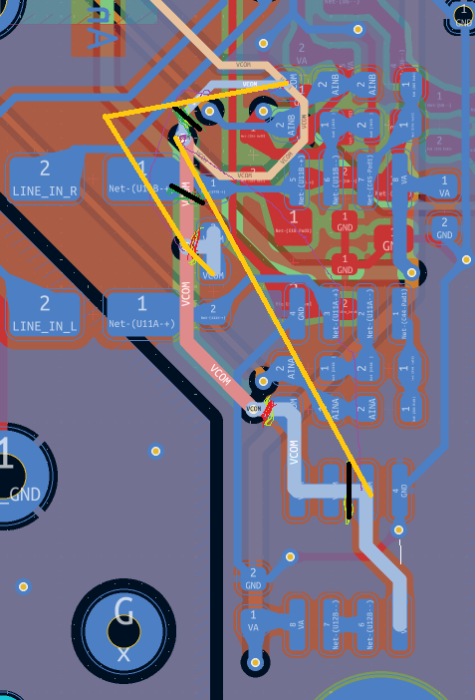
<
Modifications for the missing power flags (connections made in red)
