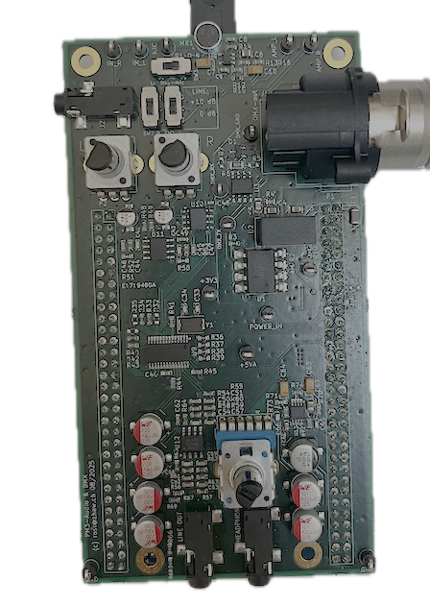

HW Testing
  - Electronics Projects

Abstract
Testing, and especially documenting tests, is often undervalued. Even if a prototype works in the laboratory this does not guarantee that it works in the field. Designing reproducible test procedures with a good coverage helps to reduce the costs of warranty and increase the profit margin. This “checklist” tells how to prepare, run and document tests on an electronic circuit.

Table of Content
Abstract 1
1. Purpose of Testing 2
2. Design for Test 2
3. Test Plan 2
4. Safety First 3
5. Run the Tests 4
6. Test Analysis 4
7. Test Documentation 5

Version 1, 9.9.2025

Purpose of Testing
- Verify or proof that the requirements and expectations on the Device Under Test (DUT) are reliably met
- Reduce the risk of failures
- Reduce the costs of warranty and increase the profit margin
- For a prototype: Make sure that the DUT is ready to be integrated into a bigger system

Design for Test
Testing starts with the hardware design!
- The tests should reflect the requirements and specifications. Ideally, the tests include the ones done while commissioning at the customer.
- When designing a circuit, identify its critical aspects and find a way to test them.
- Where meaningful a circuit can be extended for better testability:
  - Add test pins, test pads, jumpers, 0Ω resistors.
  - Connect Enable/Disable pins of ICs via pull-up or pull-down resistors to power or ground to be able to deactivate an IC for test purposes.
  - Add a jumper in the supply conductor of a sub-circuit. Thus, it is possible to test every sub-circuit independently.
  - Make sure that such built-in test circuitry has no negative influence on the main functionality of the circuit.
- Design the PCB to support testability:
  - Place the relevant nodes accessibly for oscilloscope probes, etc.
  - Include GND pins for the oscilloscope and function generator.
  - Add some supporting text on the PCB such as signal labels, jumper settings, ...
  - Here again, make sure that these additions have no negative impact on the main function of the circuit. Avoid long lines, don’t lose compactness …

Test Plan
A good test plan covers all essential tests but no redundant tests.
The test plan includes all information required to repeat the tests and get comparable results.
For each item on this list of test cases:
- Write down the test purpose, principle and sequence and check the test plan for good coverage. The cases should at least cover the main functionality under standard conditions, critical aspects and main risks.
- The test depth should be adapted accordingly and well balanced.
- Define the related requirement or the specific functionality to be measured and verified
- Specify the test equipment and test circuits
- List the test conditions, such as supply voltage, input signals, output load, temperature, any settings in the DUT (jumpers, IC registers, …) or in the test equipment
- Determine the expected results and define the conditions to pass the test
The test plan must be finished before the tests are started and not afterwards!
However, it is common practice, to modify a test plan during the tests.
Often it is possible to use a table with about five columns with the above aspects and a row for each test case. Below is an example for a signal amplifier:
Test item,  Description | Test conditions | Expected, Tolerance | Measured result | Comparison,  verdict | Remarks,  Discussion
DC level  of output | No input signal  VCC = 3.3V | Output signal:  1.250V  ±5mV | 1.252V | deviation +2mV  passed
Gain | Input signal:  1mVpp 1kHz sine | Output signal:  250mVpp  Gain: 240..270 | 234mVpp  Gain = 234 | Circuit works, but  out of tolerance  failed | Check resistor tol.  Continue with tests
Linearity  and noise | Input signal:  1mVpp 1kHz sine | THD+N < 2% | THD+N = 3% | failed | Cause unknown:  Check PCB layout,  Capacitor type: NP0?  Abort test
Stability with  capacitive load | Input signal:  1mVpp 1kHz rect  100pF on output | Output signal  overshoot < 10%
As can be seen, this table is also helpful for documenting the test procedure.

Safety First
Always follow the principle: Safety First!
Personal safety: Prevent risk of electric shock or any other danger due to high voltages or high currents, heat, intensive light, sound, …
Prevent risk of damage of the DUT or the test equipment.
Before switching on the power supply do a visual inspection of the PCB: Soldering, no short circuits, correct orientation of the components (electrolytic capacitors can explode with wrong polarisation), no missing components, correct values …
Verify the test setup: Correct power supply (voltage, current limits, polarity), instrument connection and configuration, ...
Start with safe measurements. Start with voltage, current and power limited to the lowest possible values. Use non-critical loads such as power resistors. Do the more critical measurements after having gained enough confidence.
If possible, divide the whole circuit into sections (sub-circuits), operate and test them separately before doing the overall test. Start with the low power sections.

Run the Tests
Execute the tests as defined in the test plan. It should therefore always be clear what results you would expect.
Write a test protocol while doing the tests. It should include:
- All information about the conditions and results of the measurement.
E.g. tables with raw data, generated log files or graphs
- Comments on any noteworthy observations: unexpected results, special insights, instabilities …
- Formal information: who did the test, date, time, location, identification of equipment used
With the test plan and the test protocol, it should be possible to redo a measurement and reproduce the results.
When a test case has been finished, it must be clear whether the test has passed or failed.
When a test has failed, decide whether the test session can be continued or whether it has to be aborted.
After correcting an error, all the tests depending on the affected part, must be redone and the tests documented again.

Test Analysis
Test analysis after the test session may include:
- Post processing of the test results
- Presentation of the results e.g. as graphs, tables, ...
- Detailed comparison against the expectations, simulations, datasheets, …
- Finding reasons for deviations and errors
- Commenting and discussing the results
- Make a final verdict: passed or failed

Test Documentation
Add a chapter in the HW report covering the main aspects and results of the tests.
The detailed test protocols and the raw test data go to the appendix (and, if sensible, to a digital data carrier).

