

Hardware Report

Audio Processing and Ambient Light Control
  - Electronics Projects
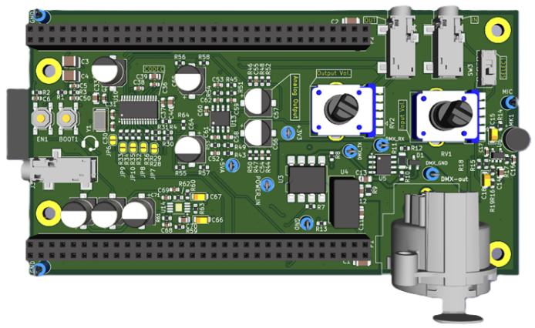 | 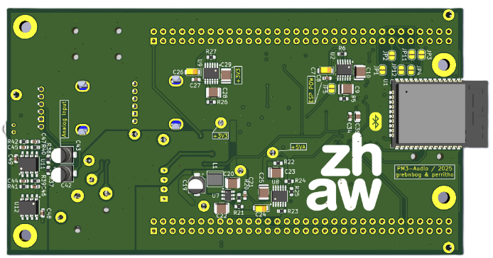

Authors |  | Thomas Perri  Bogdans Grebnevs
Main supervisor |  | Patrick Rennhard
Secondary supervisor |  | André Huber
Date |  | 21.11.2025

Abstract
Text

Table of Contents
1. Introduction 4
2. Specifications, Functionality and System Overview 4
2.1. Purpose of the System 4
2.2. Basic Functions 4
2.3. Optional Functions 5
2.4. System Specifications 5
2.5. User Interface and User Interaction 6
2.6. Functional Block Diagram 6
3. Development 7
3.1. Implementation of a Dedicated 3.3 V Rail for the ESP32 7
3.2. Analog input and filtering 9
3.3. Codec circuitry and configuration 10
3.4. Aanalog output and reconstruction filtering 11
3.5. Esp32 interconnect to stm32 and codec 12
4. Implementation 13
4.1. Schematic Design 13
4.2. PCB Layout 14
5. Testing 14
6. Abstract 15
7. Proposed Content 15

Introduction
The objective of this project is to design and implement an integrated audio-processing and ambient-light-control device on a custom printed circuit board (PCB). The system is based on an STM32F429 microcontroller and a CS4271 audio codec. Its primary functions include digitizing an incoming audio signal, performing real-time processing to extract audio-level information and control ambient lighting, and then converting the processed signal back to analog for output through a line-out or headphone interface.
Beyond the core functionality specified by the course requirements, the project will explore additional features such as audio effects or enhanced signal-analysis algorithms (e.g., beat detection).
The development process comprises electronic circuit design, PCB layout, component assembly and soldering, firmware development, and comprehensive testing of both hardware and software. All tasks are planned to be completed within a single semester.
Certain hardware modules, reference designs, and firmware components were provided by the supervising professor to support and accelerate the development process.

Specifications, Functionality and System Overview
This section provides general overview of the system, basic and optional functionalities as well as technical requirements and specifications.

Purpose of the System
Text

Basic Functions
The core functionality defined by the course framework includes the following system capabilities:
- Receive audio signals from either a microphone input or a line-in source
- Apply an anti-aliasing filter to the input signal prior to A/D conversion
- Digitize the signal as 24-bit audio data using the CS4271 codec
- Transfer the digital audio stream to the STM32F429 microcontroller via the I2S interface
- Process the signal to determine the audio level and display the measurement results on the display
- Convert the processed signal back to analog form and apply a reconstruction filter
- Control the audio codec through an I²C connection
- Generating DMX512 frames at 250 kbit/s using the microcontroller’s integrated UART

Optional Functions
Modern audio equipment is increasingly wireless, so relying only on analog audio jacks would limit the practicality of the device. To address this, an ESP32 module was added to the PCB to provide Bluetooth audio capability. The ESP32 acts as an alternative audio input/output interface without modifying the core system design.
Bluetooth Audio Functionality:
- Receive audio wirelessly via Bluetooth into the ESP32 module
- Decode the audio stream and forward it to the STM32 using an I²S connection
- Recieve the processed audio signal from the STM32 and transmit it back over Bluetooth
This feature operates strictly as an additional audio path. It does not change the main STM32 audio-processing pipeline, and it does not affect the DMX or light-control functionality.
Additional optional features are planned, but they are purely firmware-based and do not require changes to the hardware. For this reason, they are not part of the hardware documentation.

System Specifications
- Electrical Specifications
  - Analog supply voltage: 5 V
Used for the audio codec’s analog parts and audio circuit components (e.g. op-amps).
  - Digital supply voltage: 3.3 V
Required for the STM32 microcontroller, the digital section of the audio codec and the optional ESP32 module.
- Audio Subsystem
  - Sampling rate: 48 kHz
Standard professional audio rate that balances quality and computational load.
  - Audio resolution: 24 bit
Provides high dynamic range suitable for precise level detection and audio effects processing.
  - Signal levels: Line-level audio for both input and output paths.
- DMX Communication Interface
  - Bitrate: 250 kbit/s
Compliant with the DMX512 standard for stage and architectural lighting control.
  - Electrical interface: RS-485 transceiver, differential bus.
- Mechanical Specifications
  - PCB type: 4-layer PCB (course requirement)
- Interfaces and Connectivity
  - Audio Interfaces: line-in and line-out / headphone
Analog input and output to the codec’s ADC and from the codec’s DAC respectively
  - I²S interface for audio data transmission
  - I²C interface for codec configuration
  - UART interface for interaction between the microcontroller and the DMX output
  - Lighting Control: DMX output
- Additional Requirements for Optional ESP32 Bluetooth Feature
  - Additional 3.3V power supply for the ESP32 microcontroller
  - Additional routing for I²S lines
  - Additional UART connection as a backup ESP32 – STM32 communication channel

User Interface and User Interaction
This section describes the interfaces through which the user interacts with the device.
Audio Input Options
The device supports several ways of providing an audio signal:
- Line-in (standard analog input)
- On-board microphone integrated on the PCB
- Bluetooth audio input through the optional ESP32 module
The user can select between the analog audio sources (line-in or microphone) using a DIP switch on the PCB. Bluetooth input does not require hardware switching, as it is handled entirely in software.
Audio Output Options
The processed audio signal can be sent to:
- Line-out (analog analog input)
- Headphone jack
- Bluetooth audio output via the ESP32 module
Analog Volume Control
Two potentiometers are placed on the PCB for adjusting:
- The input gain/volume of the analog line-in or microphone signal
- The headphones output level
These controls operate only in the analog part of the audio path and therefore do not affect Bluetooth audio, which remains fully digital. In practice, this is not a limitation because most Bluetooth audio sources and devices (e.g., smartphones, laptops, headphones) include their own built-in volume control.
Analog Volume Control
All remaining interactions—such as managing Bluetooth connections, adjusting light-control settings, and accessing additional features—are handled through a touch display. This interface provides flexibility and can be fully defined during firmware development. It is designed to cover all necessary user interactions, so no further hardware controls are required.

Functional Block Diagram
INSERT BLOCK DIAGRAM
The functional block diagram in Figure 1 illustrates the complete signal flow within the hardware system. It shows the path from the audio input, through the microcontroller and audio codec, to the analog audio output and the DMX lighting output. The standard analog signal path is shown in blue, while the optional Bluetooth signal path is shown in green.
The system supports multiple audio input options. In the analog case, the signal enters either through the on-board microphone or the line-in connector. The microphone signal is first amplified by a preamplifier to reach the level required by the codec, while the line-in signal bypasses this stage. Both signals then pass through the input-selection block and the input volume control.
Next, the selected analog signal is routed to an anti-aliasing filter. This second-order low-pass filter removes high-frequency components above the useful audio range. By doing so, it prevents aliasing artifacts when the codec’s ADC samples the signal.
After filtering, the signal is converted into a digital data stream by the codec’s ADC. The codec sends the digitized audio to the STM32 microcontroller via the I²S interface. The microcontroller processes the audio samples – for example, to extract level information or to apply optional audio effects. The resulting audio data is then returned to the codec, where the DAC converts it back into an analog signal.
The analog output passes through a reconstruction filter that suppresses high-frequency copies of the original signal frequencies produced by the DAC. The signal is then routed to the line-out connector. In parallel, it also goes through an output volume control stage and a headphone power amplifier before reaching the headphone jack.

At the same time, the microcontroller generates DMX512 frames for lighting control based on the processed audio data. These frames are transmitted via a UART interface to the DMX driver, which both galvanically isolates the DMX interface from the rest of the system and converts the UART signal into a differential RS-485 signal. The resulting isolated signal is available at the DMX output connector and can be used to drive external lighting equipment.

In addition to the standard analog path, the system provides an optional fully digital Bluetooth audio path. In this case, the ESP32 module receives audio wirelessly, decodes it, and forwards the digital audio stream to the STM32 over I²S. After processing, the STM32 returns the audio to the codec for conversion and output, or back to the ESP32 for wireless transmission. It is also possible to use Bluetooth only as an input or only as an output, combining the analog and digital paths as needed.
A second communication option between the ESP32 and STM32 was added as a design-time precaution. During PCB design, it was uncertain whether the primary ESP32-to-STM32 I²S link would work reliably, and the project timeline did not allow for a redesign if problems appeared. Therefore, an alternative scheme was included: the ESP32 can interface directly with the codec over ^{I2}S, while a separate UART link handles communication with the STM32. Only one of these schemes is used in practice. In the block diagram, the optional fallback path is shown with dashed lines.

Development
For this project, the most critical circuit blocks were pre-designed and reviewed by the instructors. These included the regulated 5 V, 5 VA-Analog (5 VA), and 3.3 V power rails, the DMX interface circuitry, the main external connectors, and the mandatory components such as the audio codec, the headphone amplifier, and the microphone front end. The initial design used a single linear regulator for the 3.3 V rail, but after system analysis we added a second regulator to support the additional current demands introduced by the ESP32.
The remaining circuits required additional development work, including:
- Implementation of a dedicated 3.3 V rail for the ESP32
- Designing analog input stage and anti-aliasing filter
- Codec configuration and support circuitry
- Designing analog output stage and reconstruction filter
- Interfacing between the ESP32, STM32, and audio codec

Implementation of a Dedicated 3.3 V Rail for the ESP32
The instructors provided fully designed power rails for 5 V, 5 VA, and 3.3 V. However, during the system planning process it became clear that the existing 3.3 V rail – based on a linear regulator – was not suitable for powering the ESP32 together with the rest of the digital circuitry. The ESP32 can draw up to approximately 500 mA under full load, especially during wireless activity, which would push the original regulator close to or beyond its safe operating limits. In addition, since the entire system is powered from USB (5 V at roughly 500 mA), the total available power is limited to about 2.5 W, making efficient power distribution essential. Under these constraints, relying on a single 3.3 V regulator was not feasible.
To address this, we added a second 3.3 V regulator dedicated exclusively to the ESP32 (see Figure 2). Splitting the load across two regulators provides sufficient current headroom, avoids overload, and reduces thermal stress. It also improves stability for the ESP32, whose wireless transmissions can cause rapid and significant current spikes.
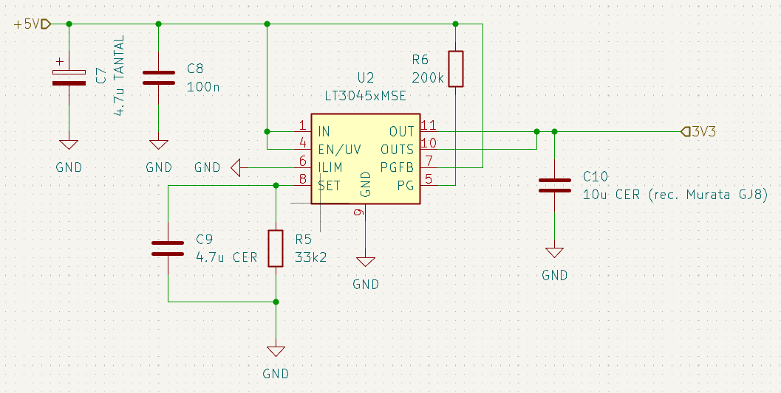

To further smooth these current spikes, we added substantial decoupling capacitance to the dedicated ESP32 rail (see Figure 3). Capacitors were placed both at the regulator output and close to the ESP32 power pins. This local energy buffering reduces high-frequency fluctuations, stabilizes the supply during wireless bursts, and increases the overall reliability of the power distribution network.
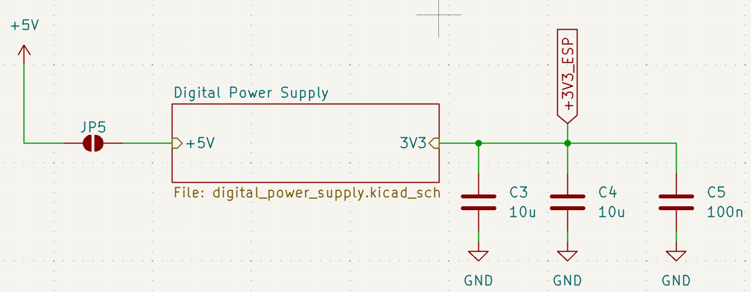

Analog input and filtering
The audio input stage supports a microphone and 3.5mm jack audio signals. These are then selected by a switch that lets either the jack signal or the microphone signal pass through into the volume control. A SEL_M_J signal has been connected to the switch which will be read out by the stm32 microcontroller, this way it knows whether the jack audio or the mic audio is passing through.
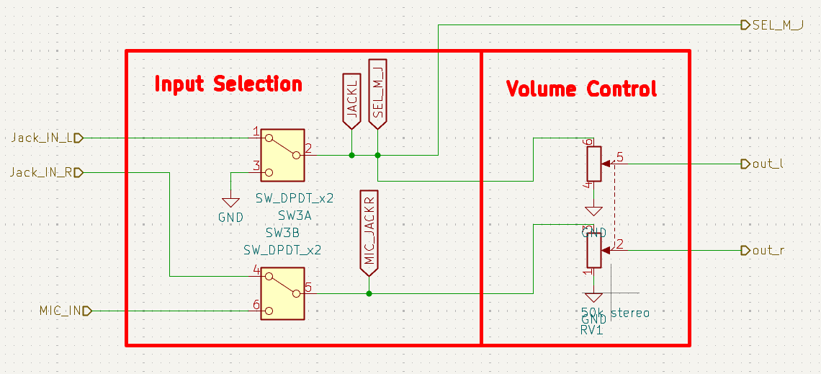
The Volume control has simply been implemented with a single 50k stereo potentiometer, this way both signals are always the same “loudness” or in other terms the same amplitude.
After the volume control the singals travel to the analog input filter before the codec. This is not only a filter, because it also conditions the signal so that it arrives to the codec as its expected. First its dc part is removed with the input capacitors and thereafter they are centered around the VCOM reference voltage buffered by the opamp. This reference voltage is sourced by the codec itself.
Unfortunatley during schematic design we made a mistake and accidentaly named the signal flags the same before and after the buffering amplifier, causing the amplifier to load the vcom supply by the codec instead of buffering it. We realized this when we measured the signal on the filters output, which showed clipping on the lower part of the signal indicating the offset given by the vcom reference voltage is not where it is supposed to be at 2.5V.

INSERT PICTURE OF CLIPPED SIGNAL HERE

after cutting some traces and connecting certain parts with ennameled bodge wire the filter is fuly funcitonal. For further details see The Hardware test report in the appendix.

INSERT PICTURE OF FIXED SIGNAL HERE

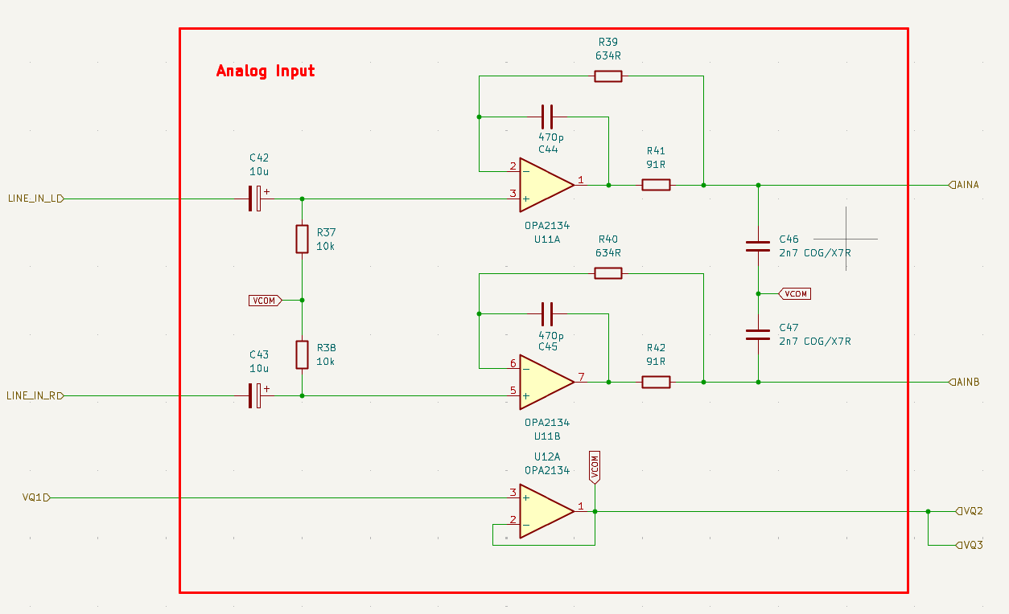

The analog frontend has been designed according to our teachers guidelines and the CODEC datasheet. Thereafter it has been simulated in Ltspice to see its function.

INSERT LTSPICE PIC HERE

Codec circuitry and configuration
The codec circuitry was quite straightforward, it was mostly a copy paste form the datasheet. The only thing we truly had to configure ourselves is the M0 and M1 pins via pull up or pull down resistors. As we did not want to commit to a single configuration, we decided to add the footprints for the resistors to either pull up or pull down depending on how we would like to use the codec.
For normal use we went witht the following condiguration: M0 = ‘1’, M1 = ‘0’
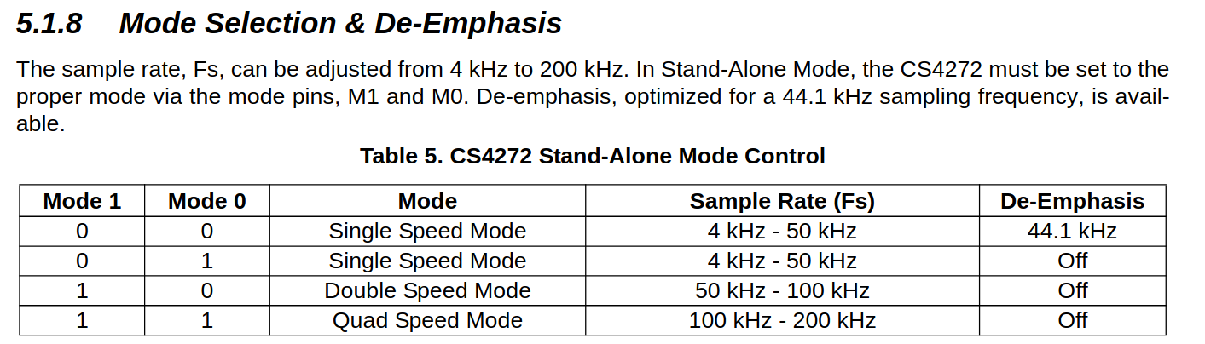
The reason being that we did not want any De-Emphasis and the single speed mode witht the 4-50kHz sample rate suffieced for our use.
ChatGPT:
In codec and audio-signal processing, de-emphasis refers to a filtering step used to undo an earlier pre-emphasis filter that boosted certain frequencies (usually high frequencies) before encoding.
As we do not have a pre-emphasis filter boosting frequencies we therfore do not need a de-emphasis filter.
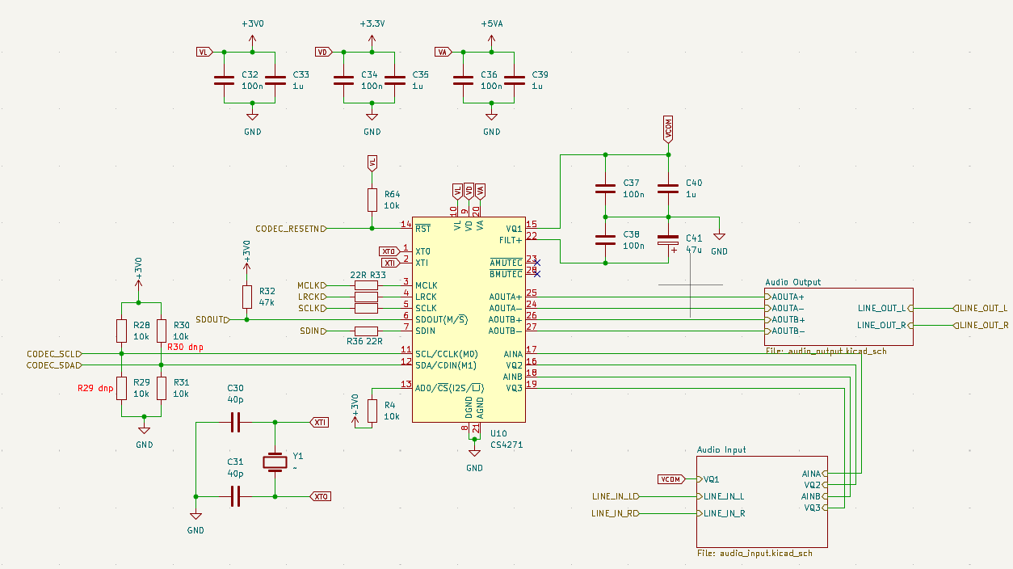
The reset pin of the codec has been fixed to the STM32 3V supply via 10k resistor and the pin has also been connected to a gpio of the stm32 enabling us to perform software resets in case we need it.

Aanalog output and reconstruction filtering
The codec outputs a differential signal which needs to be converted back into a signle ended signal and also has to go through a reconstruction filter because the codec has a finite resolution to reproduce a analog signal and has therefore discrete steps in the amplitude and time domain. Due to this the signal output form the codec contains many fine “square” edges which are not nice and the reconstruciton filter removes them.
Source: https://www.dsprelated.com/showarticle/1627.php
DAC Zero-Order Hold Models
Neil Robertson January 21, 2024

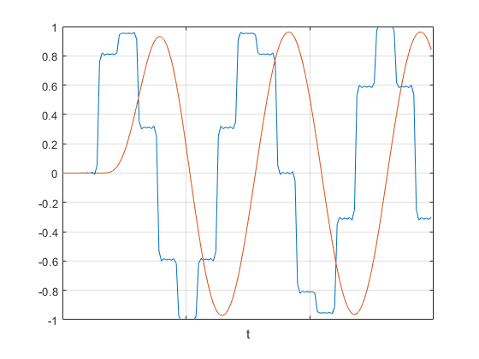
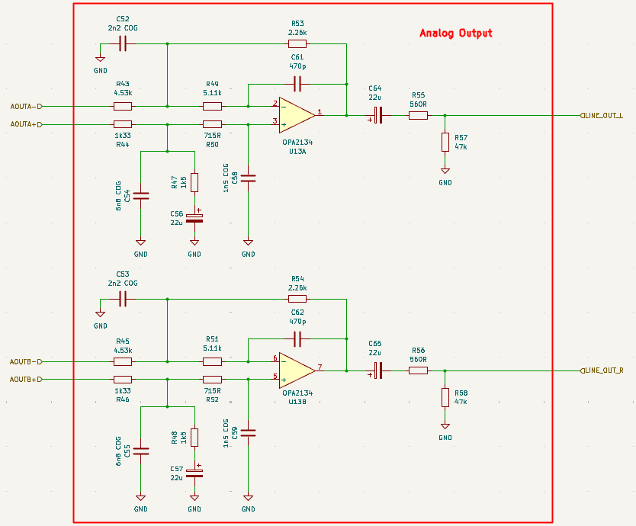

Esp32 interconnect to stm32 and codec
Our boards extra feature is the bluetooth audio capability enabled by the esp32. The idea is that we can use the esp32 as an audio source receiving music over bluetooth and sending I2S data to the codec or the stm32. Or as an audio output sending music over bluetooth.
The interconnect between the chips is not easy and has to be chosen fixed via jumper solder pads as to not have any interferance in communicaiton.
Simply put we organized the jumper pads the following way:
• STM32 → CODEC |direct I2S connection
• ESP32 → CODEC |direct I2S connection
• ESP32 ←→ STM32 → CODEC |I2S connection between ESP32 and STM32, I2S connection between STM32 and CODEC

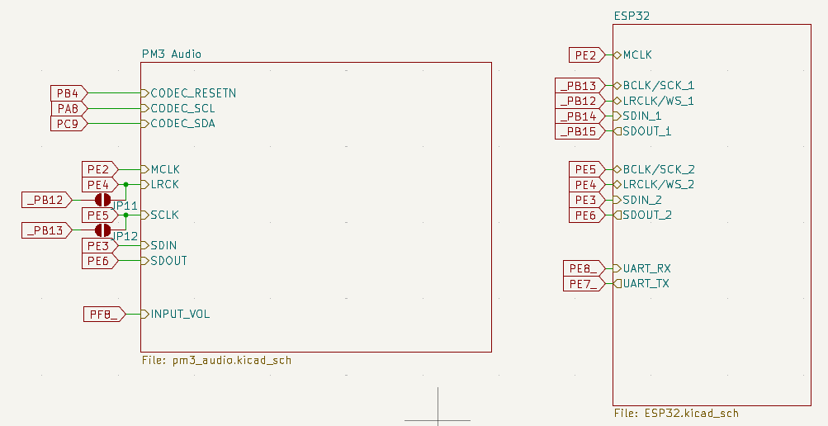
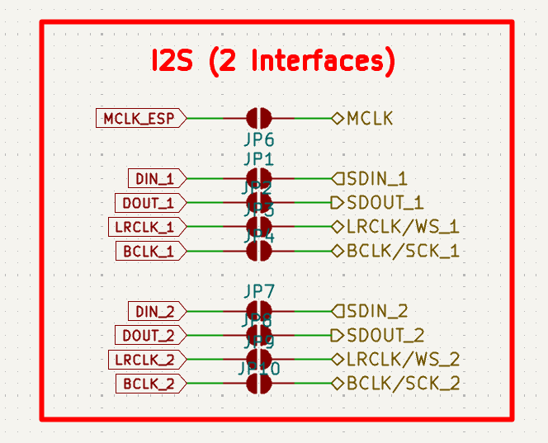

Implementation
This section describes the implementation stage of the project.

Schematic Design
We began by grouping the components into functional blocks and making small local circuit layouts for each group. This helped keep the design organized and avoided the need to resize the PCB later. Some parts of the design such as sections of the voltage rails and the DMX circuitry were provided by the teachers, so we kept their original layout and did not modify them.

PCB Layout
After finishing the schematics, the PCB layout was created in KiCad. Components were placed according to input / output flow. The audio circuitry was positioned close to the codec. The DMX output stage was placed near its connector to keep the isolated RS-485 traces short and less sensitive to noise.
Analog and digital areas were separated as much as possible to reduce interference. Their ground regions were connected at only one defined point. For the isolated ground, we made sure that the copper areas were not cut by traces and stayed clearly separated.
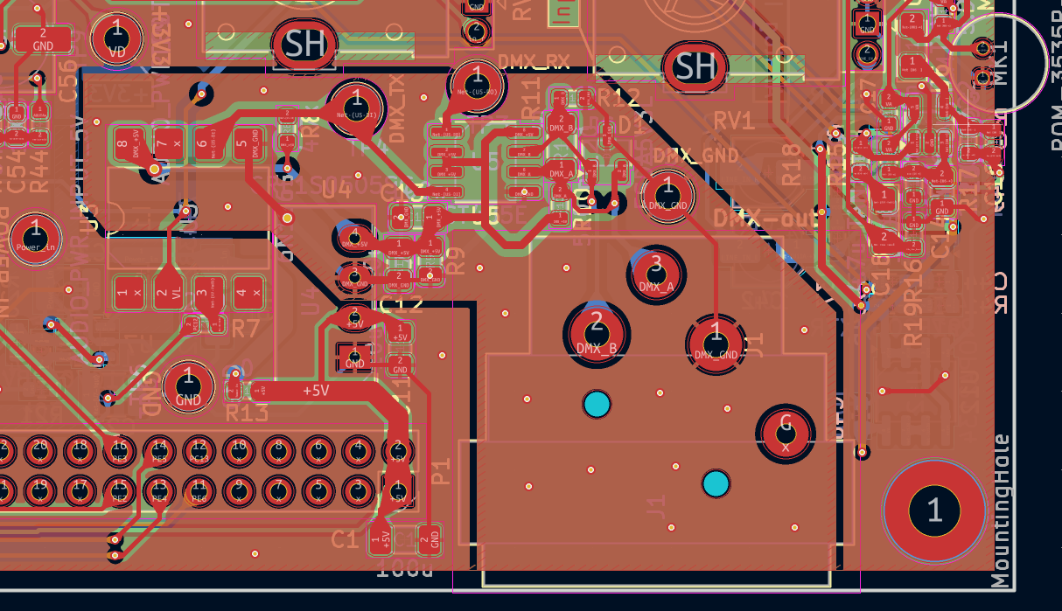
Decoupling capacitors were added next to every IC power pin, and wide traces were used for the power rails. We avoided sharp trace angles, and added thermal reliefs on ground pads to make soldering easier.
Before sending the board for manufacturing, all design rules were checked. The 3D viewer in KiCad was then used to verify mechanical fit, component spacing, and the overall layout. And the teachers reviewed the schematics and layout also.

Testing
Text

Abstract
The abstract is a means of advertising one’s work. Online search databases usually only contain the abstracts.
After skimming an abstract, the reader decides if the content seems relevant or not.
The abstract is a concise and short description of the complete work. The content is thus similar to that of the report and includes:
- Motivation for and context of the project
- Problem statement
- Solution approach
- Achieved results
The abstract is formatted as one single paragraph. It is a third to a half page long. Shorter is better, as long as the essential information is included.

Proposed Content
- Title page with authors, date, company, etc.
- Abstract
- Table of contents
- Introduction
with subject, circumstances, conditions, expectations, ...
- Specifications, functionality and block diagrams
Aspects may be purpose, primary (and secondary) functions, parameters (ranges, limits), interfaces, HW and SW requirements, user interface, time, cost, ...
This must be well defined before the development starts!
- Development
Document circuit design, formulas, simulation, dimensioning of component values.
- Implementation
Schematics with description of inputs, outputs, special components
PCB layout with explanation of the layout concepts (analog, digital, power, EMI, ESD)
- Document the tests
Testplan with description, test conditions, expected results and acceptable tolerances, measured results, comparison and verdict, discussion and remarks
More about testing is in the file HW_ Testing.docx.
- Project management
Timeline with milestones
Definition of work packages and assignment to team members
Comparison of planned and real workload
- Conclusion
Achieved results
Outlook and reflection
- Appendix with
References or bibliography
Schematics, PCB layouts, calculations, tables with test data, code snippets
Folder structure with explanation for digital documentation on USB stick or cloud.
The appendix contains all the information that is not needed for fluent reading.
As a rule, diagrams go in the main text, data tables in the appendix.

Datasheets used for references (values, design, etc.) should be cited

