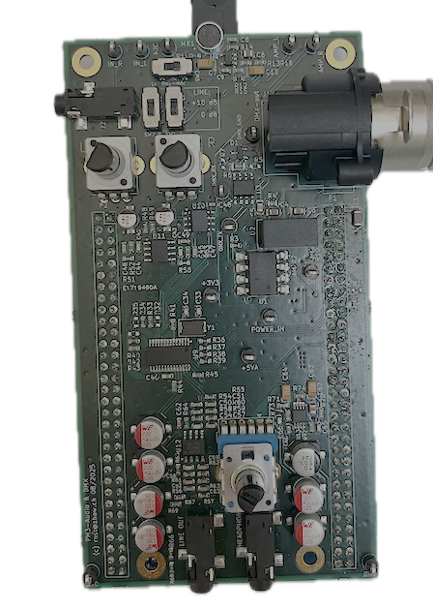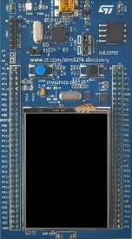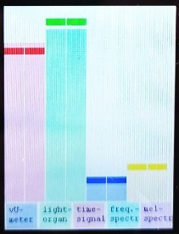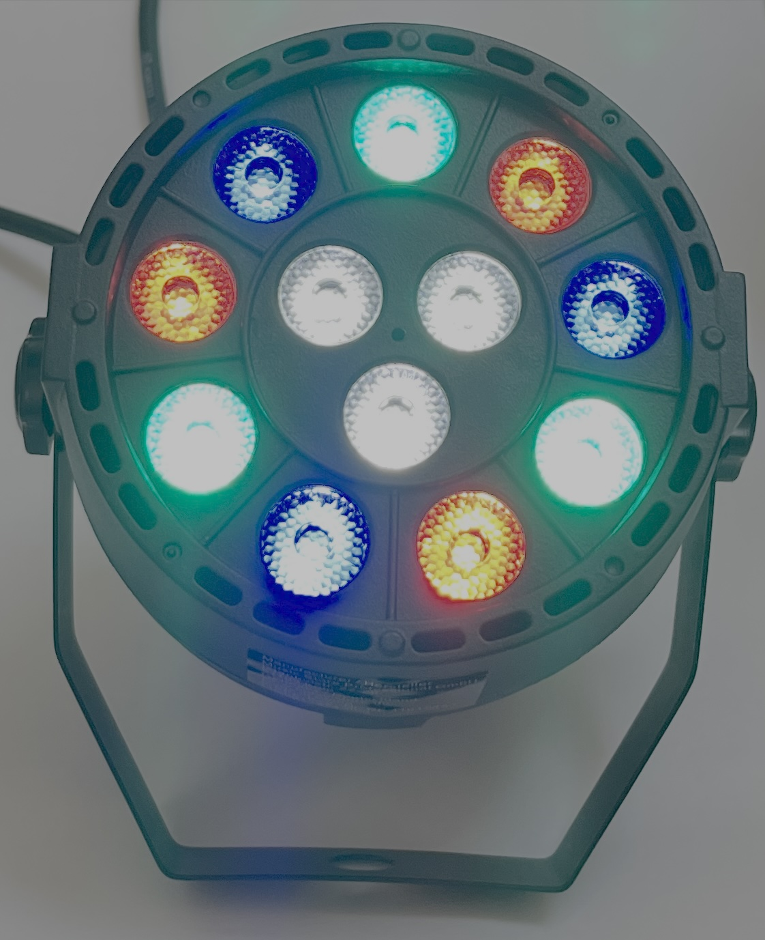

Electronics Project 1: Audio Processing and Ambient Light Control
  - in the third term of the Electrical Engineering studies at the ZHAW

Abstract
The Electronics Project 1 takes place in the third semester of the Electrical Engineering curriculum at the ZHAW School of Engineering. The concept is to apply the skills acquired so far in a holistic way by building a prototype starting from an idea. The teaching method is similar to project-based learning. In contrast, however, the goal is to build a fully functional device.
This year, an Audio Processing and Ambient Light Control device will be developed. By measuring and analyzing the audio signal either from a microphone, from the headphone output of a smartphone, or another audio source, it is possible to calculate the signal level and frequency spectrum. The signal level is used for the audio level meter display. Audio level and frequency spectrum, processed with freely chosen light-organ algorithms, can then be used to create a special ambiance while listening and dancing to music, e.g., light flashing to the beat.
The students will design implement, test, and document the hardware, firmware, and user interface of the Audio Processing and Ambient Light Control device.

Table of content
Abstract 1
1. Module Description and Goals 3
1.1. Timeline with Subjects and Milestones 3
1.2. Grading 3
2. Audio Processing Ambient Light 3
2.1. Audio Level Meter 3
2.2. Ambient Light 4
2.3. Further application ideas 4
3. How to Start and Where to Find What 5
3.1. Analog Signal Processing 5
3.2. Audio Signal Analysis 6
3.3. Project Management 6
3.4. Printed-Circuit-Board (PCB) 6
3.5. Writing the Hardware Report 7
3.6. Microcontroller 7
3.7. Presentation and Demonstration 7

Module Description and Goals
The main objective is to develop an electronic system that digitizes an audio signal, processes it for an audio level meter and for ambient light control via DMX, and then performs digital-to-analog conversion to output the signal via a line-out and/or headphone jack.
Consequently, the hardware provides an excellent basis for individual extensions and the implementation of custom functionalities, such as audio effects (equalizer, distortion, phaser, compressor, …) or event detection (e.g., recognizing clapping via a microphone).
Apart from technical skills such as developing, building, testing, and documenting hardware and firmware, this module also emphasizes communication and project management competencies. The teams consist of two students, and the working language is English.

Timeline with Subjects and Milestones
Public holydays change every year. See the document Timeline.docx in the same folder.

Grading
Checklist_Marks.xlsx can be used as checklist and includes the weights for the grading.

Audio Processing Ambient Light

Audio Level Meter
The measurement of audio level can be approached using different methodologies that have evolved over time. Historically, the analog VU meter (Volume Unit meter), introduced in the 1940s, was the dominant tool for assessing perceived loudness in audio engineering. With the transition to digital media, however, new standards have emerged to account for more accurate and perceptually relevant loudness measurement. A prominent example is Loudness Units relative to Full Scale (LUFS), which has become widely adopted in modern broadcasting and streaming platforms such as YouTube to ensure consistent playback levels across diverse content.
In this project, you are given the opportunity to implement your own audio level measurement method. As a starting point, a code template is provided that is conceptually based on the operation of the traditional VU meter.

Ambient Light
The DMX512 protocol (Digital Multiplex), introduced by the United States Institute for Theatre Technology (USITT) in 1986 [1], has been the standard for stage and event lighting control for decades. Developed to replace a variety of incompatible systems, DMX512 became widely adopted due to its reliability, simplicity, and ability to transmit multiple control channels over a single connection.
Even today, DMX512 remains the primary method for controlling event lighting, including devices such as RGB lamps, dimmers, and moving lights. Each channel within a DMX universe corresponds to a specific parameter, such as brightness or color, allowing precise and real-time adjustment during live performances.
In this project, you will explore the fundamentals of DMX-based lighting control by implementing your own algorithm to control an RGB lamp via DMX. Based on the frequency and amplitude of an audio signal, your algorithm will set the lamp’s color and brightness, thereby linking sound dynamics to visual output in real time.

Further application ideas
Here are some additional applications, which could optionally be implemented in this project or in future, as you can keep the hardware.

- Advanced Audio Level Meter (Peak, RMS, LUFS, …)
Extend your audio level meter with additional features, like e.g. LUFS, or Goniometer (https://en.wikipedia.org/wiki/Goniometer_(audio))

- DMX Beat Flasher
Detect the beat of a music tune and let the DMX lamp flash to the beat!
- BPM counter
Detect the beat of a music tune and display the tempo in BPM (Beats Per Minute) on the display
- Guitar effect processor: Phaser, Distortion, …
The circuit could be extended with a high impedance (“High-Z”) instrument input, so that you can plug in your guitar or bass and use it as a digital audio effect processor with your own effect algorithms.
- Clap switch
Switch on and off the DMX light when a hand clap is detected in the microphone signal
- Real time audio effect processor: Equalizer, Compressor, Reverb (RAM 256 kB!), …
Similar to the guitar effect processor, but with standard line input, or even balanced XLR input and output for integration in an audio studio…
- Audio Player
The Discovery board has the USB-OTG port populated. You may hook up an USB drive containing audio files and play them back
- Audio Recorder
Record your microphone audio to an USB drive connected to the USB-OTG connector
- Guitar Tuner
Analyze the exact frequency of a tone fundamental and implement a guitar tuner
- SPL meter
Use your microphone to build a (uncalibrated) SPL meter
- Bat detector
The Audio CODEC used on the board can be configured to achieve sample rates up to 192 kHz. Use this feature and digital algorithms (downmixing) to make ultrasound audible in your headphone(sampling rate 96 or even 192 kHz, downmix ultrasound into audible range)
- Advanced: Voice commands (e.g. “Green”, “Red”, “Blue”)
Try to implement Machine Learning on the STM32 (TinyML) and to change the light color according to voice commands.

How to Start and Where to Find What
The technical part of the project is divided into two main areas: hardware (HW) and firmware (FW). In addition, students apply and further develop their language and project management skills throughout the entire project.
Tested and documented HW and FW templates ensure a smooth and efficient start.
All documents are stored in the PM3 pool, structured into three main folders:
- Assessments (information about the assessments)
- Technical Documents (materials related to the technical part)
- Language (resources for the language component).

Analog Signal Processing
The implementation of a audio level meter or an Ambient Light both need an audio signal as input. The analog audio signal generated by the microphone or fed into the line-in connector must be amplified, buffered and filtered (anti-aliasing filter) by analog HW before it can be converted by the ADC of the audio codec and be further processed by the microcontroller in the digital domain.
Likewise, the DAC converts the digital audio output back to analog. This signal must as well be filtered (reconstruction filter) and buffered.
The related documents are in the folder Analog_Signal_Processing.

Audio Signal Analysis
The digitized audio signal must be analyzed by an algorithm to calculate the audio level meter value and the effects for the Ambient Light.
For the audio level meter, the peak and average amplitude over a predefined time slice are relevant.
For the Ambient Light, however, we will use frequency distribution and rhythm to generate light patterns. For this use case, it makes sense to use amplitude and frequency measuring approaches which yield scales similar to human hearing. Different scales exist to describe the sound pressure and frequency perception of the human ear, like e.g., A-weighted logarithmic scale for sound pressure and mel frequency scale for perceived pitch.
The related documents are in the folder Audio_Signal_Analysis.

Project Management
The team must be organized, and the tasks assigned to its members.
The related documents are in the folder Language.

Printed-Circuit-Board (PCB)
The PCB is the piece of hardware that must be developed in this project. It includes all the circuits that are needed to capture the audio signal and to drive the DMX-controlled Ambient Light device.
The related documents are in the folder PCB.
For a smooth start, a template file (HW_template*.zip) for the recommended PCB layout tool KiCAD is provided, including the correct dimensions and socket positions. The schematic already contains the standard components as well as predefined parts of the circuit and layout that do not require any modification, ensuring that the workload of the project module remains realistic.
KiCad.docx provides a basic tutorial on schematic capture, PCB layout, and the 3D viewer. In addition, numerous video tutorials with step-by-step instructions can be found online if needed.
The file Extension_Connectors.xlsx lists the available peripherals of each pin.
Observe PCB_Checklist.txt before ordering the PCB.
After soldering HW_Testing.docx might be useful.
The PCB is powered by the 5V and 3V header pins of the microcontroller evaluation board which in turn is powered over the USB plug.

Writing the Hardware Report
Writing a technical report involves two main aspects:
- The rules: Academic Writing_summary.docx
- Content and structure: HW_Report.docx in the same folder.
The hardware report must be updated continuously!

Microcontroller
For the Electronics Projects the microcontroller and the evaluation board have already been chosen. The folder Microcontroller contains an introduction Microcontroller_STM32F429.docx and the references needed for programming.
In the same folder the FW_template.zip is the starting point for writing own code. The file Install_IDE_and_Import_demo_code.pdf is a step-by-step guide.
The fully functional FW_template includes demos for a menu system, SAI (I2S), DMAs, etc.

Presentation and Demonstration
In the end, the device must find customers and be advertised (folder Effective Presentations).

