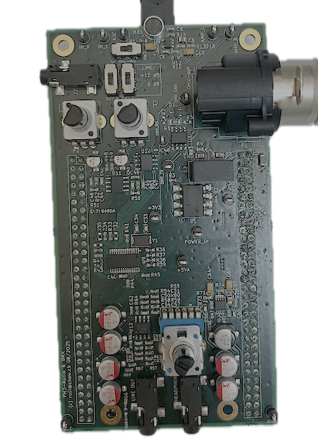

Basic FW
  - Electronics Projects

Abstract
This document provides details on the assessment component ‘Demonstration of basic FW functionalities including FW Block Diagram’ and outlines the expectations for the basic FW itself.

Table of Contents
Abstract 1
1. Basic FW expectations 2
2. Demonstration of basic FW functionalities including FW Block Diagram 2

Basic FW expectations
Based on the firmware template, the minimum requirement for students is to implement the following features:
- Reading the audio data from the codec and outputting it unchanged through the codec.
- Controlling the lamps via DMX using a custom algorithm based on audio properties, such as the volume in different frequency bands.
- Displaying the time signal on the screen.
- Displaying the FFT-Output on the screen.
- Reading the microphone input (mono) via the codec and copying it to both the left and right output channels.
Additional, optional ideas, such as a bat detector, may also be implemented. These are not part of the basic firmware demonstration, but are instead part of the end-of-semester presentation and demonstration.

Demonstration of basic FW functionalities including FW Block Diagram
What will be evaluated during the firmware demonstration can be found in the Checklist Marks document. The expectation is that you have created the block diagram of the firmware and can briefly explain the firmware and data flow based on it, while suitably demonstrating the basic firmware functionalities mentioned above. Plan in advance how to best demonstrate each feature and prepare thoroughly before the demonstration.

