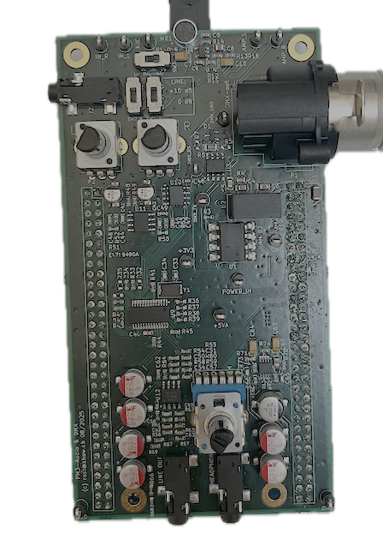

Basic HW
  - Electronics Projects

Abstract
This document provides details on the assessment component ‘Demonstration of Basic HW Functionalities including Test Report’ and outlines the expectations for the basic HW itself.

Table of Contents
Abstract 1
1. Basic HW expectations 2
2. Demonstration of Basic HW Functionalities including Test Report 2

Basic HW expectations
Based on the hardware template, the minimum requirement for students is to:
- Designing the missing parts, such as the anti-aliasing filter, reconstruction filter, and similar elements, for the audio codec using the datasheet information.
- Simulating these circuits in LTSpice, verifying the results to ensure they meet your expectations, and discussing them with the lecturer for review.
- Placing the components on the PCB and carrying out the board layout and routing.

Additional, optional own ideas, such as a bat detector, may also be implemented. These are not part of the basic hardware demonstration However, they must logically be considered already during the PCB design, and the board must be extended with the necessary components.
The additionally implemented ideas then become part of the end-of-semester presentation and demonstration.

Demonstration of Basic HW Functionalities including Test Report
What will be evaluated during the hardware demonstration can be found in the Checklist Marks document. The expectation is that you have already put your hardware into operation, completed all necessary measurements, and finalized the hardware test report.
However, it is possible that not everything may be fully functional at the time of the demonstration. In such cases, you should clearly indicate this in the test report and explain the situation transparently. Additionally, describe the steps you have already taken to address the issue and outline any further actions you plan to resolve it.
During the demonstration, you will present and explain your test report while at the same time demonstrating selected points from it live. For example, you might show on the oscilloscope what the output signal looks like when a sine wave is applied as an input signal.

