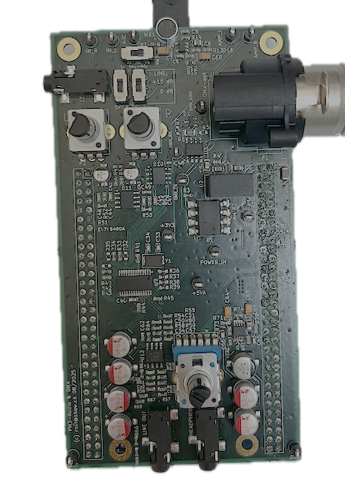

HW Report
  - Electronics Projects

Abstract
Developing a new device is a fascinating and challenging task. This article gives the reasons why and how this has to be documented.

Table of Contents
Abstract 1
1. Purpose of the HW Report 2
2. Subject and Audience 2
3. Abstract 2
4. Proposed Content 3
5. Academic Writing 4

Purpose of the HW Report
Documenting the new device for manufacturing and quality checks.
In case of problems, it is very valuable to know what has been tested and why.
For further development, variants of solutions could be interesting.
If documented the same work has not to be done again, saving time and money.
New team members take over the project.
The HW report must be updated continuously as the project evolves!

Subject and Audience
The subject is the final prototype AND the development process.
Before starting to write, the audience should be considered and defined. A report is useless if it is incomprehensible to the intended reader. For this project an audience with technical background can be assumed. The report should be written such that no particular knowledge on involved technologies and on this specific project is necessary. A good approach is to have an electrical engineering student in mind who has never heard of this project.

Abstract
The abstract is a means of advertising one’s work. Online search databases usually only contain the abstracts.
After skimming an abstract, the reader decides if the content seems relevant or not.
The abstract is a concise and short description of the complete work. The content is thus similar to that of the report and includes:
- Motivation for and context of the project
- Problem statement
- Solution approach
- Achieved results
The abstract is formatted as one single paragraph. It is a third to a half page long. Shorter is better, as long as the essential information is included.

Proposed Content
- Title page with authors, date, company, etc.
- Abstract
- Table of contents
- Introduction
with subject, circumstances, conditions, expectations, ...
- Specifications, functionality and block diagrams
Aspects may be purpose, primary (and secondary) functions, parameters (ranges, limits), interfaces, HW and SW requirements, user interface, time, cost, ...
This must be well defined before the development starts!
- Development
Document circuit design, formulas, simulation, dimensioning of component values.
- Implementation
Schematics with description of inputs, outputs, special components
PCB layout with explanation of the layout concepts (analog, digital, power, EMI, ESD)
- Document the tests
Testplan with description, test conditions, expected results and acceptable tolerances, measured results, comparison and verdict, discussion and remarks
More about testing is in the file HW_ Testing.docx.
- Project management
Timeline with milestones
Definition of work packages and assignment to team members
Comparison of planned and real workload
- Conclusion
Achieved results
Outlook and reflection
- Appendix with
References or bibliography
Schematics, PCB layouts, calculations, tables with test data, code snippets
Folder structure with explanation for digital documentation on USB stick or cloud.
The appendix contains all the information that is not needed for fluent reading.
As a rule, diagrams go in the main text, data tables in the appendix.

Academic Writing
Form and style of the HW report must follow the customary practice for academic writing as presented in the file Academic Writing_summary.docx in the folder Writing HW Report.
Read that summary carefully before starting to write and read it again after writing a first draft.

Report Length
Maximum length: 20’000 characters (excluding spaces, excluding appendices)

