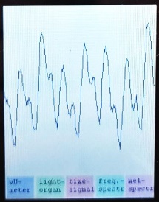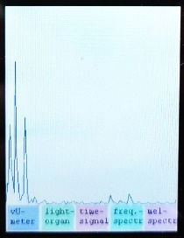

Sampling Frequency and Block Length
For the Electronics Projects

Abstract
This document gives rules for choosing a good sampling frequency and block length for the sound level meter and light-organ project.

Frequencies of Interest
The human hearing range is typically quoted as 20 Hz to 20 kHz, though it varies significantly between individuals, particularly at higher frequencies.
In telephony, the frequency range for voice transmission can be reduced to 300Hz to 3.4kHz, while keeping the conversation intelligible. The human brain uses harmonic relationships, speech patterns, and context to make the audio sound natural and intelligible. That’s why a narrowband telephone voice still sounds like a particular person’s voice, even though much of the spectral content is gone.
However, for high quality audio systems, it is desirable to have a linear frequency response that covers the whole human hearing range, i.e., 20 Hz to 20 kHz.

Sampling Frequency for Audio Signals.
When converting an analog signal to digital, the analog continuous signal is sampled at discrete, usually equally spaced time intervals.
According to the Nyquist–Shannon sampling theorem, a band-limited signal can be perfectly reconstructed from its discrete samples, provided that the sampling frequency is at least twice the bandwidth of the signal.
This implies that for perfect fidelity, we would need to sample an audio signal at a minimum of 2 x 20 kHz = 40 kHz. Although the upper frequency limit of the human ear is about 20 kHz, a microphone may still capture signals with frequency components above 20 kHz. If such components exceed f_{s}/2 (where f_{s} is the sampling frequency), they will cause unwanted aliasing in the digital signal.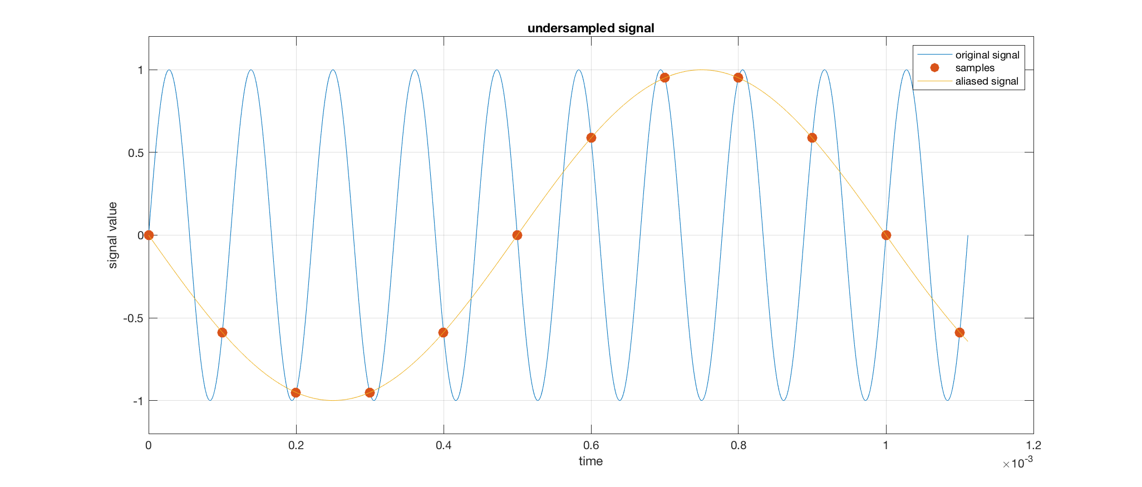
To prevent this, an analog low-pass filter (anti-aliasing filter) must be applied before the ADC to remove frequency components above f_{s}/2.
Since real analog filters cannot provide an infinitely sharp cutoff between passband and stopband, if we chose f_{s} = 40 kHz, the filter’s cutoff would need to fall below 20 kHz, thereby degrading the audible signal.
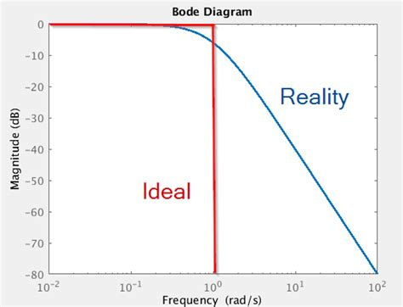
Image Source: http://ww25.everynanocounts.com/2020/02/19/
basics-on-active-rc-low-pass-filters/?subid1=20250918-0629-0728-b4d8-9eef223bdccb

This problem is mitigated by choosing a somewhat higher sampling rate. A commonly used studio standard, for example, is 48 kHz (https://en.wikipedia.org/wiki/48,000_Hz).

Block Length for Signal with Lowest Frequency
Some simulations make it easy to peak a good sampling window length for a 20 Hz signal:
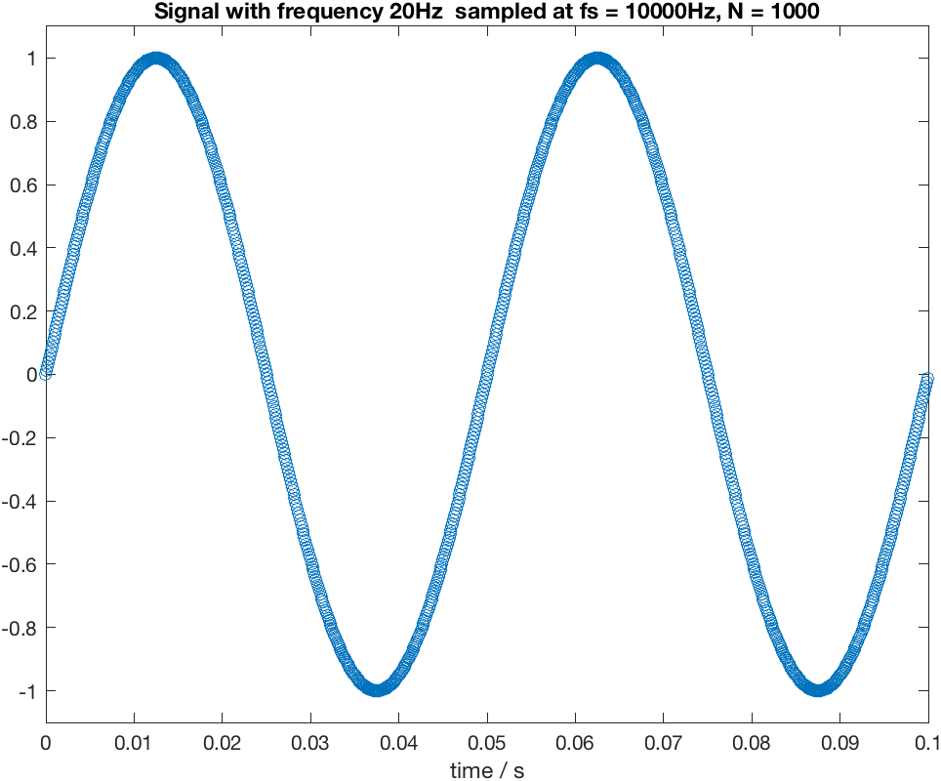
Two periods of the signal are sampled during 100 ms. This means redundant information which cost processing time and leads to delayed audio level meter and light-organ output.

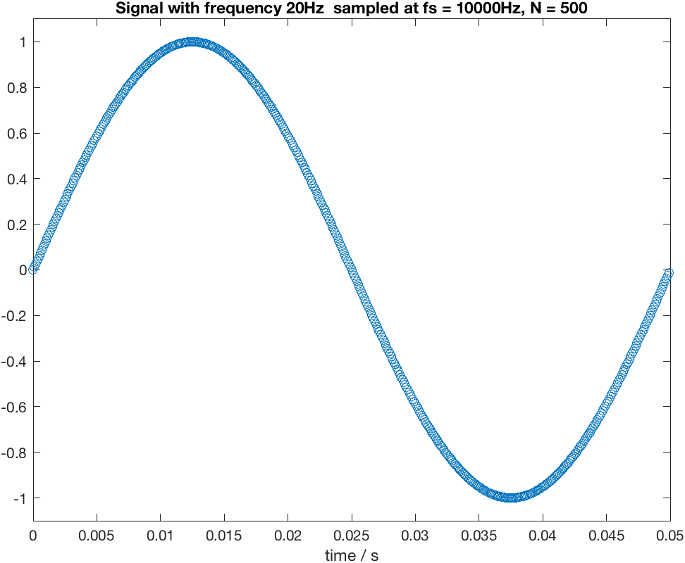
No redundant samples are present for a 20 Hz signal during 50 ms. Amplitude and frequency can be evaluated from about a whole signal period. And the delay is reduced to 50 ms.

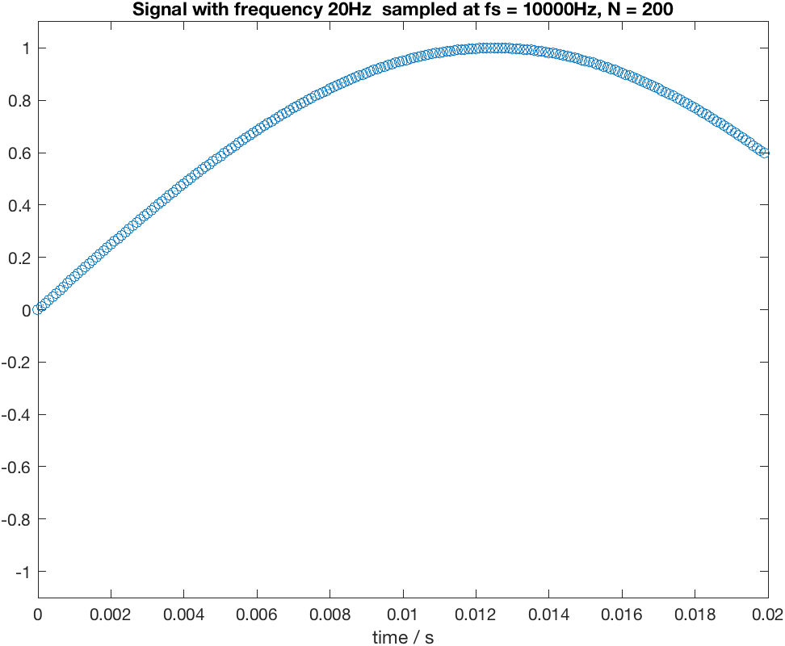
It is not possible to evaluate the signal because only a fraction of a period has been sampled.
A sampling window length of around 50 ms is a good choice.
Note: With fs = 48 kHz the number of samples for 50 ms is N = 2400. In this project, we will use the FFT (Fast Fourier Transform, an efficient algorithm for calculating the Discrete Fourier Transform). Although in general, FFT algorithms work for any integer signal length N, the optimized and very efficient FFT implementation provided by CMSIS library arm_rfft_fast_f32() requires an input length N to be a power of 2. (e.g., 32, 64, 128, …)

For a block length of N = 2048, the sampling window will be slightly shorter (42.7 ms). It is also possible to increase N to 4096 and apply zero padding.

