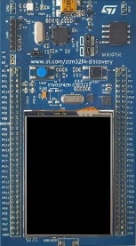

Microcontroller STM32F429
  - Used in the Electronics Projects 1 and 2

Abstract
The Electronics Projects are part of the electrical engineering curriculum at the Zurich University of Applied Sciences (ZHAW). The Electronics Projects 1 and 2 both use the STM32F429I-DISC1 (Discovery kit with STM32F429ZI MCU) as microcontroller system. The STM32F429ZI is an ARM Cortex M4F microcontroller with a 32-bit architecture and a programmer’s model that simplifies programming in C language. This document gives an overview of its architecture and explains how the peripherals can be accessed and configured. It discusses in more detail the GPIO (General Purpose Input Output) system and the associated interrupt handler. The display and touchscreen of the discovery kit are also covered. The abstraction layers CMSIS (Cortex Microcontroller Software Interface Standard), HAL (Hardware Abstraction Layer) and BSP (Board Support Package) are discussed using a GPIO example. After reading this introduction, an electrical engineering student should be able to understand the demo code provided by the lecturer and to start programming own code for their individual Electronics Projects.

Version 10.09.2025
Table of Content
Abstract 1
1. Microcontroller Architecture 3
1.1. Accessing and Controlling Peripherals 3
1.2. Clock Tree 3
1.3. HAL_Init(), SystemClock_Config() and HAL_Delay() 6
2. GPIO (General Purpose Input Output) 7
2.1. Block Diagram 7
2.2. GPIO Registers 9
3. Programmer’s Models: CMSIS - HAL – BSP 13
3.1. CMSIS (Cortex Microcontroller Software Interface Standard) 13
3.2. HAL (Hardware Abstraction Layer) 13
3.3. BSP (Board Support Package) 14
3.4. DSP (Digital Signal Processing) 14
3.5. Comparison and Recommendation: CMSIS-HAL-BSP 14
4. ISR (Interrupt Service Routine) 17
4.1. Configure the Interrupt 17
4.2. Interrupt Handler 21
4.3. Passing the Interrupt Flag to the Main Function 22
5. Display and Touchscreen 23
5.1. Display 23
5.2. Touchscreen 25
5.3. Touchscreen with Interrupt Event instead of Polling 25
6. How to start a new Microcontroller Project 26
6.1. Graphical Device Configuration Tool 26
6.2. Example Projects from Manufacturer 27
7. References 29

Microcontroller Architecture
The STM32F429 microcontroller has an ARM Cortex M4F central processing unit (CPU) with 32-bit architecture, floating-point unit (FPU), digital signal processing (DSP) instructions, 2MB flash memory for program code and 256MB RAM for variables.
Of the numerous peripherals general-purpose-input-outputs (GPIO), timers, analog-to-digital converters (ADC) are used in the Electronics Projects. The display and the touchscreen are accessed using the board support package (BSP) library provided by STmicro.
See the datasheet [1, p. 1] for a complete overview.
This document covers the microcontroller only as far as is required for the Electronics Projects.

Accessing and Controlling Peripherals
All the peripherals are accessed by writing to or reading from registers. From the programmer’s point of view this is done exactly as writing or reading the value of a variable.
Writing to a register configures the HW of the associated peripheral to do what is required.
Reading from a register gets status and data from the HW peripheral.
Important note: The clock for a peripheral must be enabled before it can be accessed. The idea behind that is to enable peripherals only when necessary, in order to minimize power consumption.
A description of the GPIO functionality and registers is in section 2 GPIO (General Purpose Input Output).
How to access the GPIOs programmatically is detailed in section 3 Programmer’s Models: CMSIS - HAL – BSP.
GPIO events and interrupts are explained in section 4 ISR (Interrupt Service Routine).

Clock Tree
The microcontroller has different clock domains that can run at different frequencies to suit best the requirements of the peripherals.
At power up the microcontroller starts with the High Speed Internal RC oscillator (HSI RC). The clock source can then be switched to the more precise High Speed External crystal oscillator (HSE).
The Low Speed External crystal oscillator (LSE) is used for the real time clock. The main purpose of the Low Speed Internal RC oscillator (LSI RC) is waking up from sleep modes.
The clocks are distributed by several multiplexers and clock gates, which must be set and enabled. PLL circuits (phase-locked-loop) multiply the base frequency and several dividers reduce the frequencies to appropriate values for the different circuit blocks.
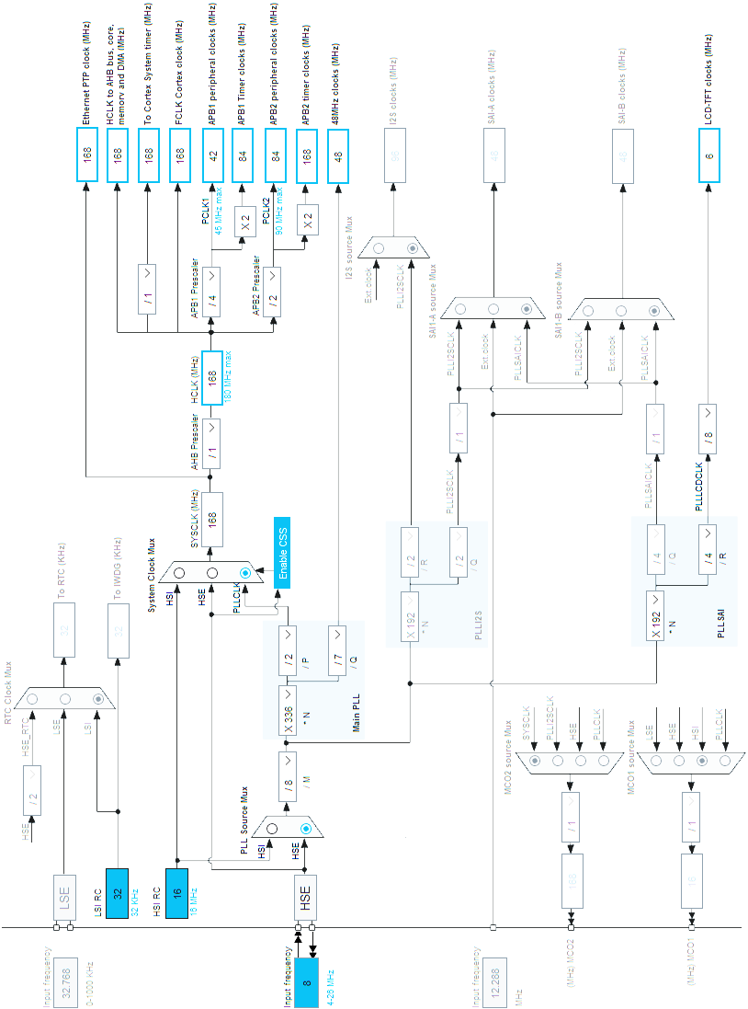
Figure 1: Clock tree as configured by SystemClock_Config() by the MX tool of STM32CubeIDE
Note: Power saving methods like reducing the clock frequency and using sleep modes with wake up by the real time clock are not covered here.

HAL_Init(), SystemClock_Config() and HAL_Delay()
At startup HAL_Init() configures the microcontroller for proper operation.
After that the clock system is usually initialized by calling SystemClock_Config(). This function sets the clock source, the PLL multiplication factors and the clock divider factors.
HAL_Delay(ms) waits for ms milliseconds.
The clock domains and frequencies relevant for the Cable-Monitor project as initialized by the provided demo code [2] are:
Clock domain | Frequency | Used for
HSE  High Speed External | 8 MHz crystal | Crystal oscillator
SYSCLK  System Clock | 168 MHz | Master clock
AHB  Advanced High-performance Bus | 168 MHz | CPU core  Memory  System timer  DMA  GPIO
APB1 peripheral clocks  Advanced Peripheral Bus 1 | 42 MHz | USART 2-5, 7-8  SPI 2-3  I2C 1-3  DAC
APB1 timer clocks | 84 MHz | TIM 2-7, 12-14
APB2 peripheral clocks  Advanced Peripheral Bus 2 | 84 MHz | SPI 1, 4-6  USART 1, 6  ADC 1-3
APB2 timer clocks | 168 MHz | TIM 1, 8-11
Table 1: Clock frequencies and domains after calling SystemClock_Config()

GPIO (General Purpose Input Output)
The General Purpose Input Output system is explained in detail because it is used in every microcontroller project and because all peripherals follow the same principle.
For a complete description, see the reference manual [3, p. 267].

Block Diagram
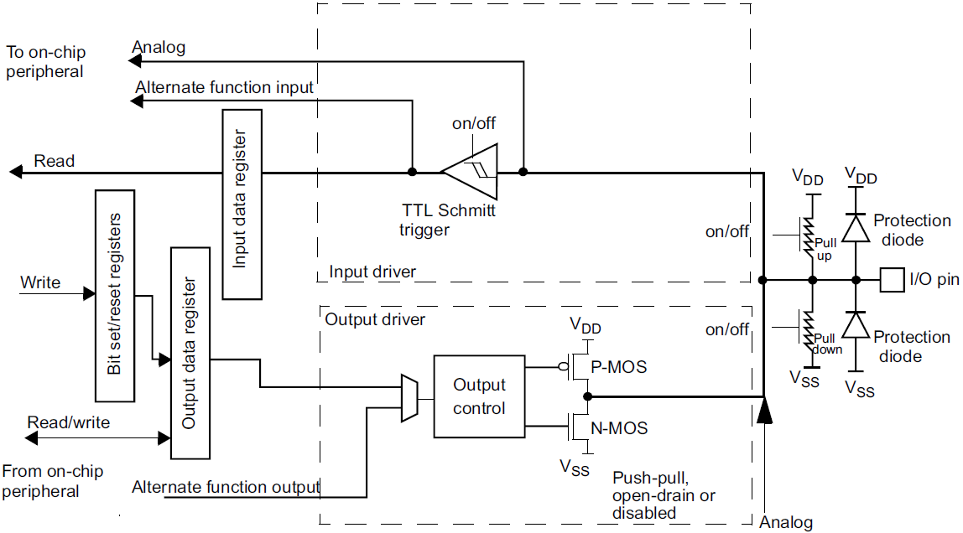
Figure 2: Basic structure of a General Purpose Input Output (GPIO) port bit [3, p. 268]
An I/O port pin can be used in different ways. Namely as
- Digital output
The output driver block (bottom in Figure 2) is active.
If the bit value in the output data register is 0 the N-MOS transistor is on. If the bit value is 1 the P_MOS transistor is on.
The output data register can be written directly, or the value can be changed by writing into the bit set/reset register.
It is possible to disable the P-MOS transistor to have open-drain functionality.
It is also possible to turn on pull-up or pull-down resistors.
- Digital input
The input driver block (top in Figure 2) is active.
The Schmitt trigger increased immunity against noise.
The bit value can be read from the input data register.
It is also possible to turn on pull-up or pull-down resistors.
- Alternate function output
The configuration is the same as for digital output. However, the bit value comes directly from a peripheral and not from the output data register.
Typical peripherals are Timer-PWM-output, serial interfaces like UART and SPI, specialized interfaces to displays or external memory, etc.
- Alternate function input
The configuration is the same as for digital input. However, the bit value goes directly to a peripheral.
Typical peripherals are pulse-counter-input, serial interfaces like UART and SPI, etc.
- Analog output
The digital blocks are disabled, and the output voltage of the Digital-to-Analog-Converter is directly routed to the port pin.
- Analog input
The digital blocks are disabled, and the input voltage is directly routed to the Analog-to-Digital-Converter.
The pins are organised in groups, called ports. The STM32F429 has up to 16 pins per port. The pins are labelled with a number, starting with “0”.
The ports are labelled with a character, starting with “A”. A “P” precedes the label.
Example: PD12 = Pin 12 of Port D.
It is possible to write or read all the 16 pins of a port with one single instruction. An unsigned integer with 16 bits represents the 16 pins.

GPIO Registers
This chapter explains the most often used registers of the GPIOs. All the registers with all the parameters are documented in the reference manual [3, p. 281 ff].
In section 3.5 Comparison and Recommendation: CMSIS-HAL-BSP code samples for configuring and controlling a GPIO output are given and compared for the different programmer’s models.
In this section the GPIO registers are listed and commented.
Figure 3: GPIO port mode register [3, p. 281]
Example: Writing ’01’ to bits 27 and 26 sets pin 13 as output.
GPIOG->MODER |= GPIO_MODER_MODER13_0;
Figure 4: GPIO port output type register [3, p. 281]
Example: Writing ‘1’ to bit 13 sets pin 13 as open-drain output (= upper transistor disabled)
GPIOG->OTYPR |= GPIO_OTYPR_OT13;
Note: Usually push-pull configuration is required. As this is the default at reset, it is seldom necessary to configure this register.
Figure 5: GPIO port output speed register [3, p. 282]
Note: Higher speed results in higher power consumption and may cause electro-magnetic compliance issues.
Figure 6: GPIO pull-up/pull-down register [3, p. 282]
Note: When no pull-up or pull-down is required, it is not necessary to configure this register.
Figure 7: GPIO port input data register [3, p. 283]
Bits 15 to 0 are the bit values of all the 16 pins of a port. Reading this register is like reading an unsigned integer variable.
Figure 8: GPIO port output data register [3, p. 283]
All the 16 bits can be written in the same way as an unsigned integer variable would be written. It is also possible to read this register to get the values of the output pins.
Figure 9: GPIO port bit set/reset register [3, p. 284]
If only one pin must be set or reset, this is preferred over writing all the 16 bits of the output data register.
Figure 10: GPIO alternate function registers [3, p. 285 f]
These registers are used for alternate functions such as PWM outputs, UART, SPI, etc.
The alternate function numbers are listed in the reference manual [3, p. 273] and in the datasheet [1, pp. 75 - 85]

Programmer’s Models: CMSIS - HAL – BSP
There are several programmer’s models for microcontrollers. Every model has its advantages and limitations. This chapter extracts the main features and differences and gives a recommendation on where to use which.

CMSIS (Cortex Microcontroller Software Interface Standard)
CMSIS is a common hardware abstraction layer for all the cortex-based microcontrollers. All (literally ALL) the registers of a peripheral are combined into a C struct. These structs are mapped to the register addresses by microcontroller specific initialisation files. Thus, it is possible to access the peripherals, etc. with talking C names instead of hexadecimal addresses.
The peripherals can be accessed using the following patterns:
peripheral->register = value; // Pseudocode
GPIOA->ODR = portA_out; // Write to OuputDataRegister of port A
GPIOB->BSRR = GPIO_BSRR_BS5; // Port B BitSetResetRegister Bit Set 5
value = peripheral->register; // Pseudocode
uint32_t portC_in = GPIOC->IDR; // Read InputDataRegister of port C
if (GPIOD->IDR & GPIO_PIN_9) { // Test pin 9 of port D
The CMSIS definitions can be found in the file stm32f429xx.h in the folder Drivers/CMSIS/Device/ST/STM32F4xx/Include
Additional definitions for bit-field manipulation are included in the file stm32f4xx.h on lines 212 to 226 in the same folder.

HAL (Hardware Abstraction Layer)
The purpose of the HAL is to hide the HW details from the program writer. The advantage is that the code is highly portable across microcontrollers of the same family. The disadvantage is that the HAL library code is quite complex and thus needs more execution time. Another disadvantage is that HW specific features might not be accessible, which can easily be solved by adding some lines of CMSIS code.
HAL_Delay(1000); // Wait for 1000ms, not depending on clock freq.
The documentation of the HAL is in the file STM32F423xx_User_Manual.chm in the folder Drivers/STM32F4xx_HAL_Driver

BSP (Board Support Package)
The BSP is a library that grants easy access to components on a specific evaluation board. The programmer just calls an initialisation function that configures all the involved peripherals and then accesses the components by high-level functions.
BSP_LCD_DrawRect(10, 5, 100, 30); // Draw a rectangle on the display
The documentation of the BSP is in the file STM32F429I-Discovery_BSP_User_Manual.chm in the folder Drivers/BSP/STM32F429I-Discovery

DSP (Digital Signal Processing)
Highly optimized functions are provided for different tasks. One of those is the DSP library for digital filtering, fast fourier transforms and more.
The documentation of the DSP library is in the file index.html in the folder Drivers/CMSIS/docs/DSP/html

Comparison and Recommendation: CMSIS-HAL-BSP
The different programmer’s models available for the microcontroller STM32F429 are discussed using the following example.
Turn on and off the green user LED3 on the evaluation board.
LED3 is connected on pin 13 of port G, called PG13. See schematic in user manual [4, p. 33].
Pseudocode:
Enable clock for port G
Configure PG13 as output
Turn on the LED
Wait for 1000ms
Turn off the LED
CMSIS:
__HAL_RCC_GPIOG_CLK_ENABLE(); // Enable clock for port G
GPIOG->MODER |= GPIO_MODER_MODER13_0; // Configure PG13 as output
GPIOG->BSRR = GPIO_BSRR_BS13; // Bit Set to turn LED on
HAL_Delay(1000); // Wait for 1000ms
GPIOG->BSRR = GPIO_BSRR_BR13; // Bit Reset to turn LED off
HAL:
__HAL_RCC_GPIOG_CLK_ENABLE(); // Enable clock for port G
#define LED3_PORT GPIOG // Port of LED3
#define LED3_PIN GPIO_PIN_13 // Pin of LED3
// Configure PG13 as output
GPIO_InitTypeDef GPIO_InitStruct;
GPIO_InitStruct.Pin = LED3_PIN;
GPIO_InitStruct.Mode = GPIO_MODE_OUTPUT_PP;
GPIO_InitStruct.Pull = GPIO_NOPULL;
GPIO_InitStruct.Speed = GPIO_SPEED_LOW;
HAL_GPIO_Init(LED3_PORT, &GPIO_InitStruct);
HAL_GPIO_WritePin(LED3_PORT, LED3_PIN, 1); // Turn on the LED
HAL_Delay(1000); // Wait for 1000ms
HAL_GPIO_WritePin(LED3_PORT, LED3_PIN, 0); // Turn off the LED
BSP:
__HAL_RCC_GPIOG_CLK_ENABLE(); // Enable clock for port G
BSP_LED_Init(LED3); // Configure PG13 as output
BSP_LED_On(LED3); // Turn on the LED
HAL_Delay(1000); // Wait for 1000ms
BSP_LED_Off(LED3); // Turn off the LED

Comparison
Model | CMSIS | HAL | BSP
Code size | Small | Large | Small
Speed | Fast | Medium | Slow
Portability | Medium  Changing peripherals implies adapting the register names, etc. | Good  Changing peripherals can often be done by updating a #define | Poor  because specific to one evaluation board
Functionality | Full control of all peripherals | Specific function of a peripheral might not be available | Only for components on one specific evaluation board
Readability | Names match register names of peripherals | Focus on functionality | Easy
Recommended | Only if microcontroller is defined | If portability is a priority | For components on the evaluation board

Recommendation: CMSIS-HAL-BSP
Use BSP for components on the evaluation board.
Use CMSIS to access peripherals because it matches exactly the registers.
Use HAL for functions, which are not directly related to peripherals.
The good news is that the code of the different programmer’s models can be mixed at any point because HAL and BSP finally call CMSIS.

ISR (Interrupt Service Routine)
Typically, the main function of a microcontroller program runs in an infinite while loop after initialisation. This while loop often measures sensor signals, processes the data, updates the display and goes into sleep mode for a fraction of a second.
At any time, the user may push a button, or a controller might send new parameters over a serial interface. These asynchronous events need immediate attention and must be processed with higher priority than the while loop.
That is where the concept of interrupts comes in. When such an event occurs, the currently executing code (while loop, sleep mode, display update, etc.) is interrupted and the interrupt service routine associated with the event is processed. After the interrupt service routine has terminated, code execution is resumed exactly where it was interrupted.
Because interrupt service routines temporarily stop execution of the normal code, they have to be short and should interfere with the main program only by setting flags or updating variables. To keep the system responsive, it is strongly discouraged to update the display or do extensive calculations within interrupt service routines.
Note: Because an interrupt may occur at any time, it is not so easy to debug this code. Setting a breakpoint in the interrupt service routine indicates that the interrupt has successfully been called. In the time needed to manually resume execution, other interrupts might have occurred, and the behaviour could be unexpected. Keeping code size small is thus very helpful.

How to configure and use an interrupt shall be explained in the next section with the example of a pushbutton, which toggles an LED when pushed.

Configure the Interrupt
The pushbutton on the evaluation board STM32F429I-DISC1 is connected to PA0.

Configure Pin 0 of Port A as Input
__HAL_RCC_GPIOA_CLK_ENABLE(); // Enable Clock for GPIO port A
GPIOA->MODER |= (0u << GPIO_MODER_MODER0_Pos); // Pin 0 port A = input
The second line could be omitted as the default configuration is «input». See section 2.2 GPIO Registers for details.

Route the Input Pin to the Interrupt Line
The next diagram shows that all pins with number 0 are routed to interrupt line 0, all pins with number 1 to interrupt line 1, etc. The multiplexer EXTIx defines the port.
Example: PD1 goes to interrupt line 1 if EXTI1 = 3 (because D is the 3rd port)
Note: For example, it is not possible to use external interrupts from PD1 and PE1 at the same time because the EXTI1 multiplexer can only select one of them at a time for interrupt line EXTI1. But it is possible to use PD1 and PD2 because they are routed to different interrupt lines.
Figure 11: External interrupt/event GPIO mapping [3, p. 383]
PA0 is routed to the interrupt line EXTI0 when the multiplexer EXTI0[3:0] bits in the SYSCFG_EXTICR1 register are set to ‘0000’.
__HAL_RCC_SYSCFG_CLK_ENABLE(); // Enable Clock for system config SYSCFG->EXTICR[0] |= SYSCFG_EXTICR1_EXTI0_PA; // EXTI multiplexer
Note: Mapping of SYSCFG_EXTICRx to SYSCFG->EXTICR[y] is as follows:
SYSCFG_EXTICR1 is mapped to SYSCFG->EXTICR[0] and configures pins 0 to 3
SYSCFG_EXTICR2 is mapped to SYSCFG->EXTICR[1] and configures pins 4 to 7
SYSCFG_EXTICR3 is mapped to SYSCFG->EXTICR[2] and configures pins 8 to 11
SYSCFG_EXTICR4 is mapped to SYSCFG->EXTICR[3] and configures pins 12 to 15
For details see the reference manual [3, p. 297 ff]. This step is a bit complex and must be configured carefully. Otherwise, the intended interrupt will not be routed correctly.

Configure and Enable the Interrupt
Several gates have to be enabled along the signal path from the input to the Nested Vectored Interrupt Controller (NVIC) according to the following block diagram.

Figure 12: External interrupt/event controller block diagram [3, p. 380]
«Input line» on the right side of the diagram is the interrupt line configured in section 4.1.2.
Enable the interrupt on the rising edge (voltage on pushbutton goes up, when pushed).
EXTI->RTSR |= EXTI_RTSR_TR0; // Rising Trigger Select on int. line 0
EXTI->IMR |= EXTI_IMR_MR0; // Interrupt Mask enable on int. line 0
Enabling the interrupt on the falling edge would be:
EXTI->FTSR |= EXTI_FTSR_TR0; // Falling Trigger Select on int line 0
EXTI->IMR |= EXTI_IMR_MR0; // Interrupt Mask enable on int. line 0
How interrupts and events are handled is described in the reference manual [3, p. 371 ff]
The EXTI registers are also covered in the reference manual [3, p. 384 ff]

Enable the Nested Vectored Interrupt Controller (NVIC)
Finally the interrupt line 0 has to be enabled in the NVIC which sits in the microcontroller core.
NVIC_ClearPendingIRQ(EXTI0_IRQn); // Clear pending interrupt on line 0
NVIC_EnableIRQ(EXTI0_IRQn); // Enable interrupt line 0 in the NVIC
Note: If only one of the steps is omitted the interrupt handler is never called. Finding the mistake might be quite difficult, because interrupt handlers are called out of order and it is not possible to step through the program or set a breakpoint like in normal code. This means it is very important to follow strictly the above steps and to carefully check the parameters. Even a minor typing or copy-paste error results in failure.
Put together, the code for configuring the interrupt on the rising edge on PA0 looks like
__HAL_RCC_SYSCFG_CLK_ENABLE(); // Enable Clock for system config SYSCFG->EXTICR[0] |= SYSCFG_EXTICR1_EXTI0_PA; // EXTI multiplexer
EXTI->RTSR |= EXTI_RTSR_TR0; // Rising Trigger Select on int. line 0
EXTI->IMR |= EXTI_IMR_MR0; // Interrupt Mask enable on int. line 0
NVIC_ClearPendingIRQ(EXTI0_IRQn); // Clear pending interrupt on line 0
NVIC_EnableIRQ(EXTI0_IRQn); // Enable interrupt line 0 in the NVIC

Interrupt Handler
The interrupt handlers have predefined names because they are always called by the Nested Vectored Interrupt Controller (NVIC). The names are defined in the file startup_stm32f429zitx.s in the folder Core/Startup.
void EXTI0_IRQHandler(void)
{
if (EXTI->PR & EXTI_PR_PR0) { // Check if interrupt on line 0
EXTI->PR |= EXTI_PR_PR0; // Clear pending int. on line 0
PB_pressed_flag = true; // Set flag
}
}
It is good practice to first check if the interrupt really came from the expected source. In the same manner it is possible to handle different interrupt sources in the same handler.
In this example, the code that has to be executed on interrupt consists only of setting a flag that will be further processed in the main function.
At last, the pending interrupt bit is cleared and the system is ready to receive another interrupt.
Note: Because interrupt service routines temporarily stop execution of the normal code, they have to be short and should interfere with the main program only by setting flags or updating variables. To keep the system responsive, it is strongly discouraged to update the display or do extensive calculations within interrupt service routines.

Passing the Interrupt Flag to the Main Function
When the code that is triggered by an interrupt is not very short, it should not be placed in the interrupt handler. The information is passed to the while loop in the main function by testing a flag which was set in the interrupt handler.
while (1) // Infinite loop in main function
{
if (PB_pressed()) { // Check if pushbutton pressed
BSP_LED_Toggle(LED4); // Do what has to be done
}
HAL_Delay(200); // Wait or sleep
}
The flag is retrieved and then reset in this function:
bool PB_pressed(void)
{
bool pressed = PB_pressed_flag; // Read/store value of flag
PB_pressed_flag = false; // Reset flag
return pressed; // Return value of flag
}

Display and Touchscreen
The simplest way to use the display and the touchscreen is to call the Board-Support-Package (BSP) functions.

Display
Code for initialisation:
BSP_LCD_Init();
BSP_LCD_LayerDefaultInit(LCD_FOREGROUND_LAYER, LCD_FRAME_BUFFER);
BSP_LCD_SelectLayer(LCD_FOREGROUND_LAYER);
BSP_LCD_DisplayOn();
BSP_LCD_Clear(LCD_COLOR_WHITE);
Writing onto the display:
BSP_LCD_SetFont(&Font16); ///< Possible font sizes: 8 12 16 20 24
BSP_LCD_SetBackColor(LCD_COLOR_WHITE);
BSP_LCD_SetTextColor(LCD_COLOR_BLACK);
BSP_LCD_DisplayStringAt(x, y, (uint8_t *)text, LEFT_MODE)
Drawing onto the display:
BSP_LCD_SetTextColor(LCD_COLOR_BLUE);
BSP_LCD_DrawLine(x1, y1, x2, y2);
BSP_LCD_FillRect(x, y, width, height);
The colours and functions are defined in the file stm32f429i_discovery_lcd.h in the folder Drivers/BSP/STM32F429I-Discovery as follows:
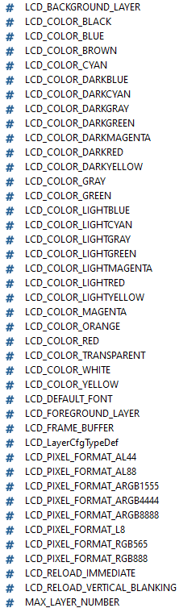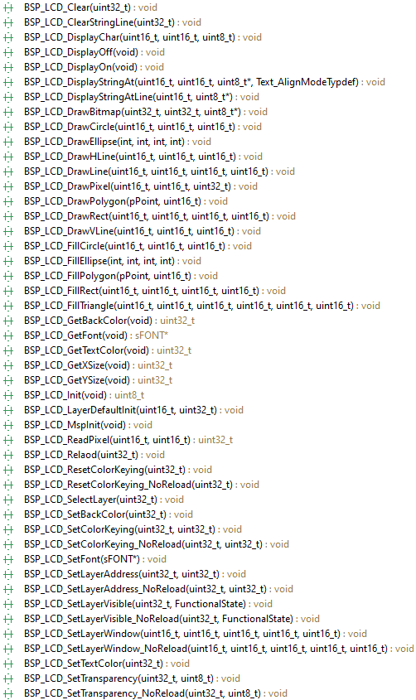

Touchscreen
The touchscreen is initialized by calling:
BSP_TS_Init(BSP_LCD_GetXSize(), BSP_LCD_GetYSize());
The touchscreen can be polled/checked periodically for user input with this code:
MENU_item_t MENU_get_transition(void)
{
MENU_item_t transition = MENU_NONE; // Default: no touch detected
static TS_StateTypeDef TS_State; // State of the touch controller
BSP_TS_GetState(&TS_State); // Get the state
if (TS_State.TouchDetected) { // If a touch was detected
if ((TS_State.X ...) && (TS_State.Y ...)) { // Touched where?
transition = ...; // Determine the touched menu item
}
}
return transition; // Return the touched menu item
}

Touchscreen with Interrupt Event instead of Polling
User input from the touchscreen can be checked by polling or by using an interrupt handler. If the user input should produce an event, the interrupt system must be configured:
BSP_TS_ITConfig(); // Enable touchscreen interrupt, if desired
The interrupt handler looks like this:
void EXTI15_10_IRQHandler(void) // Inter. handler ext. line 15-10
{
if (EXTI->PR & EXTI_PR_PR15) { // Check if touchscreen interrupt
if (BSP_TS_ITGetStatus()) { // Check touchscreen controller
; // @todo Put event code/flag here
BSP_TS_ITClear(); // Clear touchscreen controller i.
}
EXTI->PR |= EXTI_PR_PR15; // Clear pending inter. on line 15
}
}

How to start a new Microcontroller Project
In practice there are several ways to efficiently start a new microcontroller project.

Graphical Device Configuration Tool
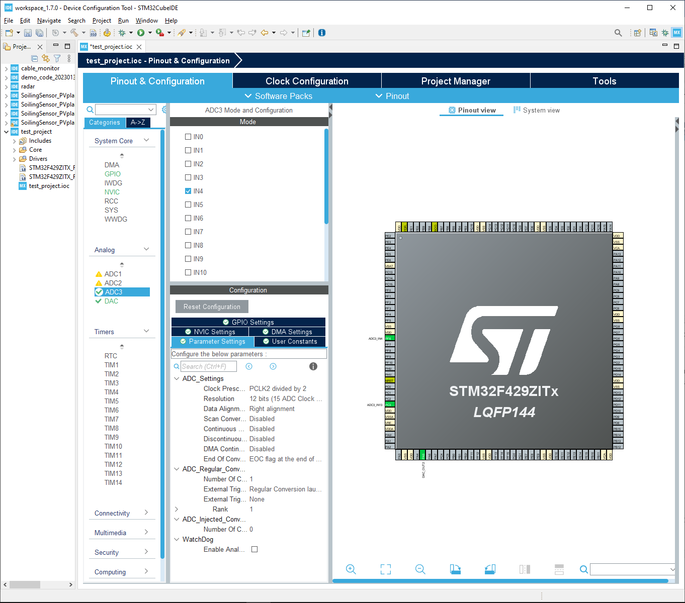
Figure 13: Device Configuration Tool for setting up the peripherals and the clock tree.
The advantage of this method is that the pinout and peripherals can be configured in a graphical tool. The code snippets for the clock tree and some peripherals can be copied into an own project.
The disadvantage is, that the tool generates bulky code, which is hard to read and understand, because it uses the HAL library excessively for compatibility reasons with other microcontrollers and boards. Furthermore, programmers must take care to place their code in dedicated user code sections to prevent it from being overwritten by code generated by the tool.

Example Projects from Manufacturer
A common way to learn the basics of a new microcontroller is to open example projects provided by the manufacturer. A good start is to look at an example which blinks the LED because it is simple enough and involves timer and GPIO configuration. Starting from here the code can be modified step by step.
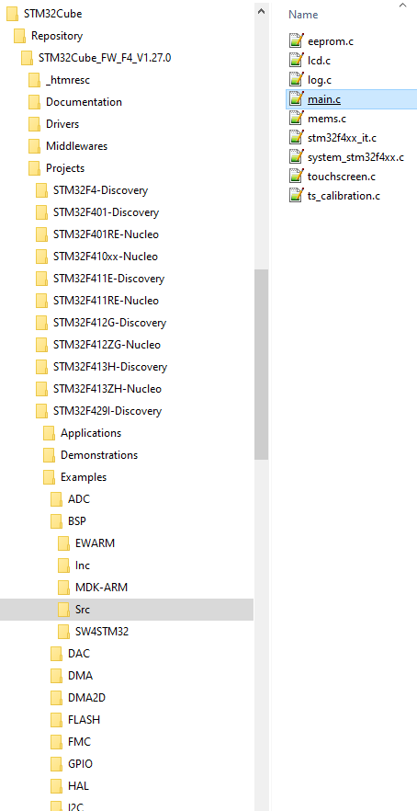
Figure 14: Path to the Board Support Package (BSP) example project which includes code for system clock, LED, pushbutton, LCDisplay and touchscreen on the Discovery board.
The advantage of this method is the code base which has been developed specifically for this microcontroller or board.

References

[1] | “STM32F429 Datasheet,” [Online]. Available: https://www.st.com search: DocID024030. [Accessed 20 01 2020].
[2] | H. Hochreutener, “Demo_Code,” May 2020.
[3] | “STM32f429 Reference Manual,” [Online]. Available: https://www.st.com search: RM0090. [Accessed 22 01 2020].
[4] | “User manual Discovery kit with STM32F429ZI MCU UM1670,” [Online]. Available: https://www.st.com search:UM1670. [Accessed 06 01 2020].
[5] | H. Hochreutener, “Base_Board,” March 2020.
[6] | H. Hochreutener, “Sensor_Board_Template,” March 2020.

