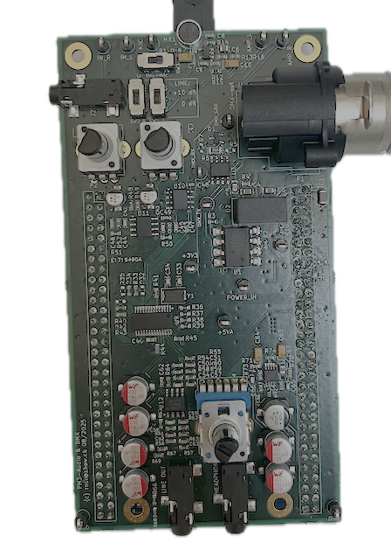

KiCad:
A Cross Platform and Open-Source Electronics Design Automation Suite

Abstract
During the PM3 and PM4 projects the students will develop their own electronic circuit which has to be implemented on a PCB. KiCad is the tool of choice because it integrates schematic capture, PCB layout and visualization in a simple to use tool which needs no prior training. And it is free open-source software. Students are provided with a template that contains the basic circuitry. This document demonstrates the KiCad features using this template.

Table of Content
1. Install KiCad and open the template 2
2. Schematic Capture 2
2.1. Electric Rule Check 3
3. PCB Layout 3
3.1. Design Rule Check 3
4. 3D Viewer 4

Version 1, 17.9.2025

Install KiCad and open the template
Download KiCad from https://www.kicad.org/ and install it with default settings.
Unzip HW_template.zip and open the project by double-clicking on the file HW_template.kicad_pro .
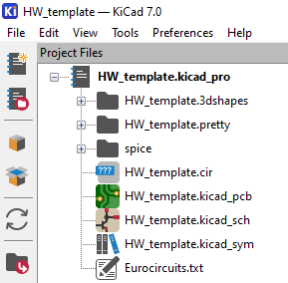

Schematic Capture
Double-click on HW_template.kicad_sch to open the schematic:
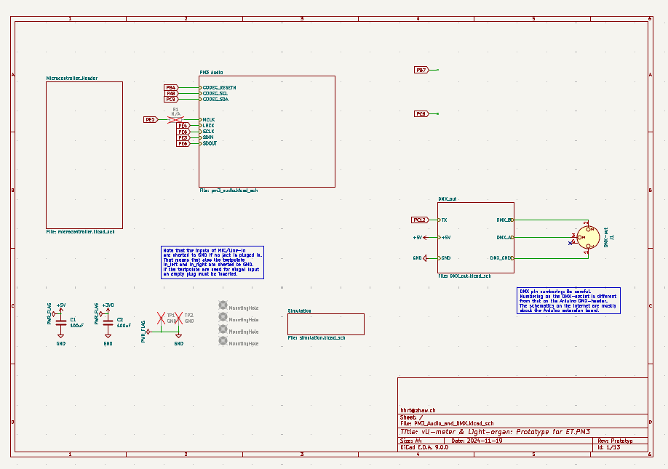
This is the top sheet in the hierarchy, with different sub-sheets (drawn as rectangles) such as the microcontroller connector, audio codec, and DMX components.
The idea is to modify the example circuits for the specific requirements of the project. New components can be selected with the library icon on the top right of the window.
Double-click on label, value, or component to modify its properties.
Wires with the same label are connected. To see what is connected use the highlight icon .
Tool tips are displayed whenever the mouse is moved over an icon. Moving the mouse over each icon is certainly a good way to explore the possibilities of the Schematic Editor.
To increase the visibility of the background grid , use the menu Preferences => Preferences… => Schematic Editor => Display Options => Grid Style => Small Crosses

Electric Rule Check
Before starting with the PCB layout and after modifying the schematic it is advisable to perform the electric rule check . Before ordering the PCB all the errors and warnings should disappear unless there is a good reason why the violation is acceptable.

PCB Layout
Once the schematic has been completed and the electric rule check has been successful the PCB layout can be invoked by clicking . Import the components to the board with .
Toggle the visibility here 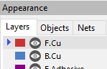 to make layouting and routing easier.
Tool tips are displayed whenever the mouse is moved over an icon. Moving the mouse over each icon is certainly a good way to explore the possibilities of the PCB Editor.

Design Rule Check
Make sure to update the PCB with changes made to the schematic by clicking on whenever changes have been made in the schematic.
Before the PCB layout is finished it is mandatory to perform the design rule check . Before ordering the PCB all the errors and warnings should disappear unless there is a good reason why the violation is acceptable.

The sizes in design rules of the template have been increases to a reasonable size. If, for some reason smaller sizes are required they can be adjusted in the PCB Editor by clicking on the menu item . However, the minimum sizes defined in https://www.eurocircuits.com/blog/kicad-design-rules/ must be observed for compatibility with the Eurocircuit Standard Services.

3D Viewer
The menu item View => 3D Viewer 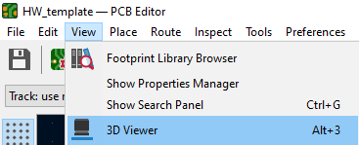 shows 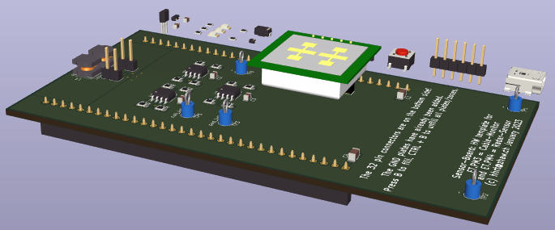The floating components in the background have not been placed yet.
Note that not all components have a 3D model included. Which ones have a 3D model can be checked in the Footprint Editor 

