

Electro-Static Discharge Protection

Abstract
Electronic devices are at risk of being damaged by Electro-Static Discharge (ESD). During production, grounding tools and workers provides a reliable protection. Fortunately, component manufacturers have greatly improved the integrated protection circuits. Only in rugged conditions or for inputs connected to long cables additional protection is required. Protection from lightning is a related topic but requires additional protection because of the higher energy level involved.

Table of Content
Abstract 1
1. Causes of ESD 2
2. ESD Protection in Production and Shipping 2
3. Models for ESD testing 2
4. ESD Maximum Ratings from Datasheet 3
5. Integrated ESD Protection Circuits 4
6. External ESD Protection 4
7. Protection against Overvoltage from Lightning 5

(c) Hanspeter Hochreutener, hhrt@zhaw.ch, 04.04.2020

Causes of ESD
Common sources are friction electricity and triboelectric charging caused by humans walking on a carpet or by rotating machines. The voltage can reach several kV.

Figure 1: Triboelectric charge.
Source: https://commons.wikimedia.org/wiki/File:Cat_demonstrating_static_cling_with_styrofoam_peanuts.jpg

ESD Protection in Production and Shipping
ESD prevention is based on avoiding charging materials and on grounding tools, anti-static mats and workers (with wrist straps). Special floors, humidity control and ionizers are often used in ESD protected areas.
Special package materials with adequate electrical resistivity are used for shipping.

Models for ESD testing
For reproducibly testing the ESD protection level, a normalized procedure had to be defined.
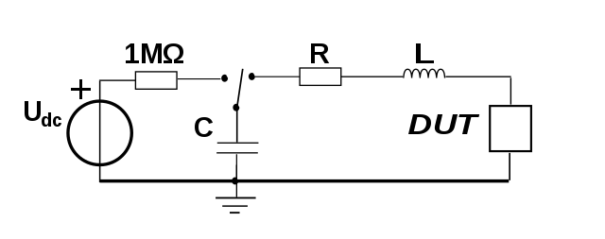
Figure 2: ESD test circuit for simulating an electro-static discharge
Source (25.02.2020): https://commons.wikimedia.org/wiki/File:ESD_Simulation_Models_incl._charging.svg
Human Body Model (HMB): A human body has a relatively high impedance and low capacitance. But the voltage might be above 10kV.
Charged Device Model (CDM): This is relevant during manufacturing. The capacitance and thus the energy are low. When all conducting surfaces and the workers are properly grounded, charged devices should not be an issue.
Machine Model (MM): The metal casing of a machine has high capacitance and low resistivity. No high voltages are expected here.
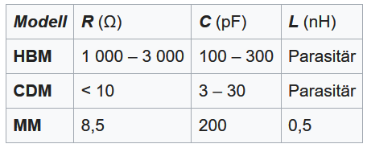
Figure 3: Parameters for the ESD test circuit
Source (25.02.2020): https://de.wikipedia.org/wiki/ESD-Simulationsmodelle

ESD Maximum Ratings from Datasheet
In the datasheets the safely manageable voltages are indicated for some ESD models as can be seen in the data sheet excerpts below.
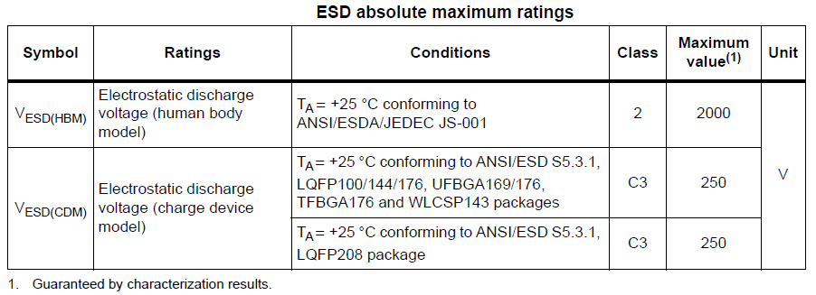
Figure 4: ESD protection level of microcontroller STM32F429. Source: Manufacturer datasheet
Figure 5: ESD protection level of operational amplifier OPA320. Source: Manufacturer datasheet

Integrated ESD Protection Circuits
The manufacturers of electronic components already integrate protection circuitry in their products. The basic principle is to protect the sensitive inputs by diodes connected to the plus and minus supply rails. Overvoltage at the pins is diverted to the supply rails which are low ohmic due to all attached transistors and blocking capacitors.
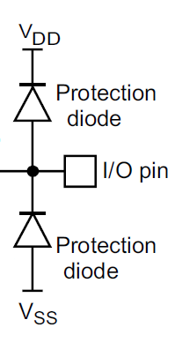
Figure 6: Basic ESD protection circuit of GPIO pins of the microcontroller STM32F429. Source: Reference manual
Protection of operational amplifier inputs is done in the same way. The outputs do not need special protection as an overvoltage turns on the output transistors which make a low ohmic connection to the supply rails.

External ESD Protection
For rugged conditions or inputs connected to long cables additional protection is required.
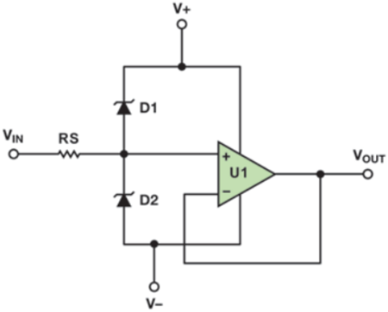
Figure 7: Recommended protection scheme for general purpose applications
Source: https://www.analog.com/en/technical-articles/key-benefits-of-input-overvoltage-protected-op-amps-in-systems.html
The external Schottky diodes can handle currents that are much higher than the 10mA typically allowed for the internal protection diodes. A bigger resistor value for RS increases the protection level. On the other hand, RS introduces thermal noise and adds errors due to the input current of the operational amplifier. The value must therefore be carefully chosen.

Protection against Overvoltage from Lightning
The main difference to overvoltage from frictional electricity is the enormous amount of energy contained in a lightning. Even if the lightning protection system conducts the energy safely to earth some overvoltage may still be induced in any metal conductor. The measures taken for ESD protection cannot handle a significant amount of energy and thus must be preceded by two other stages of protection.
As a first protection stage spark gaps or gas discharge tubes divert most of the incident energy to ground and limit the overvoltage to some hundred volts. Gas discharge tubes take a relatively long time to trigger and create an effective short circuit when triggered. They can conduct more current for their size than other components.
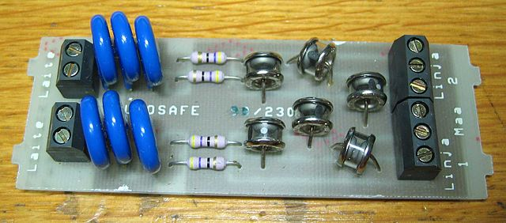
Figure 8: Gas discharge tubes to the right and varistors to the left as lightning protection in a telecom device.
Source (25.02.2020) https://commons.wikimedia.org/wiki/File:Lightningarrestor.jpg
As a second protection stage Voltage Dependant Resistors (VDR) or Transient Voltage Suppressors (TVS) are commonly used. They are fast but have limited power capabilities.
ESD protection circuits compose the third protection stage.
A circuit composed of these three stages provides a good protection level for indirect strokes of lightning.

