

Signal-Processing
  - Electronics Project 2: Radar-Sensor

Abstract
After passing successfully the HW test (preamplifier connected to a function generator) and the FW test (ADC input of microcontroller board connected to a function generator) everything is connected together, including the radar module. It might be, that the speed measurement from the doppler signal works not as good as expected respectively that it is difficult to see the speed of the target of interest. This document shows the problems that might occur and suggests possible solutions. As each group has a different HW and FW, however, things might look differently.

Table of Content
Abstract 1
1. Slow Drift on the Sampled Signals 2
2. Window on Sampled Signals 3
3. Highpass Filter 4

(c) Hanspeter Hochreutener, hhrt@zhaw.ch, 12.04.2021

Slow Drift on the Sampled Signals
This signal has been captured on a walkway with a pedestrian (walking towards the radar) and a bus passing (driving away from the radar). Red is the I channel, blue the Q channel:
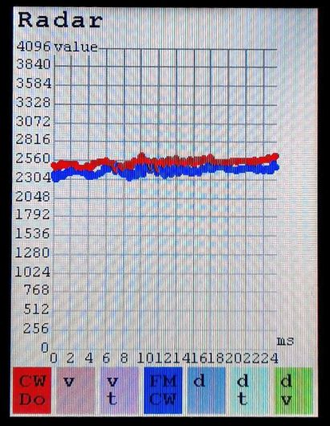
Clearly visible is that the DC-offset is not at 2047 as would be expected after a DC-decoupling capacitor. Additionally, this offset is drifting, which translates into a discontinuity of the input for the fourier transform as the signal is periodically repeated.
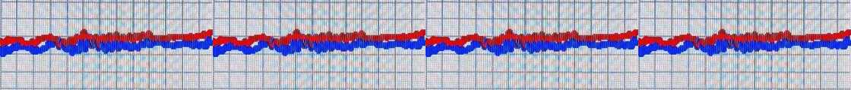Several causes could be at the origin: Slow movements of the radar itself or of objects such as trees, jitter of the radar carrier frequency, noise on the supply voltage.
The above signal translates to this spectrum (absolute values in dB for better discernability):
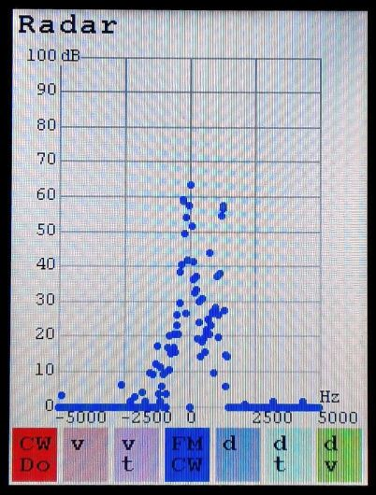
A lot of noise is present around 0Hz. The pedestrian is not visible in the spectrum and even the bus (at about 1200Hz) with its big radar cross section is below the noise.

Window on Sampled Signals
To solve the problem of the DC drift, a window is applied to the sampled signals in the time domain (in this case the window is a trapeze: /⁻⁻\ ) before the calculation the fast fourier transform. The signal now looks like this:
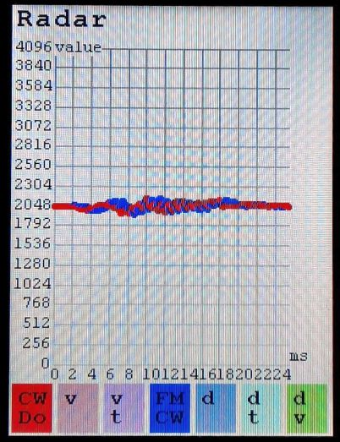
The discontinuity of the periodically repeated signal has vanished:
And the spectrum is much cleaner:
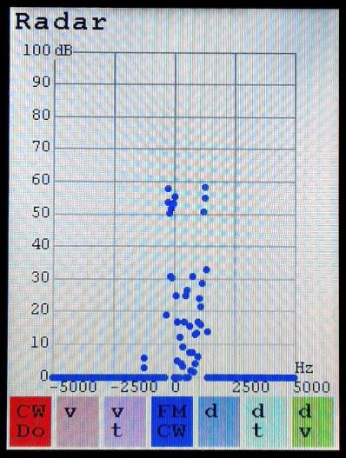
And even the pedestrian is clearly visible (at about 300Hz).
Around 0Hz a lot of noise is still present.

Highpass Filter
The noise around 0Hz can be attenuated by applying a highpass filter. This can be done at any stage of the signal processing path:
- Analog preamplifier: Chose a higher cutoff frequency for the DC decoupling and the highpass filters.
- Digital filter in the time domain: A digital FIR or IIR highpass filter can be applied to the samples before the fourier transform is calculated.
- Digital filter in the frequency domain: The frequency lines in the spectrum can be set to 0 or weighed with a frequency dependant factor.
With a linear weighing of the +-10 lowest frequency lines the spectrum is:
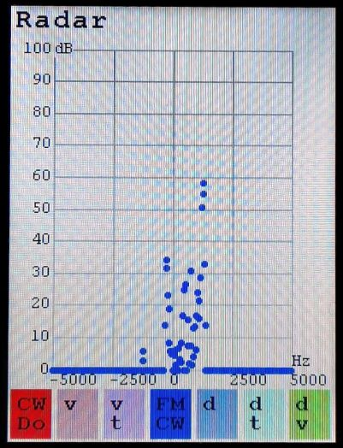
Now it is easy to find the doppler frequencies of the pedestrian and of the bus and calculate the corresponding speeds.

