**3.1 Reflection of NLID in EEG signals**

EEG signals are inherently highly nonstationary and influenced by both synchronous and asynchronous dynamics across multiple brain regions. When higher-dimensional phase space reconstruction is performed, increasing time delays lead to a gradual dispersion of interregional interaction structures, thereby weakening cross-regional nonlinear coupling. In this study, the observed decrease in NLID values with increasing embedding dimension and time delay reflects the fragile nature of EEG interactions in nonlinear space, where coupling strength tends to diminish as temporal unfolding progresses (Fig 1).

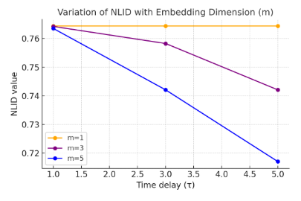

Fig1 NLID(F7|F8) dimensions and delay time changes in EEG

**3.2 The reflection of NLID in ECG signals**

In this study, a single ECG waveform was used as an example for analysis. The signal was segmented into different time windows: the first segment included the complete waveform, the second segment covered 0.05 s to the end, the third 0.10 s to the end, and so on, progressively shifting the starting point forward. NLID values were calculated for each segment to observe their trends. The results showed that NLID is sensitive to ECG waveform features: when the R wave appeared, NLID decreased(Fig 1),

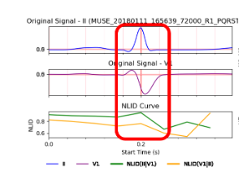

Fig.1 NLID application in ECG changes

The results of this study indicate that as the embedding dimension m increases, the NLID value rises with increasing time delay τ, particularly significantly when m=5. When m=1, the NLID value remains unchanged regardless of t variations. As the embedding dimension increases, NLID can account for more delay coordinates, thereby capturing higher-order nonlinear interactions between leads. Electrocardiographic signals from different leads exhibit temporal correlations and cross-regional dynamic characteristics in nonlinear space, and NLID amplifies these differences more effectively through higher embedding dimensions (Fig 2).

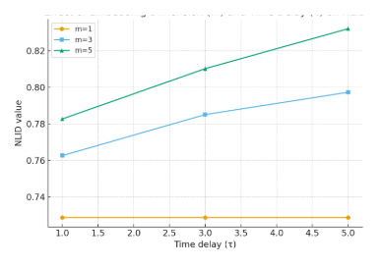

Fig2 NLID(II|V1) dimensions and delay time changes in ECG

**3.3 NLID in ECG and respiratory signals**

Combining both ECG and respiratory signals, differences can be seen depending on the direction of analysis. For the channels ECG|RESP, NLID values are high at low embedding dimensions and small delays, representing the strong and immediate influence of respiration on heart activity through Respiratory Sinus Arrhythmia (RSA). However, with increasing Embedding Dimension m and time delay τ, the values decrease, as the direct interaction becomes diluted and less dominant in higher-dimensional reconstructions(Fig 3).

In contrast, the channels RESP|ECG start at lower values but increase with larger m and τ, indicating that delayed and weaker influences of cardiac activity on respiration become detectable(Fig 4).

This asymmetry demonstrates NLID methods ability to capture not only instantaneous interactions, but also delayed, direction-specific interactions in a physiologically meaningful way.

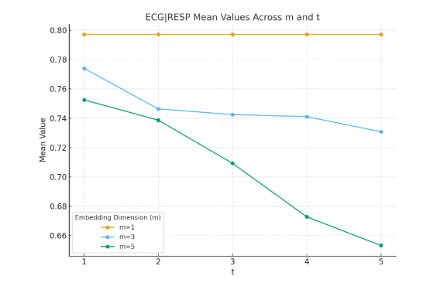

Fig3 Mean coupling (ECG→RESP) across embedding dimensions (m=1,3,5) and delays (t=1–5)

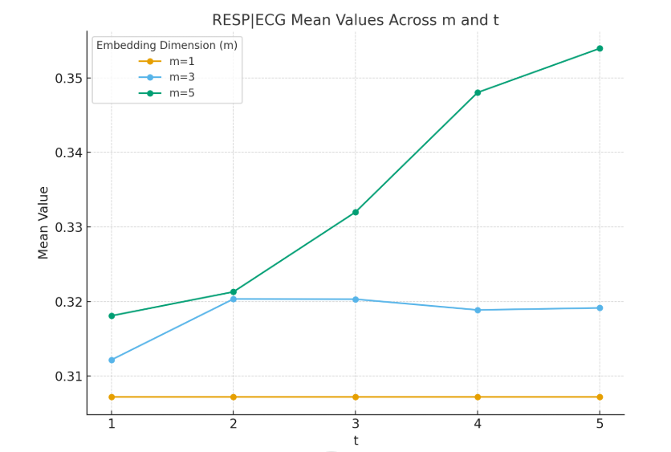

Fig4 Mean coupling (RESP→ECG) across embedding dimensions (m=1,3,5) and delays (t=1–5)

**3.4 The reflection of NLID in Eye Tracker signals**

In eye-tracking signals, the horizontal (X) and vertical (Y) gaze coordinates were analyzed as two channels, and their NLID values were used to assess interaction dynamics. Results showed that concentrated gaze points yielded higher NLID scores. Statistical analysis further revealed significant decreases under fatigue: NLID(X|Y) declined from 0.736 ± 0.185 to 0.654 ± 0.182 (p = 0.013), and NLID(Y|X) from 0.747 ± 0.151 to 0.698 ± 0.155 (p = 0.030). These findings suggest that fatigue weakens the nonlinear coupling between horizontal and vertical gaze coordinates.

The results show that as the time delay (τ) increases, NLID values gradually decrease, and higher embedding dimensions (m) yield lower overall NLID values, indicating that cross-channel nonlinear interactions become weaker in higher-dimensional spaces(Fig 5).

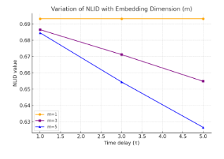

Fig 5 NLID(X|Y) eye tracker m and t changes