Nonlinear Inter-Driven Algorithm Description
Nonlinear Inter-Driven (NLID) analysis quantifies the interaction strength between two nonlinear systems.This method is built upon the theories of Phase-Space Reconstruction (PSR) and Recurrence Plot (RP) analysis,allowing the assessment of nonlinear causal influence and mutual interdependence between two dynamic systems without relying on linear assumptions.Unlike traditional spectral or linear correlation analyses, NLID reveals the nonlinear coupling characteristics of system states over time evolution,making it particularly suitable for chaotic and nonstationary physiological signals(Lin, 2023; Wang, 2020)The computational process of NLID is illustrated in Figure 1.
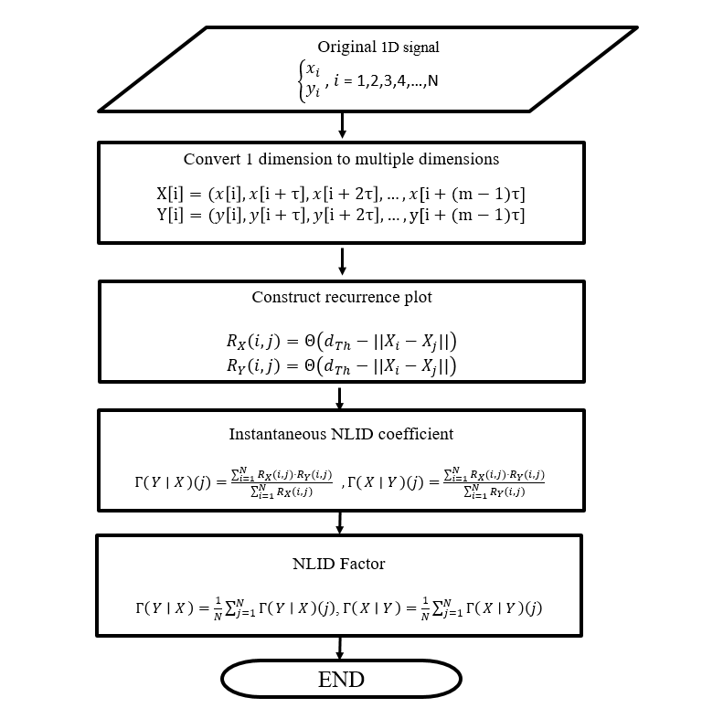
Figure 1 NLID calculation process

Converting one-dimensional time series to multi-dimensional phase space

X[i], it can be converted into a multi-dimensional phase space point by setting the time delay and embedding dimension. This conversion is based on phase space reconstruction theory, and the formula is as follows:
$X\left[i\right]=(X\left[i\right],X\left[i+τ\right],X\left[i+2τ\right],…,X[i+(m-1)τ]$ (1)
Where:
- $X\left[i\right]$is the current value of the time series.
- $X\left[i+τ\right]$is the value obtained by shifting the series forward by τ time units.
- $X\left[i+2τ\right]$ is the value obtained by shifting the series forward by 2τ time units.
This phase space trajectory preserves the key topological invariants of the original system. Here, τ represents the time delay. The magnitude of the time delay determines the geometric characteristics of the phase space trajectory and the evolution of the system dynamics. If τ is too small, highly correlated or overlapping information may appear between different coordinates; if τ is too large, it may cause distortion in the shape of the reconstructed trajectory. Figure 2 illustrates the process of mapping time series to phase space trajectories. For instance, with τ=5 and m=3, setting X[i]=0 at time delays τ and 2τ yields corresponding points x[i+τ]=0.82 and x[i+2τ]=0.94. These three values form a three-dimensional coordinate point X = (X = 0, Y = −0.82, Z = 0.94). As it increases, a series of multidimensional points is generated. Connecting these points constitutes the phase space trajectory, which describes the structure and dynamic behavior of the time series data. Through this process, the original one-dimensional time series is transformed into a trajectory in m-dimensional space, representing the evolutionary path of the system across different states.
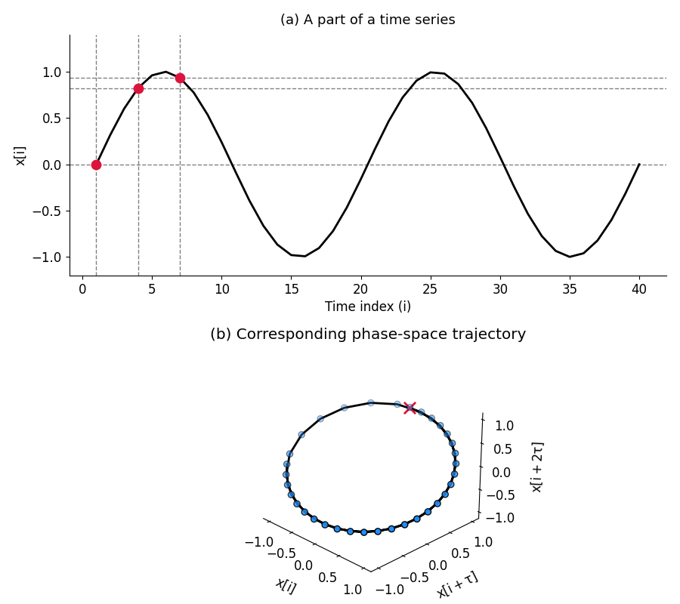
Figure 2 Schematic diagram of converting a one-dimensional time series to a multidimensional phase space

Calculation of Recurrence Plots (RP)
Given a dataset$X={\{X\}}_{i=1}^{N}$ consisting of m-dimensional phase space points, the reproduction graph$R(i,j)$ is an N×N binary matrix used to describe the reproduction relationship between two points in the phase space trajectory. It is defined as follows:
$R(i,j)=Θ(d_{TH}-‖X_{i}-X_{j}‖)$ (2)

- $Θ$ [⋅] is the Heaviside function, used to determine whether a condition is satisfied.
- $d_{TH}$ is the dynamic threshold.
- $‖X_{i}-X_{j}‖$is the Euclidean distance between system states Xi and Xj.
When $‖X_{i}-X_{j}‖$<$d_{TH}$, $R(i,j)$=1, indicating that a recurrence event occurred between i and j.
When the distance between Xi and Xj is less than the threshold $d_{TH}$,, it is considered a “recurrence event” in the phase space trajectory, meaning the system exhibits similar dynamic states at two time points i and j. $R(i,j)$=1. Typically, $d_{TH}$is set to 10%. Figure 4 shows the recurrence plot results after converting a sine wave into phase space. This indicates a highly periodic signal, representing a nearly perfectly regular system. However, eye movement signals are random signals. Therefore, recurrence events exhibit a random distribution, lacking diagonal and vertical line structures, indicating that the system lacks clear determinism and predictability.(Refer to Figure 3)
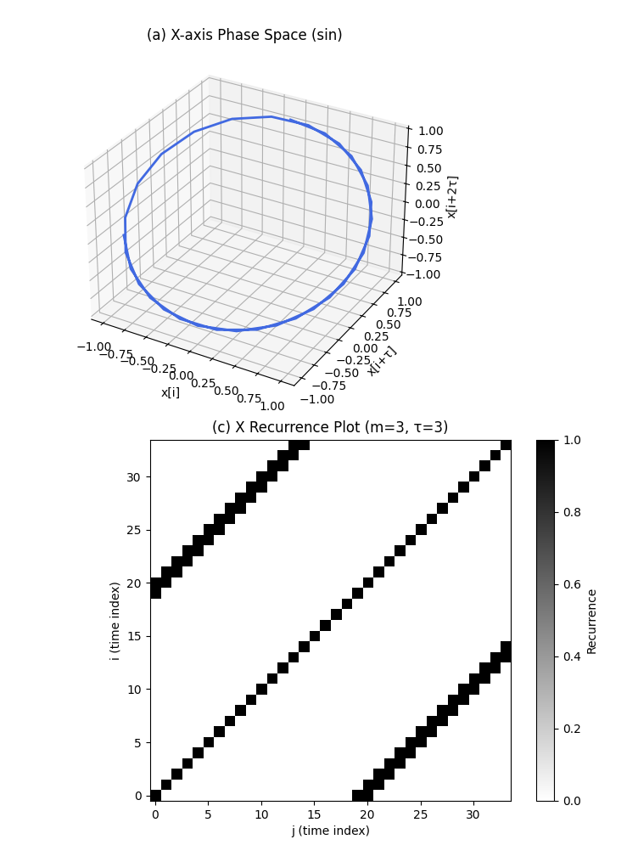
Figure 3 Sine Wave Recurrence Plot

Calculation of NLID factors
The NLID method quantifies the strength of nonlinear interactions between two systems through a reconstruction map. Assuming that X and Y represent the phase space trajectories of two channels, respectively, their reconstruction maps are.
- $R_{X}\left(i,j\right)$: Re-projection matrix for channel X
- $R_{Y}\left(i,j\right)$: Re-projection matrix for channel Y

$Γ\left(Y ∣ X\right)\left(j\right)=\frac{\sum_{i=1}^{N}{R_{X}\left(i,j\right)}⋅R_{Y}\left(i,j\right)}{\sum_{i=1}^{N}{R_{X}\left(i,j\right)}}$ (3)
Where:
- The numerator represents the degree of overlap between the j the column of the two reproduction images.
- The denominator represents the reproduction weight of channel X.
To describe the overall driving force of channel X on channel Y, take the average value of $Γ\left(Y ∣ X\right)$ (j) over the entire time range to obtain:
$Γ\left(Y ∣ X\right)=\frac{1}{N}\sum_{j=1}^{N}{Γ\left(Y ∣ X\right)\left(j\right)}$ (4)

- $Γ\left(Y ∣ X\right)\left(j\right)$ =1: The behavior of the two systems is completely identical.
- $Γ\left(Y ∣ X\right)\left(j\right)$ =0: The two systems are completely independent, with no correlation or mutual influence.
- $Γ\left(Y ∣ X\right)\left(j\right)$ is a value between 0 and 1: System X has a partial influence on system Y, and there is a certain degree of nonlinear interaction.

