| **Team Number** | 8 | **Section** | 05 |
| --- | --- | --- | --- |
| **Team Members** | 1. Hoang Tuan Anh Vu 2. Ali Cigdemoglu 3. Tommy Agarwal | | |
| **Software Name** | **Password Manager** | | |

## Problem Statement

The problem is that people need a safe, reliable, easy-to-use, password management program that securely stores their login information to various places. This program must allow multiple users to create an account, store their passwords/login/account information, and implement the proper security measures to keep that information safe.

## Functional Requirements

This product has these features:

1. Users can sign up/login/reset to their account
2. Users can access/modify/copy of all of their account information
3. The application will generate safe passwords based on a given criteria
4. Users can search for their account info based on username or website
5. Passwords will be encrypted/decrypted before retrieving

## References

## None

## 4.Use Cases

| **Use Case Name** | | LOGIN | |
| --- | --- | --- | --- |
| Goal | | | |
| User logs in to their account | | | |
| Participating Actors | | | |
| User, System | | | |
| Glossary | | | |
| Master Password: The password for the Password Manager application  Master Username: The username for the Password Manager application | | | |
| Primary Flow of Events | | | |
| Trigger | | | |
| The user runs the application | | | |
| **Steps** | **Action** | | **System Response** |
| 1 | Run the application | | Show the Home page. |
| 2 | User enters their master username and master password | |  |
| 3 | User clicks the login button | | Verifies the username and password and switches from the login screen to the dashboard |
| 4 |  | | Notifies the user of any expired passwords |
| Alternate Flow of Events | | | |
| **Alternate Trigger** | | | |
| User enters the wrong master username or master password | | | |
| **Steps** | **Action** | | **System Response** |
| 1 |  | | The program shows an error message telling the user that the login information is incorrect |
| 2 | User re-inputs their login information | |  |

| **Use Case Name** | | SIGN UP | |
| --- | --- | --- | --- |
| Goal | | | |
| This use case shows how the user signs-up and creates their account | | | |
| Participating Actors | | | |
| User, System | | | |
| Glossary | | | |
| Master Password: The password for the Password Manager application  Master Username: The username for the Password Manager application | | | |
| Primary Flow of Events | | | |
| Trigger | | | |
| User runs the application and clicks sign-up button | | | |
| **Steps** | **Action** | | **System Response** |
| 1 | User clicks sign-up | | Switch from the login page to the sign-up page |
| 2 | User enters their master username | |  |
| 3 | User enters their master password | |  |
| 4 | User chooses their security question and provides the response | |  |
| 5 | User clicks submit | | Switch from the sign-up page to the login page where the user can enter their new login information |
| Alternate Flow of Events | | | |
| **Alternate Trigger** | | | |
| User enters an already existing username | | | |
| **Steps** | **Action** | | **System Response** |
| 1 |  | | Program displays an error message informing the user that the username belongs to an existing account |
| 2 | User tries again with a different username | |  |

| **Use Case Name** | | RESET PASSWORD | |
| --- | --- | --- | --- |
| Goal | | | |
| This use case shows the reset password process. | | | |
| Participating Actors | | | |
| User, System. | | | |
| Glossary | | | |
| Master Password: The password for the Password Manager application  Master Username: The username for the Password Manager application | | | |
| Primary Flow of Events | | | |
| Trigger | | | |
| User runs the application then clicks the reset password button | | | |
| **Steps** | **Action** | | **System Response** |
| 1 | User clicks the reset password button | | Switches from the login screen to the password recovery screen |
| 2 | User enters their master username and clicks next | | If the system does not recognize the username, display an error message (eg. Account does not exist with the given username, please re-enter or create an account)  If the username is recognized, show the security question |
| 3 | User answers the security question that was set during the sign-up process and clicks submit | | Shows to the reset password text box |
| 4 | User enters their new master password and clicks submit | | Switches from the reset password |
| Alternate Flow of Events | | | |
| **Alternate Trigger** | | | |
| User enters the wrong security answer | | | |
| **Steps** | **Action** | | **System Response** |
| 1 |  | | Program displays an error message informing the user that their security answer is incorrect |
| 2 | User tries again | |  |

| **Use Case Name** | | STORE ACCOUNT INFO | |
| --- | --- | --- | --- |
| Goal | | | |
| User can store usernames/passwords for their various accounts across the internet | | | |
| Participating Actors | | | |
| User, System. | | | |
| Glossary | | | |
| Password: The password of their account, NOT the password for the actual Password Manager application  Username: The username of their account, NOT the username for the actual Password Manager application | | | |
| Primary Flow of Events | | | |
| Trigger | | | |
| Runs the application, logs in, and clicks Add-Account-Info button | | | |
| **Steps** | **Action** | | **System Response** |
| 1 | Run the application and logs into their account | | Switch from the login page to the dashboard |
| 2 | Clicks the Add Account Info button | | Switch from the dashboard to the Add-Account-Info page |
| 3 | The user enters the website/application name, their username, and their password | |  |
| 4 | Then, the user clicks the submit button | | Switches from the Add-Account page to the dashboard |
| Alternate Flow of Events | | | |
| **Alternate Trigger** | | | |
| User leaves the fields blank | | | |
| **Steps** | **Action** | | **System Response** |
| 1 |  | | The system displays an error message which prompts the user to enter some information for their new account |
| 2 | User tries again | |  |

| **Use Case Name** | | GENERATE PASSWORD | |
| --- | --- | --- | --- |
| Goal | | | |
| Shows how the user can generate a new password for one of their accounts | | | |
| Participating Actors | | | |
| User, System. | | | |
| Glossary | | | |
| Password: The password of their account, NOT the password for the actual Password Manager application | | | |
| Primary Flow of Events | | | |
| Trigger | | | |
| The user logs in, clicks on one of their accounts, and clicks the Generate New Password button | | | |
| **Steps** | **Action** | | **System Response** |
| 1 | The user logs in | | Goes from the login page to the dashboard |
| 2 | The user clicks on one of their accounts | | Goes from dashboard to the View-Account page |
| 3 | The user clicks the Generate New Password button | | Shows the Generate New Password page |
| 4 | The user can set the criteria/requirements for the newly generated password (length, numbers, capital letters, special characters) as well as the expiration date of the password | |  |
| 5 | Once the user finishes setting the criteria, they click submit | | Goes back to the View-Account page |
| Alternate Flow of Events | | | |
| **Alternate Trigger** | | | |
| N/A | | | |

| **Use Case Name** | | COPY TO CLIPBOARD | |
| --- | --- | --- | --- |
| Goal | | | |
| This use case shows the user copying one of their passwords to the clipboard | | | |
| Participating Actors | | | |
| User, System. | | | |
| Glossary | | | |
| Password: The password of their account, NOT the password for the actual Password Manager application | | | |
| Primary Flow of Events | | | |
| Trigger | | | |
| The user runs the application, logs in to their account, and clicks the Copy-Password button | | | |
| **Steps** | **Action** | | **System Response** |
| 1 | The user logs in to their account | | Switch from the login screen to the dashboard |
| 2 | The user clicks on the Copy-Password button | | The password is copied to their clipboard and they can paste it wherever they want |
| Alternate Flow of Events | | | |
| **Alternate Trigger** | | | |
| N/A | | | |

| **Use Case Name** | | SEARCH | |
| --- | --- | --- | --- |
| Goal | | | |
| The user can search their account info based on the website OR the username | | | |
| Participating Actors | | | |
| User, System. | | | |
| Glossary | | | |
| Username: The username of their account, NOT the username for the actual Password Manager application | | | |
| Primary Flow of Events | | | |
| Trigger | | | |
| User runs the application, logs in, and enters either their username or the account website via the search bar | | | |
| **Steps** | **Action** | | **System Response** |
| 1 | The user runs the application and logs in | | Goes from the login screen to the dashboard |
| 2 | The user clicks on the search bar and starts typing | | Their list of account information is filtered and it finds a match based on what the user puts into the search bar |
| Alternate Flow of Events | | | |
| **Alternate Trigger** | | | |
| User searches for non-existing account | | | |
| **Steps** | **Action** | | **System Response** |
| 1 |  | | The list of passwords disappears because no accounts match the search criteria |

| **Use Case Name** | | MODIFY ACCOUNT INFO | |
| --- | --- | --- | --- |
| Goal | | | |
| User can edit account into for their various accounts that are stored in Password Manager | | | |
| Participating Actors | | | |
| User, System. | | | |
| Glossary | | | |
| Username: The username of their account, NOT the username for the actual Password Manager application  Password: The password of their account, NOT the password for the actual Password Manager application | | | |
| Primary Flow of Events | | | |
| Trigger | | | |
| The user runs the application, logs in, and clicks the Edit Account Info button | | | |
| **Steps** | **Action** | | **System Response** |
| 1 | The user runs the application and logs in | | Go from login screen to the dashboard |
| 2 | The user clicks on the Edit Account Info button (next to the view account info and copy password buttons) | |  |
| 3 | The user can edit their username, password, and website/application name | |  |
| 4 | When they are finished editing, they can click submit | | Goes back to the dashboard |
| Alternate Flow of Events | | | |
| **Alternate Trigger** | | | |
| User enters an existing account username and website | | | |
| **Steps** | **Action** | | **System Response** |
| 1 |  | | Program displays an error message informing the user that an account with the same username/website already exists |
| 2 | User tries again | |  |

| **Use Case Name** | | LOGOUT | |
| --- | --- | --- | --- |
| Goal | | | |
| The user can log out of their account | | | |
| Participating Actors | | | |
| User, System. | | | |
| Glossary | | | |
| Master Password: The password for the Password Manager application  Master Username: The username for the Password Manager application | | | |
| Primary Flow of Events | | | |
| Trigger | | | |
| The user clicks the logout button | | | |
| **Steps** | **Action** | | **System Response** |
| 1 | The user runs the application, and logs in using their master password/username | | Goes from login screen to the dashboard |
| 2 | The user clicks the logout button | | Goes from dashboard back to the login screen |
| Alternate Flow of Events | | | |
| **Alternate Trigger** | | | |
| N/A | | | |

## 5.Mockups

**Login Page:**

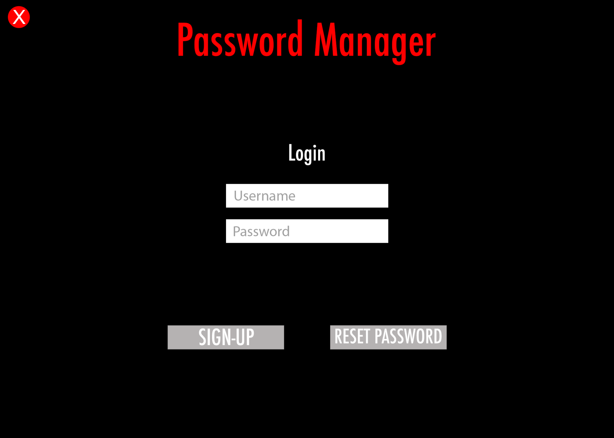

**Sign-up Page:**

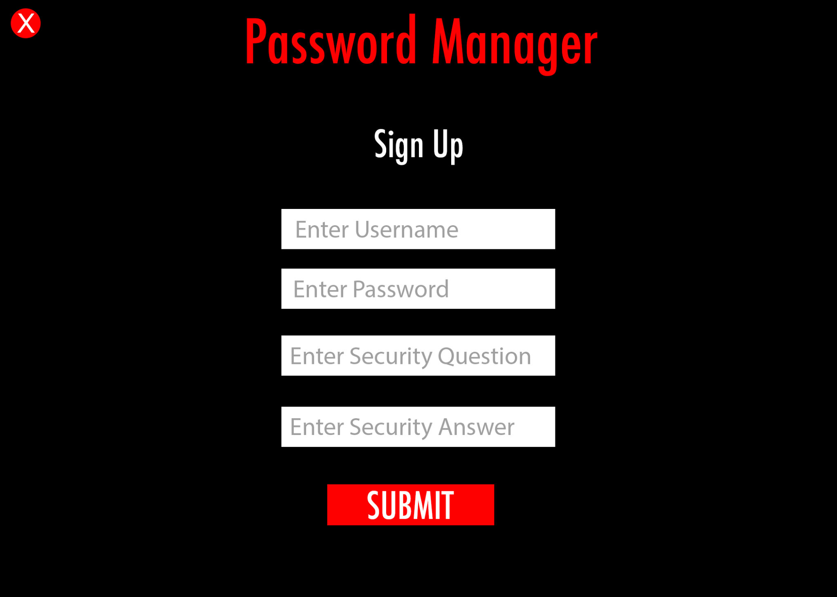

**Reset Password:**

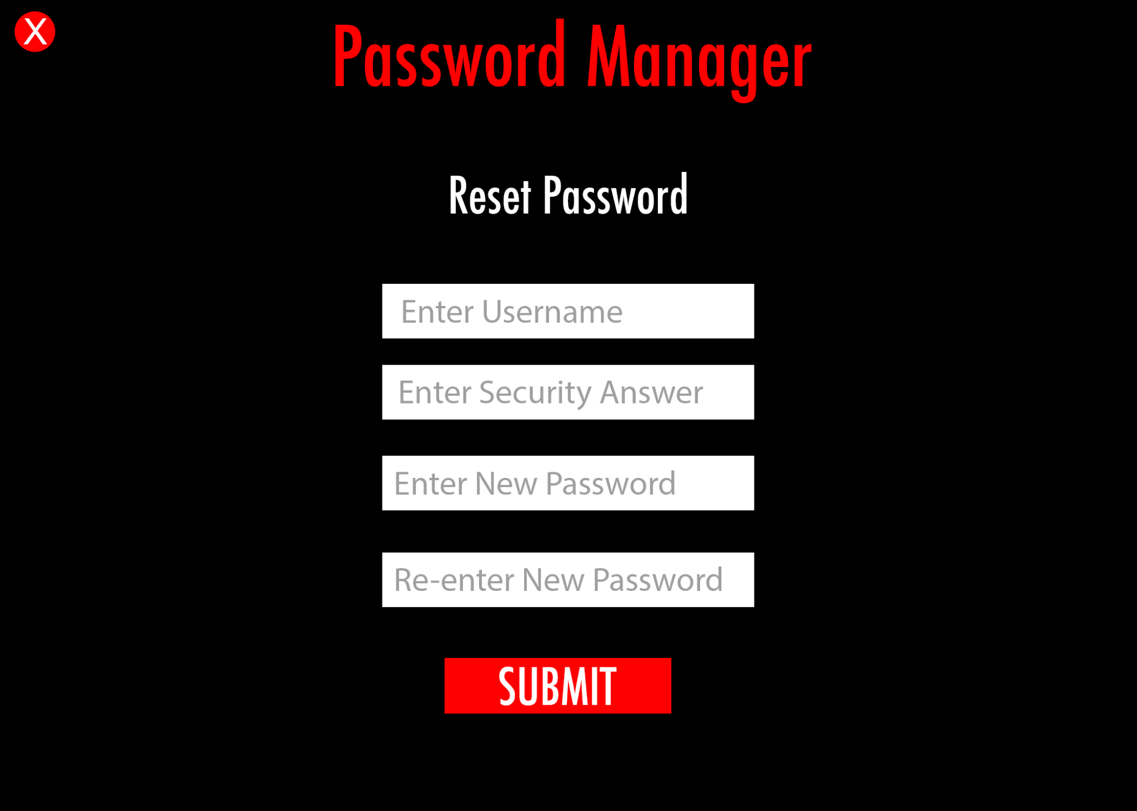

**Dashboard:**

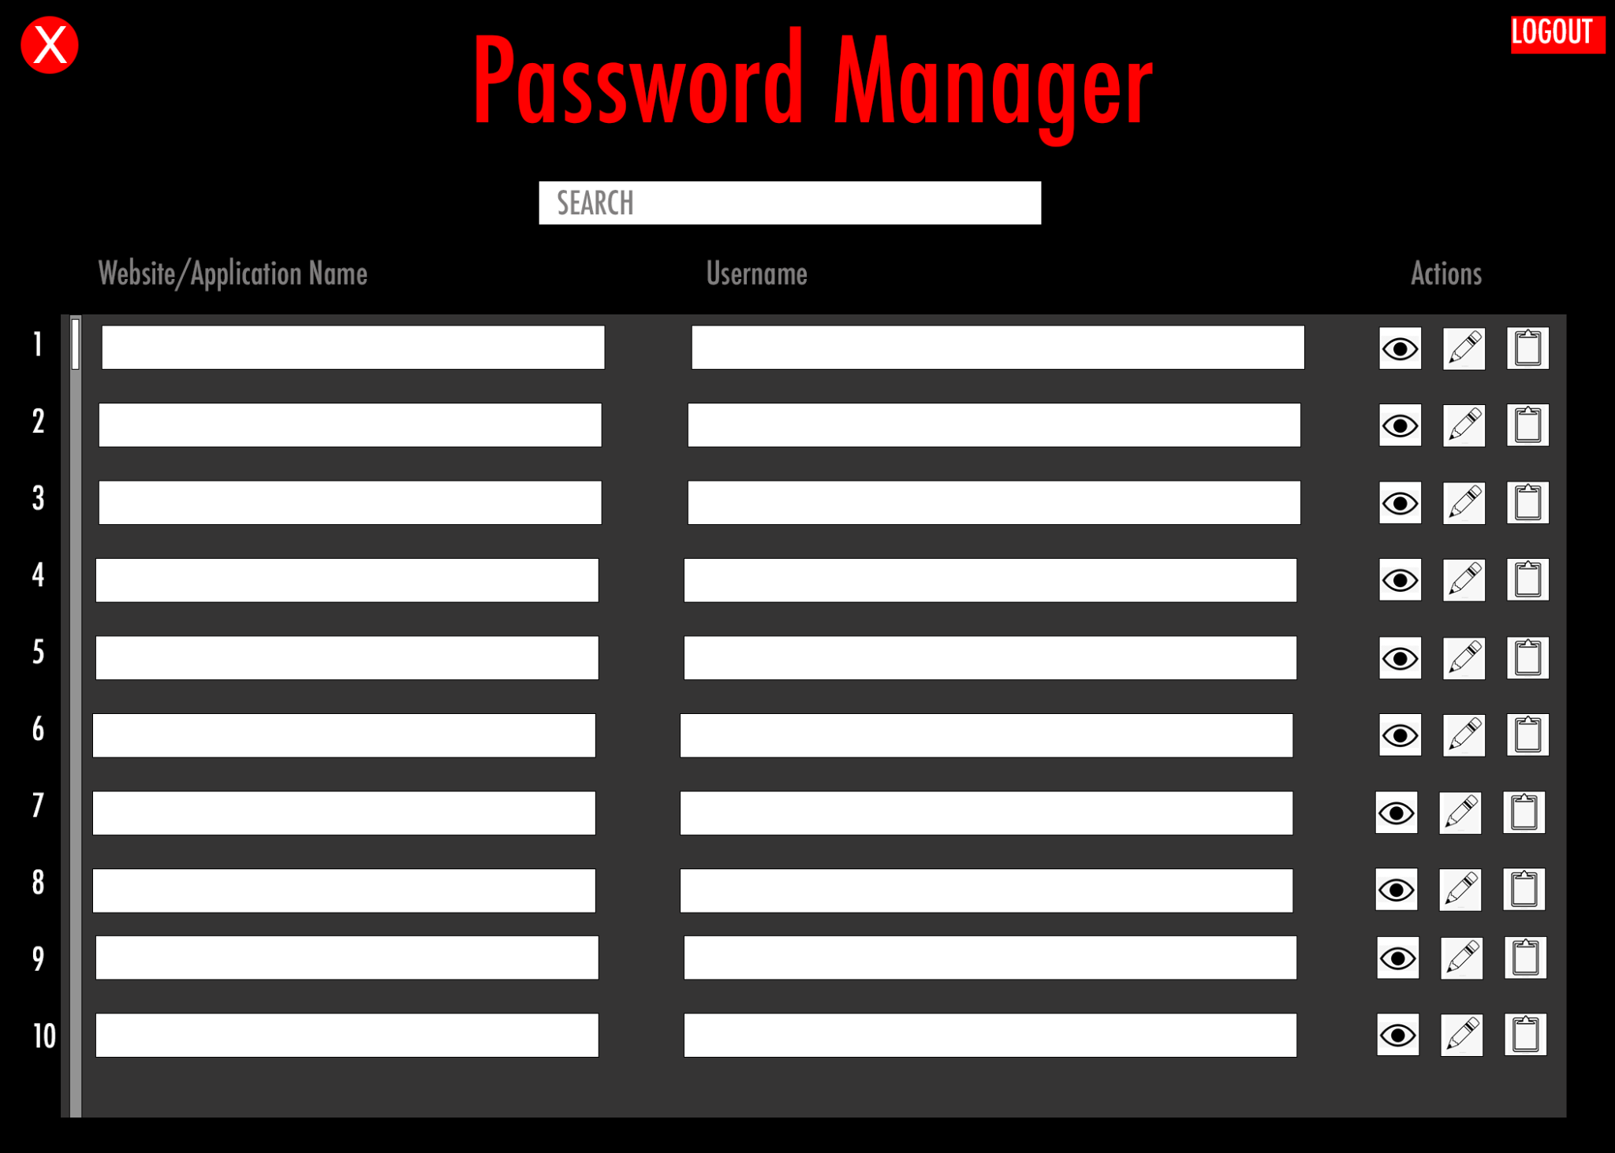

**View Account Info:**

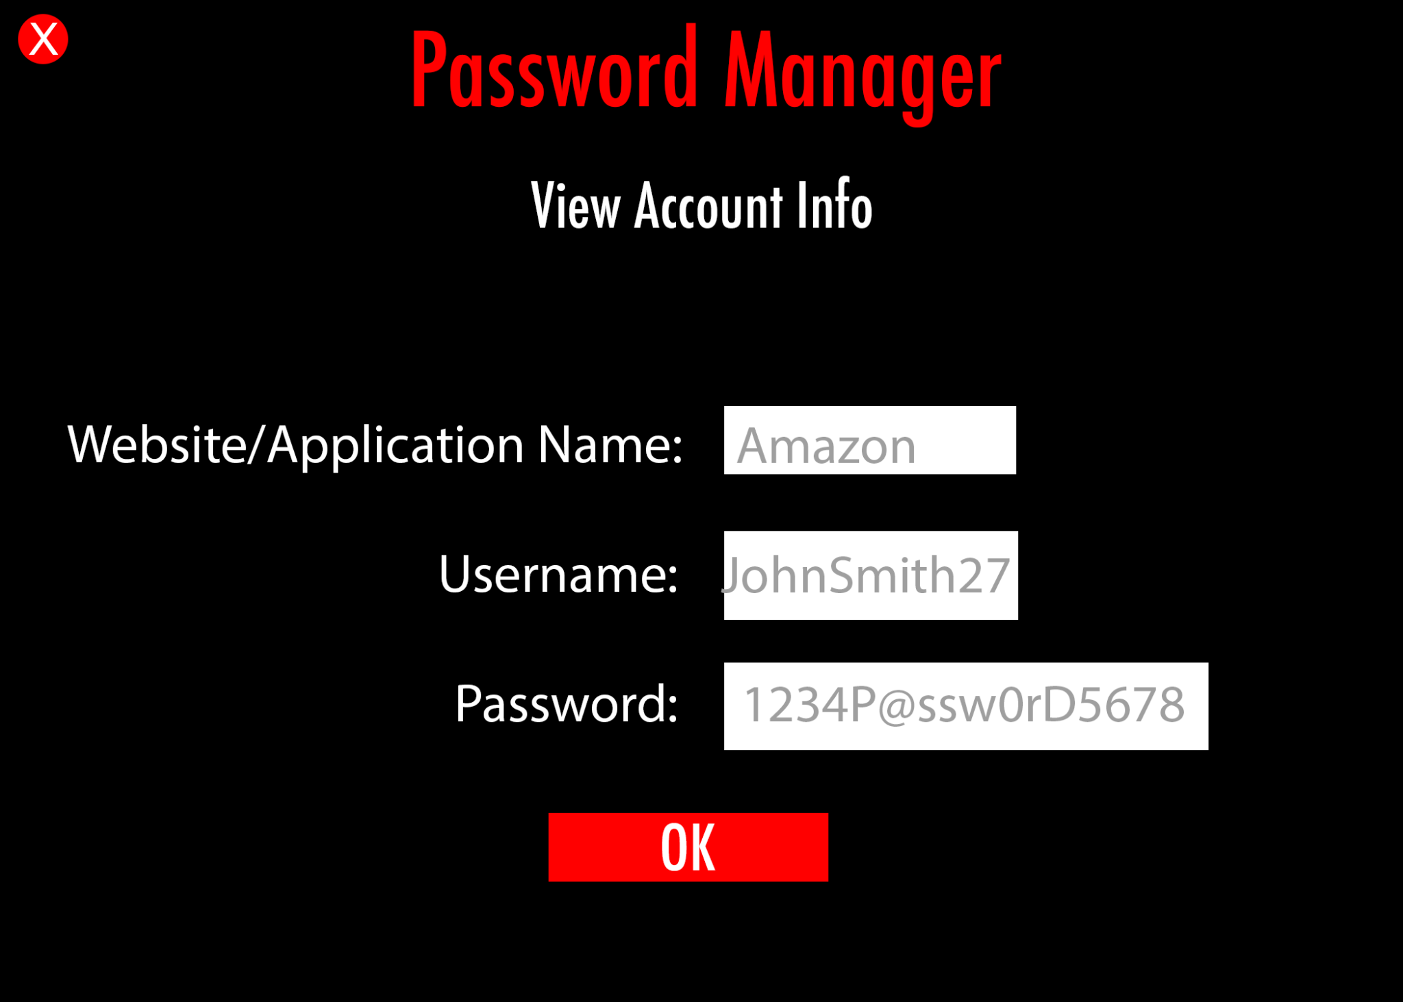

**Edit Account Info:**

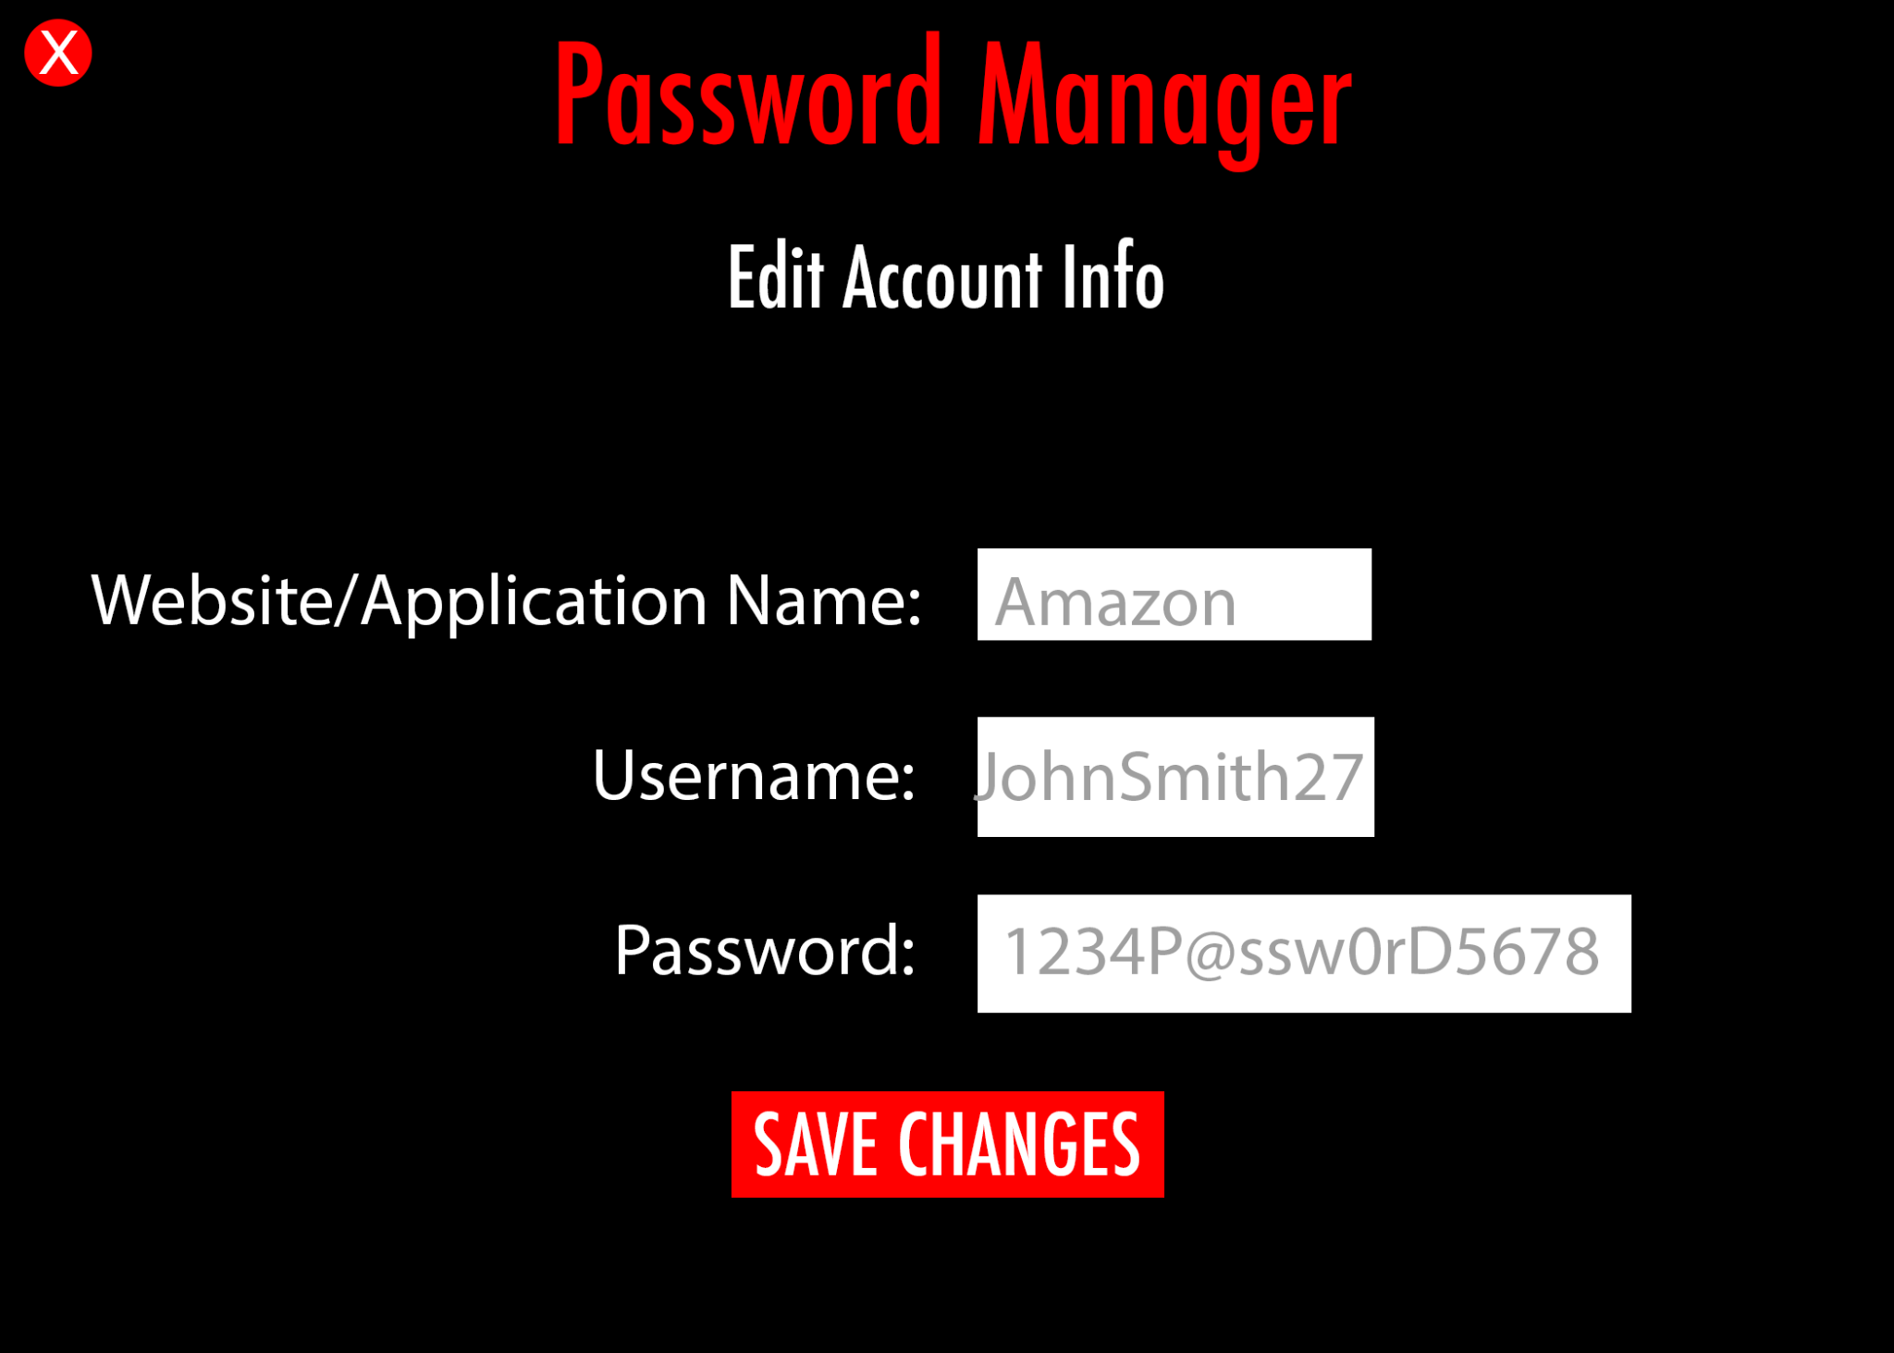

## 6.Glossary

| Master Password: | The password for the Password Manager application |
| --- | --- |
| Master Username: | The username for the Password Manager application |
| Password: | The password of their account, NOT the password for the actual Password Manager application |
| Username: | The username of their account, NOT the username for the actual Password Manager application |