|  |  |  |  |
| --- | --- | --- | --- |
| **Team Number** | 8 | **Section** | 05 |
| **Team Members** | 1. Hoang Tuan Anh Vu 2. Ali Cigdemoglu 3. Tommy Agarwal | | |
| **Software Name** | **Password Manager** | | |

# Introduction

## Objective [5 Points]

This document outlines the problem being solved, the project's scope, how the classes interact, how the sequences of actions are performed, and a mockup of these actions. The document is intended for the engineers and all the stakeholders involved in this project.

## References [5 Points]

Violet: <https://horstmann.com/violet/>

Draw.io: https://app.diagrams.net/

Adobe Photoshop

## Acronyms, and Abbreviations [5 Points]

We don’t have any acronyms/complex language

|  |  |
| --- | --- |
|  |  |
|  |  |
|  |  |

# Software Overview

## Problem Statement [5 Points]

With the advent of the internet, registering to new websites, applications, etc., has been common. People register new accounts each year; the more registrations you make, the more passwords you have, creating a new problem. If you use the same password for every registration, you are jeopardizing your account's security. However, if you use a unique password each time, you will not be able to remember which password you used for which website. Password Manager solves this by keeping all your passwords in a safe place. You can keep an online record of your passwords for each website.

## Scope [5 Points]

Password Manager is for users with multiple passwords who would like to keep them safe online. Users will be able to access their passwords from anywhere, anytime.

# Detailed Design

## UML Class Diagrams (for all classes/interfaces) [30 Points]

*Figure 1: UML Diagram*

## UML Sequence and/or State Diagrams (at least two) [20 Points]

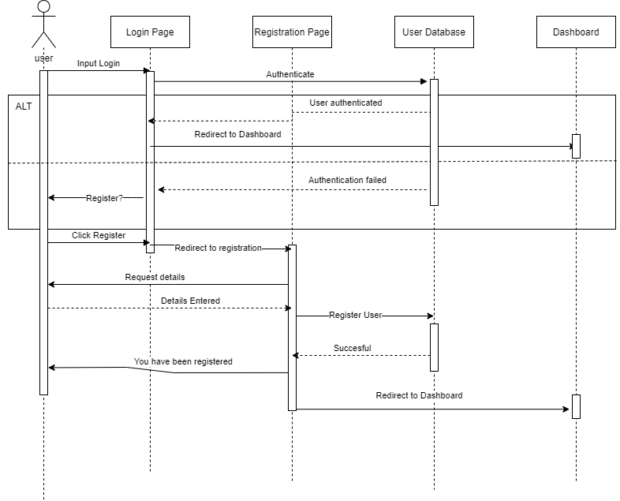

*Figure 2: Login/Register Sequance Diagram*

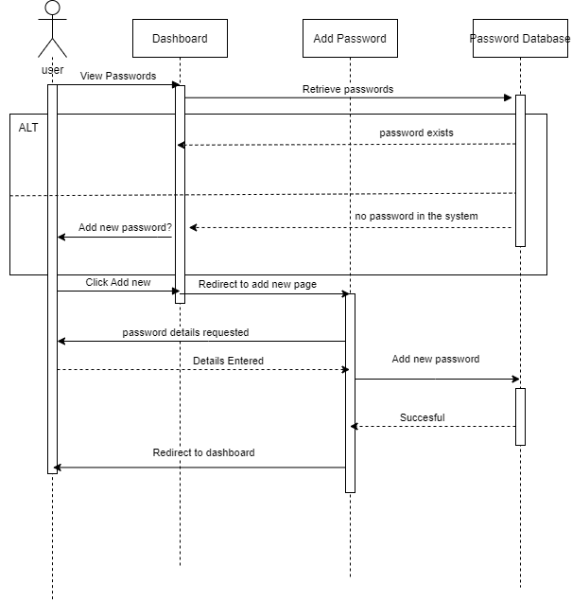

*Figure 3: Add new password sequence*

## Mockups [20 Points]

*Figure 4: Login*

*Figure 5: Dashboard*

*Figure 6: Signup*