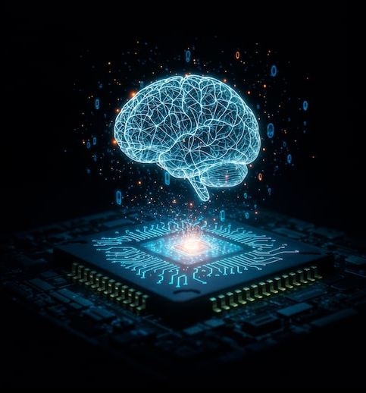

This is the academic report containing the labs that were completed through the 5001CMD Artificial Intelligence Module at Coventry University. This report contains all the content from labs 1, 2, 3, 4, 5 and 7 along with python code, screenshots, written calculations and explanations.

5001CMD Artificial Intelligence
Student ID: 13660992
Table of Contents
Lab 1 – Introduction to AI 4
Basic Task 4
a) AI – Human Rights 4
Advanced Tasks 5
a) United National Sustainable Development Goals 5
b) Robot Simulation 6
Lab 2b – Machine Learning Techniques 7
Basic Tasks 7
a) Outputs from Perceptron 7
b) Outputs from the Multilayer Perception Neural Network 7
c) Root Decision Tree 8
Advanced Tasks 9
a) Machine Learning Model 9
b) Multilayer perceptron 10
Lab 3b – Knowledge Representation 13
Basic Tasks 13
a) Project Fall App Semantic Network 13
Advanced Tasks 13
a) Outcomes from Prolog for Olympics Semantic Network 13
b) Prolog Knowledge Base for Fall App Semantic Network 14
Lab 4 – Human Factors 16
Basic Tasks 16
a) human factors on recruitment AI 16
Advanced Tasks 16
a) Satisfactory Answers of Entities 16
b) Types of Entities 17
Lab 5 – Fuzzy Logic 18
Basic Tasks 18
a) Fuzzy Level of Dirtiness 18
b) Manual Fuzzy Inferencer to Determine Amount of Water Washing Machine 18
Advanced Tasks 19
a) Fuzzy Logic Inferencer to Determine the risk of a art project being unsuccessful. 19
b) Own Fuzzy Logic Inferencer 21
Lab 7a – Intelligent Agents and Robotics 23
Basic Tasks 23
a) Impact of Educational Robots 23
Advanced Task 24
a) Intelligent Agent System 24
References 29

Table of Figures
Figure 1 6
Figure 2 6
Figure 3 6
Figure 4 7
Figure 5 7
Figure 6 8
Figure 7 9
Figure 8 9
Figure 9 9
Figure 10 12
Figure 11 12
Figure 12 13
Figure 13 14
Figure 14 15
Figure 15 18
Figure 16 19
Figure 17 19
Figure 18 19
Figure 19 20
Figure 20 20
Figure 21 20
Figure 22 20
Figure 26 21
Figure 25 21
Figure 23 21
Figure 24 21
Figure 28 22
Figure 27 22
Figure 29 28

Lab 1 – Introduction to AI

AI is a discipline of computer science that aims to mimic human intelligence as accurately as possible. This lab explores the impact of AI on human-rights, decision processes related to UN sustainability goals and the creation of a robot using CoppeliaSim.

Basic Task

a) AI – Human Rights

You should be aware that AI can and will have a very large impact on many things in our lifetimes. Perhaps being overlooked however, is the possible effects it could have on our human rights. Whilst AI has many positive effects, there are possible large negative points when it comes to our human rights.
For example, it is famously stated in the 1948 universal declaration of human rights “all human beings are born free and equal in dignity and rights” (Article 1, universal declaration of human rights). But what if this is broken, judges using AI models to assess the risk of criminals re-offending found that the model they used “appeared to discriminate against Black offenders despite the algorithms' promised objectivity” (Tulane University. 2024).
In this case it is clear to see that AI is clearly breaking the humble human right that all are born equal as it is discriminating against a specific group based on the colour of their skin. This directly contradicts the human right stated as people do not have the autonomy to choose their skin colour, they are in fact born with it therefore should not be treated differently because of it.
The advice you should take on how to aid stopping this is by introducing a reward-based function and a training procedure to mitigate ethnicity-based and site-based bias. This has been proven to have worked in AI systems in hospitals predicting covid-19 outcomes (Banerjee et al. 2023). They found that their AI model under predicted risk for black and south Asian patients meaning people from specific groups didn’t get the right care. To solve this, they introduced a reward system so that the AI was penalized when its errors were unfairly distributed between groups. This was a success and over time the AI managed to balance accuracy and fairness appropriately.
This shows if left unchecked AI can have negative impacts on human rights. However, with the correct precautions and training you can dial it out to ensure our human rights are not encroached on.

United Nations. (1948). Universal Declaration of Human Rights. United Nations.
Banerjee et al. (2023). Algorithmic Fairness for Clinical Machine Learning: Mitigating Ethnicity-Based Bias in Deep Reinforcement Learning Models. Clinical Pharmacology & Therapeutics.
Tulane University. (2024). AI Sentencing Cut Jail Time for Low-Risk Offenders, but Study Finds Racial Bias Persisted. Tulane University News.

Advanced Tasks

United National Sustainable Development Goals
def selectUNGoals():
# function to select united nations goals

# Get student ID
sid = input("Enter Student ID: ")

# make sure id is only numbers
if not sid.isdigit():
return "Error: Student ID should only have numbers in it"

# sum of all numbers in student id for num1
sum = 0
for i in sid:
sum = sum + int(i)

# modulus of sum with 17 and add 1 to ensure value is between 1 and 17 for num1
num1 = (sum % 17) + 1

# multiply all numbers in student id for num2
prod = 1
for i in sid:
# cant multiply by zero in this case
if i == '0':
continue
prod = prod * int(i)

# modulus of product with 17 and add 1 to ensure value is between 1 and 17 for num2
num2 = (prod % 17) + 1

# make sure num1 and num2 are between 1 and 17
if 1 > num1 or num1 > 17:
print("An error has occurred, you will be automatically assigned goals 1 and 2")
return (1, 2)
if 1 > num2 or num2 > 17:
print("An error has occurred, you will be automatically assigned goals 16 and 17")
return (16, 17)

# make sure user does'nt get the same un goal twice
if num1 == num2:
if num2 > 6:
num2 = num2 -1
else:
num2 = num2 + 1

# return the two un goals
return (num1, num2)

goal1, goal2 = selectUNGoals()

print("your un goals are numbers:", goal1, "and", goal2)

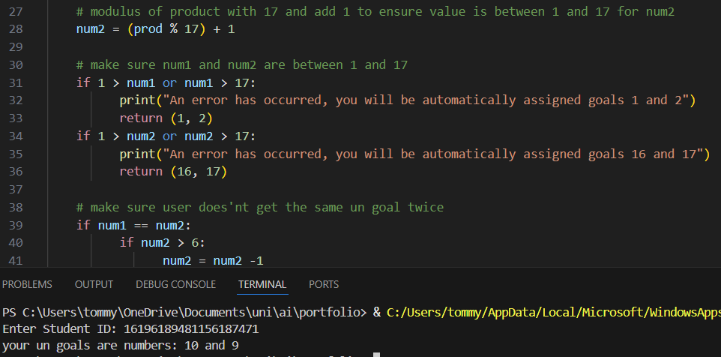
Figure 1

Cornelius. For UN goal number 9 (industry, innovation and infrastructure) there are many possible ways you can leverage AI. For example, you could use artificial intelligence to predict building failures for ease of maintenance. This could drastically reduce the number of injuries sustained due to building failure but also drastically reduce material waste. This is because buildings are checked and refurbished at a more appropriate time instead of too early, or more fatally, too late.

Ethel. For UN goal number 10 (reduced inequalities). You can work on AI in education. AI teaching software can ensure many more people get elite tier personalized education. This means in countries with a severe lack of great teachers and educators, students can still get a high level of education and study efficiently. With this you will get more people learning more languages and thinking critically to get the world communicating and working more in harmony to greatly increase the advancements of humanity and help ensure survival.

Robot Simulation
A simulator called CopelliaSim is used to build a robot capable of moving in forwards in the given environment.
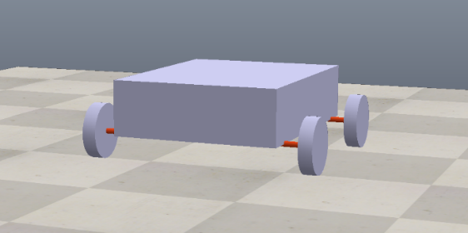
Figure 2
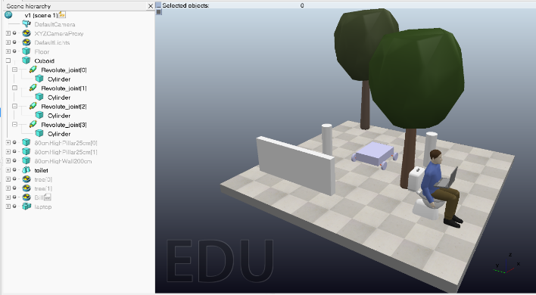
Figure 3

Lab 2b – Machine Learning Techniques

There are multiple techniques that are used in machine learning. This lab shows the calculations of outputs from neural networks, the application of the Gini impurity approach to determining data in a table, the use of MATLAB to create a fine tree classifier and the python code of a basic neural network.

Basic Tasks

a) Outputs from Perceptron
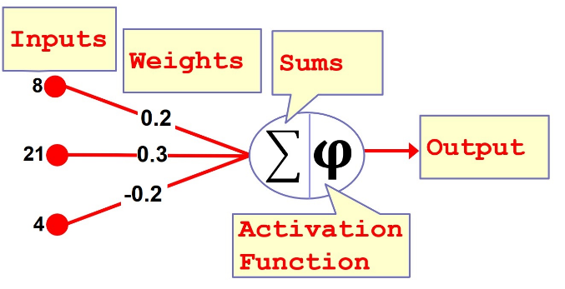
Figure 4

(8*0.2)+(21*0.3)+(4*-0.2) = 7.1
7.1 > 1.4 therefore output = 1

b) Outputs from the Multilayer Perception Neural Network
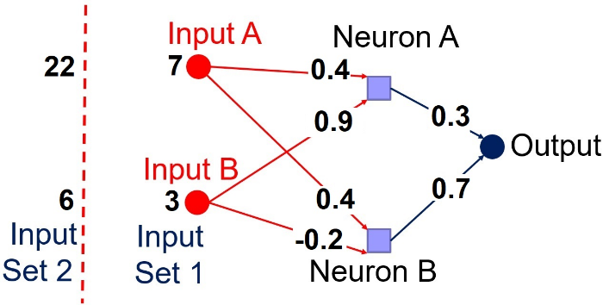
Figure 5

For input 7, 3 (set 1)

Output of neuron a:
Input = (7*0.4) + (3*0.9) = 5.5
1/(1 + e^-5.5) = 0.9959

Output of neuron b:
Input = (3*-0.2) + (7*0.4) = 2.2
1/(1 + e^-2.2) = 0.9

Overall output:
(0.9959*0.3) + (0.9*0.7) = 0.9287
1/(1 + e^-0.9287) = 0.7168
0.7168 > 0.5 therefore person has good health

For input 22, 6 (set 2):

Output of neuron a:
Input = (22*0.4) + (6*0.9) = 14.2
1/(1 + e^-14.2) = 0.999999

Output of neuron b:
Input = (6*-0.2) + (22*0.4) = 7.6
1/(1 + e^-7.6) = 0.999

Overall output:
(0.999999*0.3) + (0.999*0.7) = 0.999
1/(1 + e^-0.999) = 0.73
0.73 > 0.5 therefore person has good health

c) Root Decision Tree

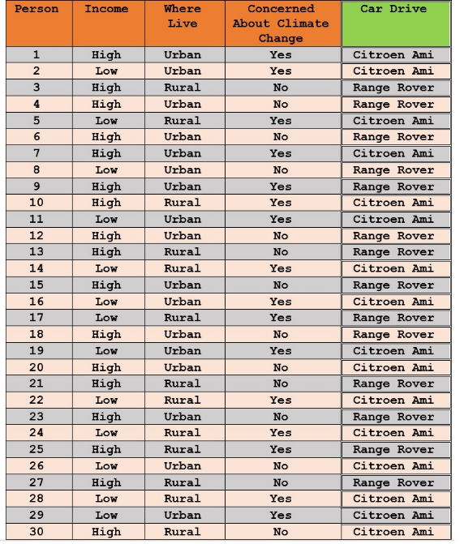
Citeron Ami’s = 16 = 0.533
Figure 6
Range rover’s = 14 = 0.467
1 – ((0.533^2) + (0.467^2)) = 0.498
Overall Gini = 0.498

Income:
High = 17 = 0.566: (Amis = 5, rovers = 12) = 0.415
Low = 13 = 0.434: (Amis = 11, rovers = 2) = 0.260
Weighted Gini = 0.349

Live:
Urban = 17 = 0.566: (Amis = 9, rovers = 8) = 0.498
Rural = 13 = 0.434: (Amis = 7, rovers = 6) = 0.498
Weighted Gini = 0.498

Climate change:
yes = 16 = 0.533: (Amis = 13, rovers = 3) = 0.305
no = 14 = 0.467: (Amis = 3, rovers = 11) = 0.336
weighted Gini = 0.319

Therefore, root node should be climate change as it had the lowest value for the weighted Gini.

Advanced Tasks

Machine Learning Model

Data was gathered from Kaggle and is based on heart disease. Data preprocessing was done to set the target variables to binary. The screenshots below show the tree classification results that where gathered using MATLAB.
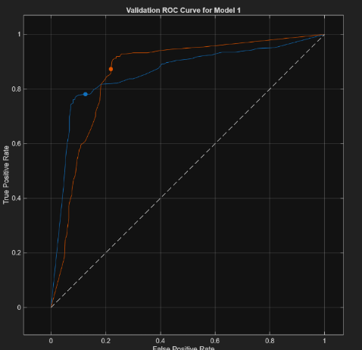
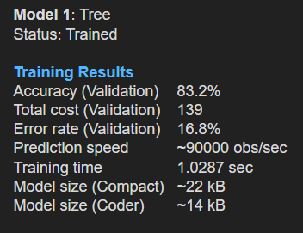
Figure 7
Figure 8

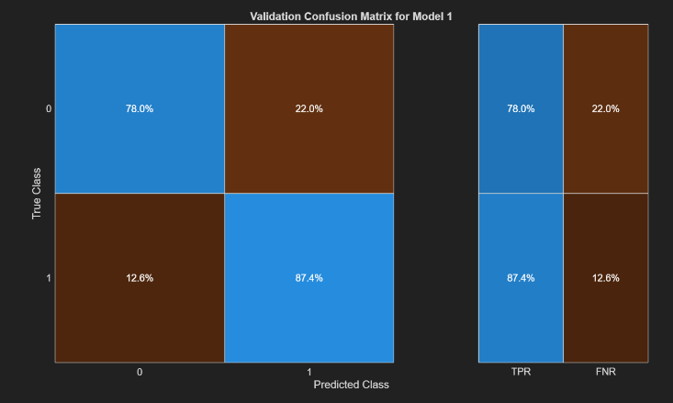
Figure 9

The model had an accuracy of 83.2%. This is a good number however with medical applications such as predicting heart disease this is nowhere near high enough to be effectively used. The ROC curve (figure 7) shows that we are massively better than the diagonal baseline and can confidently say this is significantly better than random. The ROC curve (figure 7) and confusion matrix (figure 9) both however also show that this is much better at classifying 1 (when patient does have heart disease) than when they do not.

b) Multilayer perceptron

Below is the python code of a basic neural network coded in Python. The data used to get the results of figure 10 are shown in figure 11 below the code.

import csv
import random
import numpy as np
import pandas as pd

def parameters():
num_inputs = 2
num_hidden_units = 2
num_outputs = 1
num_epochs = 20
learning_rate = 0.1
activation_function = "sigmoid"

return num_inputs, num_hidden_units, num_outputs, num_epochs, learning_rate, activation_function

def input_data():
choose = input("Type 0 if you want to enter data manually, type 1 to upload a file (note the file must have 3 columns with the third column containing only 0's and 1's)...")

if choose == "0":

with open('data.csv', mode='w', newline='') as file:
writer = csv.writer(file)
writer.writerow(['Input1', 'Input2', 'Result'])

rows = input("how many rows do you want to enter? ")
for i in range(0, int(rows)):
input_value = float(input("Enter input value 1: "))
input_value2 = float(input("Enter input value 2: "))
result = int(input("Enter the result (1 or 0):"))

with open('data.csv', mode='a', newline='') as file:
writer = csv.writer(file)
writer.writerow([input_value, input_value2, result])
filename = 'data.csv'

if choose == "1":
filename = input("Enter the filename (with .csv extension): ")
data = pd.read_csv(filename)

return data

def structure(num_inputs, num_hidden_units, num_outputs):

input_to_hidden_unit = num_inputs * num_hidden_units
hidden_to_output_unit = num_hidden_units * num_outputs
weights_needed = input_to_hidden_unit + hidden_to_output_unit

return {
"num_inputs": num_inputs,
"num_hidden": num_hidden_units,
"num_outputs": num_outputs,
"weights_needed": weights_needed, }

def initialise(weights_needed):
weights = []
for i in range(weights_needed):
weights.append(random.uniform(0, 1))

return weights

def introduced(data, weights, num_epochs, learning_rate):
for epoch in range(num_epochs):
rows = list(range(len(data)))
random.shuffle(rows)

for row in rows:
x11, x12, h1, h2, result = output(data, weights, row)
target = data.iloc[row, 2]
weights = weightUpdate(weights, result, target, learning_rate, x11, x12, h1, h2)

print("epoch:", epoch + 1, "complete")

return weights

def sigmoid(x):
return 1 / (1 + np.exp(-x))

def output(data, weights, row):

x11 = data.iloc[row, 0]
x12 = data.iloc[row, 1]
x21 = x11*weights[0] + x12*weights[1]
x22 = x11*weights[2] + x12*weights[3]
h1 = sigmoid(x21)
h2 = sigmoid(x22)
y = weights[4]*h1 + weights[5]*h2
result = sigmoid(y)

return x11, x12, h1, h2, result

def weightUpdate(weights, result, target, learning_rate, x11, x12, h1, h2):
w = weights
error = float(target - result)
lr = float(learning_rate)
x11 = float(x11)
x12 = float(x12)
h1 = float(h1)
h2 = float(h2)

w[0] = w[0] + lr * error * x11
w[1] = w[1] + lr * error * x12
w[2] = w[2] + lr * error * x11
w[3] = w[3] + lr * error * x12
w[4] = w[4] + lr * error * h1
w[5] = w[5] + lr * error * h2

return list(w)

def print_weights(weights):
print("Final weights after training:")
print("weight 1 = input 1 to hidden unit 1", weights[0])
print("weight 2 = input 2 to hidden unit 1", weights[1])
print("weight 3 = input 1 to hidden unit 2", weights[2])
print("weight 4 = input 2 to hidden unit 2", weights[3])
print("weight 5 = hidden unit 1 to output", weights[4])
print("weight 6 = hidden unit 2 to output", weights[5])

num_inputs, num_hidden_units, num_outputs, num_epochs, learning_rate, activation_function = parameters()
struct = structure(num_inputs, num_hidden_units, num_outputs)
weights_needed = struct["weights_needed"]

parameters()
data = input_data()
weights = initialise(weights_needed)
introduced(data, weights, num_epochs, learning_rate)
print_weights(weights)
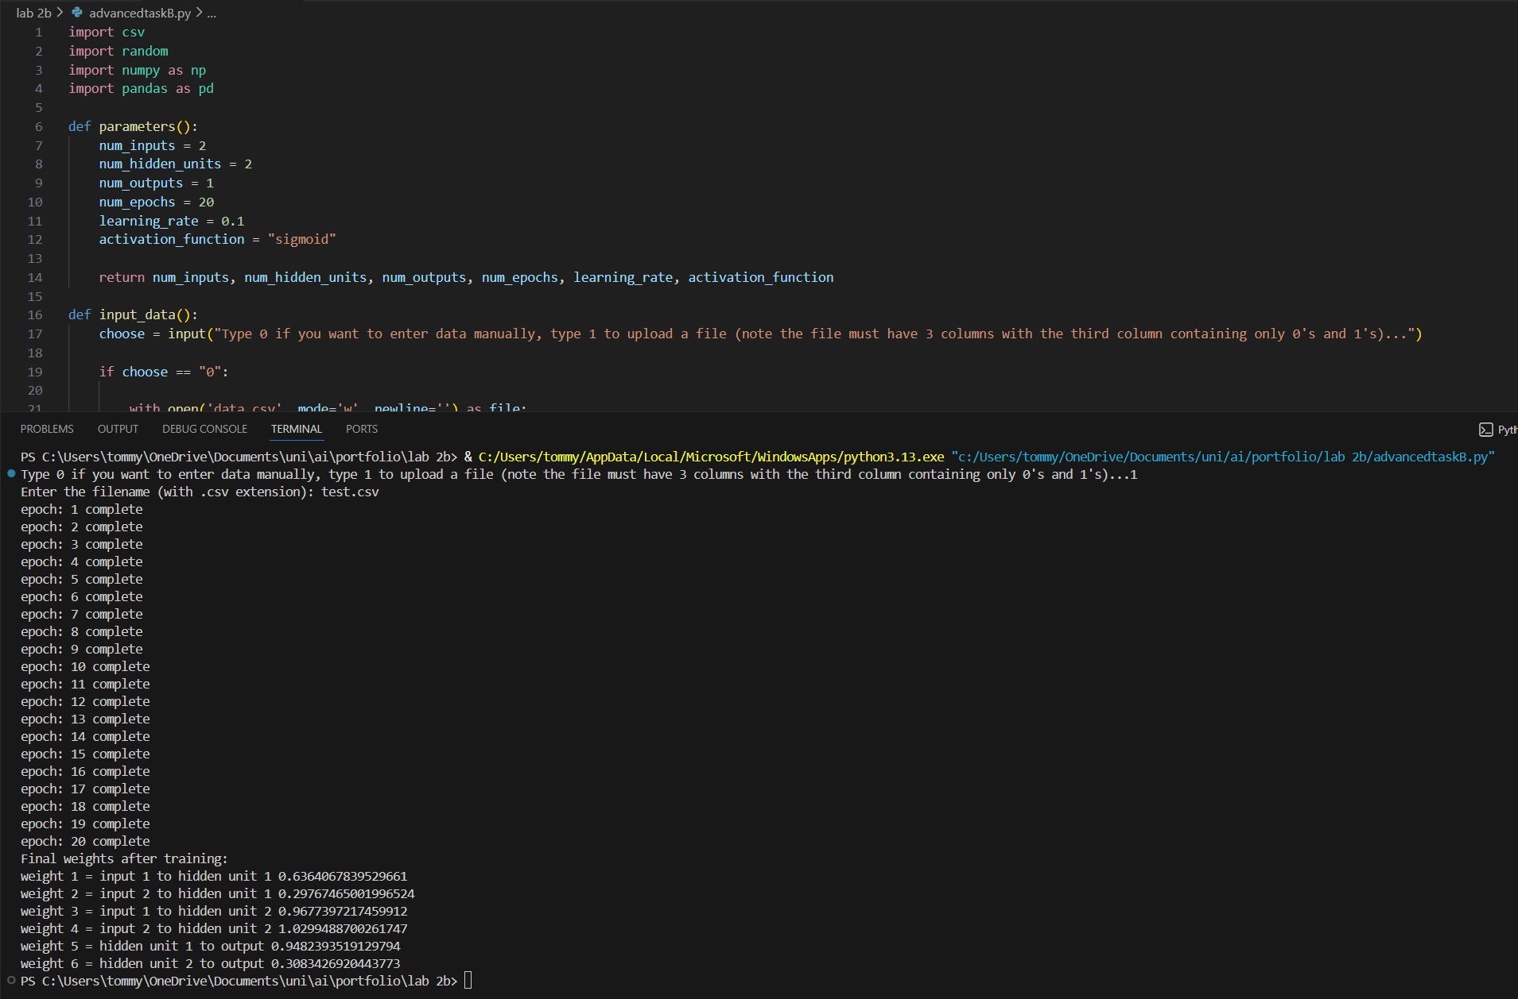
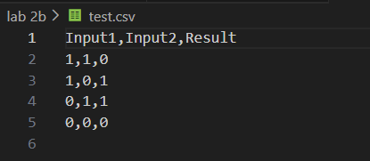
Figure 10
Figure 11

Lab 3b – Knowledge Representation

Data and knowledge can be shown in many ways. This lab shows the creation of a semantic network, the outputs of a Prolog code and a written Prolog code.

Basic Tasks

a) Project Fall App Semantic Network

Figure 12 shows a semantic network that shows the relationships between AI researchers and the app they are developing.
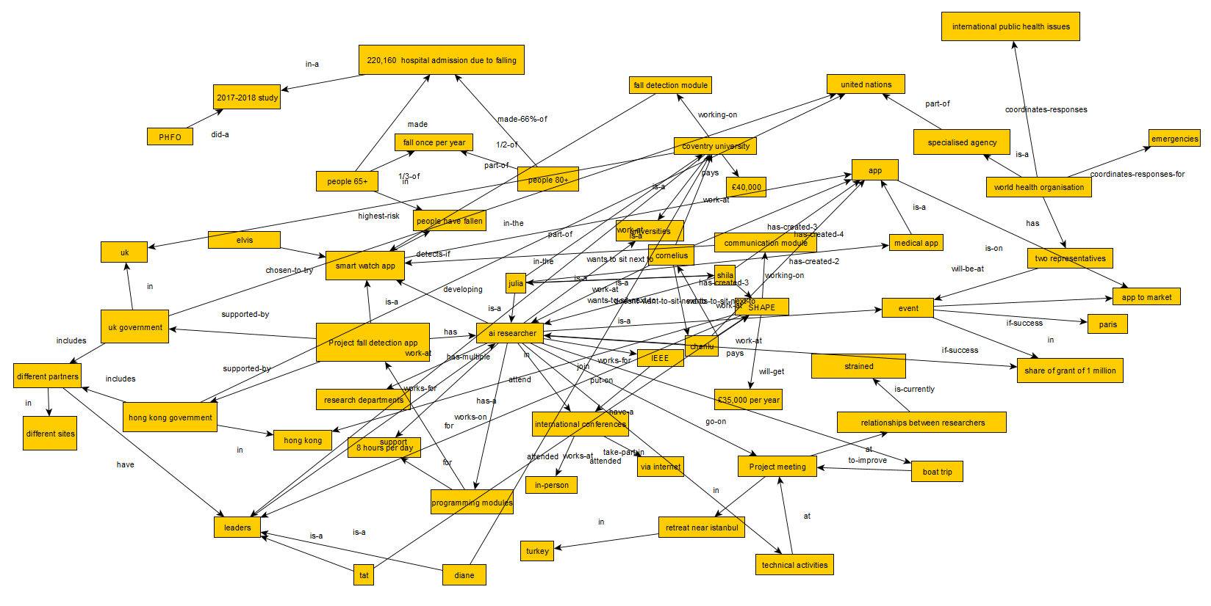
Figure 12

Advanced Tasks

a) Outcomes from Prolog for Olympics Semantic Network

Figure 13 shows the queries to a prolog code and the output that the queries give.

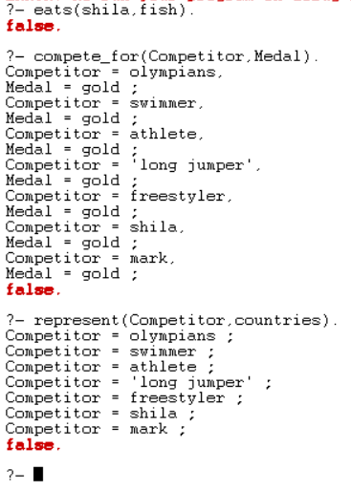

Figure 13

b) Prolog Knowledge Base for Fall App Semantic Network

This is Prolog code containing facts and rules along with some queries based on the AI researchers in basic task a. Figure 14 below the code shows it working and being queried.

% isa: facts
isa(julia, ai_researcher).
isa(shila, ai_researcher).
isa(cornelius, ai_researcher).
isa(chenlu, ai_researcher).
isa(tat, leader).
isa(diane, leader).

% works_at: facts
works_at(julia, university_of_coventry).
works_at(cornelius, university_of_coventry).
works_at(chenlu, shape).
works_at(shila, shape).
works_at(tat, shape).
works_at(diane, university_of_coventry).

% pays: facts
pays(shape, 35000).
pays(university_of_coventry, 40000).

% go_on: facts
go_on(ai_researcher, boat_trip).

% gets_paid: rule
gets_paid(Person, Paid) :- isa(Person, ai_researcher), works_at(Person, Organisation), pays(Organisation, Salary).

% who_leader: rule
who_leader(Person, Leader) :- isa(Person, ai_researcher), works_at(Person, Organisation), isa(Leader, leader), works_at(Leader, Organisation).

% goes_on: rule
goes_on(Person, Activity) :- isa(Person, ai_researcher), go_on(ai_researcher, Activity).

------------------------------------------------------------------------------------------------------------------------------------------------------

?- works_at(julia, Organisation).
?- goes_on(Person, Activity).
?- gets_paid(Person, Paid), goes_on(Person, boat_trip).

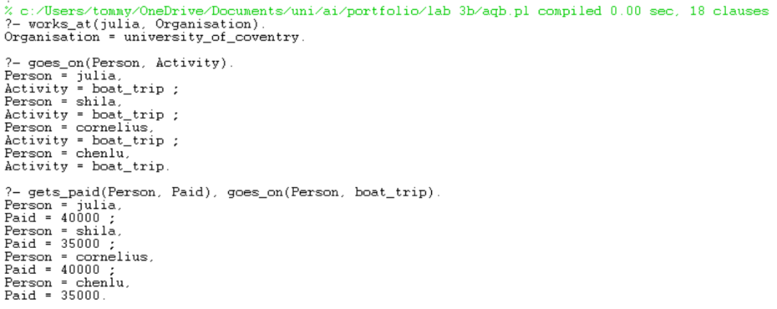
Figure 14

Lab 4 – Human Factors

Human factors are human abilities, limitations, behaviours, and biases that must be considered to ensure AI systems are used safely and effectively. This lab involves advising a researcher named Sheila on human factors within AI recruitment tools along with the evaluation of transcripts and whether they meet Turing’s criteria.

Basic Tasks

a) human factors on recruitment AI

Sheila should take great care when implementing a recruitment AI, especially for creative positions. It is critical human factors are considered with implementing such a system, as using an AI and fully replacing human judgement in this position can affect people/businesses a very large amount.
Applicants will feel the AI bot will not be totally fair and could have internal biases. For instance, it might like one type of creativity over others and over hire people with one specific skill set. This could have catastrophic consequences as you could get one skillset being massively over-represented with other key skills being overlooked if the AI isn’t tuned in perfectly. This could lead to huge doubt and loss of trust from both the businesses you work with to implement this and applicants alike.
It should also be known that AI is not inherently creative. Therefore, is not a good judge of creativity. It is hard to represent creativity in data; creativity is a mix of emotions, artistic intuition and originality. These qualities cannot be shown in data, so the AI will be very hard to train on these parameters. This makes it not a totally fair judge of what is a good, creative, original piece of work and what has been stolen from the internet. This could hugely negatively impact the perception of AI as forged, non-original ideas could be seen as perfect by the ai.
In summary, Sheila should be very aware of human factors. It may not only harm her own reputation, but the businesses she works with too. It can be agreed that technology should enhance and not replace human judgement, so maybe Sheila could implement AI in some early rounds of the hiring process and use humans later to get both AI and humans working well in harmony.

Advanced Tasks

a) Satisfactory Answers of Entities

In transcript 1 the left hidden entity does not meet Turing’s criteria as the answers often are not relevant and ignore the question entirely. This makes the hidden entity not seem like its “thinking” but just rolling out rubbish or trying to deflect away from a question. The interviewer asks simple direct questions and the left hidden entity very rarely replied to its questions showing little contextual understanding.
The right hidden unit in transcript 1 also does not meet Turing’s criteria. Again, some of the replies don’t really make any sense compared to the questions being asked. When the interrogator said “lets play a game … its starts with my next line” the reply “I have know idea” doesn’t make any sense.
Left hidden entity in transcript two also fails. Near the end, one of the responses is completely cut off and ends with “I don’t mind if -,” which is a complete conversational breakdown and is not a satisfactory sustained response at all. Some of the sentences are not correct English either “I believe machines should do many to assist…”. This is not a satisfactory response as it doesn’t make any sense.
Right hidden unit in transcript 2 aces it. The answers perfectly make sense with the questions being asked and the conversation has a perfect flow to it with great continuity. The hidden entity even asks relevant questions of its own! This meets Turing’s criteria.

b) Types of Entities

Both hidden units are bots in transcript 1. Not only do they both fail to meet Turing’s criteria, both conversations don’t make any logical sense. Both give very wishy-washy avoidant answers such as “I am bored with that” which is purely just deflecting a difficult question or “Yes I know these abeivations” which doesn’t even come close to answering what the interrogator asked it. While there are some good answers such as the “Kevin Warwick?” answer, the overwhelming majority do not answer the direct questions they are being asked. This gives us these very confusing, weird conversations which I would ever see two humans have as lots of the questions being asked are just completely ignored or parried away because they don’t want to answer them. I think if a person was being intentionally rude, they wouldn’t give these answers either.
In transcript two we have one bot and one human. Left hidden entity has many red flags which suggest it is a bot. Whilst it does have an attempt at humour, it fails miserably. The joke it’s attempting to tell makes absolutely no sense and is cut off halfway through. A human would never write three quarters of a joke, then put a dash to suggest it should carry on and send it.
The right hidden unit is a perfect showcase of a human to human conversation. The subtle use of the smiley face shows emotion and personality I think a bot would lack. The responses are straight forward and to the point whilst keeping the conversation on topic and flowing with all answers from the hidden unit making perfect sense whilst also conveying an inquisitive nature by asking the interrogator a question.

Lab 5 – Fuzzy Logic

Fuzzy logic is a method of reasoning that allows computers to handle uncertain and imprecise values instead of simple true/false. This lab shows the finding of membership values from membership functions, the building of membership functions using a fuzzy inference in python and the creation of a fuzzy logic inference using MATLAB.

Basic Tasks

a) Fuzzy Level of Dirtiness

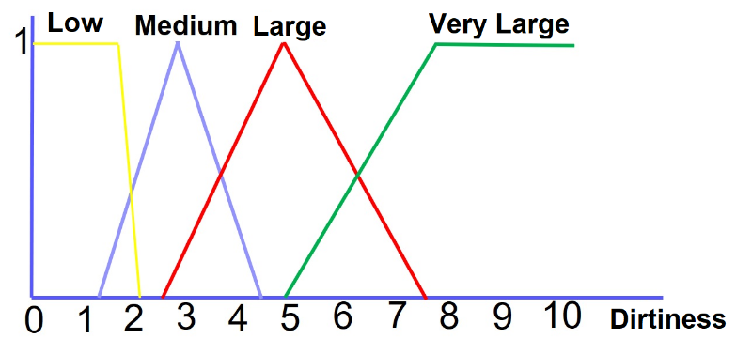
Person a:
Figure 15
Low = 0
Medium = 5
Large = 4.5
Very large = 0

Person B:
Low = 0
Medium = 0
Large = 3.5
Very large = 5

b) Manual Fuzzy Inferencer to Determine Amount of Water Washing Machine

level_of_dirty = float(input("Enter the level of dirtiness (0-10): "))
low = 0
medium = 0
large = 0
very_large = 0

type_of_dirt = float(input("Enter the type of dirt (0-10): "))
small_greasy = 0
medium_greasy = 0
greasy = 0
very_greasy = 0

def triangular(x, a, b, c):
if x < a or x > c:
return 0.0
elif a <= x < b:
return (x - a) / (b - a)
elif b <= x <= c:
return (c - x) / (c - b)
else:
return 0.0

def trapezoidal(x, a, b, c, d):
if x < a or x > d:
return 0.0
elif a <= x < b:
return (x - a) / (b - a)
elif b <= x <= c:
return 1.0
elif c < x <= d:
return (d - x) / (d - c)
else:
return 0.0

low = trapezoidal(level_of_dirty, 0, 0, 1.7, 2.1)
medium = triangular(level_of_dirty, 1.2, 2.9, 4.4)
large = triangular(level_of_dirty, 2.6, 4.9, 7.5)
very_large = trapezoidal(level_of_dirty, 4.9, 7.9, 10, 10)

small_greasy = trapezoidal(type_of_dirt, 0, 0, 1, 2)
medium_greasy = triangular(type_of_dirt, 2, 4, 5)
greasy = triangular(type_of_dirt, 4, 5, 8)
very_greasy = trapezoidal(type_of_dirt, 7, 8, 10, 10)

rule1 = min(large, greasy)
rule2 = min(very_large, very_greasy)

center_short = 5
center_med = 30
center_long = 45
center_very_long = 57.5

num = rule1 * center_long + rule2 * center_very_long
den = rule1 + rule2

if den == 0:
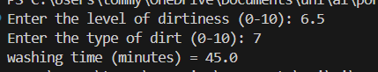
output = 0.0
Figure 16
else:
output = num / den

print("washing time (minutes) =", output)

Advanced Tasks

a) Fuzzy Logic Inferencer to Determine the risk of an art project being unsuccessful.

Figures 17, 18 and 20 show the creation of the input variables. Figure 19 shows the rules and figures 21 and 22 show the outputs of the fuzzy inferencer.
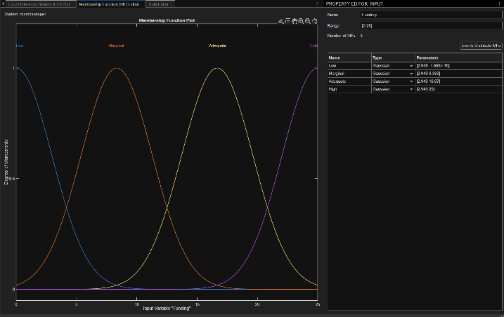
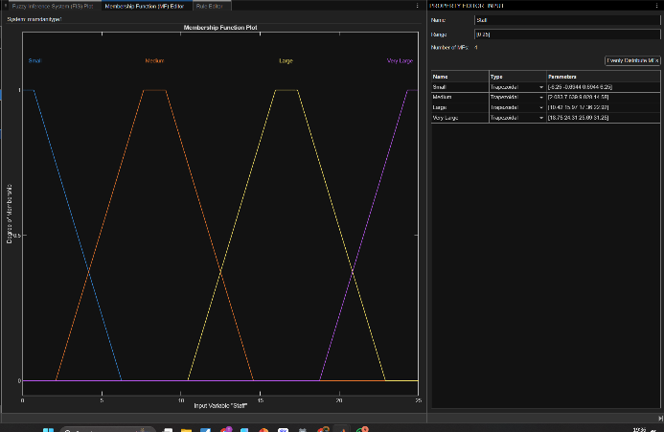
Figure 17
Figure 18

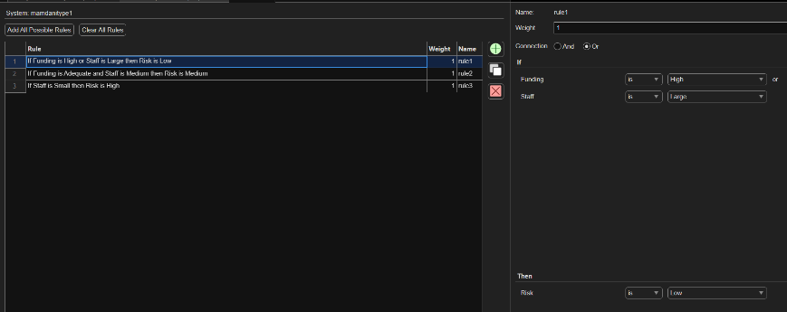
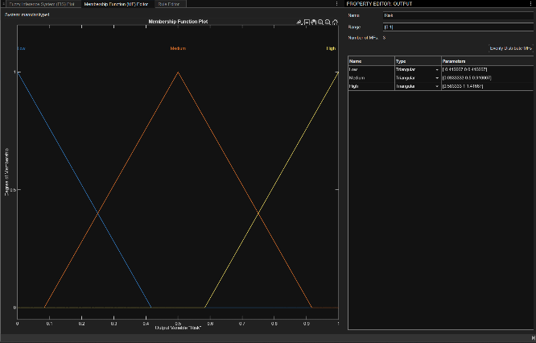
Figure 19
Figure 20

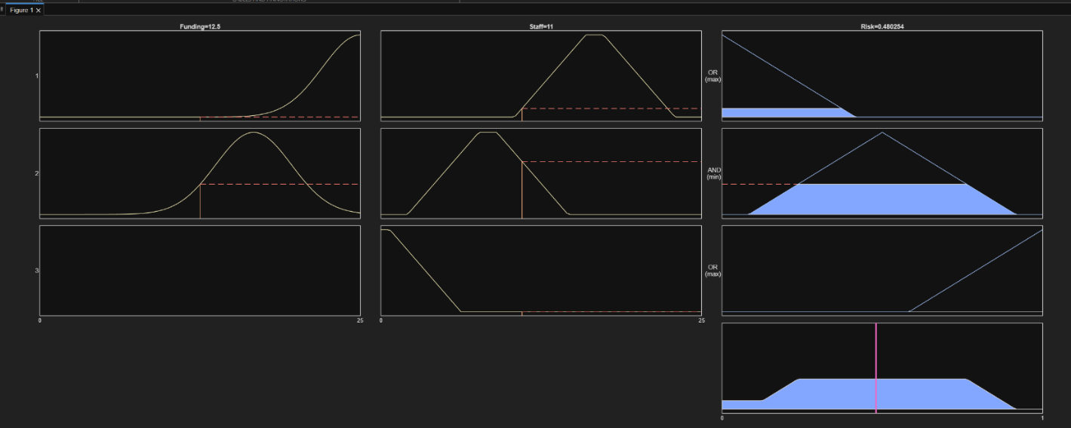
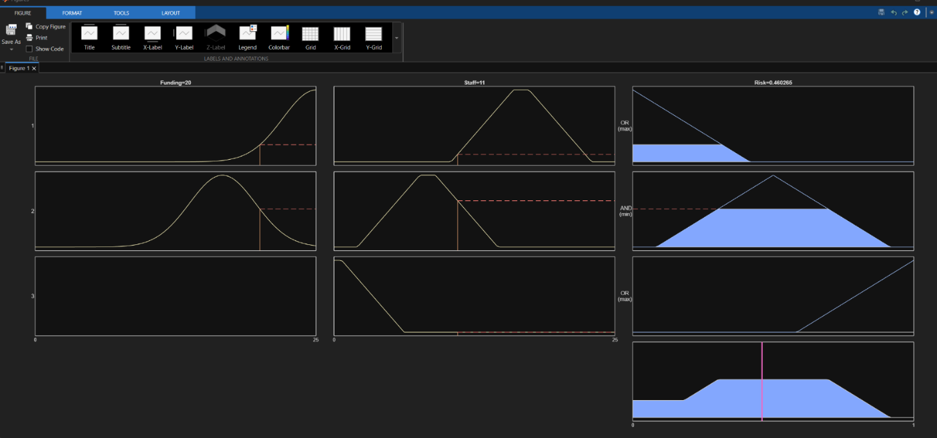
Figure 21
Figure 22

b) Own Fuzzy Logic Inferencer

Figures 24, 23 and 25 show the inputs of the created fuzzy inferencer. Figure 26 shows the rules and figures 27 along with 28 show the output.
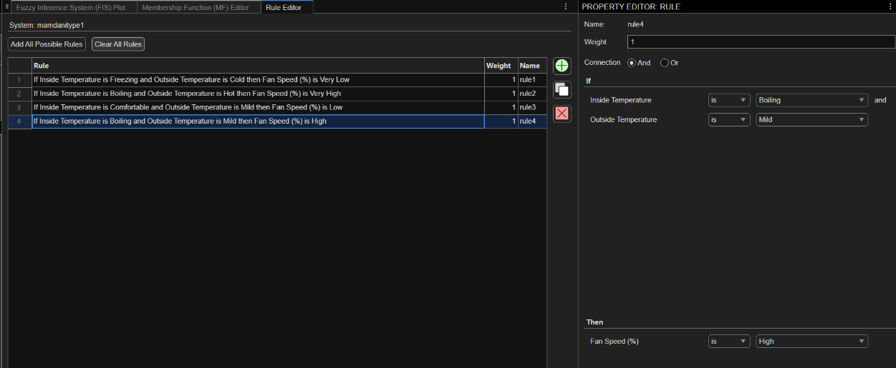
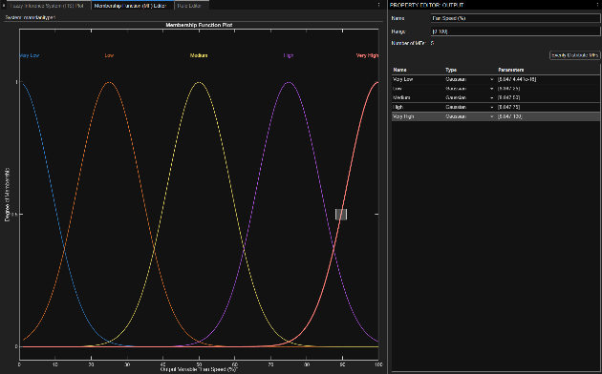
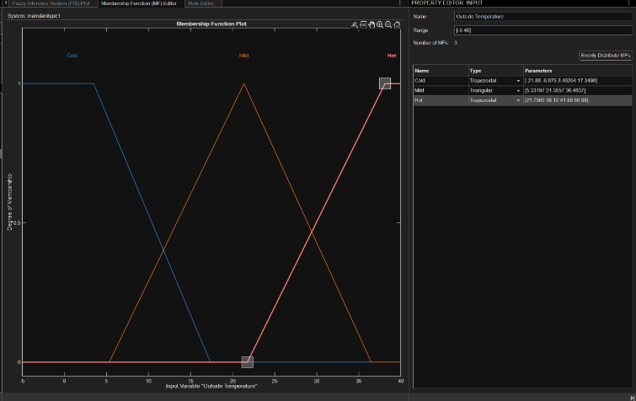
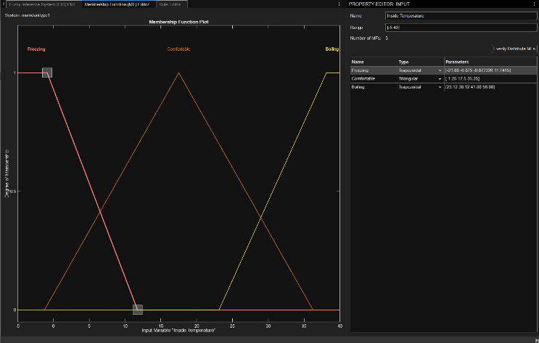
Figure 26
Figure 25
Figure 23
Figure 24
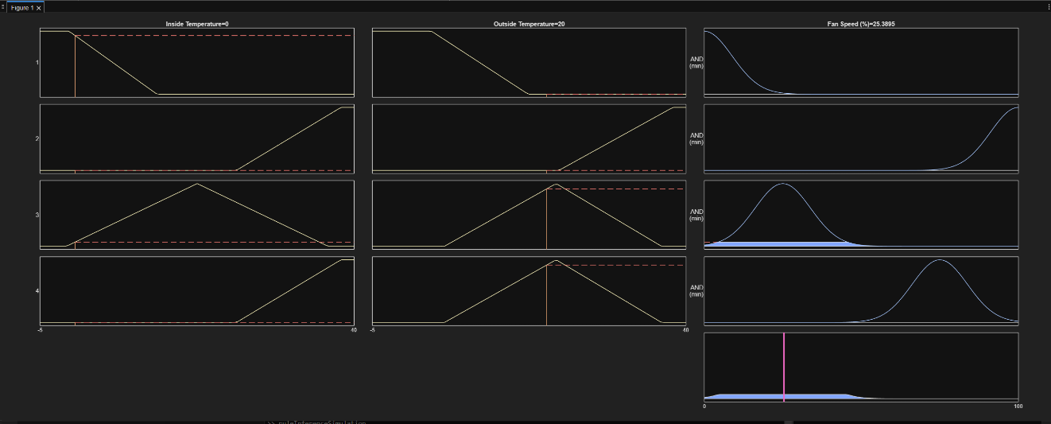
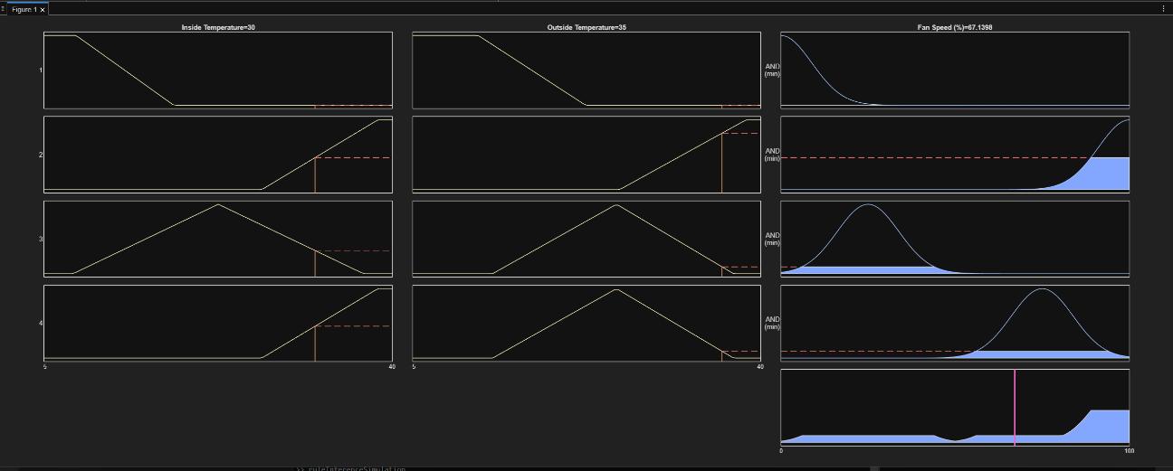
Figure 28
Figure 27

Lab 7a – Intelligent Agents and Robotics

Intelligent agents are autonomous systems that perceive their environment, make decisions and act to achieve a goal with little to no human intervention. This lab contains an essay for Diane who has grown interested in robotics in education and a Python code of a basic ChatBot.

Basic Tasks

a) Impact of Educational Robots

Diane should use an educational robot which is a capable chatbot with built in worksheet generation and obviously contains the answers. By doing this, students can show their working out and answer for each question in their own time and the chatbot will reveal what they did right, wrong and what can be done better next time. This way students don’t get answers revealed to them when they are not ready and is a much more one-to-one teaching experience they get. It can also give/generate tailored worksheets for homework or at the end of each week based on the areas they are the weakest in. They can work at their own pace, link accounts and show two people working together and you get real time reporting on what work students are doing/how much work they’re and to what level. This should greatly improve the performance of students as it has been shown that “AI performance shows the largest increase... including ‘problem identification, repair, problem-solving, and problem-solving thinking.’”.

The main challenges coming from the co-existence of AI and physical teachers. Studies show “there is not enough education or support for field teachers or preservice teachers, creating a gap between the policy and field atmosphere.” This shows that teachers are not educated in AI and will not know how to accurately use/implement the technology to get the most out of it. While governments and higher ups might be all for the implementation, without significant technical support and ground level training. Teachers simply won’t have the confidence in operating ai software systems. This is proven by the fact “65.4% of elementary school teachers in charge of AI education answered, ‘I do not know how to apply AI convergence education in the subject.’”. This is a major issue as without the teachers being on board and knowing how to properly implement the AI models, students simply will not get the best learning experience and may end up with a worse experience than just the teacher.

Park, W., & Kwon, H. (2024). Implementing artificial intelligence education for middle school technology education in Republic of Korea. International journal of technology and design education, 34(1), 109-135.

https://scholar.google.com/scholar?hl=en&as_sdt=0%2C5&q=implementing+ai+education&btnG=#d=gs_cit&t=1762425094981&u=%2Fscholar%3Fq%3Dinfo%3Ak5acnOnbBCMJ%3Ascholar.google.com%2F%26output%3Dcite%26scirp%3D0%26hl%3Den

Advanced Task

a) Intelligent Agent System

Python ChatBot containing keyword search, emotion recognition, personalized responses, remembering and incorporating previous information from the user, variation in responses, appropriate responses if it doesn’t understand, spell checking and game playing. Figure 29 below the code shows it running and being tested.
import re
import json
import os
import random

MEMORY_FILE = "memory.json"

VOCAB = {
"what","is","ai","artificial","intelligence","will","take","my","job",
"intelligent","agent","agents","how","used","world","hello","hi","hey",
"help","explain","name","thanks","bye","goodbye","examples","code",
"takeover","scared","worried","fear","sad","angry","happy"
}

KB = {
"what_is_ai": [
"AI is software that can learn patterns from data and uses it to make predictions or decisions. It isnt some which craft and is not magic — just maths and training on data.",
"AI is systems that can recognise patterns, reason, or make choices based on data that has been fed into it for it to learn from. Think of it like giving a computer the ability to notice patterns."
],
"will_ai_take_my_job": [
"Alot of tasks can get automated, but most jobs change rather than disappear completely. People who learn to use AI usually become more valuable to the companies they work for.",
"AI replaces repetitive and monotanous tasks, not entire people. Your creativity and judgement still matter massively and it will only be jobs you dont want to do because theyre too boring that it can take over."
],
"intelligent_agents": [
"An intelligent agent observes and sees the world, makes a decision, and acts. Virtual assistants and robots are classic examples.",
"They follow a loop: sense → think → act. Very similar to how we would approach tackling a task."
],
"ai_takeover_claim": [
"Nah, AI isn't close to that level. It's powerful but not anywhere near clever enough (yet!). It can't form intentions or goals on its own wothout someone setting them.",
"Most 'AI takeover' stuff is sci-fi. Real systems are specialised and depend fully on human direction. Alot have systems in place to prevent these things from happening"
],
}

EMOTIONS = {
"happy": ["happy","glad","great","excited","pleased"],
"sad": ["sad","down","unhappy","depressed"],
"angry": ["angry","furious","annoyed","frustrated"],
"fear": ["scared","afraid","worried","anxious","concerned"],
"neutral": []
}

QUIZ = [
{
"q": "What does 'AI' stand for?",
"opts": ["a) Automated Internet", "b) Artificial Intelligence", "c) Active Interface"],
"ans": "b"
},
{
"q": "What does LLM stand for in AI?",
"opts": ["a) Large Languagey Modem", "b) Lazy Language Model", "c) Large Language Model"],
"ans": "c"
},
{
"q": "Levenshtein edit distance measures:",
"opts": ["a) The length of a text", "b) Minimum character edits between strings", "c) Computational Cost of an algorithm"],
"ans": "b"
}
]

def play_quiz():

print("\nAlright, quick 3-question quiz. Answer with a, b or c. Or you can just say quit if you dont want to bother")
score = 0

for i, item in enumerate(QUIZ, start=1):
print(f"\nQuestion {i}: {item['q']}")

for o in item["opts"]:
print(" ", o)

while True:
answer = input("You: ").strip().lower()

if answer == "quit":
print("Quiz stopped. Your score:", score, "out of 3")
return

if answer[0] in ("a","b","c"):

if answer[0] == item["ans"]:
print("Nice — that's correct.")
score = score + 1

else:
print(f"Not quite. The correct answer was '{item['ans']}'.")
break

else:
print("Please answer with a, b or c (or 'quit').")

print("\nDone. Your final score:", score, "out of 3")

return

GREETINGS = ["Hi", "Hello", "Hey"]
FALLBACKS = [
"chat like that just doesnt tickle my brain. Ask me a question about AI, i'm fascinated by AI right now so ask me about that",
"forget all that, you want to do a quiz about AI? If you do just say quiz or play quix or something like that",
"dude, just ask me about ai or say quiz to play a game."
]

def load_memory():
if os.path.exists(MEMORY_FILE):
try:
return json.load(open(MEMORY_FILE, "r", encoding="utf-8"))
except:
return {}
return {}

def save_memory(mem):
json.dump(mem, open(MEMORY_FILE, "w", encoding="utf-8"), indent=2)

def normalize(text):
text = text.lower().strip()
text = re.sub(r"[^a-z0-9'\s]", " ", text)
return re.sub(r"\s+", " ", text)

def tokenize(text):
return normalize(text).split()

def edit_distance(a, b):

la, lb = len(a), len(b)
if a == b:
return 0
if la == 0:
return lb
if lb == 0:
return la

dp = [[0]*(lb+1) for _ in range(la+1)]
for i in range(la+1): dp[i][0] = i
for j in range(lb+1): dp[0][j] = j

for i in range(1, la+1):
for j in range(1, lb+1):
cost = 0 if a[i-1] == b[j-1] else 1
dp[i][j] = min(dp[i-1][j] + 1, dp[i][j-1] + 1, dp[i-1][j-1] + cost)

return dp[la][lb]

def correct_token(token, vocab=VOCAB, thresh=2):
if token in vocab:
return token

best = token
best_dist = 999

for v in vocab:
d = edit_distance(token, v)
if d < best_dist:
best_dist = d
best = v

return best if best_dist <= thresh else token

def preprocess(text):

tokens = tokenize(text)
corrected = [correct_token(t) for t in tokens]
return " ".join(corrected)

def detect_intents(text):
t = text.lower()
intents = []
if "what is ai" in t or "what ai" in t:
intents.append("what_is_ai")
if "take my job" in t or "will ai take" in t:
intents.append("will_ai_take_my_job")
if "intelligent agent" in t or "intelligent agents" in t:
intents.append("intelligent_agents")
if "take over the world" in t or "ai takeover" in t:
intents.append("ai_takeover_claim")
if any(g in t for g in ["hello","hi","hey"]):
intents.append("greeting")

if "quiz" in t or "play quiz" in t or "play a quiz" in t:
intents.append("play_quiz")
return intents

def detect_emotion(text):
t = normalize(text)
counts = {k: 0 for k in EMOTIONS}
for emo, words in EMOTIONS.items():
for w in words:
if re.search(r"\b" + w + r"\b", t):
counts[emo] += 1
top = max(counts.items(), key=lambda x: x[1])
return top[0] if top[1] > 0 else "neutral"

def reply_prefix(memory):
name = memory.get("name")
if name:
return f"{name}, "
return ""

def generate_response(user_text, memory):

clean = preprocess(user_text)
intents = detect_intents(clean)
emotion = detect_emotion(user_text)

if emotion != "neutral":

memory["last_emotion"] = emotion

if not memory.get("name"):
name_match = None

patterns = [
r"\bmy name is ([a-z]{2,})\b",
r"\bmy name's ([a-z]{2,})\b",
r"\bcall me ([a-z]{2,})\b",
r"\bi am ([a-z]{2,})\b",
r"\bi'm ([a-z]{2,})\b"
]

for pat in patterns:
m = re.search(pat, clean)
if m:
name_match = m.group(1)
break
if name_match:
memory["name"] = name_match.capitalize()

prefix = reply_prefix(memory)

if "play_quiz" in intents:
return "__PLAY_QUIZ__", memory

if "greeting" in intents:
return f"{prefix}{random.choice(GREETINGS)} — what's on your mind?", memory

for intent in intents:
if intent in KB:
resp = random.choice(KB[intent])
if emotion == "fear":
resp += " And don't worry — none of this is as scary as headlines make it look."
return prefix + resp, memory

if emotion != "neutral":
return prefix + f"I can't fully answer that, but you sound a bit {emotion}. Want to tell me more?", memory

return prefix + random.choice(FALLBACKS), memory

def main():
memory = load_memory()

if memory.get("name"):
print(f"Hey {memory['name']}, what's up?")
else:
print("Hey — what's your name?")

while True:
user = input("\nYou: ").strip()
if user.lower() in ["bye","exit","quit"]:
print("Alright, take care.")
save_memory(memory)
break

response, memory = generate_response(user, memory)
save_memory(memory)

if response == "__PLAY_QUIZ__":
play_quiz()
continue

print(response)

main()

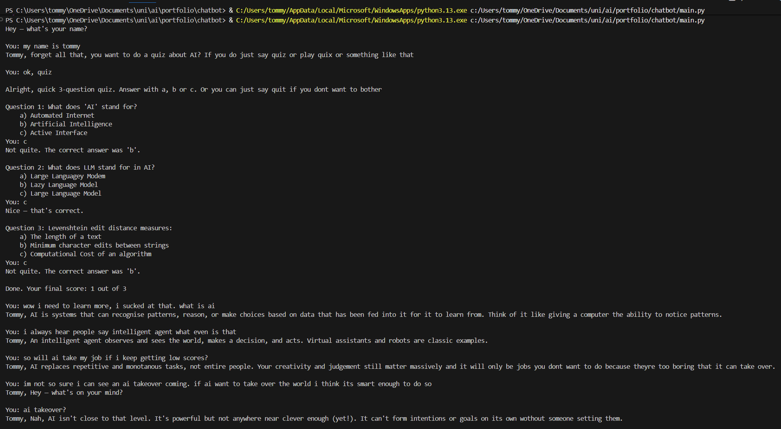
Figure 29

References

United Nations. (1948). Universal Declaration of Human Rights. United Nations.
Banerjee et al. (2023). Algorithmic Fairness for Clinical Machine Learning: Mitigating Ethnicity-Based Bias in Deep Reinforcement Learning Models. Clinical Pharmacology & Therapeutics.
Tulane University. (2024). AI Sentencing Cut Jail Time for Low-Risk Offenders, but Study Finds Racial Bias Persisted. Tulane University News.

Park, W., & Kwon, H. (2024). Implementing artificial intelligence education for middle school technology education in Republic of Korea. International journal of technology and design education, 34(1), 109-135.

