ITS概论作业一

王锦宏 19351125

本次作业的所有操作均在Python下完成

测试运行环境

Python 3.8.3

需要安装numpy, pandas, matplotlib, datetime

**第一题**

此题第一部分为非常普通的数据提取，使用pandas的read_csv读取，然后在pandas中进行数据筛选，分词，制作输出表格并将代码填入输出表格中即可，代码如下：

import numpy as np

import pandas as pd

if __name__ == "__main__":

    a = pd.read_csv("C:\\Users\\jhong\\Documents\\GitHub\\OpenITS-HeFei-Analyzation\\黄天路口视频交通流检测数据(2016.06.22~2016.06.30).csv")

    a['FTIME']=pd.to_datetime(a['FTIME'])

    a['TTIME']=pd.to_datetime(a['TTIME'])

    timecodeflitered=a.loc[(a['FTIME']>='2016/6/25 8:00')&(a['TTIME']<='2016/6/25 9:00')&(a['DEVICECODE'].isin(['hte001','hte002','hts001','htw001','htw002','htn001']))]

    flitered=timecodeflitered[['DEVICECODE','LANENUMBER','FLOW','SPEED','INTERVAL']]

    pathnum = [2,2,2,2,3,2]

    device = ['hte001','hte002','hts001','htw001','htw002','htn001']

    output=pd.DataFrame(columns=['路段','FLOW','SPEED','INTERVAL'])

    for i in range(0,6):

        for j in range(1,pathnum[i]+1):

            indname = (device[i]+'(车道'+str(j)+')')

            new=pd.DataFrame({'路段':indname,'FLOW':0,'SPEED':0,'INTERVAL':0},index=[1])

            output=output.append(new)

    output=output.set_index('路段')

    dividerate=pd.DataFrame(columns=device,index=[1]).fillna(0)

    for index,row in flitered.iterrows():

        laneNum = row['LANENUMBER']

        FLOWS = row['FLOW'].split('_',laneNum-1)

        SPEEDS = row['SPEED'].split('_',laneNum-1)

        INTERVALS = row['INTERVAL'].split('_',laneNum-1)

        dividerate.loc[1,row['DEVICECODE']] = dividerate.loc[1,row['DEVICECODE']]+1

        for i in range(0,laneNum):

            odname = (row['DEVICECODE']+'(车道'+str(i+1)+')')

            output.loc[odname].loc['FLOW']=int(output.loc[odname].loc['FLOW'])+int(FLOWS[i])

            output.loc[odname].loc['SPEED']=int(output.loc[odname].loc['SPEED'])+int(SPEEDS[i])

            output.loc[odname].loc['INTERVAL']=float(output.loc[odname].loc['INTERVAL'])+float(INTERVALS[i])

    for i in range(0,6):

        for j in range(1,pathnum[i]+1):

            indname = (device[i]+'(车道'+str(j)+')')

            output.loc[indname].loc['SPEED'] = output.loc[indname].loc['SPEED']/dividerate.loc[1,device[i]]

            output.loc[indname].loc['INTERVAL'] = output.loc[indname].loc['INTERVAL']/dividerate.loc[1,device[i]]

    output.columns = ['流量(辆)','平均速度(km/h)','平均车头时距(s/辆)']

    output.to_excel("ITS作业1.1.xls")

得到的excel表格截图如下：

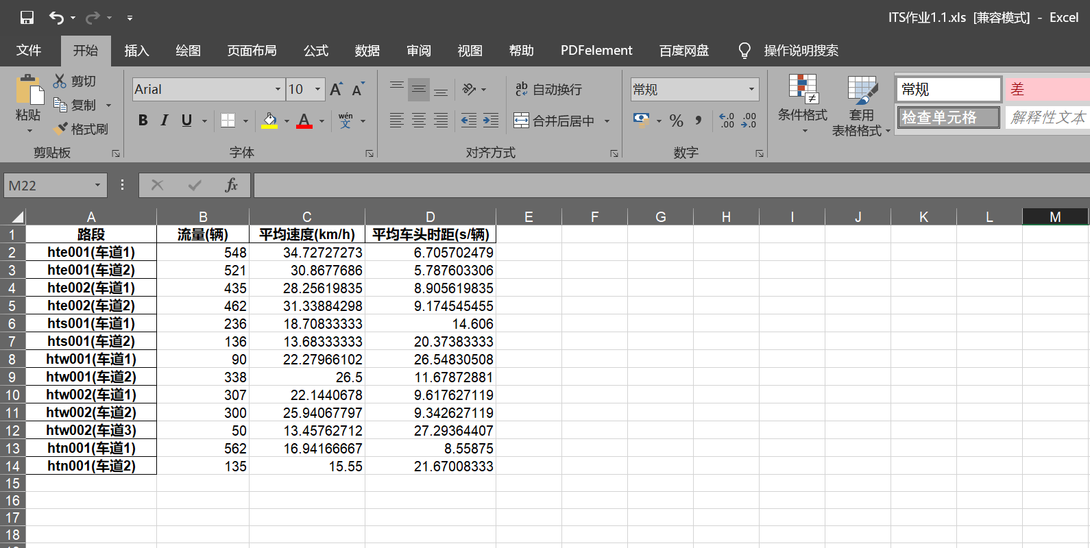

|  |  |  |  |
| --- | --- | --- | --- |
| 路段 | 流量(辆) | 平均速度(km/h) | 平均车头时距(s/辆) |
| hte001(车道1) | 548 | 34.72727273 | 6.705702479 |
| hte001(车道2) | 521 | 30.8677686 | 5.787603306 |
| hte002(车道1) | 435 | 28.25619835 | 8.905619835 |
| hte002(车道2) | 462 | 31.33884298 | 9.174545455 |
| hts001(车道1) | 236 | 18.70833333 | 14.606 |
| hts001(车道2) | 136 | 13.68333333 | 20.37383333 |
| htw001(车道1) | 90 | 22.27966102 | 26.54830508 |
| htw001(车道2) | 338 | 26.5 | 11.67872881 |
| htw002(车道1) | 307 | 22.1440678 | 9.617627119 |
| htw002(车道2) | 300 | 25.94067797 | 9.342627119 |
| htw002(车道3) | 50 | 13.45762712 | 27.29364407 |
| htn001(车道1) | 562 | 16.94166667 | 8.55875 |
| htn001(车道2) | 135 | 15.55 | 21.67008333 |