Blueprint for a Professional AI Voice Clone Generator
You want more than TTS. You want presence — truer prosody, breath, grit, and multilingual reach. Here’s a step-by-step path to build it right.

Core Capabilities to Target
- Human-like TTS: Natural prosody, correct pronunciation, controllable pace, pitch, and energy.
- Voice cloning: Few-shot or zero-shot speaker replication with consented data.
- Emotion control: Fine control over tone (neutral, joyful, sad, angry, empathetic) and intensity.
- Singing voice: Note-accurate SVS (singing voice synthesis) with vibrato and breath.
- Dubbing/voice conversion: Preserve source timing and linguistic content while swapping timbre.
- Multilingual output: At least 32 languages with robust phonemization and code-switching.
- Production I/O: Text-to-speech from text/SSML; export mp3, wav, m4a with broadcast-grade loudness.

Step-by-step build
- Scope and guardrails: Define use cases and consent
  - Who and what: Only clone voices with explicit written consent and verified identity.
  - Controls: Add user approval gates, audit logs, and opt-out deletion.
  - Watermarking: Include inaudible watermark or metadata tags on generated audio.
- Data pipeline: Collect, clean, and label
  - Recording specs: 24–48 kHz, 16–24 bit PCM, mono, noise floor < −60 dB, consistent mic and space.
  - Variety: 1–3 hours per voice for high-fidelity cloning (read + conversational + emotive).
  - Transcripts: Time-aligned text; add phonemes (G2P) and punctuation; label emotion, style, language.
  - Multilingual: Build a shared phoneme/IPA inventory and language IDs for 32-language coverage.
- Frontend linguistic processing: Normalize text to pronunciation
  - Normalization: Expand numbers, dates, abbreviations.
  - Phonemization: Convert text to phonemes; add stress markers; handle homographs with POS tags.
  - Prosody cues: Insert punctuation-derived pauses and emphasis markers.
- Core TTS model: Learn content→acoustics, then vocode to waveform
  - Acoustic model: Non-autoregressive (e.g., Fast duration/pitch/energy predictors) for low latency.
  - Speaker conditioning: Speaker embeddings (d-vector/x-vector/ECAPA) for zero-/few-shot cloning.
  - Emotion/style: Global style tokens or reference encoders to capture prosody “style.”
  - Vocoder: High-fidelity neural vocoder (e.g., HiFi-grade) tuned for clean, low-latency synthesis.
- Voice cloning paths: Zero-shot vs. fine-tuned
  - Zero-shot:
    - Input: 30–120 seconds of clean speech.
    - Mechanism: Extract speaker embedding; condition the acoustic model at inference.
    - Use case: Fast onboarding; slightly less precise timbre.
  - Few-shot fine-tune:
    - Input: 30–60 minutes.
    - Mechanism: LoRA/PEFT adapters to adapt the base model to a specific voice.
    - Use case: Highest fidelity; better emotional range and phoneme edge cases.
- Emotion and prosody control: Make it feel human
  - Discrete styles: Pretrained styles (neutral, warm, excited, empathetic, serious).
  - Continuous controls: Predict/condition on (F_0) (pitch), duration, and energy scalars for fine shaping.
  - Reference audio: Optionally feed a short reference clip to transfer prosody.
  - SSML-like tags: Support <prosody rate="slow" pitch="+2st" volume="+2dB"> and <emotion type="joy" intensity="0.7">.
- Singing voice synthesis (SVS): Notes, breath, and phrasing
  - Inputs: Musical score (MIDI/notes), lyrics (phonemes), tempo map.
  - F0 modeling: Explicit pitch trajectories with vibrato parameters and legato handling.
  - Expressivity: Breath noise layers, consonant timing, sibilance control, phrase-level dynamics.
- Voice conversion (dubbing): Keep timing, change timbre
  - Content extraction: Self-supervised units (e.g., discrete content tokens) from source audio.
  - Prosody transfer: Preserve timing and energy contours; swap only speaker identity.
  - Alignment: Forced aligner maps original syllable timing; constrain TTS/VC to match durations.
  - Lip sync (optional): For video, keep phoneme timing and adjust micro-pauses to the frame cadence.
- Multilingual stack: Scale to 32 languages
  - G2P per language: High-quality phonemizers; shared phoneme set with language IDs.
  - Cross-lingual speakers: Train with multilingual corpora; balance data to avoid accent drift.
  - Code-switching: Allow inline language tags with correct phonotactics and prosody.
- Training regimen: Quality in, quality out
  - Curriculum: Start neutral English; add multilingual and emotional data in phases.
  - Losses/metrics: Spectral, duration, F0, energy; prosody/style losses for stability.
  - Regularization: Noise augmentation, speaker balancing, pitch augmentation for robustness.
  - Checkpoints: Early-stop on validation MOS proxy; keep best by mean opinion score estimates.
- Inference and scaling: Snappy, reliable synthesis
  - Latency targets: < 300 ms for short prompts; stream longer text in chunks with overlap-add.
  - Optimization: Quantize/compile models; cache speaker embeddings; batch small requests.
  - Fail-safes: Fallback to neutral prosody on out-of-distribution inputs; timeout guards.
- Product surface: API, UX, and formats
  - Inputs: Text/SSML; optional reference audio; style and emotion sliders.
  - Outputs: wav (48 kHz/24-bit), wav (24 kHz/16-bit), mp3 (192–256 kbps), m4a/AAC (192 kbps).
  - Loudness: Normalize to −16 LUFS (speech) or −14 LUFS (music); true peak ≤ −1 dBFS.
  - Batch tools: Script chunking, punctuation-aware segmentation, de-breath/de-click post-FX.

- Emotion and singing realism
-  (What moves people)
- Data balance:
  - Coverage: Neutral, “smile voice,” lament, urgency, whisper, projection, laughter.
  - Labels: Valence/arousal scores and discrete tags; avoid emotion leakage across styles.
- Control surface:
  - Macro: Emotion and intensity.
  - Micro: Syllable-level emphasis, pause length, breath placement, consonant duration.
- Singing details:
  - Breath layer: Separate noise component blended under phrases.
  - Expressive F0: Vibrato depth/rate curves and note transitions (portamento).
  - De-esser/de-plosive: Task-tuned post-processing for mix-ready stems.

Multilingual dubbing and timing fidelity
- Pipeline:
  - Transcribe/translate: Accurate transcript; preserve named entities and timings.
  - Align: Forced alignment in target language to set syllable durations.
  - Synthesize/convert: TTS with prosody targets or VC from content units.
  - Conform: Time-stretch within ±5–8% to hit marks; keep formants natural.
- Pronunciation controls:
  - Lexicon overrides: User dictionary per project.
  - Regional variants: Language-region tags (e.g., pt-BR vs pt-PT) and accent sliders.

Quality control and evaluation
- Subjective tests:
  - MOS panels: 1–5 scale with blind ABX against ground truth.
  - Emotion recognition: Third-party classifier agreement with intended label.
- Objective metrics:
  - Prosody: F0 RMSE, energy correlation, duration deviation.
  - Spectral: Mel-cepstral distortion; CMOS vs. references.
- Acceptance gates:
  - Cloning fidelity: Speaker verification score ≥ threshold.
  - Intelligibility: WER on ASR re-transcription under 5–7% for clean speech.

Packaging, APIs, and output formats
- API design:
  - Synthesize endpoint: text/SSML, voice_id, emotion, intensity, rate, pitch, format, sample_rate.
  - Clone endpoint: voice name, consent proof, sample upload (mp3/wav/m4a), language tags.
  - Dubbing endpoint: source audio, transcript, target language, voice_id, timing=strict/loose.
- File handling:
  - Accepted inputs: mp3, wav, m4a; auto-convert to internal 24–48 kHz mono wav.
  - Exports:
    - wav: 48 kHz/24-bit or 24 kHz/16-bit for editing.
    - mp3: 192–256 kbps CBR for distribution.
    - m4a/AAC: 192 kbps for web/mobile.
- Post-FX chain:
  - Order: De-click → De-ess → Gentle EQ → Light compression (2:1) → Loudness normalize.
Example SSML snippet with style control:
<speak>
<voice name="thomas_clone">
<emotion type="empathetic" intensity="0.6">
<prosody rate="slow" pitch="+1st">
Thank you for being here today. Your story matters.
</prosody>
</emotion>
</voice>
</speak>

Ethics, consent, and safeguards
- Consent verification:
  - Required docs: Written consent and ID match for any cloning.
  - Revocation: One-click delete and model purge for the owner.
- Safety systems:
  - Watermarking: Embed provenance; add clear metadata flags.
  - Abuse detection: Block requests targeting public figures or minors; keyword/NER filters.
- Transparency:
  - Labeling: “Synthetic audio generated by AI” when distributed.
  - Usage logs: Tamper-evident logs for audits.

Launch checklist
- MVP fidelity: Neutral English TTS with speaker cloning and basic emotion.
- Emotion pack: Joy/sad/serious/empathetic with intensity control.
- Multilingual v1: Top 10 languages; lexicon overrides.
- Dubbing v1: Timing-constrained synthesis and VC option.
- Singing v1: Note-driven pipeline with vibrato and breath.
- Production I/O: Text→mp3/wav/m4a; −16 LUFS; SSML support.
- Safety: Watermarking, consent workflows, rate limits, abuse filters.
- Ops: Monitoring, latency SLOs, error budgets, usage analytics.

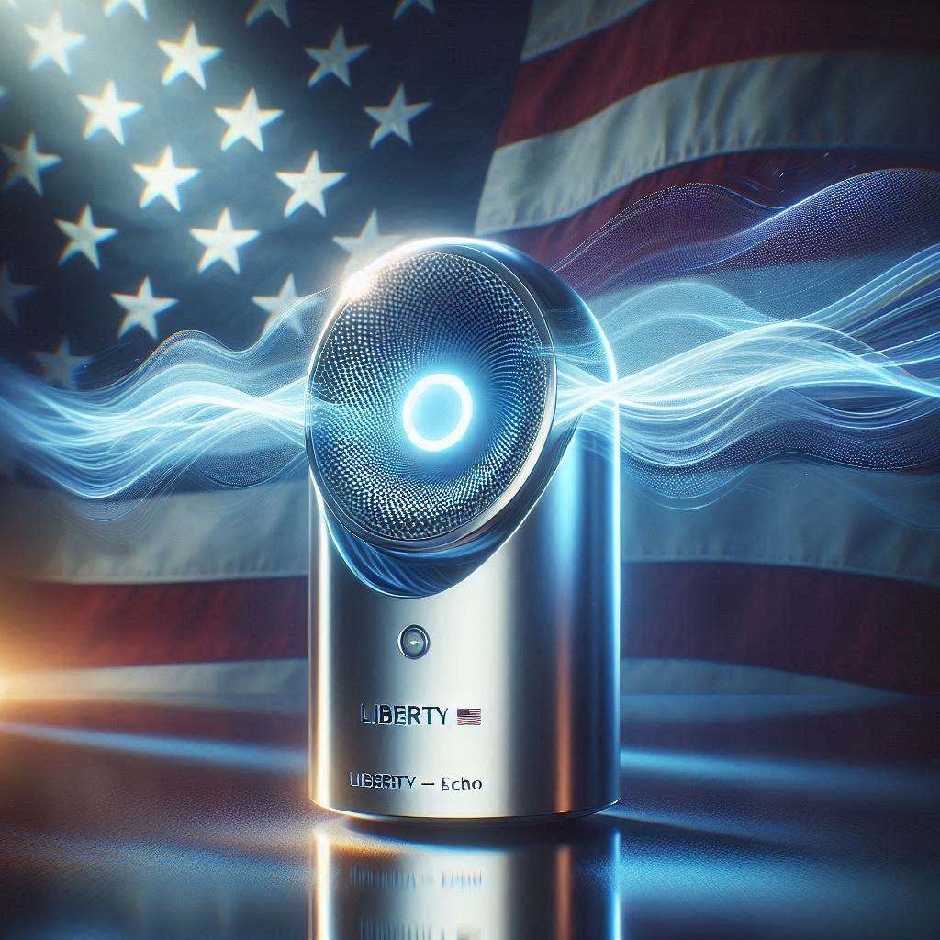
- Freedom’s voice reverberating across New Media Platforms

