**Noje JS Project – Food 24x7**

**Github Link of the project**

<https://github.com/skragarwaltcs/mern/tree/master/back-end/express/food24x7>

1. API for Registration

Create an user

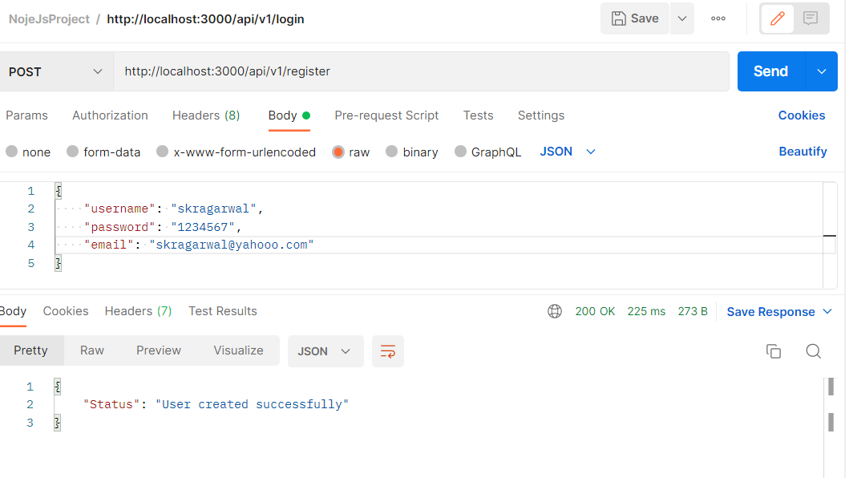

Try to create the same user again

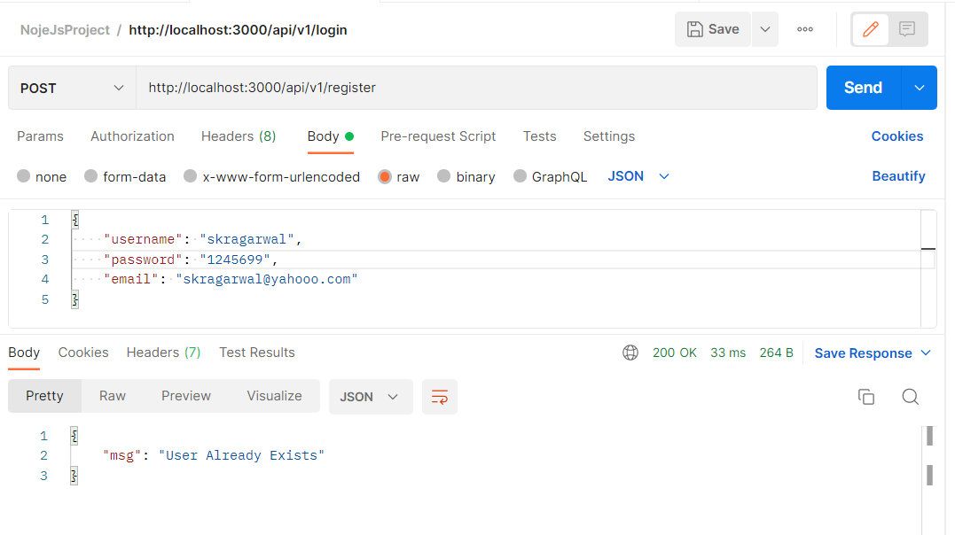

1. API for Login

Login with incorrect password

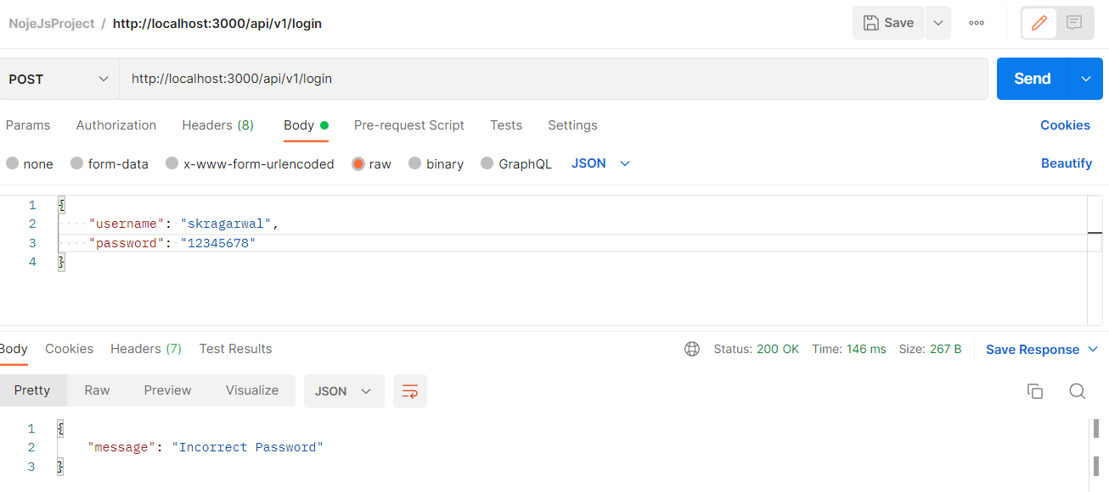

Login with invalid username

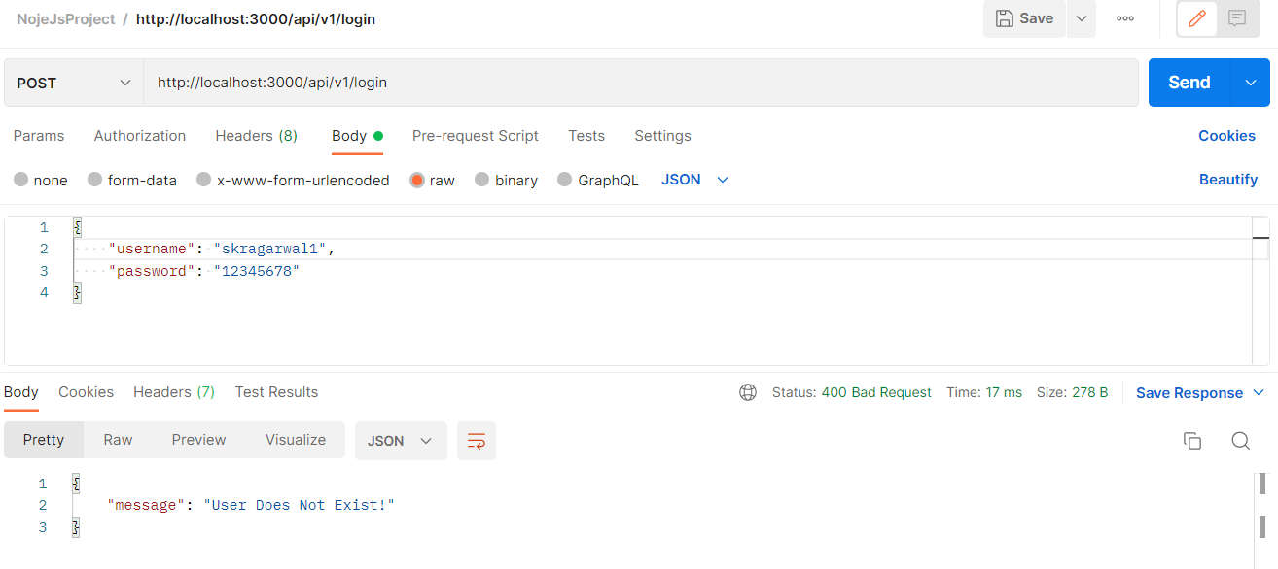

Login with valid username and password

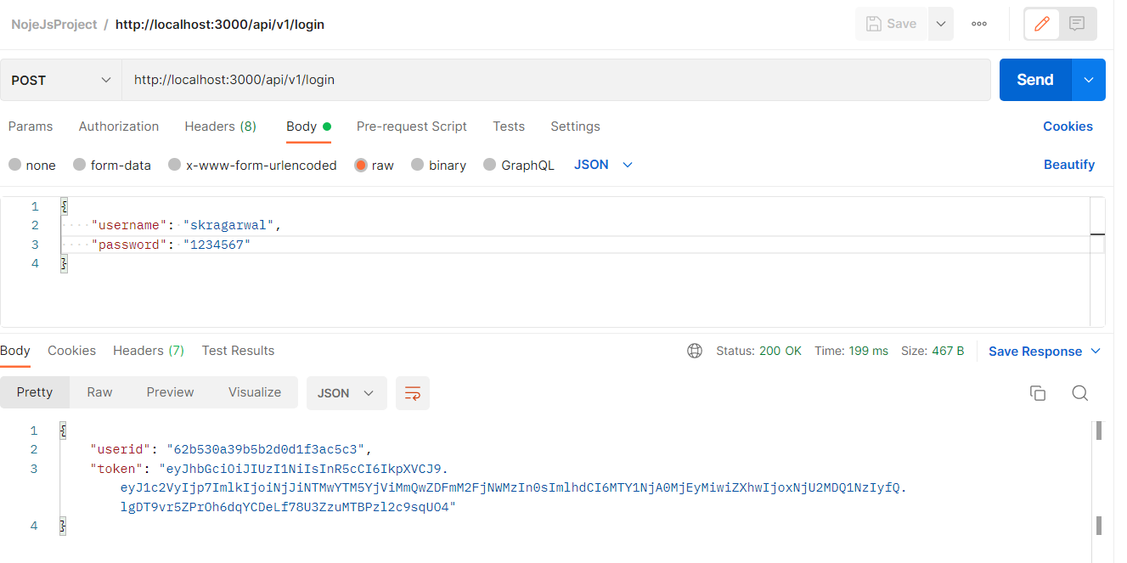

1. API for Products

API endpoint for creating a product

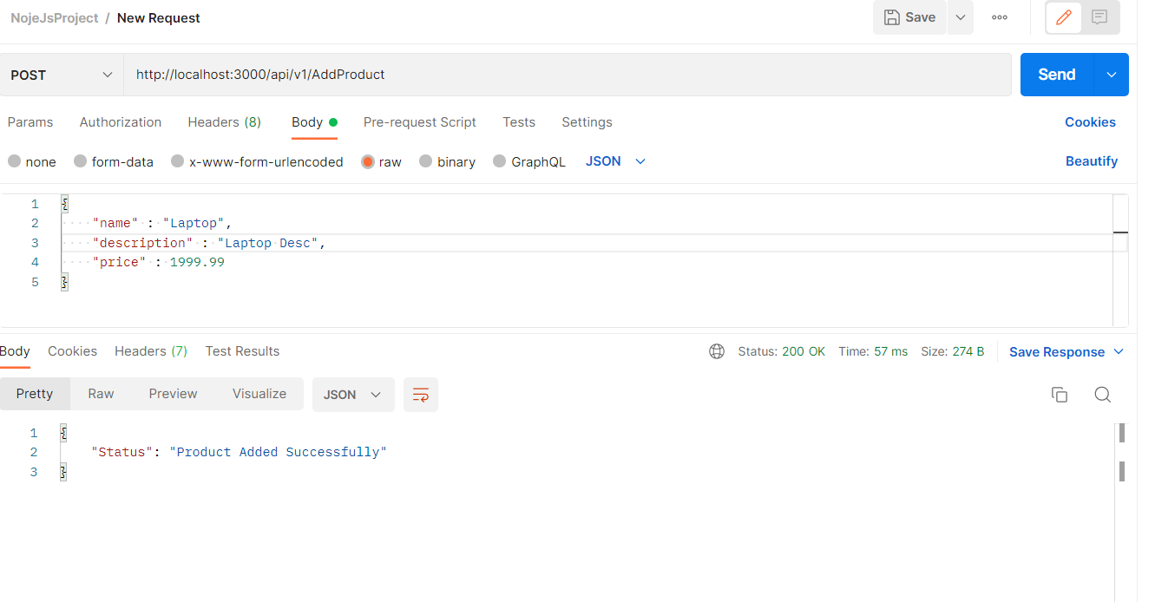

Endpoint to get products

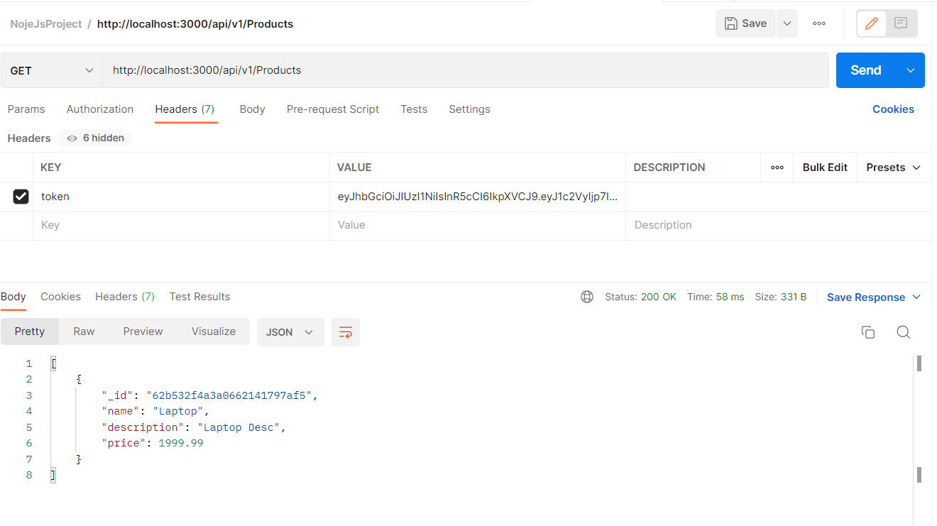

Postman collection of the endpoints

