[API]: /hottestFlower

[方法]: get

[參數]:

{

}

[回應]:

string (“flower1 flower2 flower3 ”) # 用空白分隔

[範例]:

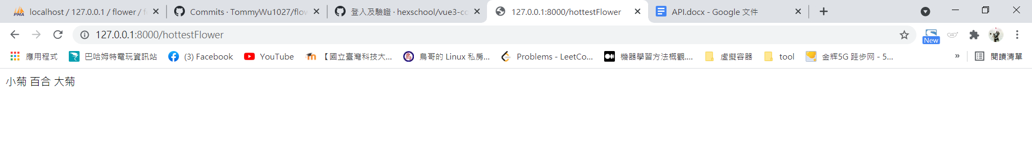

[API]: /upcomingfestival

[方法]: get

[參數]:

{

}

[回應]:

array({“name”: ”festival1”},

{“name”: “festival2”},

…...

)

[範例]

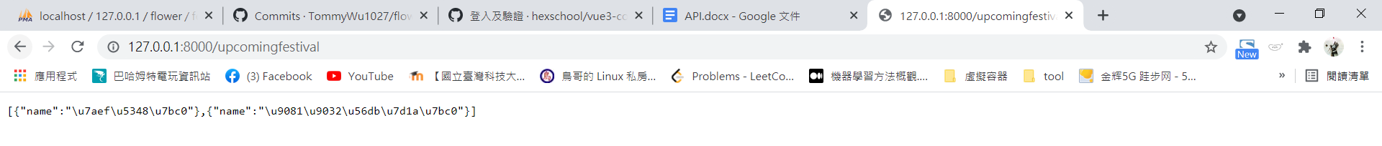

[API]: /festival2flower

[方法]: post

[參數]:

{

“festival”: “XX節"

}

[回應]:

array(

{“name”: “小菊”},

{“name”: “百合”},

...

)

[範例]

request:

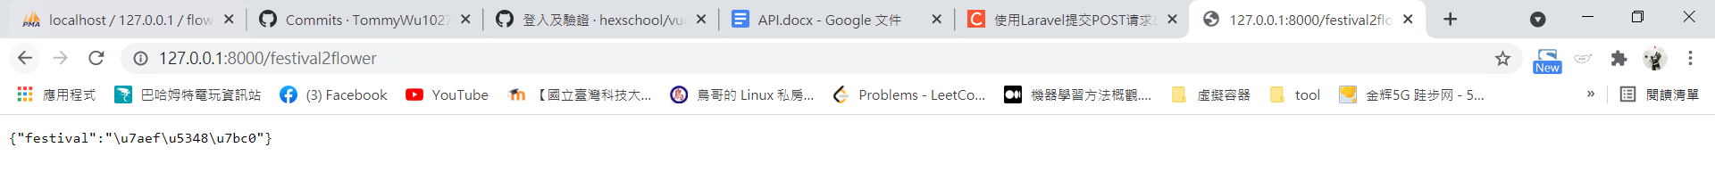

return:



[API]: /flowerspecies

[方法]: post

[參數]:

{

“flower”: “<festival2flower回傳的選擇一個>"

}

[回應]:

array(

{“name”: “百合-白”},

{“name”: “百合-黃”},

...

)

[範例]

request:



return:

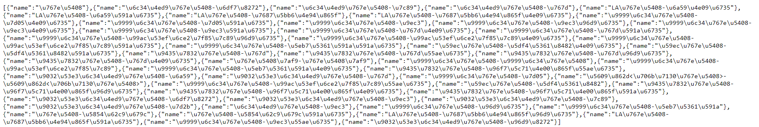

[API]: /flowerArgPrice

[方法]: post

[參數]:

{

“species”: “水仙百合-白”

}

[回應]:

float (123.456789)

[範例]

request:



return:



[API]: /flowermeaning

[方法]: post

[參數]:

{

"label”: “花名” # 所有跟"百合"有關的花與其花語

}

[回應]:

array(

{“id”:1, “name”:”詳細花名”, “label”:“花名”,"description":"..."},

{“id”:2, “name”:”詳細花名”, “label”:“花名”,"description":"..."},

...

)

[範例]

request:

{“label”:”百合”}

return:

