**Authors:** Tommy Xiang, Allen Bai, Steffen Cucos

**School:** York Mills Collegiate Institute

**Date:** Dec 19 2015

**Relevance of emergency requests and emergency station placement**

**Keywords:** Emergency Services / Emergency Station / Resource Distribution / Location Visualization

**Abstract:**

This project was done for the Big Data Challenge hosted by the STEM Fellowship by our group, consisting of three high school students. We decided to use data sets on Toronto’s safety statistics (1-5), which included the number of accidents, ambulance calls and crimes, to produce maps of Toronto that are colour coded in order to show “hot spots” in terms of calls to emergency services. The goal of this was to see if there is existed disproportionately high amounts of requests in some areas compared to the average, and to see if these areas were in fact further away from first responders than others. By mapping the data to a map of Toronto neighborhoods, overlaying the locations of first responders, and finally calculating the average distance to nearest emergency service stations for each neighborhood, we were able to show that there are in fact neighborhoods in Toronto that can be considered to be hotspots for emergency requests, and are further away or similarly distanced from first responders than other neighborhoods with lower accident counts.

**Background:** Our group did all of our research for the Big Data Challenge, a competition hosted by the STEM Fellowship for high school students to compete in as teams. The task was to use Open Data Toronto and the hundreds of available data sets to find some fascinating patterns/observations and to come up with a conclusion based on those findings. After looking through many data sets that we found to be interesting, we decided on a hand full that provided statistics on ambulance calls, major crimes and so on for each of the 141 neighborhoods of Toronto for the years of 2008 and 2011 (2), and data sets that provided the locations of the many ambulance stations, fire stations, and police stations in Toronto (3-5).

The goal that our group set out to accomplish was to see how emergency service requests are distributed throughout the city, and to compare those statistics to the locations of first responders (ambulances, fire department, and police department). We wanted to see if there were areas with a relatively high number of emergency calls and accidents, which were also further away from first responders than average. Doing this research required us to extend our knowledge of programming into the realm of data analysis, which had us learn new and novel ways to use code to interpret large sets of information into a useable form that can be extrapolated from.

Our group selected data sets that were pertinent to the topic of emergency requests, as well as data sets that allowed us to see how far away first responders would be from a particular incident. We hypothesized that there would be areas of high emergency call density that are further away from first responders than most areas, and thus would take longer for help to arrive at. Doing our analysis will allow us to find these areas, and select these locations as potential areas for new fire/ambulance/police stations to be built, so that the time it takes for first responders to arrive at a scene can be made as low as possible.

**Method:** The following method is used to calculate how close a neighborhood is to its nearest emergency service station:

First, 10000 equally spaced sample points are placed on top of the map of toronto. Then, for each point, its distance to the nearest emergency service station is calculated and stored. After that, for each toronto neighborhood, calculate the average result of all the sample points that fall within the border of that neighborhood. The result will be the approximated average distance for each neighborhood to its nearest emergency service station. This result is then inverted (taken reciprocal) to show the closeness of each neighborhood to the nearest station. Finally, we take the percentage of each result over the sum of all results, and compare them with the percentage of number of emergency services required per square kilometer for each neighborhood, and any significant mismatch in these two data will indicate that the location of one or more emergency stations is unbalanced and should be adjusted.

To obtain the result to the calculation, a variety of tools are used to process the data, including Microsoft Excel, Python and a variety of Python modules specialized in data processing (6-12). The "process.py" contains Python code written to visualize the data and to calculate the approximated average distance for each neighborhood to the nearest emergency service station. The program reads the toronto neighborhood shapefile and the number of emergency service request for each neighborhood, then draws a choropleth using the emergency service request data. After that, the program reads in the shapefile containing the location of every emergency service stations, and then calculates the average distance to the stations using the method described above. The program ends by drawing the station locations, outputting the computed data to a file, and saving the image drawn.

Once generated, the output data file is processed using Microsoft Excel. The data set from Wellbeing Toronto that contains the number of emergency requests is also included in. The sum, reciprocal and percentage of each set of data are calculated, and a bar chart is generated for each type of emergency service. The “compiled_data.xlsx” is the final Excel file after processing.

**Results:**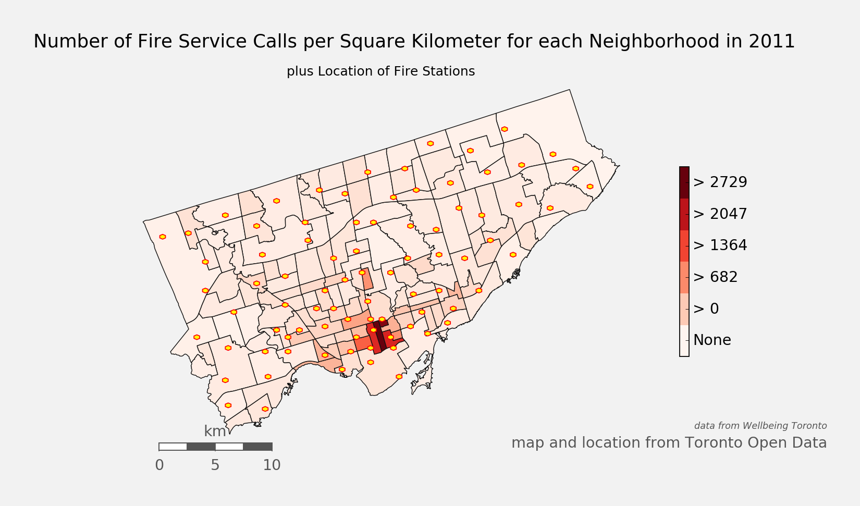

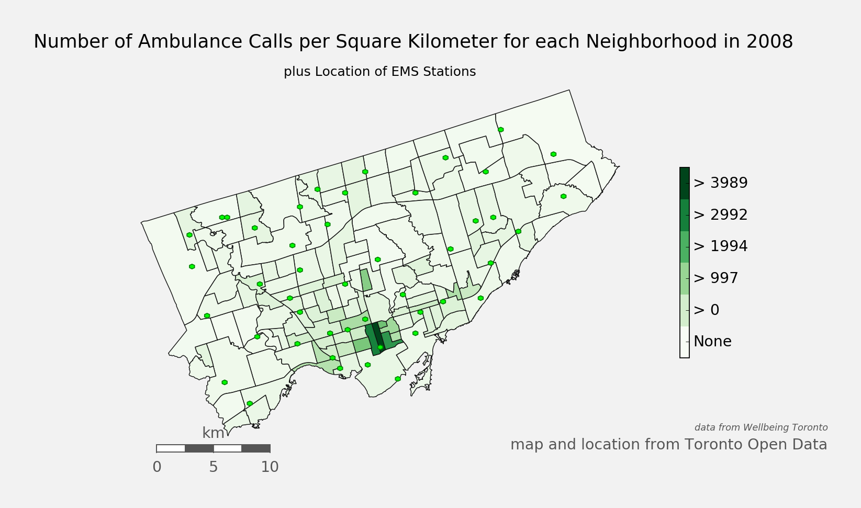

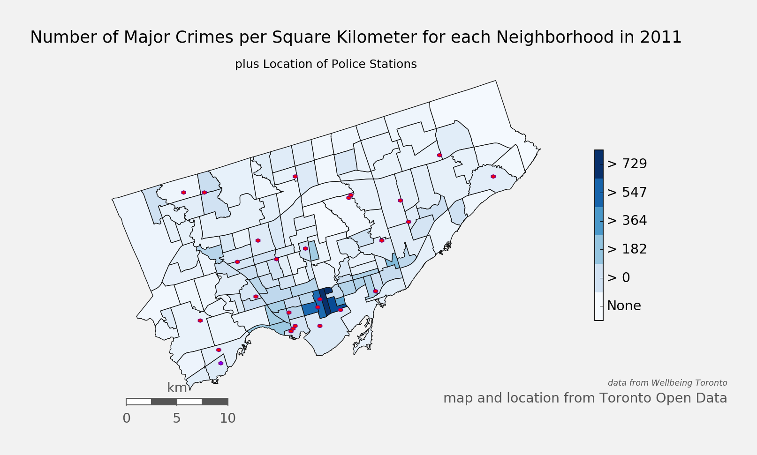

The images generated by our program all show that downtown Toronto receives a great deal many more calls for emergency services than the rest of the city. These regions show up as dark red/green/blue for their respective service, but further analysis is required to determine if these regions have a lower ratio of requests/stations than other regions.

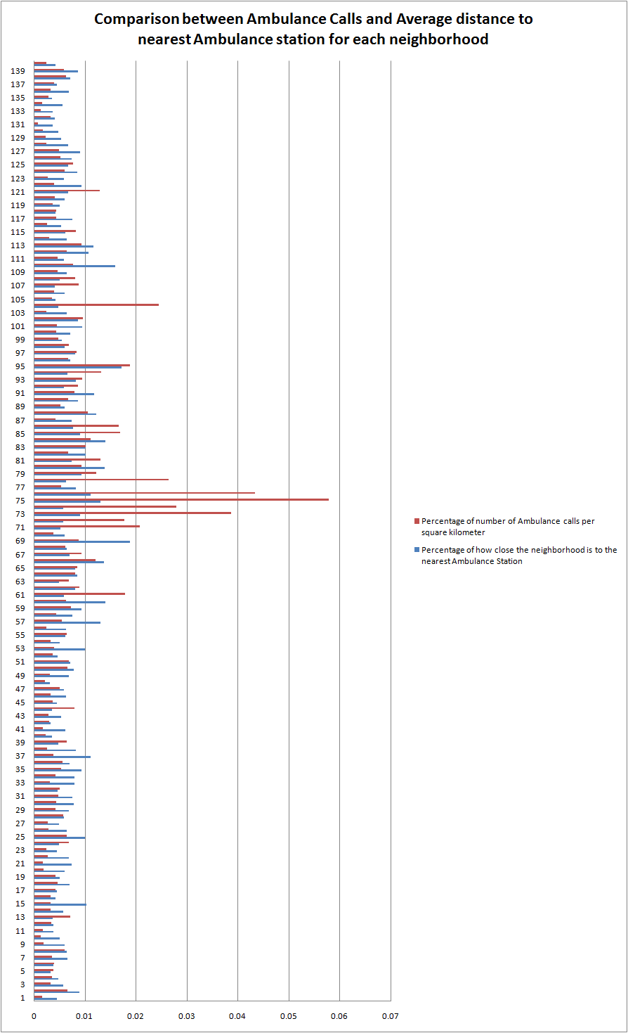

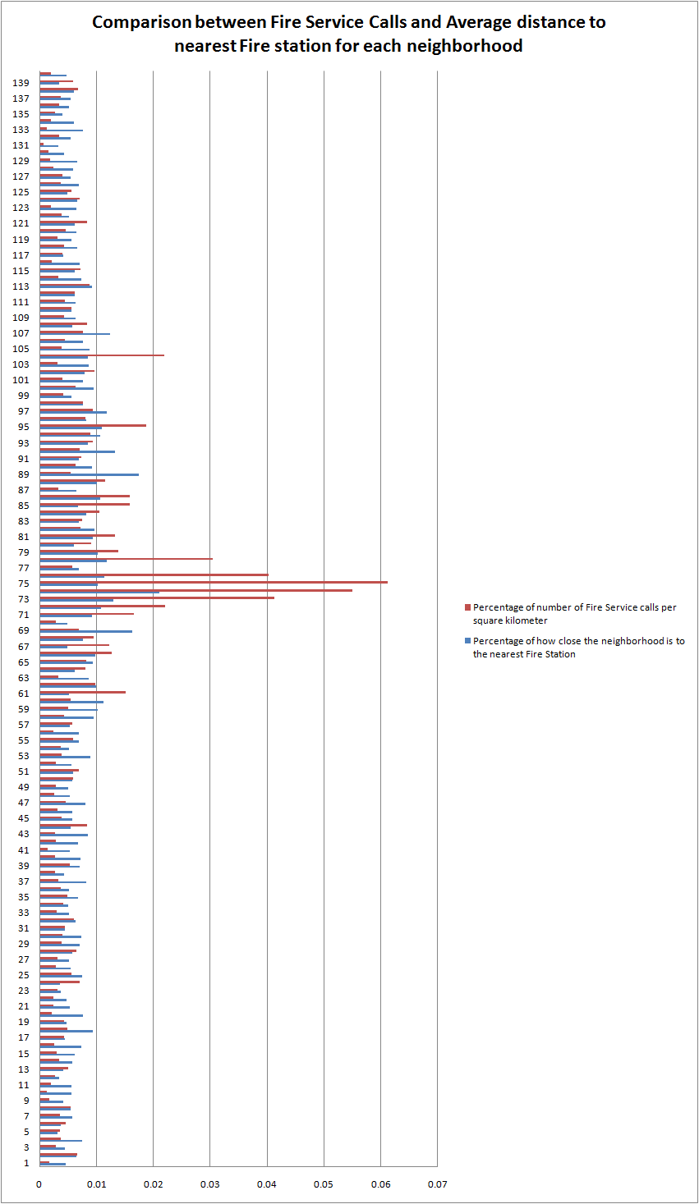

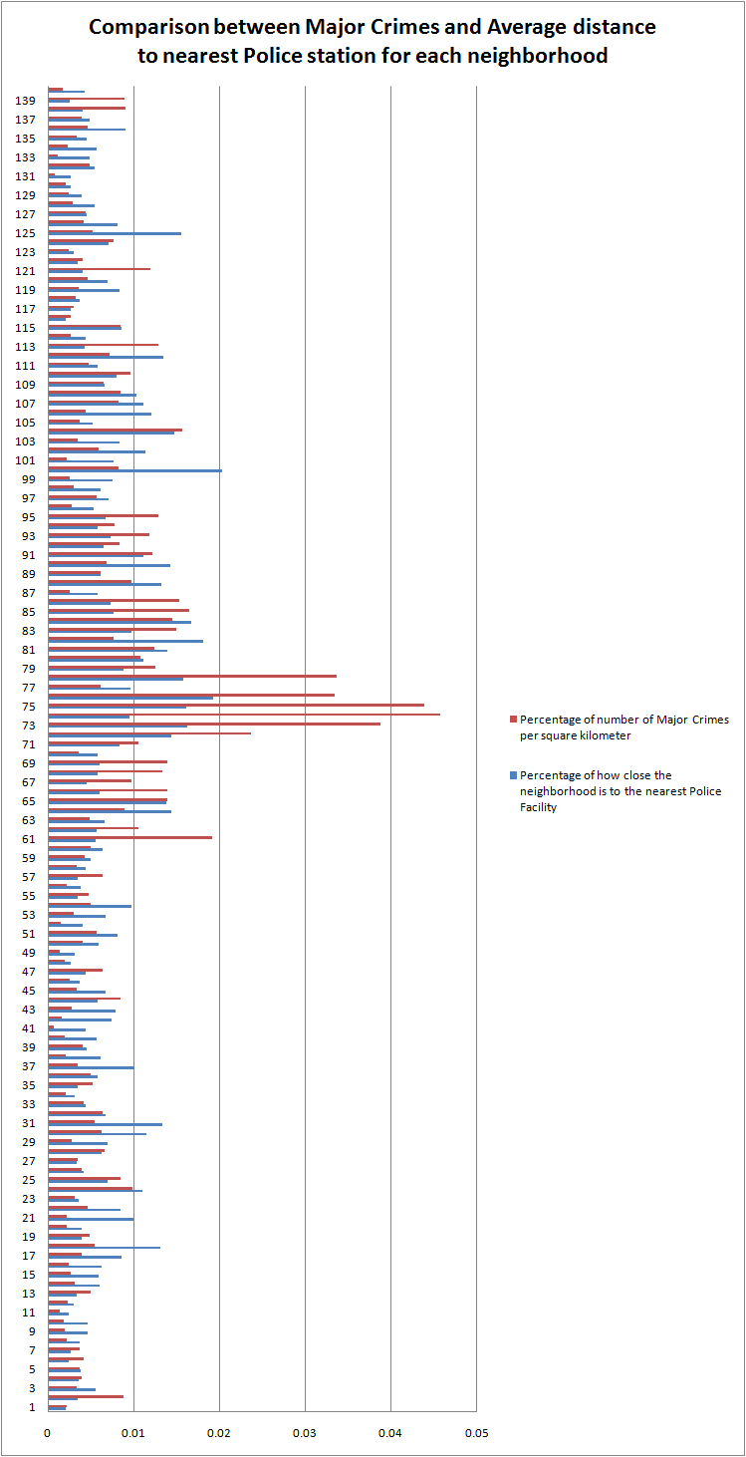

The bar graphs show the relationship between the amount of calls a neighborhood receives, and the average closeness to the nearest police/ambulance/fire station. The vast majority of neighborhoods have low very similarly sized bars for both calls and average distance across all three services, which indicates that these areas have an appropriate amount of services available for the number of calls/requests they receive. However, in all three of the graphs we see that there is a huge spike in number of calls in the downtown core, but there is a disproportionate amount of stations to deal with the increased volume of requests.

**Conclusion**: The results we arrived at show us that there are indeed areas within Toronto that behave like the ones described in our hypothesis: higher ratios of calls versus number of stations close by when compared to the average neighborhood. We see from the bar graphs generated by our code that certain neighborhoods exhibit large spikes in call volume across all three categories, but do not experience a proportional spike in availability of the service. The analysis of our data sets has allowed us to determine that these areas are prime candidates for future stations to built in; be it police stations, fire stations, or ambulance stations, as it would help bring the ratios of calls/availability closer to what can be considered acceptable levels when compared to other neighborhoods.

**Reference:**

***Data Sources:***

***1.*** *Toronto Neighborhood Map:*

Www1.toronto.ca. Neighbourhoods - Locations and mapping - Data catalogue | City of Toronto [Internet]. 2015 [cited 20 December 2015]. Available from: <http://www1.toronto.ca/wps/portal/contentonly?vgnextoid=04b489fe9c18b210VgnVCM1000003dd60f89RCRD&vgnextchannel=75d6e03bb8d1e310VgnVCM10000071d60f89RCRD>

***2.*** *Emergency Service Requests:*

Www1.toronto.ca. Wellbeing Toronto - Safety - Data catalogue - Open Data | City of Toronto [Internet]. 2015 [cited 20 December 2015]. Available from: <http://www1.toronto.ca/wps/portal/contentonly?vgnextoid=b3ff80ece073b410VgnVCM10000071d60f89RCRD>

***3.*** *Ambulance Station Locations:*

Www1.toronto.ca. Ambulance Station Locations - Locations and mapping - Data catalogue | City of Toronto [Internet]. 2015 [cited 20 December 2015]. Available from: <http://www1.toronto.ca/wps/portal/contentonly?vgnextoid=93f91c98d2b6d310VgnVCM10000071d60f89RCRD&vgnextchannel=75d6e03bb8d1e310VgnVCM10000071d60f89RCRD>

***4.*** *Fire Station Locations:*

Www1.toronto.ca. Fire Station Locations - Locations and mapping - Data catalogue | City of Toronto [Internet]. 2015 [cited 20 December 2015]. Available from: <http://www1.toronto.ca/wps/portal/contentonly?vgnextoid=373ef5f39ad5e210VgnVCM1000003dd60f89RCRD&vgnextchannel=75d6e03bb8d1e310VgnVCM10000071d60f89RCRD>

***5.*** *Police Facility Locations:*

Www1.toronto.ca. Police Facility Locations - Locations and mapping - Data catalogue | City of Toronto [Internet]. 2015 [cited 20 December 2015]. Available from: <http://www1.toronto.ca/wps/portal/contentonly?vgnextoid=4071790e6f21d210VgnVCM1000003dd60f89RCRD&vgnextchannel=75d6e03bb8d1e310VgnVCM10000071d60f89RCRD>

***Python Libraries:***

***6.*** *Visualizing Data using Python:*

Hartley T. Visualizing My Location History with Python, Shapely, and Basemap - Beneath Data [Internet]. Beneathdata.com. 2014 [cited 20 December 2015]. Available from: <http://beneathdata.com/how-to/visualizing-my-location-history/>

***7.*** *Matplotlib:*

Matplotlib.org. matplotlib: python plotting â€” Matplotlib 1.5.0 documentation [Internet]. 2015 [cited 20 December 2015]. Available from: <http://matplotlib.org/>

***8.*** *Basemap:*

Matplotlib.org. Welcome to the Matplotlib Basemap Toolkit documentation! â€” Basemap Matplotlib Toolkit 1.0.8 documentation [Internet]. 2015 [cited 20 December 2015]. Available from: <http://matplotlib.org/basemap/>

***9.*** *Shapely:*

Pypi.python.org. Shapely 1.5.13 : Python Package Index [Internet]. 2015 [cited 20 December 2015]. Available from: <https://pypi.python.org/pypi/Shapely>

***10.*** *Pandas:*

Pandas.pydata.org. Python Data Analysis Library â€” pandas: Python Data Analysis Library [Internet]. 2015 [cited 20 December 2015]. Available from: <http://pandas.pydata.org/>

***11.*** *Numpy:*

Numpy.org. NumPy â€” Numpy [Internet]. 2015 [cited 20 December 2015]. Available from: <http://www.numpy.org/>

***12.*** *Fiona:*

Pypi.python.org. Fiona 1.6.2 : Python Package Index [Internet]. 2015 [cited 20 December 2015]. Available from: <https://pypi.python.org/pypi/Fiona>

**Appendix:**

Compiled data generated by python script combined with data from Wellbeing Toronto:

|  |  |  |  |  |  |  |  |
| --- | --- | --- | --- | --- | --- | --- | --- |
| Neighborhood ID | Area (square kilometer) | Average Distance to Ambulance Station | Average Distance to Fire Station | Average Distance to Police Station | 2008 Ambulance Calls | 2011 Fire Medical Calls + Fire Vehicle Incidents + Fires & Fire Alarms | 2011 Total Major Crime Incidents |
| 1 | 30.16004824 | 0.021938796 | 0.015905619 | 0.06350346 | 3613 | 2528 | 1119 |
| 2 | 4.639858703 | 0.011229634 | 0.011246121 | 0.03767411 | 2229 | 1436 | 690 |
| 3 | 3.341142921 | 0.017463552 | 0.016569638 | 0.023619108 | 793 | 461 | 192 |
| 4 | 2.506850622 | 0.020595447 | 0.009680297 | 0.036784921 | 664 | 433 | 164 |
| 5 | 2.932612368 | 0.030892541 | 0.022594072 | 0.034740638 | 836 | 499 | 185 |
| 6 | 5.065728423 | 0.026257556 | 0.019673693 | 0.052920858 | 1447 | 1110 | 351 |
| 7 | 5.520056891 | 0.015128107 | 0.012851449 | 0.048961694 | 1458 | 946 | 342 |
| 8 | 2.80398611 | 0.015371113 | 0.013343815 | 0.034906297 | 1244 | 714 | 106 |
| 9 | 5.514135619 | 0.016602619 | 0.017286012 | 0.028114456 | 795 | 455 | 185 |
| 10 | 5.173772098 | 0.019719887 | 0.013092615 | 0.028185013 | 520 | 312 | 157 |
| 11 | 8.649743354 | 0.026314729 | 0.013036094 | 0.054019495 | 1133 | 805 | 204 |
| 12 | 2.955215628 | 0.026147288 | 0.02121601 | 0.04418885 | 727 | 372 | 113 |
| 13 | 1.797509505 | 0.027192449 | 0.017366721 | 0.039726073 | 938 | 422 | 151 |
| 14 | 16.2474304 | 0.017521332 | 0.01279433 | 0.021694044 | 3953 | 2615 | 853 |
| 15 | 2.639363998 | 0.009737709 | 0.011710036 | 0.022310164 | 626 | 381 | 120 |
| 16 | 7.949462924 | 0.023699973 | 0.00992194 | 0.021141574 | 1930 | 977 | 326 |
| 17 | 7.062226379 | 0.022309756 | 0.016165671 | 0.015281975 | 2203 | 1448 | 466 |
| 18 | 3.482889532 | 0.014378629 | 0.007769024 | 0.010019364 | 1195 | 811 | 321 |
| 19 | 2.262861455 | 0.019549195 | 0.015367497 | 0.032961929 | 706 | 452 | 184 |
| 20 | 4.980696698 | 0.016431131 | 0.009615816 | 0.033494208 | 718 | 507 | 189 |
| 21 | 7.970692445 | 0.013366925 | 0.013725392 | 0.013232066 | 1035 | 891 | 289 |
| 22 | 4.423744592 | 0.014476237 | 0.015435349 | 0.015434734 | 896 | 501 | 345 |
| 23 | 4.278172927 | 0.021826849 | 0.019267368 | 0.036532383 | 765 | 648 | 222 |
| 24 | 3.455427803 | 0.020111681 | 0.020376988 | 0.01188617 | 1712 | 1148 | 572 |
| 25 | 5.152136981 | 0.00995299 | 0.009822001 | 0.01894438 | 2430 | 1371 | 734 |
| 26 | 14.99891383 | 0.015609682 | 0.013348751 | 0.031361468 | 3113 | 2068 | 981 |
| 27 | 13.2525441 | 0.019972539 | 0.014041235 | 0.039676439 | 2605 | 1948 | 776 |
| 28 | 2.097305186 | 0.016733732 | 0.012846819 | 0.021093202 | 887 | 644 | 233 |
| 29 | 2.527589508 | 0.014409763 | 0.010267111 | 0.019013632 | 778 | 460 | 117 |
| 30 | 3.508841428 | 0.012662788 | 0.009926036 | 0.011464248 | 1139 | 666 | 371 |
| 31 | 6.04085315 | 0.01313425 | 0.016521571 | 0.009827217 | 2095 | 1272 | 551 |
| 32 | 3.479554767 | 0.021341302 | 0.011614076 | 0.019657572 | 1299 | 984 | 376 |
| 33 | 4.144266388 | 0.012528494 | 0.014154864 | 0.030091602 | 935 | 596 | 291 |
| 34 | 4.762406984 | 0.012611253 | 0.014718091 | 0.041871033 | 1474 | 931 | 170 |
| 35 | 3.669335241 | 0.010683371 | 0.010918819 | 0.037553058 | 1430 | 846 | 323 |
| 36 | 4.697578782 | 0.014290355 | 0.014294696 | 0.022855381 | 1940 | 826 | 392 |
| 37 | 2.884598397 | 0.008992113 | 0.008988413 | 0.013017666 | 812 | 445 | 168 |
| 38 | 5.348444925 | 0.012079402 | 0.016714533 | 0.021187113 | 1028 | 705 | 186 |
| 39 | 5.520507139 | 0.020680838 | 0.010289013 | 0.028846062 | 2581 | 1380 | 375 |
| 40 | 7.302532427 | 0.028408818 | 0.010122568 | 0.0231518 | 1225 | 951 | 235 |
| 41 | 8.841877645 | 0.016072226 | 0.013866241 | 0.029486033 | 1144 | 627 | 104 |
| 42 | 10.04535533 | 0.030017645 | 0.010862627 | 0.017755042 | 2185 | 1356 | 279 |
| 43 | 4.756986013 | 0.018463945 | 0.008666886 | 0.016643972 | 1022 | 605 | 221 |
| 44 | 2.474154389 | 0.02775633 | 0.013381277 | 0.022592143 | 1447 | 978 | 354 |
| 45 | 7.467131346 | 0.022162221 | 0.012826554 | 0.019698408 | 1988 | 1382 | 423 |
| 46 | 2.968522231 | 0.01576802 | 0.01278612 | 0.035444765 | 725 | 450 | 127 |
| 47 | 4.213931548 | 0.016809568 | 0.009074216 | 0.02968403 | 1576 | 909 | 449 |
| 48 | 5.397566981 | 0.031305626 | 0.013685161 | 0.049299299 | 847 | 642 | 184 |
| 49 | 4.090512011 | 0.0146778 | 0.014428991 | 0.041645452 | 949 | 545 | 96 |
| 50 | 4.086284607 | 0.012817463 | 0.012818062 | 0.022210864 | 1973 | 1134 | 275 |
| 51 | 5.063047322 | 0.014086406 | 0.01252782 | 0.016215196 | 2533 | 1639 | 485 |
| 52 | 5.161146591 | 0.021610864 | 0.012874529 | 0.031998122 | 1373 | 709 | 132 |
| 53 | 2.594152514 | 0.009931203 | 0.008200474 | 0.019407246 | 750 | 470 | 134 |
| 54 | 4.878422322 | 0.019800085 | 0.014039709 | 0.013450487 | 1163 | 855 | 409 |
| 55 | 3.127654699 | 0.01628676 | 0.010527045 | 0.038209799 | 1463 | 877 | 253 |
| 56 | 4.786627121 | 0.015693909 | 0.010528781 | 0.034049748 | 874 | 535 | 178 |
| 57 | 1.746620571 | 0.007657947 | 0.013593818 | 0.037589362 | 702 | 470 | 186 |
| 58 | 2.35071314 | 0.013229173 | 0.007719876 | 0.029770478 | 748 | 477 | 134 |
| 59 | 2.189388802 | 0.010635332 | 0.007163694 | 0.026552673 | 1157 | 512 | 156 |
| 60 | 1.196660984 | 0.007159494 | 0.006547433 | 0.020654289 | 548 | 305 | 101 |
| 61 | 1.063295886 | 0.016736089 | 0.014292676 | 0.023371289 | 1386 | 753 | 343 |
| 62 | 2.6398456 | 0.012295545 | 0.007359305 | 0.023052823 | 1712 | 1209 | 468 |
| 63 | 3.597000187 | 0.020404078 | 0.008508377 | 0.019711287 | 1808 | 557 | 292 |
| 64 | 1.596218571 | 0.011670852 | 0.011893881 | 0.009150054 | 943 | 600 | 239 |
| 65 | 1.675755575 | 0.012380142 | 0.007864302 | 0.009485366 | 1040 | 649 | 392 |
| 66 | 1.120078543 | 0.007294591 | 0.007452923 | 0.021779464 | 989 | 669 | 262 |
| 67 | 0.887914744 | 0.014256994 | 0.014748471 | 0.028866298 | 607 | 514 | 146 |
| 68 | 1.786734825 | 0.015479243 | 0.009615951 | 0.022653562 | 802 | 799 | 402 |
| 69 | 0.94153928 | 0.005308563 | 0.004493921 | 0.021905214 | 604 | 309 | 221 |
| 70 | 10.96861797 | 0.016720561 | 0.015032502 | 0.022762437 | 3086 | 1461 | 660 |
| 71 | 1.418447844 | 0.019066525 | 0.00792444 | 0.015680772 | 2138 | 1103 | 253 |
| 72 | 0.65051903 | 0.01744538 | 0.006796378 | 0.009131313 | 839 | 676 | 259 |
| 73 | 1.4135557 | 0.011042243 | 0.005628538 | 0.008076857 | 3973 | 2740 | 921 |
| 74 | 0.424345969 | 0.017371537 | 0.003471883 | 0.013868315 | 863 | 1094 | 326 |
| 75 | 1.365074769 | 0.007699335 | 0.007166427 | 0.008143247 | 5733 | 3922 | 1006 |
| 76 | 1.809966962 | 0.008976272 | 0.006421058 | 0.006840349 | 5700 | 3419 | 1017 |
| 77 | 13.42130551 | 0.012088568 | 0.010641253 | 0.013726543 | 5208 | 3604 | 1393 |
| 78 | 1.535204984 | 0.015943021 | 0.006206849 | 0.008308159 | 2945 | 2196 | 869 |
| 79 | 1.405771134 | 0.010738068 | 0.007107911 | 0.014844502 | 1246 | 918 | 296 |
| 80 | 1.435830033 | 0.007174227 | 0.012225753 | 0.011832391 | 973 | 611 | 261 |
| 81 | 1.730310161 | 0.013532202 | 0.007823914 | 0.009475677 | 1651 | 1074 | 361 |
| 82 | 3.242547888 | 0.009885113 | 0.007629617 | 0.007240929 | 1582 | 1102 | 417 |
| 83 | 1.388535875 | 0.009875423 | 0.01048642 | 0.01347494 | 1031 | 485 | 348 |
| 84 | 1.216827641 | 0.007103684 | 0.008840195 | 0.007846601 | 985 | 600 | 296 |
| 85 | 2.287944174 | 0.01110745 | 0.010825574 | 0.017252262 | 2817 | 1705 | 634 |
| 86 | 1.50512588 | 0.013005855 | 0.006837578 | 0.017978572 | 1826 | 1123 | 386 |
| 87 | 5.360180508 | 0.013537103 | 0.011169805 | 0.022451478 | 1644 | 832 | 232 |
| 88 | 1.883067988 | 0.008203779 | 0.007293535 | 0.009976829 | 1448 | 1022 | 309 |
| 89 | 1.594643044 | 0.016398153 | 0.00421483 | 0.021442027 | 612 | 414 | 165 |
| 90 | 2.632954651 | 0.011613767 | 0.007898651 | 0.009188224 | 1290 | 783 | 304 |
| 91 | 1.461200469 | 0.00845111 | 0.010485953 | 0.011827071 | 855 | 503 | 300 |
| 92 | 1.885443325 | 0.016822205 | 0.005549794 | 0.020265045 | 1195 | 626 | 264 |
| 93 | 3.727362051 | 0.012228521 | 0.008668019 | 0.017960398 | 2592 | 1647 | 743 |
| 94 | 1.682721508 | 0.015164996 | 0.006890393 | 0.022829832 | 1611 | 703 | 220 |
| 95 | 2.791395849 | 0.005842794 | 0.006712309 | 0.019524708 | 3828 | 2464 | 604 |
| 96 | 1.923172033 | 0.013882127 | 0.008839934 | 0.024737375 | 942 | 735 | 91 |
| 97 | 1.161740768 | 0.012381632 | 0.006184882 | 0.018704919 | 711 | 515 | 111 |
| 98 | 4.670670913 | 0.016596386 | 0.009549236 | 0.021466482 | 2360 | 1680 | 237 |
| 99 | 3.090057754 | 0.018098276 | 0.012983254 | 0.017441176 | 1093 | 607 | 135 |
| 100 | 1.651069992 | 0.013950871 | 0.007715061 | 0.006474711 | 523 | 488 | 229 |
| 101 | 2.480899958 | 0.010621146 | 0.009671996 | 0.017104834 | 812 | 473 | 92 |
| 102 | 1.569731532 | 0.011495757 | 0.009189536 | 0.011544154 | 1097 | 714 | 155 |
| 103 | 3.243675757 | 0.015379793 | 0.008461682 | 0.015717477 | 587 | 474 | 191 |
| 104 | 1.34375226 | 0.020869536 | 0.008641216 | 0.008942055 | 2394 | 1387 | 355 |
| 105 | 2.290822768 | 0.023854333 | 0.008375528 | 0.025303549 | 588 | 422 | 141 |
| 106 | 1.871939839 | 0.016581047 | 0.009664994 | 0.01093339 | 541 | 398 | 139 |
| 107 | 2.220286457 | 0.024042393 | 0.005891673 | 0.011845095 | 1415 | 803 | 307 |
| 108 | 1.831092853 | 0.019487617 | 0.012817811 | 0.012711506 | 1090 | 718 | 259 |
| 109 | 1.545070308 | 0.015511047 | 0.011457248 | 0.019998207 | 519 | 310 | 170 |
| 110 | 1.751517439 | 0.00629229 | 0.013002421 | 0.016312089 | 981 | 461 | 283 |
| 111 | 5.072943444 | 0.017110003 | 0.011531695 | 0.02259999 | 1730 | 1052 | 404 |
| 112 | 1.834376262 | 0.009349513 | 0.011869751 | 0.009758409 | 854 | 540 | 222 |
| 113 | 2.566779019 | 0.008589578 | 0.007966158 | 0.030259907 | 1757 | 1066 | 554 |
| 114 | 1.782653911 | 0.015526278 | 0.009983285 | 0.030012054 | 385 | 275 | 81 |
| 115 | 2.130304949 | 0.016035919 | 0.011715355 | 0.015407095 | 1281 | 718 | 302 |
| 116 | 4.56293134 | 0.018892239 | 0.010389363 | 0.063236311 | 868 | 473 | 205 |
| 117 | 7.157284144 | 0.01319037 | 0.017318218 | 0.049227424 | 2266 | 1367 | 367 |
| 118 | 5.424200908 | 0.023780193 | 0.011000656 | 0.035245886 | 1722 | 1098 | 292 |
| 119 | 10.26761166 | 0.019843042 | 0.013175596 | 0.015792346 | 2782 | 1536 | 620 |
| 120 | 7.399970201 | 0.016627901 | 0.011195968 | 0.019006804 | 2245 | 1588 | 583 |
| 121 | 1.879205571 | 0.014938525 | 0.011951746 | 0.032468994 | 1773 | 736 | 376 |
| 122 | 6.010997495 | 0.010622791 | 0.013934685 | 0.038014488 | 1753 | 1117 | 411 |
| 123 | 7.19379569 | 0.016783816 | 0.011368865 | 0.043762513 | 1451 | 679 | 289 |
| 124 | 3.581986964 | 0.011695621 | 0.011160132 | 0.018498168 | 1592 | 1182 | 461 |
| 125 | 1.953532964 | 0.014774353 | 0.014898111 | 0.00847725 | 1102 | 513 | 173 |
| 126 | 6.014128475 | 0.013543078 | 0.010638427 | 0.016263368 | 2290 | 1069 | 419 |
| 127 | 7.458887342 | 0.011012537 | 0.013492531 | 0.029040726 | 2682 | 1398 | 546 |
| 128 | 7.87589184 | 0.014790401 | 0.012486278 | 0.024295626 | 1415 | 916 | 380 |
| 129 | 7.264406834 | 0.018808415 | 0.011009383 | 0.03286927 | 1255 | 632 | 296 |
| 130 | 9.481110241 | 0.020714333 | 0.017178374 | 0.049101911 | 1207 | 697 | 325 |
| 131 | 37.54571755 | 0.027261139 | 0.022522261 | 0.050238513 | 2376 | 1354 | 534 |
| 132 | 8.869114169 | 0.024200941 | 0.013438014 | 0.0241625 | 2095 | 1436 | 729 |
| 133 | 5.469814364 | 0.027127421 | 0.009579193 | 0.026939147 | 557 | 338 | 107 |
| 134 | 5.249612131 | 0.017587842 | 0.011988517 | 0.023020494 | 624 | 480 | 207 |
| 135 | 5.7419101 | 0.028015244 | 0.017944144 | 0.0291401 | 1231 | 734 | 330 |
| 136 | 9.628154503 | 0.014607325 | 0.014099885 | 0.014590216 | 2323 | 1561 | 749 |
| 137 | 12.33805194 | 0.022050773 | 0.013378673 | 0.02727843 | 3607 | 2192 | 808 |
| 138 | 3.22427568 | 0.013925397 | 0.011969863 | 0.032279071 | 1500 | 1019 | 492 |
| 139 | 3.152021453 | 0.01164163 | 0.021202737 | 0.051544727 | 1364 | 867 | 474 |
| 140 | 3.805502424 | 0.023684536 | 0.015496848 | 0.03036899 | 688 | 356 | 113 |
|  |  |  |  |  |  |  |  |
| Sum | 642.7677534 | 2.242936234 | 1.615230046 | 3.377365451 | 215064 | 134502 | 49158 |