**Linux Basic Commands and VI Editor**

**Common shortcuts**

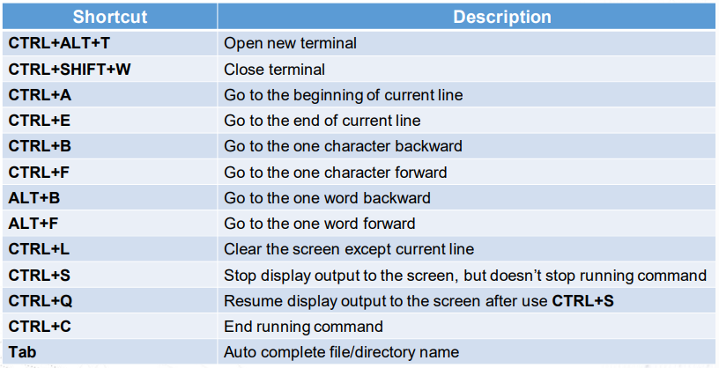

**File management commands**

Ls [option] [file]: list info about files (-l –ld –a -1)

Mv [option] [sources/dir] [destination/dir]: move/rename file + dir (--backup, -f, -I, -n)

Cd: change dir

Pwd: print current dir

Cp [option] [source] [destination/dir]: copy files to files/dir

Rm/rmdir: remove file/dir

Chmod: change file permission

Mkdir: create directory

Touch:update timestamp/create a file

Cat:view contents of a file

Vi:edit a file

Man:manual

**Other command**

Hostname, passwd, whoami, who, w, last, find, grep, ln

**Find command**

Find [dir] [type] [option] [name]

Type: expression determines what to find (-name, -path, -readable,...)

[option] : -exec, -ok, -print,…

[name] : what to find

**Grep command**

Grep [option] Pattern [file]

[Option]:

-r : search recursively, ie. Read all files under directory

-i : search for a string case insensitively

-w : search for a word case insensitively

-c : number of times that pattern has been matched

**Chmod command**

Format drwxrwxrwx

First char : ‘d’ directory, ‘l’ symbolic link, ‘-‘ otherwise

Next 3 rwx: user, group, everyone

Rwx: read write execute

* Chmod [Option] Mode [File]
  + Mode : [ugoa…][-+=][rwx…]

u : The file owner.

g : The users who are members of the group.

o : All other users.

a : All users, identical to ugo

- : Removes the specified permissions.

+ : Adds specified permissions.

= : Changes the current permissions to the specified permissions

r -> file can be read, represented by a value of 4

w -> file can be modified, represented by a value of 2

x -> file can be executed, represented by a value of 1

No permission = 0

**Ln command**

Hard link: create link to DATA, delete all file but keep 1 in any place -> DATA still be remained. Syntax : ln [option] [target] [link]

Symbolic link: create link to SOURCE FILE, delete source file will cause lose all data. Syntax : ln -s [option] [target] [link]

**VI editor**

