1. Dùng tăm chỉnh switch về **QSPI Mode**

4.2.1 For H3/M3/M3N/E3 
a) QSPI Mode 
Switch 
Number 
SWI 
SW2 
SW3 
SWIO 
SW31*1 
Switch 
Name 
QSPI-A 
QSPI-B 
QSPI-C 
MODESW-A 
QSPI-D 
Pini 
ON 
ON 
set(OFF) 
OFF 
Pin2 
ON 
ON 
Pin3 
ON 
ON 
Refer to 2.2 
*I: Only E3 System Evaluation Board needs to set SW31. 
b) Hyper Flash Mode 
Pin4 
ON 
ON 
Pin4 
OFF 
OFF 
Refer to 2.2 
Pin5 
ON 
ON 
ON 
Pin5 
OFF 
OFF 
Pin6 
ON 
ON 
OFF 
Pin6 
OFF 
OFF 
Pin7 
ON 
Pin7 
Pin8 
ON 
Pin8 
Switch 
Number 
SWI 
SW2 
SW3 
SW10 
SW31*1 
Switch 
Name 
QSPI-A 
QSPI-B 
QSPI-C 
MODESW-A 
QSPI-D 
Pinl 
OFF 
OFF 
ON 
Pin2 
OFF 
OFF 
Set(ON) 
Pin3 
OFF 
OFF 

 From yocto guilde ta tìm qua 2.2 /JUN-2024/RENESAS\_RCH3M3M3NE3D3\_YoctoStartupGuide\_UME\_v5.9.4\_06\_Body.pdf

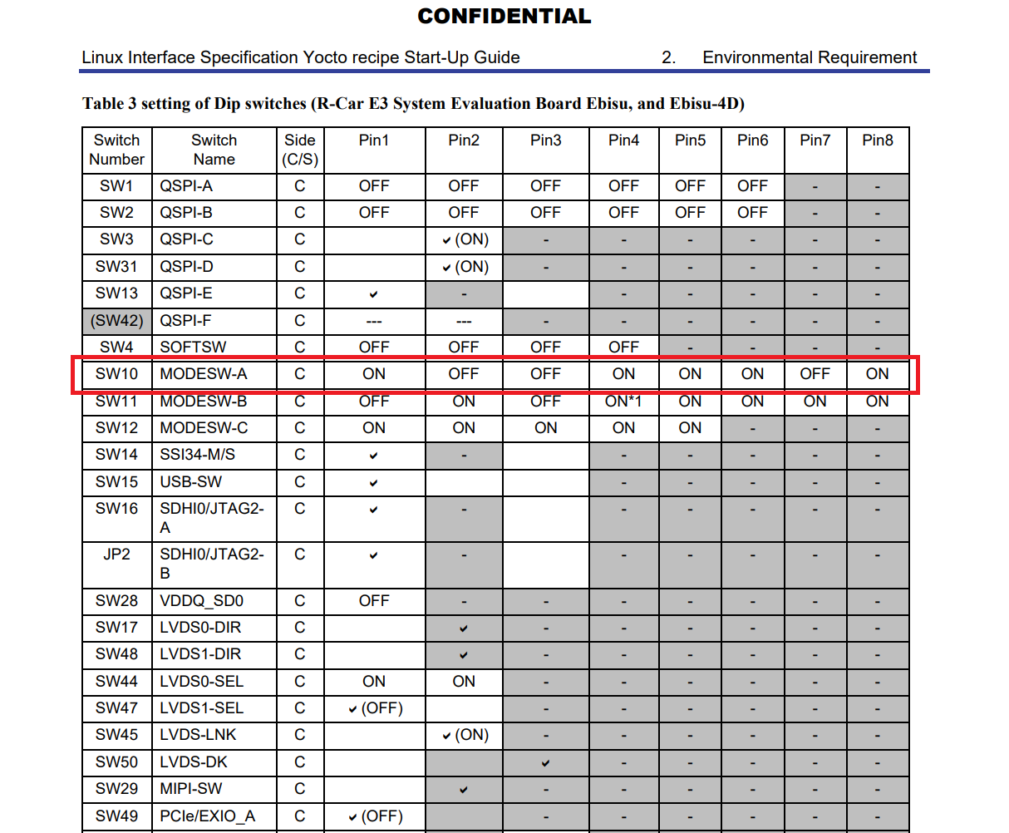

1. Bật nguồn
2. Gõ trên tetra term

--> xls2 --> Bấm Enter --> Chọn 3

1. Chỉnh sw1, sw2 off, sw3 on
2. Nhấn Y trên tetra term
3. Nhập Program Top Address cho từng file

4.1 
Writing data 
Filename 
bootparam_sa0* 
b12-* 
cert_header_sa6* 
b131 
u-boot-elf-* 
Program Top 
Address 
OxE6320000 
OxE6304000 
OxE6320000 
Flash Save 
Address 
oxoooooo 
oxl 80000 
oxl COOOO 
Description 
Loader(Boot parameter) 
Loader 
Loader(Certification) 
ARM Trusted Firmware 
OP-Tee 
U-Boot 

1. Chọn file tương ứng
2. File -> Send file... rồi chọn file

4.1 
Writing data 
Filename 
bootparam_sa0* 
b12-* 
cert_header_sa6* 
b131 
u-boot-elf-* 
Program Top 
Address 
OxE6320000 
OxE6304000 
OxE6320000 
Flash Save 
Address 
oxoooooo 
oxl 80000 
oxl COOOO 
Description 
Loader(Boot parameter) 
Loader 
Loader(Certification) 
ARM Trusted Firmware 
OP-Tee 
U-Boot 

1. Please repeat the xls2 command, if other files are written.
2. Power OFF.
3. Set dip switch to “Hyper Flash Mode”. Note) SW1, SW2, and SW3 are already Hyper Flash mode. Please set SW10.