Instructions for opening raw images with YUView and rawpixels web

Rev. 1.00

May/16/2022

This document describes how to open raw images with YUView and rawpixels web

References

* N/A

|  |  |  |  |  |
| --- | --- | --- | --- | --- |
| Rev. | Modified points | Approver | Checker | Author |
| 1.0 | Newly created | Bac Huynh  (Dec/03/2022) | Hung Bui (Nov/30/2022) | Tran Co Tam  (May/10/2022) |
|  |  |  |  |  |

Table of Contents

1. Open raw images with YUView 3

1.1 Description 3

1.2 Download 3

1.3 Open YUView 3

1.4 Result 7

2. Open raw images with rawpixels web 8

2.1 Description 8

2.2 Acces to rawpixels web 8

2.3 Rawpixels web 8

2.4 Result 10

# Open raw images with YUView

## Description

- Simple navigation/zooming in the video

- Support for a wide variety of YUV formats using various subsamplings and bit depts

- Support for raw RGB files, image files and image sequences

- Direct decoding of raw h.265/HEVC bitstreams with visualization of internals like prediction modes and motion vectors and many more

- Interface with visualization for the reference software decoders HM and JEM

- Support for opening almost any file using FFmpeg

- Image comparison using side-by-side and comparison view

- Calculation and display of differences (in YUV or RGB colorspace)

- Save and load playlists

- Overlay the video with statistics data

## Download

Clone source code in github: <https://github.com/IENT/YUView.git>

Build:

|  |
| --- |
| mkdir build  cd build  C:\Qt\somewhere\qtbase\bin\qmake.exe YUView.pro  make # For MinGW |

## Open YUView

Run YUView.exe:

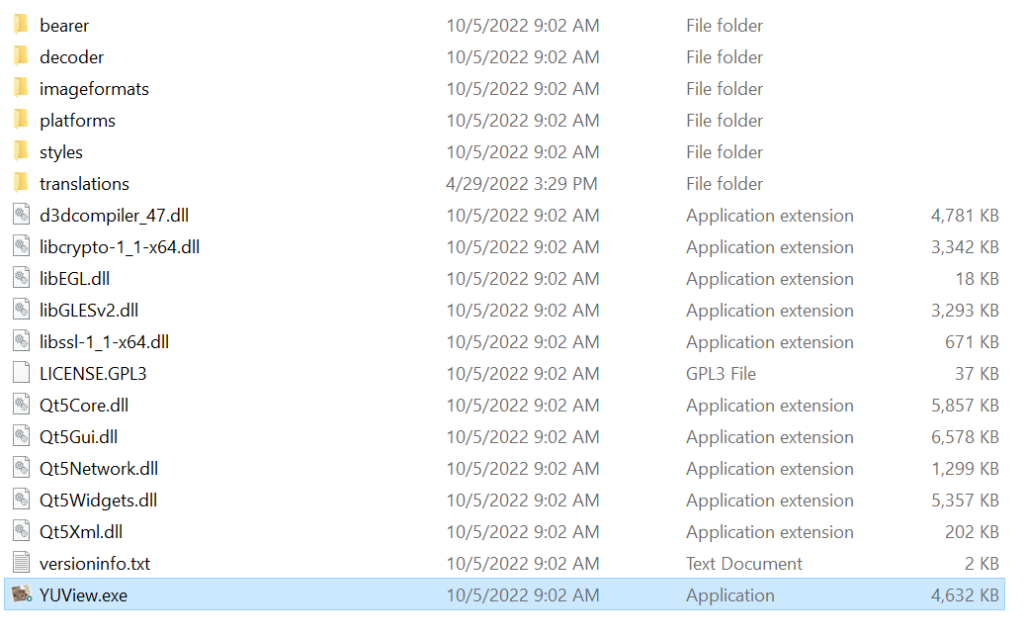

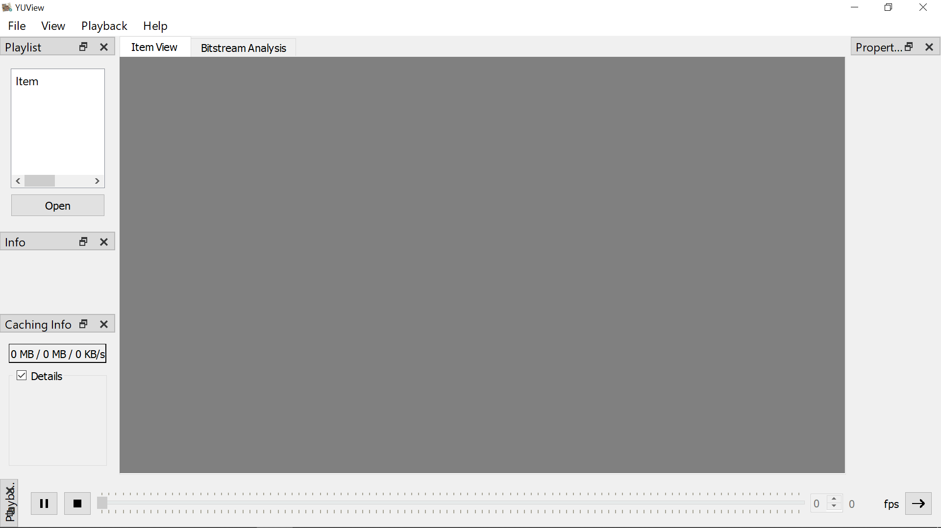

Open file YUV

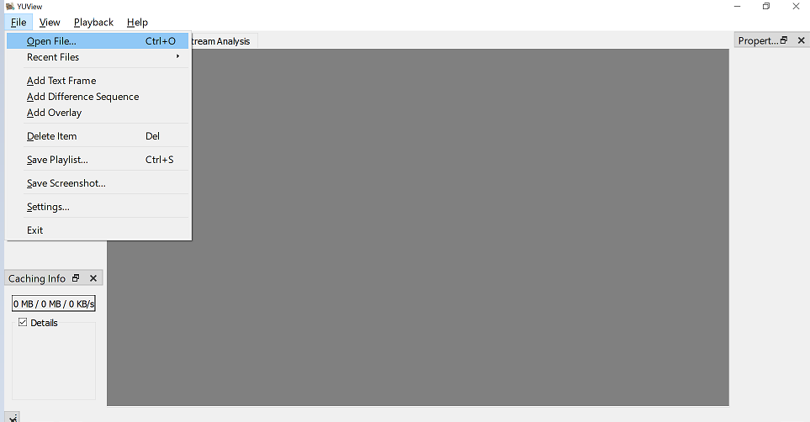

Setting parameter:

We just need to pay attention to some information

-Width: the width of picture

-Height: the height of picture

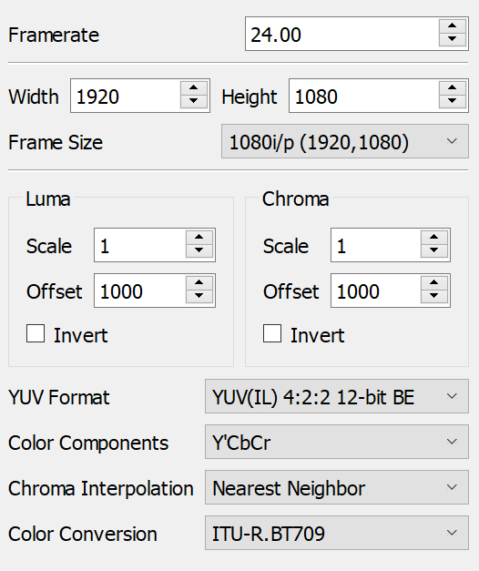

Color components:



There are four choices:

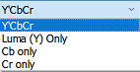

The YUV model defines one luminance component (Y) meaning physical linear-space brightness, and two chrominance components, called U (blue projection) and V (red projection) respectively.

Choose component which you want to show.

Chose YUV Format:

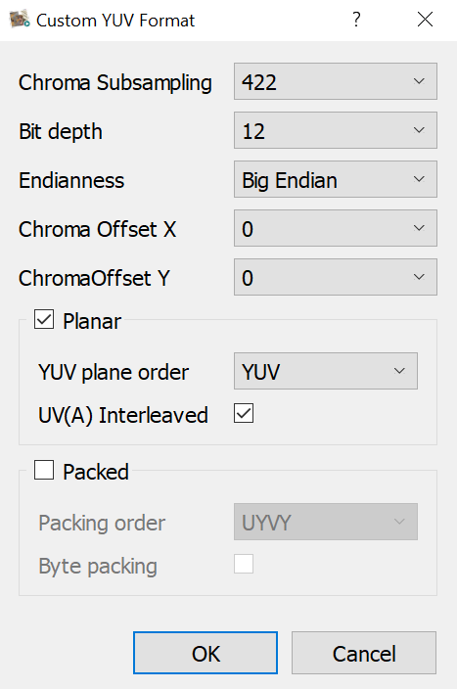

**Chroma Subsampling**: base on setting in source code we chose 4:4:4, 4:4:2 or 4:2:0

In the 4×2 grid sample above, 4:4:4 represents no chroma subsampling used, whereas 4:2:2 has every other pixel duplicated, and 4:2:0 has bottom pixels copying top pixels.

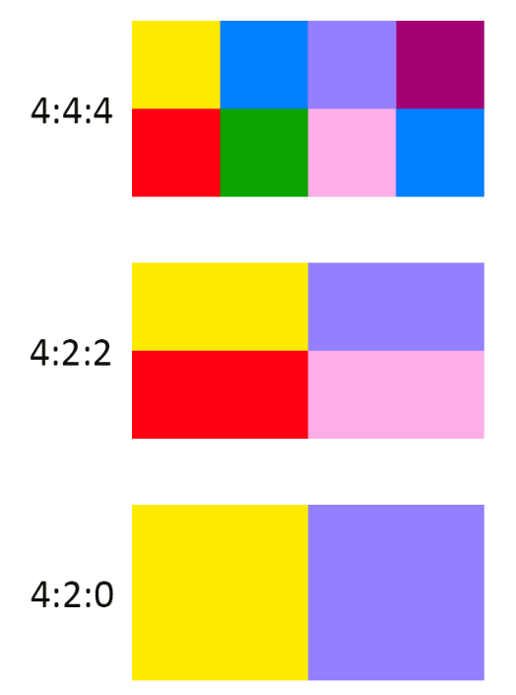

**Bit depth**: Bit depth refers to the color information stored in an image. The higher the bit depth of an image, the more colors it can store. The simplest image, a 1 bit image, can only show two colors, black and white. That is because the 1 bit can only store one of two values, 0 (white) and 1 (black). An 8 bit image can store 256 possible colors, while a 24 bit image can display over 16 million colors.

**Endianness:** is the order or sequence of bytes of a word of digital data in computer memory. Endianness is primarily expressed as big-endian (BE) or little-endian (LE)

**Planar and Packed: is chose base on source code**

UV formats are either:

1. Packed (or interleaved)

2. Planar (the names of those formats often end with "p")

3. Semi-planar (the names of those formats often end with "sp")

Those terms define how the planes are ordered in the format. In the memory:

1. Packed means the components of Y, U, and V are interleaved. For instance: Y1U1Y2V1Y3U2Y4V2…Yn-1Un/2YnVn/2.

2. Planar means the components of Y, U, and V are respectively grouped together. For instance: Y1Y2…YnU1U2…Un/2V1V2…Vn/2.

3. Semi-planar means the components of Y are grouped together, and the components of U and V are interleaved. For instance: Y1Y2…YnU1V1U2V2…Un/2Vn/2

Semi-planar formats are sometimes put in the Planar familly.

## Result

# Open raw images with rawpixels web

## Description

This application allows you analyze raw image data, you can display memory dumps of frame buffers, video buffers and uncompressed video files. Play with image parameters below to explore world of colors.

## Acces to rawpixels web

<https://rawpixels.net/>

## Rawpixels web

Choose file which we wanna open:



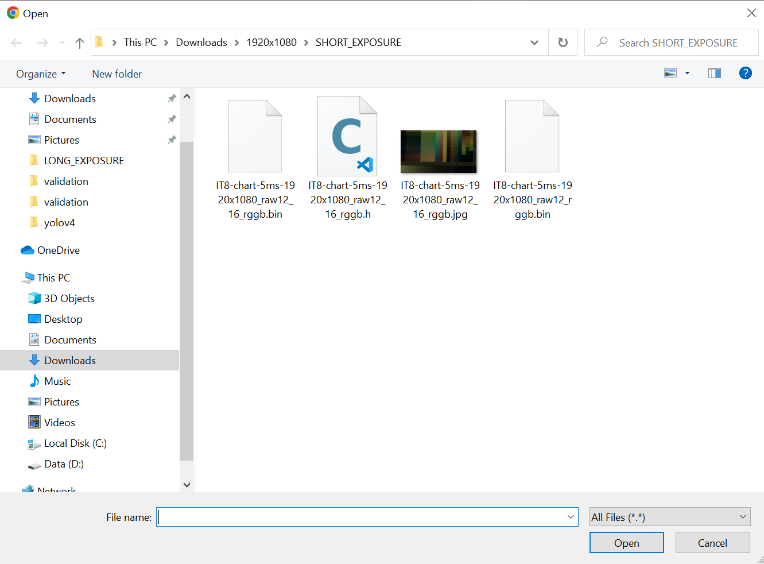



This is format of your picture. Example: RGB24 this mean your format picture is RGB 24 bit.

**Pixel Format:** The Pixel Format is related to the color channel or color space of the visual data. It describes how the color data is encoded and organized. Usually, the value given for the Pixel Format in a file includes the bits per pixel (bpp) and the color channel or model. Example: RGB have three color channel, red green blue per pixel.

**Bit per planar**



Example RGB have three planars, they are red, green blue. Each of them is described by 16bit, and expressed as big-endian (BE).



**Planar and Packed: is chose base on source code**

Example with YUV picture:

UV formats are either:

1. Packed (or interleaved)

2. Planar (the names of those formats often end with "p")

3. Semi-planar (the names of those formats often end with "sp")

Those terms define how the planes are ordered in the format. In the memory:

1. Packed means the components of Y, U, and V are interleaved. For instance: Y1U1Y2V1Y3U2Y4V2…Yn-1Un/2YnVn/2.

2. Planar means the components of Y, U, and V are respectively grouped together. For instance: Y1Y2…YnU1U2…Un/2V1V2…Vn/2.

3. Semi-planar means the components of Y are grouped together, and the components of U and V are interleaved. For instance: Y1Y2…YnU1V1U2V2…Un/2Vn/2

Semi-planar formats are sometimes put in the Planar familly.

## Result

