**RULE WFH**

**Check in, Checkout**

**Principle:**

[**https://banviencorp-my.sharepoint.com/:p:/g/personal/vien_nguyen_banvien_com_vn/EZ98lOmLvJZAh86bJsWq_PgBHTyrwcyZoRKVg4pvhqqpUA?e=Uc0eg7**](https://banviencorp-my.sharepoint.com/:p:/g/personal/vien_nguyen_banvien_com_vn/EZ98lOmLvJZAh86bJsWq_PgBHTyrwcyZoRKVg4pvhqqpUA?e=Uc0eg7)

Time send email check in:

**Morning**:    From 8h - 8h30

**Afternoon**:  After finishing work

Fill time-log after finishing work:

[**https://banviencorp-my.sharepoint.com/:x:/g/personal/hung_bui-viet_banvien_com_vn/Ed_6ro57gt1NvK08BES5bh8B47f7hzkJvlUNKWkcClKTOQ?e=bCv2LG**](https://banviencorp-my.sharepoint.com/:x:/g/personal/hung_bui-viet_banvien_com_vn/Ed_6ro57gt1NvK08BES5bh8B47f7hzkJvlUNKWkcClKTOQ?e=bCv2LG)

Email group:

**bv-rvc-rcar-mmp@banvien.com.vn**

**bv-rvc-rcar-adas@banvien.com.vn**

Example :

**Check in:**

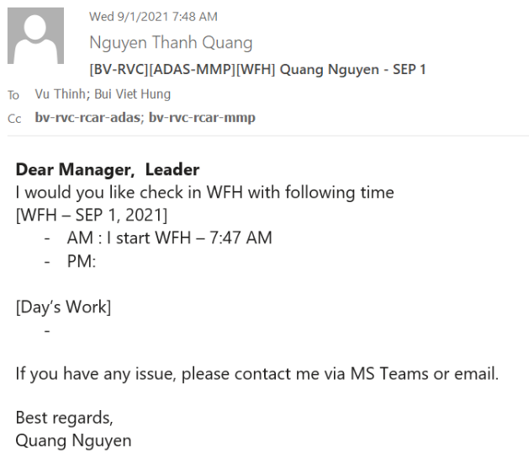

**Checkout:**

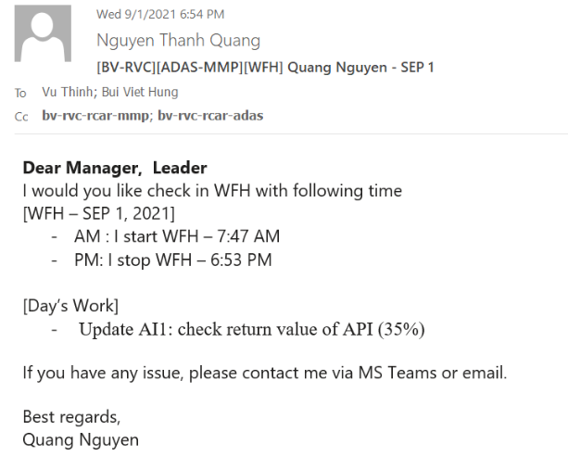

**Rule Leave/Late-in/Late-Out Request**

**Email for RVC Leader and cc all manager**

Sub: [BV-RVC][R-CAR_XX][yy-mm-dd][Leave] Name - ID

To: RVC Leader, BV Leader, BV Manager

cc: RVC Manager, group member BV

**Dear Manager, Leaders,**

I would like to register a leave request with following information

|  |  |
| --- | --- |
| **Requestor:** | NAME |
| **Team:** | PJ NAME |
| **Leave date:** | yy-mm-dd |
| **Duration (format: #h or #d):** | Example 1d , 1.5h , 0.5d (Morning) |
| **Leave type:** | Paid-leave/Late-in/Late-out |
| **1. Reason:** |  |
| **2. Impact:** |  |
| **3. Countermeasures:** | Phone: xx  MsTeam:xx |

**Dear BV Manager/Leaders,**  
  
Please help to consider my request.  
  
**Dear RVC Managers/Leaders,**  
  
I hope to receive your acknowledgement.  
  
Thanks for your consideration,

NAME

Example:

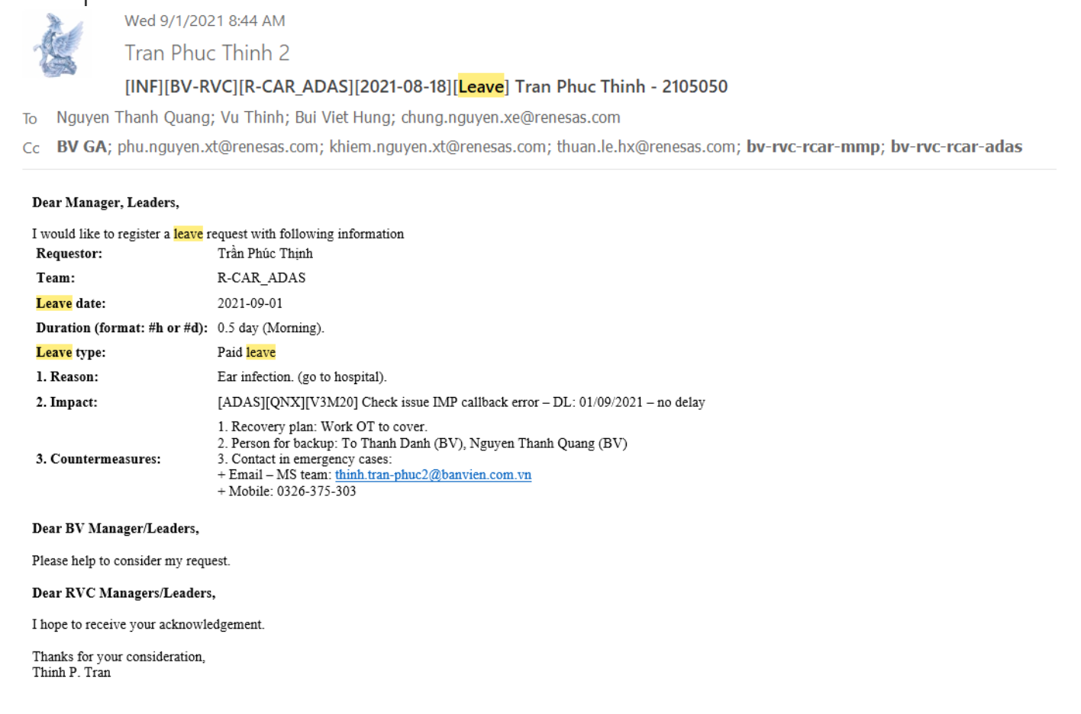

**Submit HRM Ban Vien**

-Access link:

<https://hrm.banvien.com.vn/symfony/web/index.php/auth/login>

-After access link choose Leave -> Apply ->Submit.

-Wait Leader/PM confirm. If after 1d leave request unconfirmed please reminder to the leader.

**Rule Request OT**

**Work flow**

Step 1:

If you received request OT from RVC then you need cc mail request OT for BV Leader.

Step 2:

BV Leader will email for PM/HR BV request OT for member

Step 3:

After PM BV approve request , HR will calculate working days

**Fill OverTime Tracking**

Access link:

[**https://banviencorp.sharepoint.com/:x:/s/BV_RVC/EZaOrxEDPWlHjavcuMA9MMEBGfWXHuh22FEEptNrEcJoxw?e=4%3AXFYzIG&at=9**](https://banviencorp.sharepoint.com/:x:/s/BV_RVC/EZaOrxEDPWlHjavcuMA9MMEBGfWXHuh22FEEptNrEcJoxw?e=4%3AXFYzIG&at=9)

Fill in more timelog WFH if your WFH:

[**https://banviencorp-my.sharepoint.com/:x:/g/personal/hung_bui-viet_banvien_com_vn/Ed_6ro57gt1NvK08BES5bh8B47f7hzkJvlUNKWkcClKTOQ?e=bCv2LG&isSPOFile=1**](https://banviencorp-my.sharepoint.com/:x:/g/personal/hung_bui-viet_banvien_com_vn/Ed_6ro57gt1NvK08BES5bh8B47f7hzkJvlUNKWkcClKTOQ?e=bCv2LG&isSPOFile=1)

# Rule Weekly report

# Information

**Every Wednesday(Ban Vien) and Thursday (RVC)**

# Content:

--------------------------------------------------------------------

**Subject:**[BV-RVC][ADAS-MMP] Weekly report <week>/<yyyy> - <Name>

**Body:**  
------------------------------------------------------------------------------------------------------------------

* [TOPIC]  
  Please describe overall status of current progress, status of develop, tasks,  
  issues, important info in week.
* [Project Tasks or Activity - Status]  
  1. Task 1  
  - Deadline: mm/dd/yyyy *<deadline of task>*  
  - Status: on-time/delayed/finished  
  - Detail:  
  <Please describe info of task, ex activities, issue, ...>  
  <If status is delayed, let give reason and countermeasure>
* 2. Task xxx

[Action item]  
*<Describe action items for next week in here. Action item should have specific deadline>*

--------------------------------------------------------------------

**Example:**

**----------------------------------------------------------------------**  
Dear ABC_XYZ

I would like to send you a report for week XX (xx/xx/xxxx –xx/xx/xxxx) of my task:

=========================================================================

**[TOPIC]**

Understand overview about Yocto.                      **(delayed 0D)     (Progress: 80% -> 90%)         [D/L: xx/xx/xx]**

Understand overview about GStreammer.        **(delayed 0D)     (Progress: 90% -> 100%)         [D/L: xx/xx/xx]**

Build Yocto on Linux PC.                                         **(delayed 0D)     (Done)       [D/L: xx/xx/xx]**

Build GStreamer on Linux PC.                                **(delayed 0D)     (Done)       [D/L: xx/xx/xx]**

**[Project Tasks or Activity - Status]**  
===============================  
1. Task 1: understand overview about Yocto, Gstreamer and can upgrade Gen3 GStreamer development into new version (v1.18.2)

**- D/L: xx/xx/xxxx**  
- Status: **On-time**  
- Detail:

  + Build Yocto on Linux PC **(Done)**.

  + Build GStreamer on Linux PC **(Done)**.  
  + Read documents for GStreamer (**Done**).

  + Read documents for Yocto. (0 % -> 40%)

-Issue: N/A

**[Action Items]**  
===============================  
1.   Understand overview about Yocto, Gstreamer and can upgrade Gen3 GStreamer development into new version (v1.18.2) (Continuous).

**- D/L: xx/xx/xxxx.**

2.   Study build and setup environment build Yocto OS on laptop RVC.

**- D/L: xx/xx/xxxx.**

3.  Investigate source code porting new version for GStreamer.  
**- D/L: xx/xx/xxxx.**

**---------------------------------------------------**