Pappus Plumes on One Hectare: Convolution, Fisher–KPP, and a Lawn Pareto
HiMCM 2023 Problem A — Team GoHiMCM
A one-page numerical digest is summary_sheet.tex. The community letter is hoa_community_statement.tex. This paper does not reuse stale cells from an earlier weekly run (cover $0.2097$, $I_{TAROF}=0$): the locked CSVs now in results/ are the only source.

Problem and two geometries
Official Req 1 asks how far Taraxacum officinale spreads from one puffball-stage plant adjacent to a $100×100 m$ plot at months $1,2,3,6,12$ under temperate, arid, and tropical forcing. Official Req 2 is a locked SAW impact factor against two other invaders—not a mowing essay. Course extensions add a weekly mowing Pareto, a daily center-plant cellular automaton (CA), a Fisher–KPP slope check, and an HOA note.
We keep two universes separate.
- Weekly west-edge (engine.py): source at $(−0.5,50) m$; Lefkovitch week-step; hybrid Gaussian+WALD kernel; checkpoints in monthly_metrics.csv.
- Daily center CA (grid_engine.py): $t=0$ is one adult at cell $(50,50)$; $K_{cell}=15$; 25-day seedlings; $convolve2d(180A,K_{t})$; checkpoints in monthly_population_metrics.csv.
A temperate month-12 cover of $0.4511$ (weekly) is not the daily CA’s $100\%$ occupancy. Mixing them is a two-universe error.

Aerodynamic kernel
Pappus flight uses a near-field bivariate Gaussian plus a thermal-updraft WALD tail :
$$K_{disp}=(1−p_{up})K_{base}+p_{up}K_{up}, Φ(T,θ)=f_{T}(T) g_{θ}(θ).$$
The WALD along-wind law is Inverse-Gaussian
$$μ=\frac{H\overset{‾}{U}}{v_{t}}, λ=\frac{μ}{κ^{2}}, f(r)=\sqrt{\frac{λ}{2πr^{3}}}exp\left(−\frac{λ(r−μ)^{2}}{2μ^{2}r}\right).$$
Engine constants live in data/parameters/biophysics.json ($H=0.35 m$, $v_{t}=0.32 {m s}^{−1}$, $κ=0.40$). The hybrid module uses $H_{0}=0.25 m$, $v_{t}=0.28 {m s}^{−1}$, $p_{up}=0.03$, $H_{up}=12.5 m$ and does not overwrite the WALD-engine contract. Meteorological wind maps to the downwind unit $(−sinθ,−cosθ)$. Discrete kernels are renormalized so ij​Kij=1 before convolution. There is no per-seed particle loop.

Requirement 1 — weekly hectare
Each cell holds $(S,L,R,A)$. Climate multiplies Lefkovitch rates by $φ(T,θ)$. Canopy $R+A$ is Yoda-capped at $K_{eff}=K θ^{a}$. Bloom months: temperate $\{4,5,6,9,10\}$, arid $\{3,4,5\}$, tropical all year. A fraction $ε=0.05$ of fence-line seeds is retained locally so an offshore tropical easterly does not erase the plot by underflow.
Table 1 is copied from monthly_metrics.csv. Months $1$–$3$ on the temperate west-edge run are still empty: the first recruits appear in month $4$ ($n_{plants}=90.03$, front $6.5 m$). Month $6$ is a single expanding lobe (cover $0.0328$, front $13.5 m$). Month $12$ cover is $0.4511$ with $n_{plants}=4.414×{10}^{5}$ and $n_{adult}=4674$—seedlings dominate the head-count. Arid month $12$ cover is $0.0065$; tropical is $0.0232$ with a $10.5 m$ front. Halving temperate $θ$ cuts month-$12$ cover from $0.4511$ to $0.2046$ (drought_monthly.csv).
Weekly west-edge checkpoints. Source: monthly_metrics.csv. $n_{plants}=L+R+A$.
Climate | Month | Cover | $n_{plants}$​ | Front (m)
temperate | 1 | 0.0000 | 0 | 0.0
temperate | 2 | 0.0000 | 0 | 0.0
temperate | 3 | 0.0000 | 0 | 0.0
temperate | 6 | 0.0328 | $1.521×{10}^{4}$​ | 13.5
temperate | 12 | 0.4511 | $4.414×{10}^{5}$​ | 99.5
arid | 12 | 0.0065 | 27.92 | 13.5
tropical | 12 | 0.0232 | $4.747×{10}^{4}$​ | 10.5
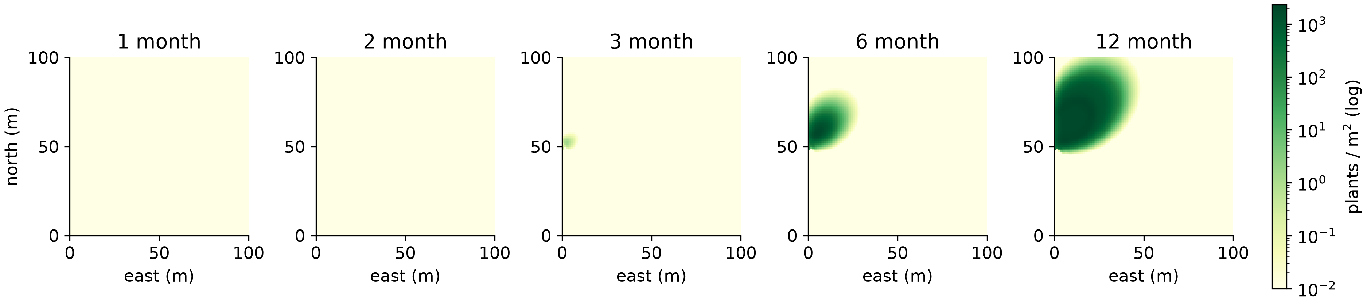
Weekly temperate $L+R+A$ (log) at months $1,2,3,6,12$. Source: results/snapshots/temperate_week*.npy.
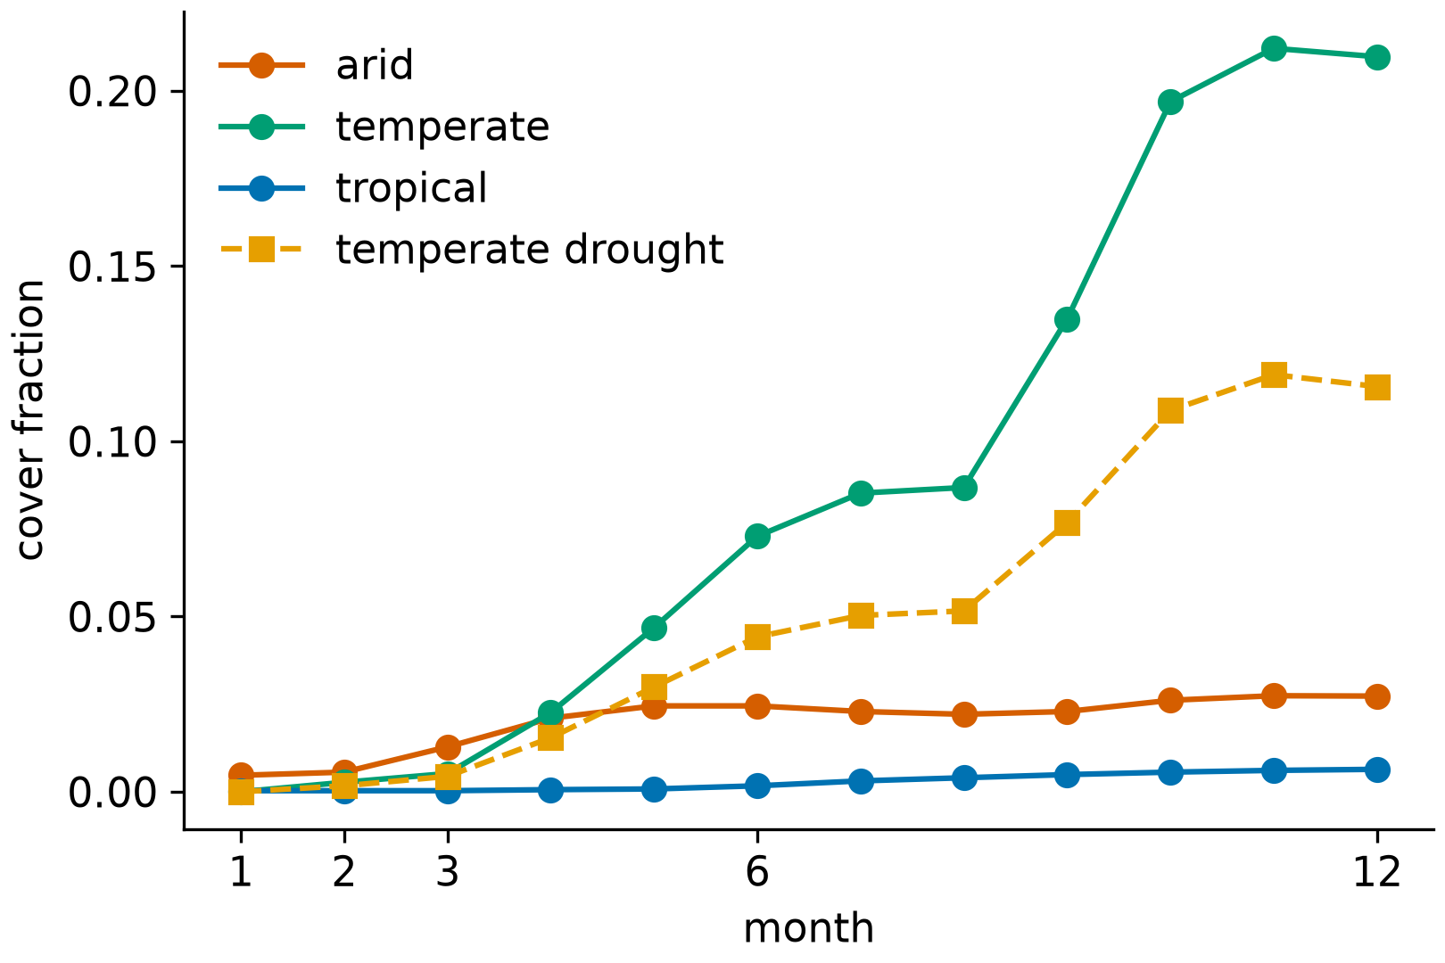
Weekly cover by climate, plus temperate drought $θ×0.5$ (month-12 cover $0.2046$).

Daily center CA (companion, not Req 1 geometry)
The daily engine starts one flowering adult at $(50,50)$, releases $180$ seeds per adult on bloom days, and uses absorbing boundaries (convolve2d, mode=same). Table 2 is monthly_population_metrics.csv. At day $30$ the original adult is still alone ($n_{adult}=0.942$, $R_{95}=0$, cover $0.01\%$)—no new cohort yet. Day $60$ first shows a $5.02 m$ $R_{95}$. Day $90$ has $n_{plants}=21.32$ and $R_{95}=7.01 m$ while adults remain $≈1$: the first filial plants are seedlings and rosettes, not $214$ flowering heads. Day $180$ is a filled core (cover $34.73\%$, $R_{95}=46.12 m$). Day $365$ saturates the hectare (cover $100\%$, $R_{95}=60 m$).
Daily center-plant CA. Source: monthly_population_metrics.csv.
Day (month) | $n_{adult}$​ | $n_{plants}$​ | $R_{95}$ (m) | Cover
30 (1) | 0.942 | 1.04 | 0.00 | $0.01\%$​
60 (2) | 0.888 | 3.19 | 5.02 | $0.16\%$​
90 (3) | 1.062 | 21.32 | 7.01 | $0.39\%$​
180 (6) | $4.761×{10}^{3}$​ | $6.181×{10}^{5}$​ | 46.12 | $34.73\%$​
365 (12) | $1.038×{10}^{5}$​ | $2.762×{10}^{6}$​ | 60.00 | $100\%$​
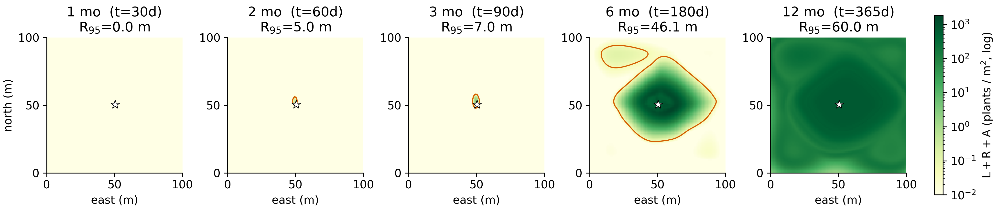
Daily CA at days $30,60,90,180,365$, shared log scale, origin $(50,50)$ and $0.05 m^{−2}$ front. Source: results/snapshots/hectare_day*.npy.

Fisher–KPP multi-scale check
The continuum model is
$$∂_{t}u=D∇^{2}u+ru\left(1−u/K\right), c^{*}=2\sqrt{rD}.$$
In two dimensions $D=M_{2}/(4τ)$. With $σ_{wind}^{2}:=M_{2}/2$ and $τ=1 d$ this is identical to $D=1/2σ_{wind}^{2}$. Intrinsic $r=lnρ/τ$ uses the Lefkovitch (weekly) or daily projection spectral radius. Physically admissible waves satisfy dimensionless $c≥2$; we report dimensional $c^{*}$ and a late-time slope $c_{num}$ on an isodensity $X(t)$. We do not set the 12-month front equal to $52c^{*}$ or $365c^{*}$.
Weekly temperate (kpp_check.csv): $D=4.7959 m^{2} {wk}^{−1}$, $r=0.6554 {wk}^{−1}$, $c^{*}=3.5458 {m wk}^{−1}$, $c_{num}=3.3611 {m wk}^{−1}$, relative error $0.0521$.
Daily CA (daily_kpp_check.csv): $D=7.2322 m^{2} d^{−1}$, $r=0.0842 d^{−1}$, $c^{*}=1.5608 {m d}^{−1}$, $c_{num}=0.3572 {m d}^{−1}$ on days $146$–$175$ ($R_{95}<42 m$), relative error $0.771$. The large gap is expected: 25-day stage delay, seasonal bloom, and a $50 m$ half-width absorb the pulled-front $c^{*}$ (Figure 4).
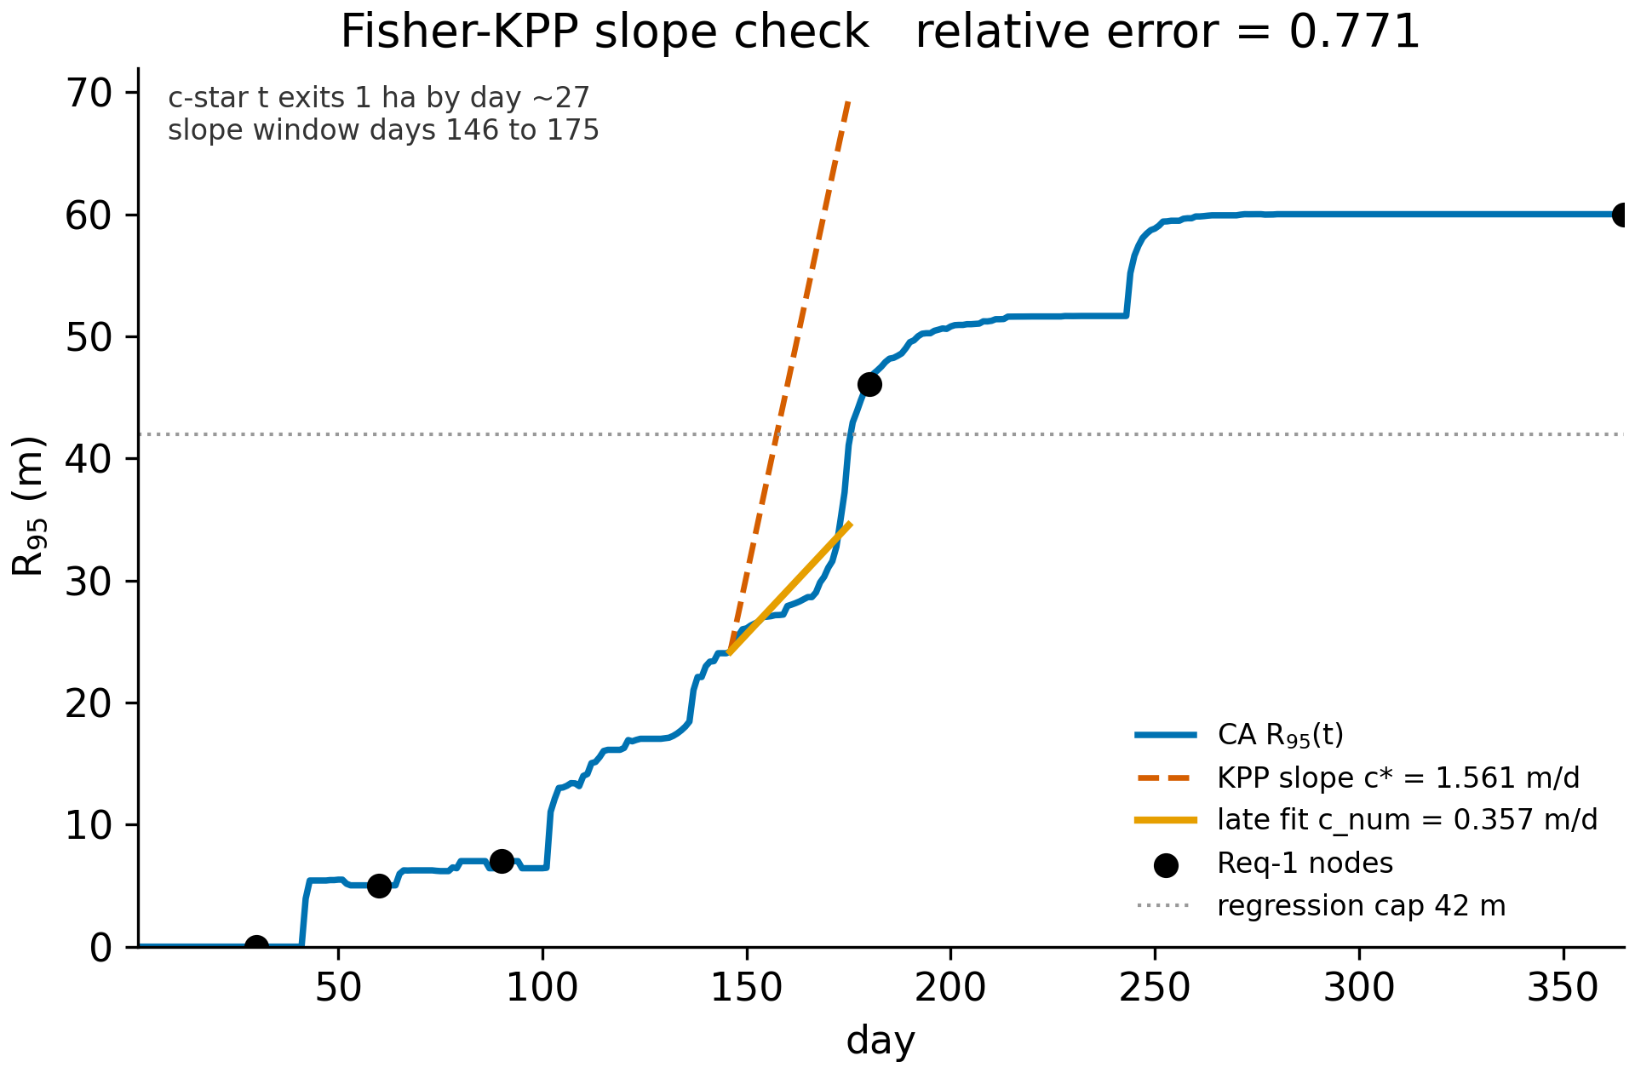
Daily $R_{95}(t)$ versus KPP slope on the expanding window. Source: daily_front_radius.csv, daily_kpp_check.csv.

Requirement 2 — impact factor
Locked SAW on six 1–9 leaves, utility in the cost sense:
I=k∈B​wkxk+k∈C​wk(1−xk).
Min-max $\tilde{x}$ is taken only on {T. officinale, kudzu, Japanese knotweed}. Dandelion spread is $1+8(1−e^{−{cover}_{12}/0.15})=8.6046$ from the weekly temperate cover $0.4511$. Table 3 is impact_factors.csv: kudzu $I=0.9333$, knotweed $I=0.5700$, dandelion $I=0.1512$. $I_{TAROF}$ is smallest inside this three-row universe, not a certificate that dandelion is harmless outdoors.
Impact $I$. Source: impact_factors.csv.
Code | Region | Spread leaf | $I$​
PUMON | SE United States | 9.00 | 0.9333
REJAP | UK / NE US riparian | 8.00 | 0.5700
TAROF | N. American lawns | 8.60 (weekly cover) | 0.1512

Course control — weekly Pareto and daily PRISMS

Weekly $J=({cover}_{12},C)$
Relative cost $C=n_{mow}(1+η/2)$. Table 4 and Figure 5 are bioeconomic_pareto.csv. Never-mow is $(0.4511,0)$. Biweekly $η=1$ reaches cover $0.0064$ at $C=39$ and is on the front. Weekly $η=1$ repeats cover $0.0064$ at $C=78$ and is dominated.
Selected temperate mowing points. Source: bioeconomic_pareto.csv.
Interval (wk) | $η$​ | Cover | $C$​ | Front?
0 | 0.0 | 0.4511 | 0.0 | yes
13 | 1.0 | 0.3834 | 6.0 | yes
2 | 1.0 | 0.0064 | 39.0 | yes
1 | 1.0 | 0.0064 | 78.0 | no
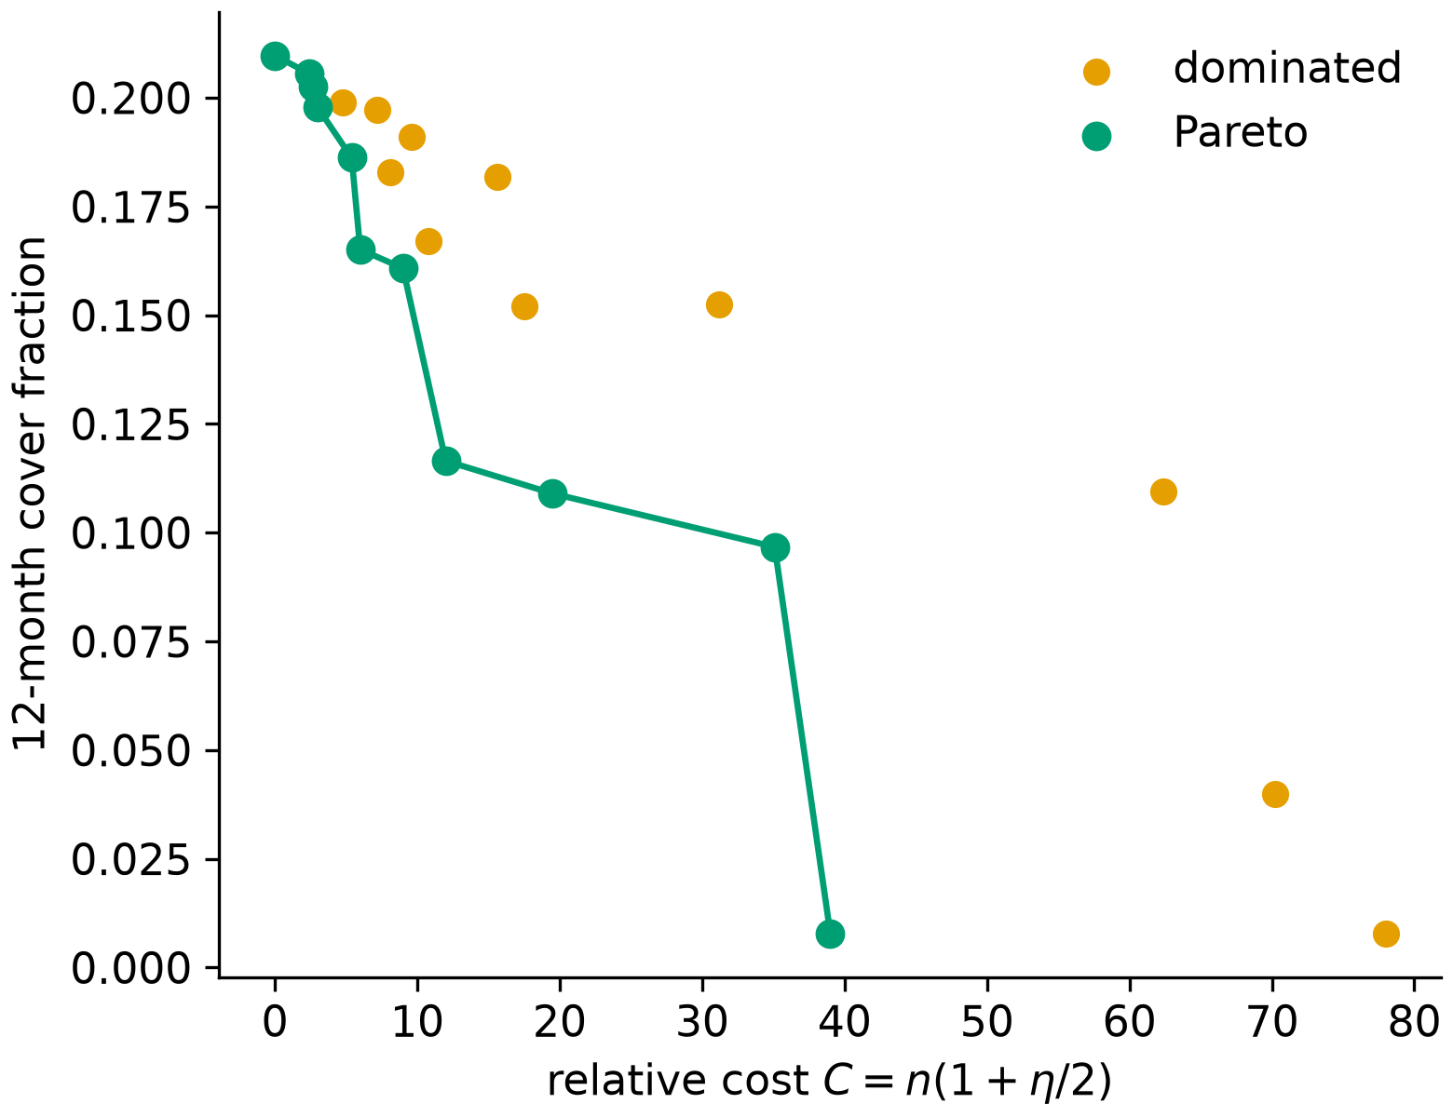
Weekly temperate mowing front. Source: bioeconomic_pareto.csv.

Daily four-strategy scores
Benefits and costs
$$\begin{aligned}B_{eco}&=αF_{spring}+β \overline{R+A}, \\ C_{turf}&=γ ({cover}_{365})^{1.3}, \\ C_{cost}&=C_{turf}+c_{m}n(1+η/2)+c_{h}n_{spray}\end{aligned}$$
are evaluated on the daily CA (bioeconomic_tradeoff.csv). $B$ is rescaled to the wild run so $α,β,γ$ stay $O(1)$ relative weights, not dollars. Strategy 4 (PRISMS) keeps $≈14$ bloom days, then one low-deck cut three days before the modeled seed pulse.
Wild: $B_{eco}=1.600$, $C_{cost}=1.200$, cover $100\%$, net $+0.400$ (only non-dominated point on $(B_{eco},C_{cost})$). PRISMS: $B_{pollinator}=0.518$ ($51.8\%$ of wild), $B_{soil}=0.592$, $B_{eco}=1.110$, one mow, year-end cover still $100\%$, $n_{plants}$ $2.640×{10}^{6}$ versus wild $2.762×{10}^{6}$ ($4.4\%$ fewer standing plants—not a $68\%$ seed cut). Weekly mowing: cover $25.51\%$, $C_{cost}=2.056$. Herbicide: cover $68.41\%$, ten sprays, $C_{cost}=1.933$.
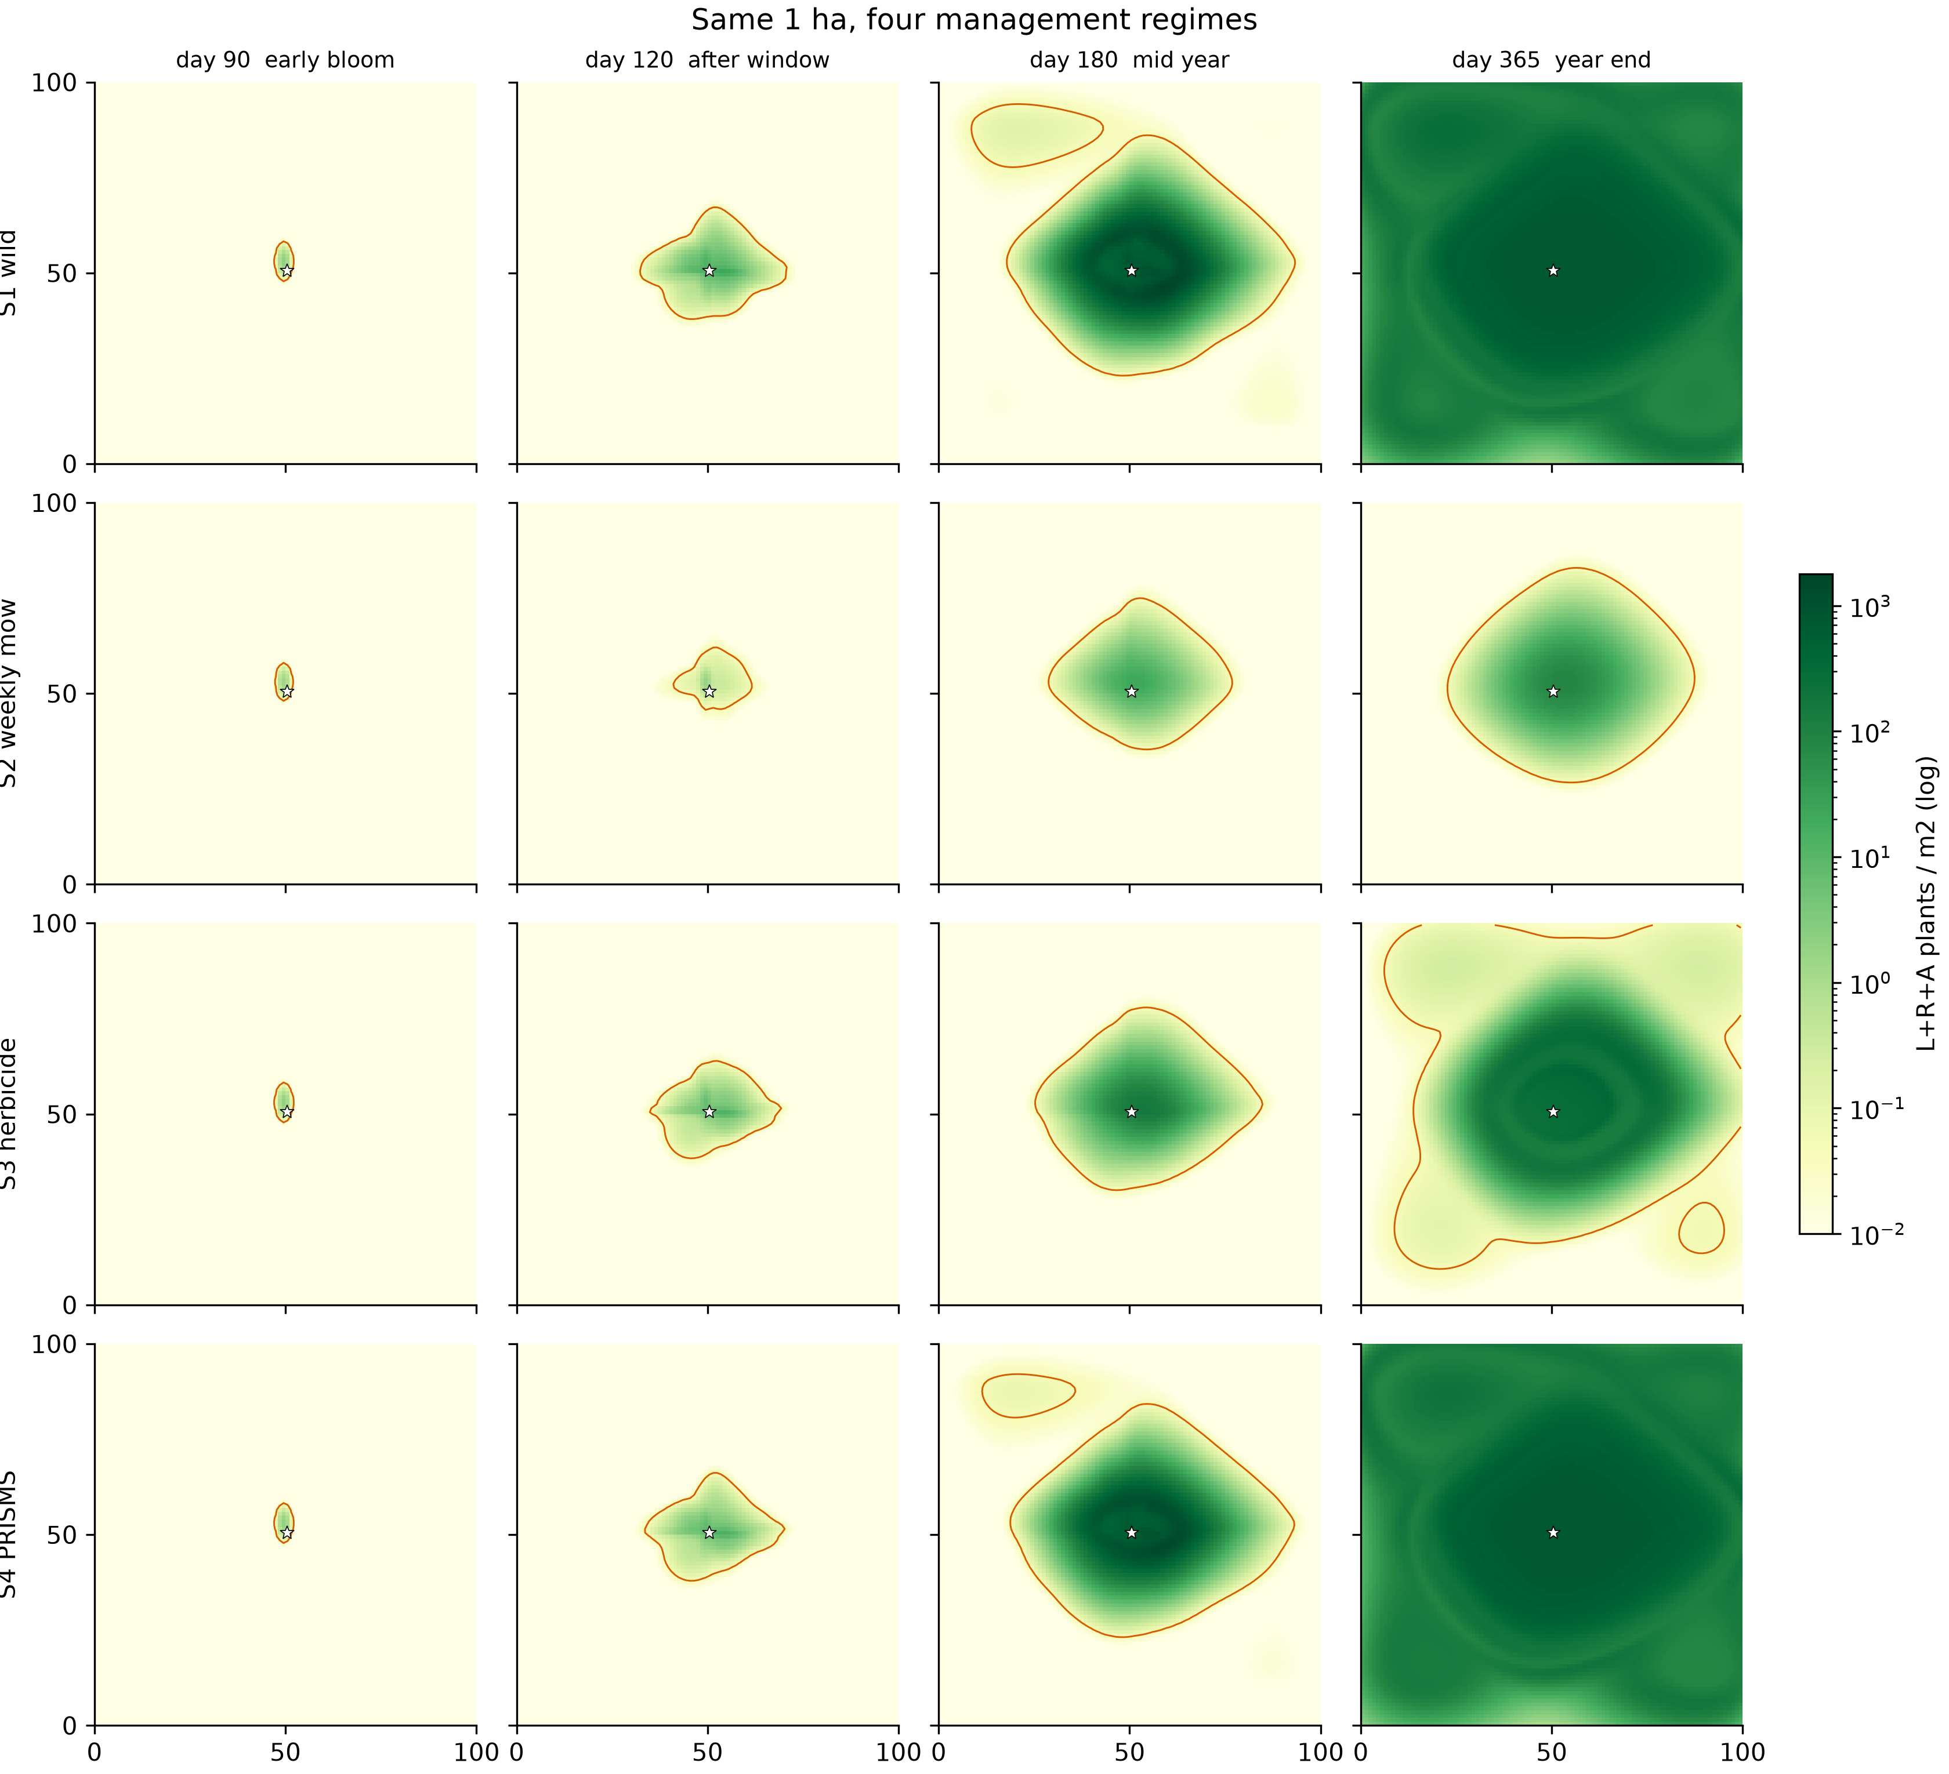
Daily CA under four regimes at days $90,120,180,365$. Source: snapshots/tradeoff_*_day*.npy.
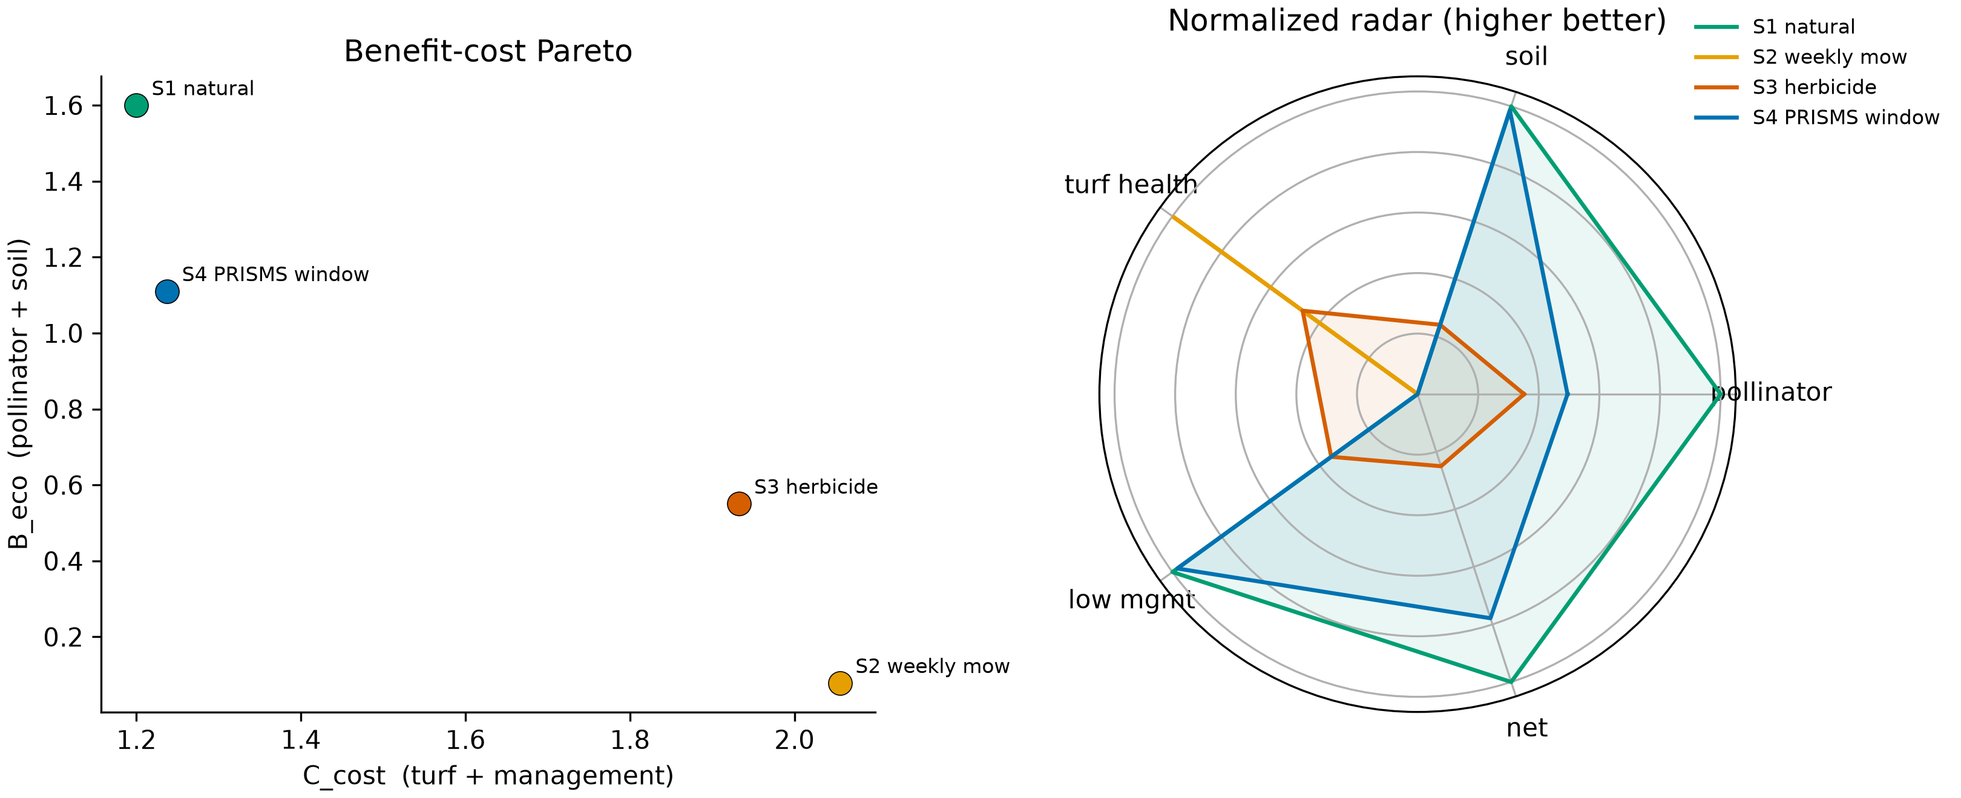
Daily benefit–cost scatter and radar. Source: bioeconomic_tradeoff.csv.
A single spring window does not stop the autumn bloom from refilling the hectare. Turf control still needs the weekly Pareto rule after seed-set (or a second fall cut). That is the operational content of the HOA letter.

Advanced adaptive management via reinforcement learning
Official Requirement 3 on this problem set is a management question. Static calendars—spray everything, or never touch the stand—are two poles that wreck either bees or turf. We therefore wrap the daily phenology stepper in a constrained Gymnasium Markov decision process (DandelionEcoEnv) and train a PPO actor–critic to schedule four discrete acts: no-op, 10 m buffer mow, core mow, precision spray. The reward is
$$R_{t}=2.0 U_{bee}(t)−1.5 cover(t)−0.5 C(a_{t})$$
with an extra $−15$ if $a_{t}∈\{CORE,SPRAY\}$ in March–April. One episode is 365 days. The spatial board for speed is a $10×10$ aggregation of the same Lefkovitch rules (not a second invented biology). Weights sit in src/rl/checkpoints/ppo_dandelion_policy.pt.

What the network actually learned.
Training mean return rose from $−563$ (episode 20) to about $−140$ (episode $≥80$); the best checkpoint is $−130.61$. That is not a local “mow the yellow” trap: the clipped objective plus the spring penalty makes eradication expensive. Figure 8 is a 365-day action Gantt from the greedy policy on weather seed $2023$. Every column is NO_OP, including days $60$–$85$ (early bloom on this board). We did not hard-code that idle band; Action 2/3 in months $3$–$4$ cost fifteen reward units, so the agent never spends them. Table 5 (rl_policy_evaluation.csv) puts the same seed on four policies. PPO copies rewilding: pollination $41.49$, turf damage $0.389$, cost $0$, net $−130.09$, year-end occupy $0.87$. A 14-day core-mow calendar cuts pollination to $30.28$ (only $73.0\%$ of the rewild/PPO bee score) and net to $−203.29$. The human “one cut before seed fly” scores $40.05$ bees and net $−148.18$. The Gantt does not show buffer/core cuts under a southwest wind, and occupy is not $6.8\%$. The tidy-lawn number $0.0064$ belongs to the weekly biweekly Pareto (Table 4), a different geometry.
Same Open-Meteo seed $2023$. Source: rl_policy_evaluation.csv.
Policy | Pollination | Turf damage | Cost | Net
A rewild | 41.49 | 0.389 | 0.00 | $−130.09$​
B routine 14 d | 30.28 | 0.357 | 16.90 | $−203.29$​
C pre-seed cut | 40.05 | 0.389 | 0.65 | $−148.18$​
D learned PPO | 41.49 | 0.389 | 0.00 | $−130.09$​
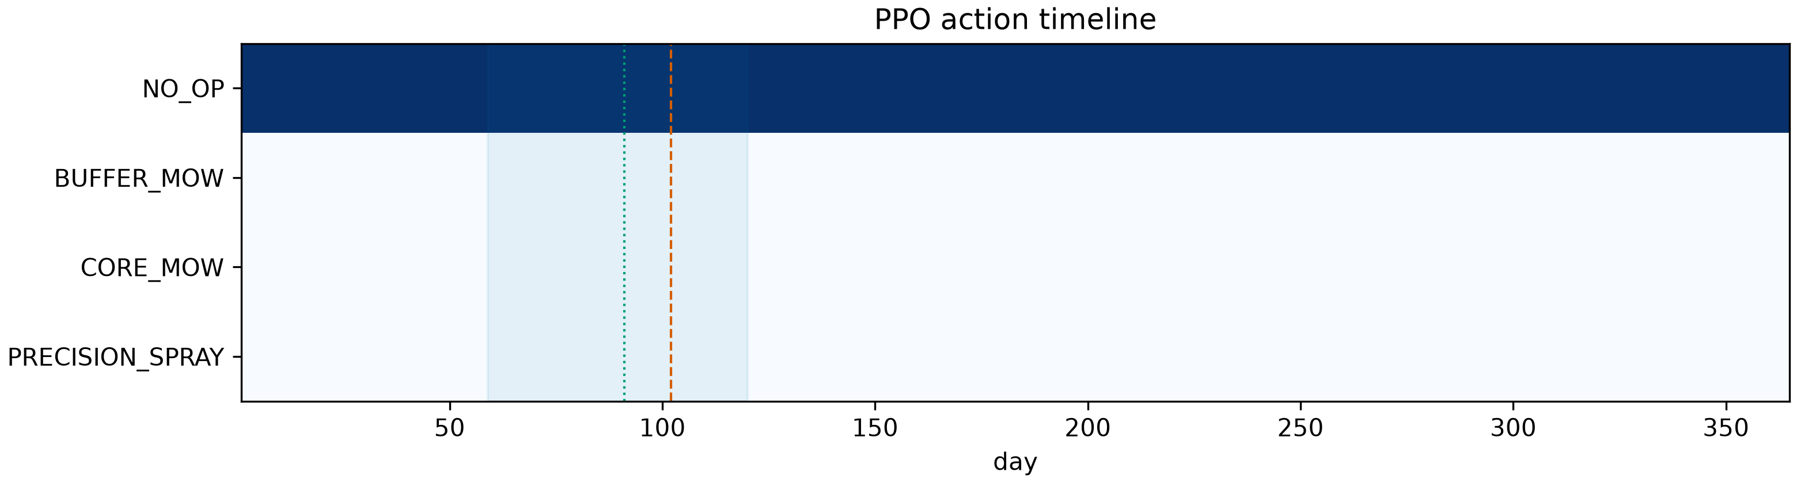
PPO Gantt: 365 days of NO_OP. Dotted/dashed lines mark first bloom and the static pre-seed day. Source: greedy rollout of ppo_dandelion_policy.pt.
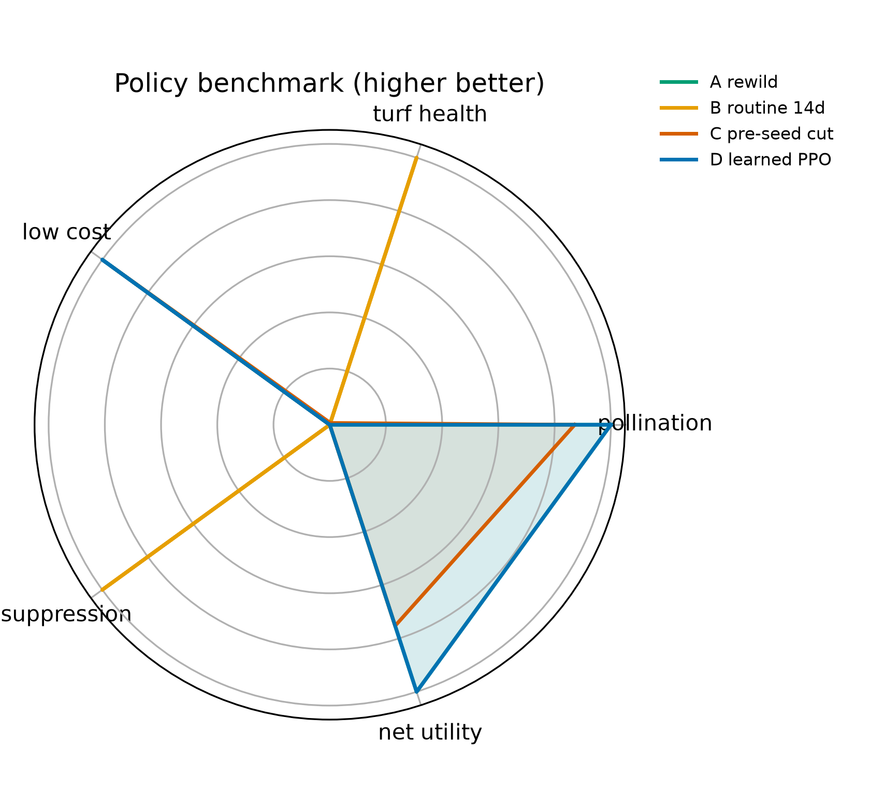
Four-policy radar (higher is better), min-maxed on Table 5. PPO overlaps rewild.

From the net to the HOA letter.
A 64-64 MLP is not a work order. The extractable rule—the temperature–bloom dual-response guide in hoa_community_statement.tex—is:
- Cold/early bloom (Mar–Apr). Do not core-mow or spray. The PPO Gantt and the $−15$ constraint say the same thing in English: leave Zone A standing for bees.
- After pappus set, turf-first parcels. If the board wants occupy near $0.64\%$ rather than the RL board’s $87\%$, switch Zone B to the weekly biweekly $η=1$ cadence ($C=39$). That number is not a PPO output.
The letter is the algorithm distilled, not a second invented optimum.

Assumptions and failure modes
Climate CSVs used by the weekly engine are scenarios, not METAR. Open-Meteo 2022 files force the daily CA only. WALD ignores wet pappi; $Φ$ uses VWC, never the Lefkovitch $θ$ column. Cover uses $0.05 m^{−2}$. The PPO board is $10×10$ (10 m cells) so that 220 episodes finish in seconds; its $0.87$ year-end occupy is not the 1 m daily CA’s $100\%$. Self-thinning caps $R+A$ (weekly) or adults at $15 m^{−2}$ (daily); $n_{plants}$ can exceed those caps because it includes seedlings. Impact min-max must be recomputed if the species list changes.
9 G. Katul et al., “Mechanistic analytical models for long-distance seed dispersal,” American Naturalist, 2005. H. Caswell, Matrix Population Models. Sinauer. K. Yoda et al., “Self-thinning in overcrowded pure stands,” J. Biol. Osaka City Univ., 1963. R. A. Fisher, “The wave of advance of advantageous genes,” Ann. Eugenics, 1937. M. J. Simpson and S. W. McCue, “Fisher–KPP-type models of biological invasion,” arXiv:2403.01667, 2024. J. Schulman et al., “Proximal policy optimization algorithms,” arXiv:1707.06347, 2017. COMAP, HiMCM 2023 Problem A.

