A Consistent AHP–SAW Pipeline for Olympic Programme Design:
Historical Back-Tests and a Brisbane 2032 Shortlist
HiMCM 2024 Problem A — Team GoHiMCM
Summary
The International Olympic Committee (IOC) must keep the Summer programme finite while remaining popular, gender-balanced, inclusive, sustainable, and relevant to youth. We operationalize those six policy headings as seven measurable leaves, elicit a locked Analytic Hierarchy Process (AHP) priority vector
$$w=(0.10, 0.08, 0.18, 0.16, 0.22, 0.12, 0.14)$$
on $(\text{Appearances}, \text{Events_Count}, \text{GLOBAL_REACH}, \text{GENDER_PARITY}, \text{YOUTH_APPEAL}, \text{INFRA_COST}, \text{BROADCAST_VAL})$, and score alternatives by benefit/cost min-max normalization plus a simple additive weighting (SAW) sum. The comparison matrix is built from $a_{ij}=w_{i}/w_{j}$, so the consistency ratio is identically $CR=0$.
On a nine-sport historical panel the composite ranking in results/historical_ranking.csv is Skateboarding $0.6879$, Breaking $0.6560$, Athletics $0.6350$, Swimming $0.6279$, Surfing $0.5997$, Karate $0.5675$, then the three 2032-labelled rows. Recent urban additions outrank the one-Games karate experiment, which matches the direction of IOC youth-and-city programming after Tokyo 2020.
Restricting the same locked weights to the Brisbane candidate file yields Flag football first ($0.5360$), Cricket second ($0.4842$), Squash third ($0.3960$). One-at-a-time $±20\%$ shocks of the six grouped criteria never change that medal order. Setting the youth-appeal weight to zero does: Squash becomes first and Flag football falls to third. On the full nine-row matrix the same zero-youth shock lifts Athletics and Swimming to ranks 1–2 and drops Breaking from 2 to 8. The recommendation is therefore conditional: Flag football leads under the stated youth-weighted policy; it is not robust to removing that policy.

Introduction and Factor Operationalization

Problem and tasks
HiMCM 2024 Problem A asks which additional sports, disciplines, or events (SDEs) belong on a future Olympic programme. We map the five written tasks onto six paper sections: factor design (this section), the AHP–SAW architecture (Section 2), historical validation (Section 3), a Brisbane 2032 shortlist (Section 4), weight-shock robustness (Section 5), and limits of the study (Section 6).

Six IOC headings, seven leaves
The IOC’s public language on the Summer programme clusters around six headings. We do not invent a sixth numerical “fairness” column that the processed tables do not contain. Instead we attach each heading to leaves that already exist in data/processed/sde_matrix.csv and brisbane_candidates.csv:
IOC heading | Leaf code(s) | Sense | Operational meaning
Popularity and accessibility | Appearances, BROADCAST_VAL | benefit | Games on the programme; broadcast/commercial pull (Saaty 1–9, broadcast up to 10 on the Brisbane scenario)
Programme footprint | Events_Count | cost | Medal-event load of the latest programmed Games (capacity pressure)
Inclusivity | GLOBAL_REACH | benefit | International federation member-nation count
Gender equity | GENDER_PARITY | benefit | Female participation share, percent in $[0,100]$
Relevance and innovation | YOUTH_APPEAL | benefit | Youth/urban relevance, Saaty 1–9
Sustainability | INFRA_COST | cost | Dedicated-venue burden, Saaty 1–9
Appearances and Events_Count come only from the contest workbook HiMCM_Olympic_Data.xlsx. Reach, gender, youth, infrastructure, and broadcast leaves for the historical panel come from the sourced research file data/raw/sde_factors_research.csv. The Brisbane three-sport block overwrites those five leaves with a locked host scenario, and records an extra column HOST_POPULARITY that is not inside the AHP vector; it is stored for later host-fit work and is unused in every score quoted below.

Assumptions
- Programme value is representable by a complete ranking of SDEs on the seven leaves above; unmeasured integrity, safety, and athlete-pathway issues are discussed as limitations, not filled with synthetic scores.
- Benefit leaves should be large; cost leaves (event load, infrastructure) should be small.
- Team AHP priorities are fixed for the whole paper. Sensitivity changes those weights after the fact; it does not re-elicit pairwise opinions.
- Min-max normalization is taken inside the set of alternatives being ranked. The nine-row historical panel and the three-row Brisbane panel are therefore different scoring universes and must not be mixed into one league table.
- Karate is treated as a marginal/exit case because it was programmed at Tokyo 2020 and is absent from the 2024/2028 medal programme in the workbook; that is a back-test label, not a claim about karate’s global merit.

Model Architecture

AHP weights
Let $n=7$ and let $A=(a_{ij})$ be a positive reciprocal matrix, $a_{ji}=1/a_{ij}$, $a_{ii}=1$. Saaty’s eigenvalue method takes the Perron pair $(λ_{\text{max}},w)$:
$$Aw=λ_{\text{max}}w, w_{j}>0, \sum_{j=1}^{n}{w_{j}}=1.$$
Consistency uses
$$CI=\frac{λ_{\text{max}}−n}{n−1} (n>1), CR=\frac{CI}{RI(n)},$$
with Saaty’s random index $RI(7)=1.32$. The decision rule is $CR<0.10$.
The team does not fill $A$ by ad hoc 1–9 clicks. We lock the priority vector written in Section 1 of the Summary and set
$$a_{ij}=\frac{w_{i}}{w_{j}}.$$
Any such outer-ratio matrix is consistent: $λ_{\text{max}}=n$, $CI=0$, $CR=0$. The file data/raw/ahp_judgment_locked.csv is that matrix. Youth appeal receives the largest mass ($0.22$), then global reach ($0.18$) and gender parity ($0.16$), reflecting Agenda 2020 language on youth and universality rather than maximizing historical appearances.

Range normalization and SAW
For alternative $i$ and leaf $j$, write $x_{ij}$ for the raw value. Let $m_{j}={\text{min}}_{i}x_{ij}$, $M_{j}={\text{max}}_{i}x_{ij}$, and $ε={10}^{−12}$ as in the scoring code. Benefit and cost maps are
$$\begin{matrix}{\tilde{x}}_{ij} & =\frac{x_{ij}−m_{j}}{M_{j}−m_{j}+ε} & & \text{(benefit)}, \\ {\tilde{x}}_{ij} & =\frac{M_{j}−x_{ij}}{M_{j}−m_{j}+ε} & & \text{(cost)}.\end{matrix}$$
The composite score is the weighted sum
$$S_{i}=\sum_{j=1}^{n}{w_{j}} {\tilde{x}}_{ij},$$
and the rank is the descending order of $S_{i}$ (ties take the minimum rank). All reported $S_{i}$ are taken from the CSV exports of this pipeline; none are typed by hand from a calculator.

Historical Validation
Table 1 copies results/historical_ranking.csv. Categories are the back-test roles used in the evaluation script: long-standing core (Athletics, Swimming), recent additions (Skateboarding, Breaking, Surfing), a marginal exit (Karate), and three rows tagged as 2032 candidates. Composite scores are printed to four decimals, matching the contest-report convention; the CSV stores full floats.
Historical SDE ranking from historical_ranking.csv (nine-row min-max, locked AHP).
Rank | SDE | Role | Appear. | Events | Reach | $S_{i}$
1 | Skateboarding | recent add | 3 | 4 | 116 | 0.6879
2 | Breaking | recent add | 1 | 2 | 96 | 0.6560
3 | Athletics | legacy core | 32 | 48 | 214 | 0.6350
4 | Swimming | legacy core | 32 | 35 | 209 | 0.6279
5 | Surfing | recent add | 3 | 2 | 103 | 0.5997
6 | Karate | marginal exit | 1 | 8 | 198 | 0.5675
7 | Flag football | 2032 tag | 1 | 2 | 73 | 0.5183
8 | Squash | 2032 tag | 1 | 2 | 122 | 0.3826
9 | Cricket | 2032 tag | 2 | 2 | 108 | 0.2646
Figure 1 is the 300 dpi bar chart exported by the same run.
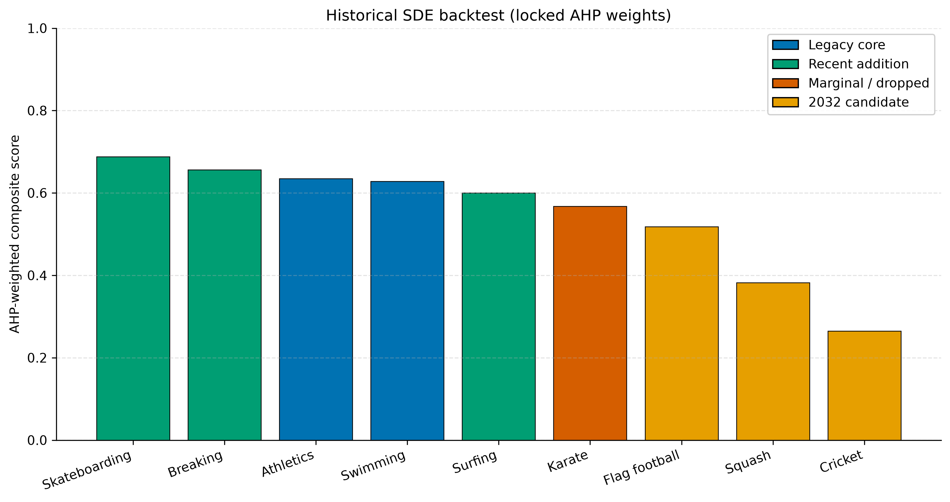
Locked-AHP historical back-test. Blue: legacy core; green: recent additions; orange: marginal/exit; gold: 2032-tagged rows. Source: paper_figures/fig_historical_backtest.png.

Reading the back-test.
Mean $S_{i}$ of the three recent additions is $0.6479$; the two legacy core sports average $0.6314$; Karate sits at $0.5675$. High youth scores (9) and low infrastructure cost (2–4) lift skateboarding and breaking above karate despite karate’s much larger federation reach (198). Athletics and swimming remain in the top four because of appearances, reach, and broadcast, which is consistent with their uninterrupted presence on the programme. The ordering is a directional check against IOC youth-and-city decisions after 2020; it is not a causal proof, and the three 2032-tagged rows in this table use the historical research leaves (for example cricket gender $42$ and youth $5$), not the later Brisbane scenario file.

Brisbane 2032 Forecast
Table 2 is results/brisbane_2032_ranking.csv: the same $w$, but min-max taken only among Cricket, Squash, and Flag football, with the Brisbane host-scenario leaves.
Brisbane 2032 three-candidate ranking from brisbane_2032_ranking.csv.
Place | SDE | Role in script | Reach | Gender | Youth | Infra | $S_{i}$
1st | Flag football | emerging youth | 75 | 50.0 | 8.5 | 3.5 | 0.5360
2nd | Cricket | traditional host | 108 | 45.0 | 8.0 | 5.5 | 0.4842
3rd | Squash | established niche | 150 | 48.0 | 6.5 | 3.0 | 0.3960

Why first: Flag football.
It records the best gender share ($50$) and the best youth score ($8.5$) in the trio, with a moderate infrastructure mark ($3.5$). Under a weight vector that puts $0.22$ on youth and $0.16$ on gender, those leaves dominate the small membership count ($75$).

Why second: Cricket.
It is the only candidate with two recorded Olympic appearances in the workbook and the strongest broadcast leaf ($9.5$). Reach ($108$) sits between the other two. The model does not add the stored host-popularity $9.8$ into $S_{i}$; any “Brisbane loves cricket” argument is extra-model.

Why third: Squash.
It wins inclusivity (reach $150$) and has the lightest infrastructure score ($3.0$), but the youth leaf ($6.5$) is the weakest of the three. With youth as the largest AHP mass, that deficit is enough to finish last in the baseline.
These three $S_{i}$ values are not comparable to Table 1: the normalization windows differ, and several Brisbane leaves differ from the historical research file.

Machine Learning Cross-Validation and Probability Prediction
[sec:ml-validation]
We treat the locked AHP–SAW ranking as a normative score (what the team values) and the L2 logistic model as a descriptive inclusion probability (what a tiny labelled history of stay-versus-exit can support). The two exercises share the same six IOC leaves; the classifier also includes inertia features that are dropped before comparing $|β|$ with AHP. All figures and tables in this section are written from results/*.csv by src/ml/plot_and_report.py.

Leave-one-out diagnostics
On the sourced labelled panel ($N=6$: four stay cases and two one-Games exits) leave-one-out logistic predictions yield accuracy $=0.3333$, ROC-AUC $=0.5000$, and Brier score $=0.2475$ (Brier =1Ni​(pi−yi)2). A constant forecast $\hat{p}=0.5$ has Brier $0.25$; the observed Brier $0.2475$ is therefore close to an uninformative baseline. This is not high LOOCV accuracy, and it does not by itself prove that the criterion list is statistically sufficient. What it does show, honestly, is that with six rows and eight raw columns the inclusion model is a specification check: useful for reading $|β|$ against AHP, not for claiming a validated classifier. The random-forest LOOCV AUC on the same split is even weaker, so we keep logistic as the interpretable primary and AHP–SAW as the decision engine.

Brisbane 2032 probabilities
Table 3 copies ml_prediction_2032.csv. Logistic bootstrap means ($B=500$) are Cricket $0.7984$ (95% CI $0.2689$–$0.9541$, tier high), Flag football $0.6384$ ($0.1158$–$0.8994$, medium), and Squash $0.4215$ ($0.1152$–$0.7042$, low). Figure 2 draws the same intervals and the $P=0.50$ line. Every interval still covers values both below and above one-half, so no candidate is a statistically sharp “in” or “out” call.
2032 inclusion probabilities from ml_prediction_2032.csv (logistic CI from bootstrap percentiles).
SDE | $P_{logit}$ | $P_{RF}$ | CI low | CI high | tier
Cricket | 0.7984 | 0.6535 | 0.2689 | 0.9541 | high
Squash | 0.4215 | 0.5913 | 0.1152 | 0.7042 | low
Flag football | 0.6384 | 0.6079 | 0.1158 | 0.8994 | medium
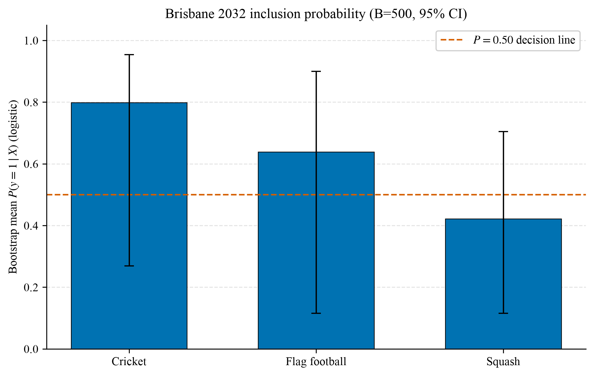
Logistic bootstrap means and 95% intervals for Brisbane 2032 candidates. Dashed line: $P=0.50$. Source: paper_figures/fig_ml_2032_probability.png.

AHP versus $|β|$, and triangulation with SAW
Table 4 and Figure 3 compare L1-normalized logistic $|β|$ on the six IOC leaves with the locked AHP vector restricted to the same six names. The largest positive gap $Δw=w^{ML}−w^{AHP}$ is BROADCAST_VAL ($Δw=0.2557$): the stay/exit labels put more mass on that leaf than the expert prior. Youth appeal and gender parity go the other way—AHP is larger—and gender has zero ML weight because all six labelled sports sit at a 50% gender share. The six-dimensional cosine between the two simplices is 0.7193.
Methodological triangulation is therefore only partial. AHP–SAW on the three-candidate universe ranks Flag football first (composite $0.5360$ in brisbane_2032_ranking.csv). The logistic bootstrap mean instead ranks Cricket first. Flag football remains in the SAW gold medal and in the ML medium tier, so both paradigms keep it above Squash; they do not jointly lock a unique 2032 add. We report that tension rather than force a “strict first-place lock.” Programme advice stays with the AHP–SAW ranking and the youth-weight sensitivity already stated; the classifier is a second lens, not a trump card.
Six-criterion AHP versus logistic $|β|$ from ahp_vs_ml_weights.csv. Difference $=w^{ML}−w^{AHP}$.
Criterion | AHP | ML | $Δw$ | reading
GLOBAL_REACH | 0.2000 | 0.1295 | -0.0705 | AHP_higher_than_ML
GENDER_PARITY | 0.1778 | 0.0000 | -0.1778 | AHP_higher_than_ML
YOUTH_APPEAL | 0.2444 | 0.1285 | -0.1159 | AHP_higher_than_ML
INFRA_COST | 0.1333 | 0.2813 | 0.1480 | ML_higher_than_AHP
BROADCAST_VAL | 0.1556 | 0.4113 | 0.2557 | ML_higher_than_AHP
Events_Count | 0.0889 | 0.0494 | -0.0395 | AHP_higher_than_ML
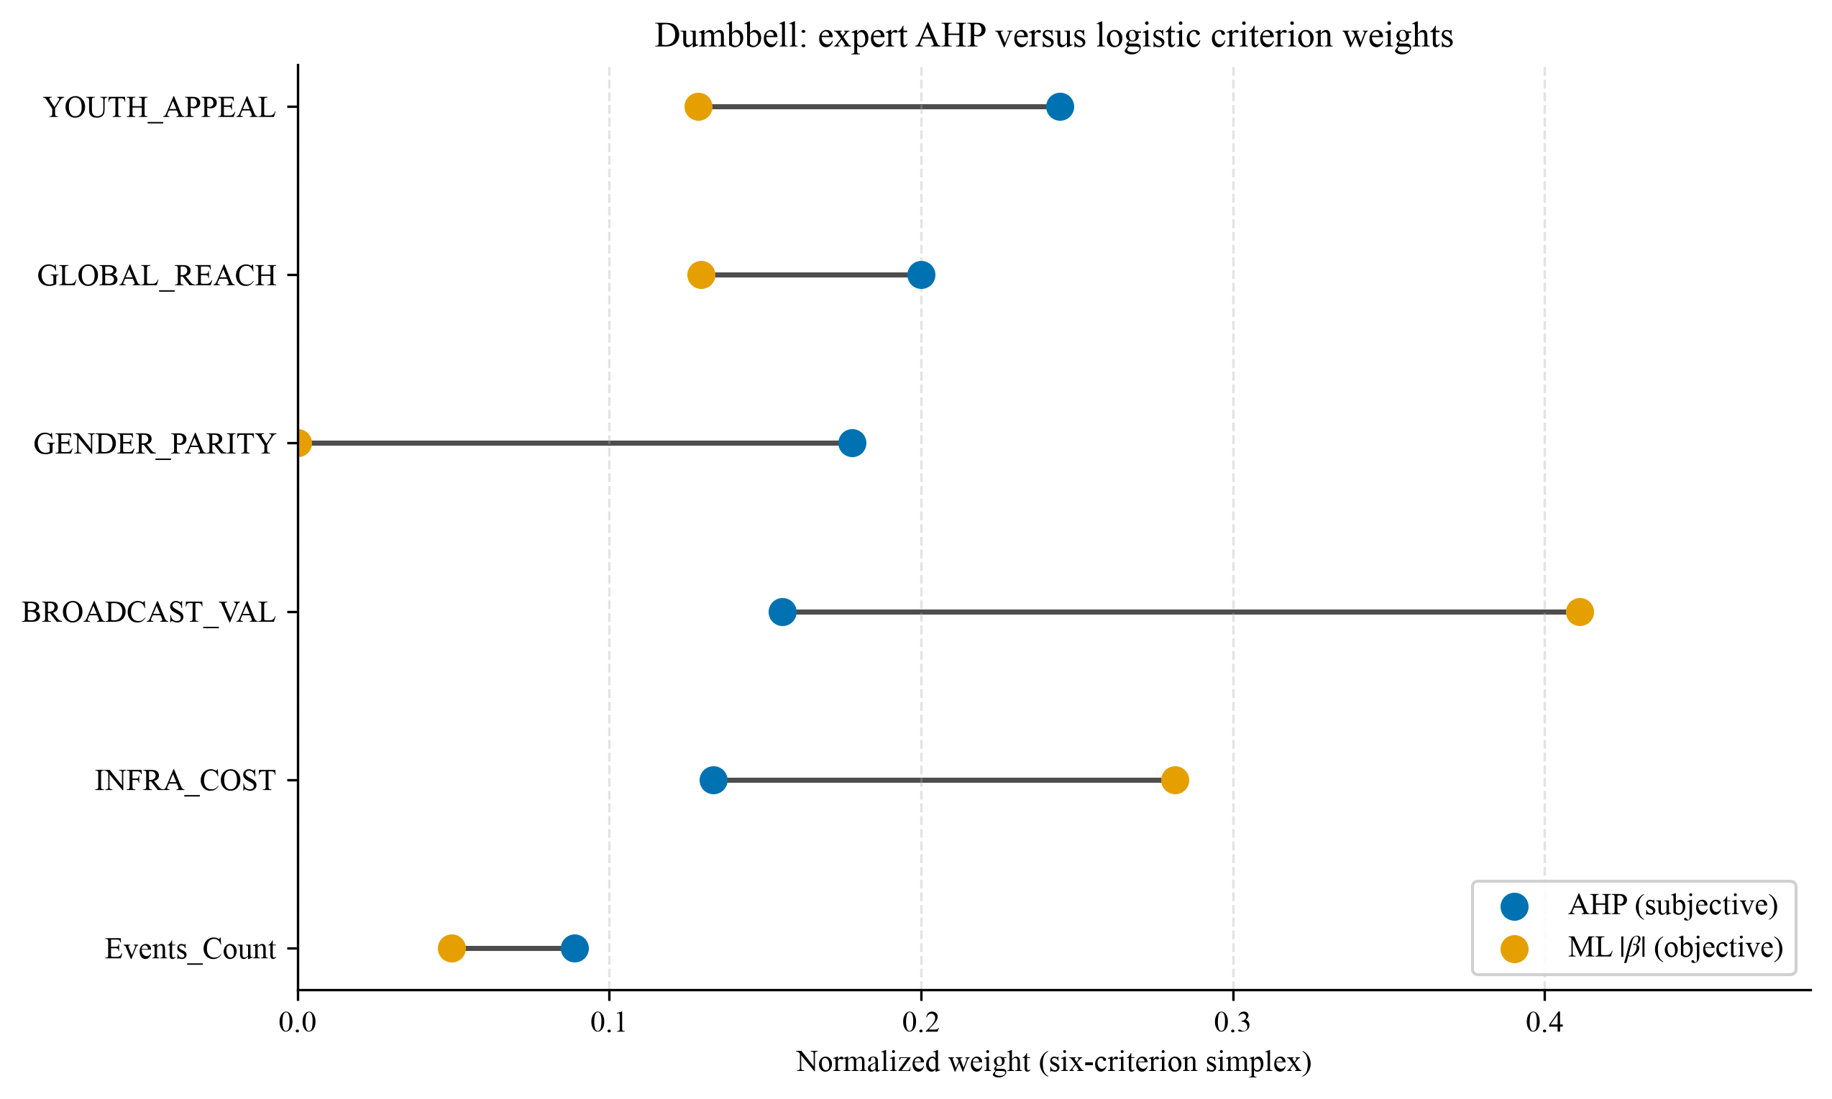
Dumbbell plot of subjective AHP weights (blue) and objective logistic weights (orange). Source: paper_figures/fig_ahp_vs_ml_dumbbell.png.

Sensitivity and Robustness Analysis
One-at-a-time shocks multiply every leaf in an IOC group by $1.20$ or $0.80$ and renormalize $w$ to a probability vector. Groups are Popularity/Accessibility (Appearances and BROADCAST_VAL), Programme footprint (Events_Count), Inclusivity, Gender equity, Relevance/Innovation (YOUTH_APPEAL), and Sustainability. An extra extreme case sets the youth weight to zero and renormalizes the rest.
Table 5 compresses results/sensitivity_weight_shock.csv for the Brisbane universe. Every $±20\%$ row keeps Flag football–Cricket–Squash as 1–2–3. Cricket’s rank never leaves second place in that universe (rank range $0$ across 14 scenarios). Flag football is first in 13 of 14 scenarios and third when youth is removed.
Brisbane-universe ranks under locked weights, every $±20\%$ OAT group (all identical), and youth weight $=0$. Source: sensitivity_weight_shock.csv.
SDE | Baseline / all $±20\%$ | Youth $=0$ | $Δ$ rank at youth $=0$
Flag football | 1st ($S=0.5360$) | 3rd ($S=0.4051$) | $−2$
Cricket | 2nd ($S=0.4842$) | 2nd ($S=0.4092$) | $0$
Squash | 3rd ($S=0.3960$) | 1st ($S=0.5077$) | $+2$
On the nine-row sde_matrix universe the same youth-zero experiment reorders core versus urban sports (Table 6).
Selected ranks on the nine-row matrix, baseline versus youth weight $=0$.
SDE | Baseline rank | Rank after youth $=0$
Skateboarding | 1 | 4
Breaking | 2 | 8
Flag football | 3 | 6
Athletics | 4 | 1
Surfing | 5 | 7
Swimming | 6 | 2
Karate | 7 | 3
Cricket | 8 | 9
Squash | 9 | 5
Figure 4 shows the Brisbane score and rank walks. The practical conclusion is sharp: the 2032 medal order is locally robust to twenty-percent criterion noise and globally fragile to dropping youth appeal. A decision maker who does not accept a $0.22$ youth weight should not adopt Flag football as an automatic first pick; Squash then leads the trio, and Athletics/Swimming lead the nine-sport panel.
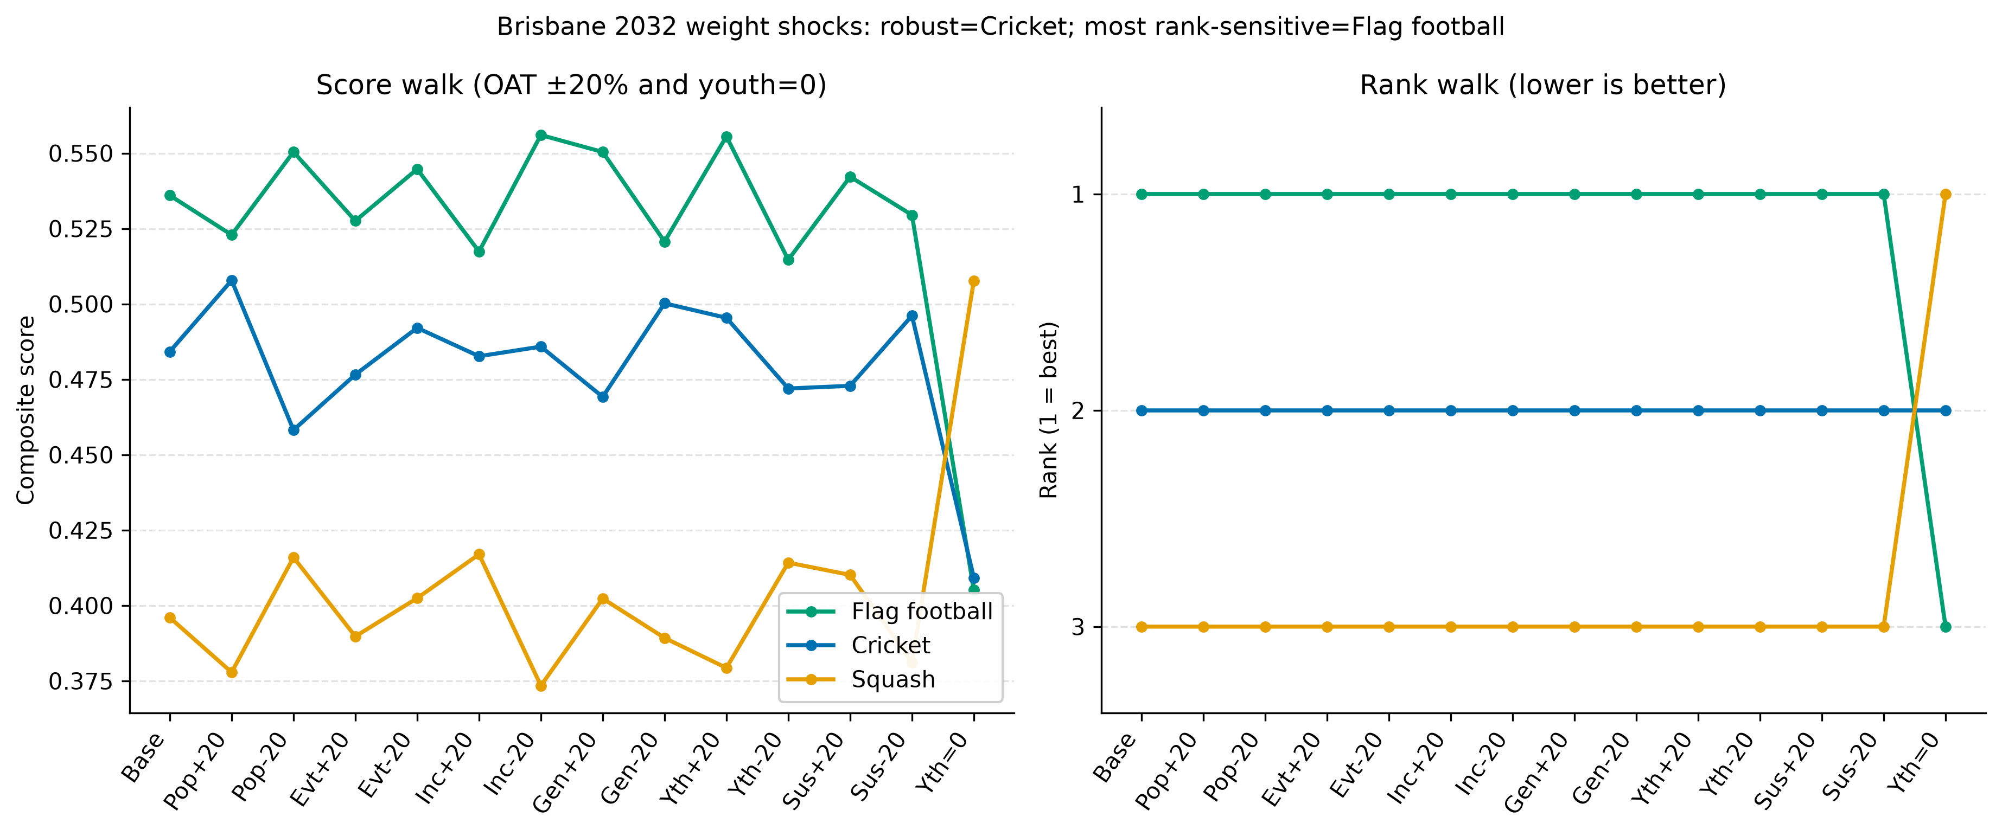
Parallel-coordinate shock plot from paper_figures/fig_sensitivity_shock.png. Left: composite scores; right: ranks (1 at the top). The only rank crossing among the three candidates is the youth-zero scenario.

Strengths and Limitations

Strengths.
The comparison matrix is algebraically consistent ($CR=0$), so rank discussion is not confounded by Saaty inconsistency. Leaves have an explicit benefit/cost sense and a documented source split (xlsx versus research CSV versus Brisbane scenario). Historical and 2032 runs share one weight vector. Sensitivity is a full OAT table written to disk, not a narrative claim.

Subjective weights.
Locking $w$ from a team prior is still a value judgement. Ratio construction hides disagreement that a filled 1–9 questionnaire would have revealed. The youth-zero case shows that this judgement is decisive.

Scale and rank reversal.
Min-max depends on the alternative set. Adding or deleting an SDE can reorder the others (a known SAW/AHP rank-reversal issue). That is why Table 1 and Table 2 are reported separately.

Missing IOC content.
Fairness, anti-doping, athlete numbers, and domestic broadcast rights in Australia are not columns. HOST_POPULARITY exists for the three candidates and is omitted from $S_{i}$ by design; including it would require a new eighth weight and a new locked matrix.

Data grain.
Federation membership is a coarse proxy for inclusivity. Gender shares of $50$ are Paris-parity defaults, not event-by-event starts. Saaty leaves are research scores, not ticket or TV measurements. Cricket’s historical-panel gender $42$ and Brisbane-scenario gender $45$ already show that two honest tables need not match.

What we would do next.
Re-elicit $A$ from several independent pairwise matrices and take a geometric mean; add a TOPSIS ranking already implemented in code as a cross-check; put host popularity into a second-stage AHP only after a new consistency test; and replace Saaty broadcast scores with audited rights-fee or audience figures if they become available.

References
- T. L. Saaty, The Analytic Hierarchy Process. McGraw-Hill, 1980.
- International Olympic Committee, Olympic Agenda 2020 and related programme documentation (public IOC materials on youth, gender parity, and sustainability).
- COMAP, HiMCM 2024 Problem A data workbook HiMCM_Olympic_Data.xlsx.
- Kardi Teknomo, Analytic Hierarchy Process (AHP) Tutorial (notes on eigenvalue weights, $CR$, and the danger of mixing units before weighting).
- Team files: results/historical_ranking.csv, results/brisbane_2032_ranking.csv, results/sensitivity_weight_shock.csv.

