Coordinated Firefighter Sweeps under Time, Vulnerability,
and Spreading Hazards
HiMCM 2025 Problem A — Team XXXX
Summary
We model emergency primary-search as a multi-agent covering process on a metric graph. Rooms are leaves (or bays) that must be entered, visually confirmed, and tagged; hallways and stairs are circulation edges with length in metres. Two firefighters clearing the one-story office of Figure 1 admit an exact Split-Half lower bound
$$T_{clear}^{SH}=\frac{L/2}{v_{h}}+3t_{svc}=145 s$$
when interior round-trips of depth $D=8 m$ are folded into service time $t_{svc}=45 s$. A deterministic scoring planner that walks room-access edges instead of double-counting those round-trips clears the same building in $T_{clear}=135 s$ (9 discrete steps of $15 s$).
The planner assigns idle agents the room $r$ maximising
$$Score(r)=−w_{dist} d(a,r)−w_{hazard} h(r)+w_{priority} v(r)−w_{redundancy}1_{tgt}−w_{tabu}1_{T_{a}}(r)+w_{mom}M(a,r),$$
with a tenure-3 room tabu list and a same-hub momentum bonus to prevent edge-reversal cycling on loopy graphs. Scaling to a three-floor daycare (18 rooms) and an open warehouse (40 searchable bays) shows strictly decreasing clearance time as crew size grows: daycare $439.0→300.7→255.7 s$ for $2,3,4$ firefighters; warehouse $424.7→333.0→262.3 s$ for $3,4,5$ firefighters ($N=30$ identical ideal-condition replications). The steepest personnel marginal return is the step to 3 firefighters in the daycare ($ΔT_{clear}=138.3 s$) and to 4 in the warehouse ($ΔT_{clear}=91.7 s$). A graph-attention PPO policy trained for 200 office episodes (no fire) does not replace the timed planner: greedy decoding never fully clears ($0/30$), while stochastic decoding fully clears $20/30$ trials (mean $5.60$ of $6$ rooms tagged; Table 2). We therefore keep the scoring planner as the operational baseline and treat GAT-PPO as a learned covering heuristic on the unweighted graph.
Under a dynamic fire/smoke process with $P_{spread}=1−(1−p_{0})^{k}$ and smoke-front speed $1.5 v_{h}^{fire}$, full-building clearance never occurred in 210 smoke trials: graphs become disconnected before every room is tagged. Vulnerable-population salvage (weighted rooms tagged before abort) remains informative: about $20\%$ in the office, $16$–$27\%$ in the daycare as crew grows, and $32$–$53\%$ in the warehouse. We treat abort times as not clearance times, recommend thermal/tag sensors as information that would enter $h(r)$ and $v(r)$, and report sensitivity of $T_{clear}$ and salvage to crew size and hazard mode directly from experiment_summary.csv.

Problem Clarification & Verification Criteria

Restatement of the task
HiMCM 2025 Problem A asks how firefighters should sweep a building so that every occupiable space is confirmed empty (or a victim is found) as quickly as possible, under realistic movement, tagging, crew coordination, and spreading hazards. The contest statement decomposes the work into five requirements, which we map one-to-one onto Sections 1.2–5 of this paper:
- verification language and assumptions (this section);
- a closed-form solution of the Figure 1 office;
- a scalable multi-agent model on a daycare and a warehouse;
- fire, smoke, and sensor-aware adjustments;
- sensitivity and robustness of the recommendations.

Decision variables, parameters, and notation
A building is an undirected graph $G=(V,E)$ with edge lengths $ℓ_{e}$ in metres. A subset $R⊆V$ of nodes is searchable (offices, classrooms, storage bays). Firefighters $a=1,…,m$ start at exit nodes. Time is continuous within discrete planning steps of length $Δt$.
Core kinematic parameters (office geometry of Figure 1, used as the default scale) are
$$L=30 m, D=8 m, v_{h}=1.5 m/s, v_{r}=0.8 m/s, t_{sw}=20 s, t_{tag}=5 s.$$
Single-room service in the analytical model is
$$t_{svc}=\frac{2D}{v_{r}}+t_{sw}+t_{tag}=45 s.$$

Verification criteria (what “success” means)
A policy is evaluated on three observable, CSV-recorded criteria.
Total sweep time $T_{clear}$.
The instant at which the last searchable node is tagged. If the crew deadlocks or hits a step cap, we record the abort clock but do not interpret it as a completed sweep.
Vulnerable-population salvage $η$.
Let $v(r)≥0$ be a vulnerability weight (infants $5$, nap rooms $4.5$, classrooms $3$, staff $1$; office rooms default to $1$). Then
η=r∈Rtagged​v(r)r∈R​v(r)∈[0,1].
Redundancy rate $ρ$.
If firefighter trajectories enter searchable node $r$ a total of $c_{r}$ times,
ρ=1|R|r∈R​max(cr−1,0).
A run is a full clearance only when $η=1$ and every $r∈R$ is tagged. All numerical claims below are computed from the 420-row file results/experiment_summary.csv ($N=30$ Monte Carlo replications per scenario $×$ crew size $×$ hazard mode).

Assumptions
- Agents share a common tagged-set (perfect radio); they do not re-clear a tagged room except via residual path geometry.
- Tagging occurs at the room node after a visual sweep of duration $t_{sw}$.
- Fire renders a node impassable; smoke multiplies speed by $\text{max}(v_{\text{min}},1−βσ)$ with $β=0.4$ at full density $σ=1$.
- No civilian counter-flow is simulated; vulnerability enters only through $v(r)$.
- Warehouse racks are obstacles, not searchable interiors; searchable bays are aisle cells adjacent to racks.

Base Model: One-Story Office Analytical Solution

Graph of Figure 1
The office is the 11-node hanging graph
$$E_{W}−H_{1}−H_{2}−H_{3}−E_{E},$$
with north rooms $N_{1},N_{2},N_{3}$ and south rooms $S_{1},S_{2},S_{3}$ attached to $H_{1},H_{2},H_{3}$. Door abscissae matching Figure 1 are $x_{H_{1}}=10$, $x_{H_{2}}=15$, $x_{H_{3}}=20$, $x_{E_{W}}=0$, $x_{E_{E}}=L=30$.

Split-Half lower bound
Two firefighters entering from opposite exits, each taking three rooms, cannot beat the load-balance bound ${\text{max}}_{i}|R_{i}|≥3$ nor the hallway covering bound of $15 m$ from an exit to the mid-door. Hence
$$T_{clear}^{SH}=\frac{15}{v_{h}}+3t_{svc}=10+135=145 s$$
($W_{h}=0$). The realizing partitions are $R_{1}=\{N_{1},S_{1},N_{2}\}$ and $R_{2}=\{N_{3},S_{3},S_{2}\}$, with column-first routes
$$\begin{matrix}F_{1} & :E_{W}→N_{1}→S_{1}→N_{2}, \\ F_{2} & :E_{E}→N_{3}→S_{3}→S_{2}.\end{matrix}$$
Returning to an exit after the last tag adds another $15/v_{h}=10 s$ ($T_{clear}^{egress}=155 s$).
Smoke that cuts hallway speed by $40\%$ replaces $v_{h}$ by $v_{h}′=0.9 m/s$. Dual cross-check of the two centre rooms adds one extra $t_{svc}$ after the meeting at $x=15$, giving $T_{clear}^{RV}=15/v_{h}′+4t_{svc}=196.67 s$ when $γ=1$.

Operational FSM versus the bound
The implemented planner walks the $8 m$ room-access edge as movement at $v_{r}$, then spends $t_{sw}+t_{tag}=25 s$ in place. That FSM therefore does not add a second interior round-trip of $2D/v_{r}=20 s$ on top of the access edge. Discrete-event simulation from both exits yields
$$T_{clear}^{sim}=135.0 s$$
(9 steps $×$ $15 s$), with tags at $41.67 s$ ($N_{1},N_{3}$), $86.67 s$ ($S_{1},S_{3}$), and $135 s$ ($N_{2},S_{2}$). The $10 s$ gap relative to [eq:tsh] is exactly the accounting difference in interior travel, not a violation of the covering lower bound on that service model.
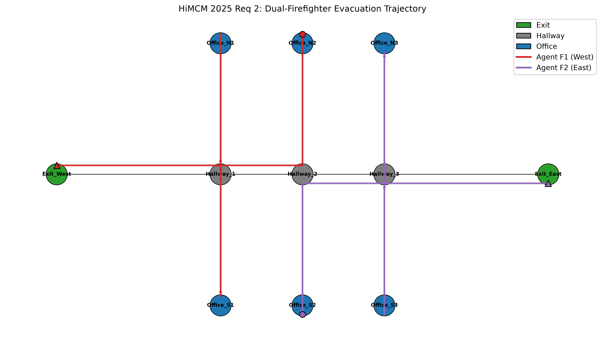
Figure 1 office: dual-firefighter trajectories produced by the scoring planner. $F_{1}$ (west, red) clears $N_{1},S_{1},N_{2}$; $F_{2}$ (east, purple) clears $N_{3},S_{3},S_{2}$. Repeated visits to a hallway hub are tree backtracks, not assignment oscillations.
Monte Carlo confirmation under the ideal (no-smoke) condition, $N=30$, is deterministic: every replication reports $T_{clear}=135.0 s$, $η=1$, $ρ=0$ (Table 1).

Scaled Multi-Agent Sweep Model (Daycare & Warehouse Case Studies)

Scoring planner
Idle firefighter $a$ at node $u$ scores each untagged room $r∈R$ by
$$\begin{matrix}Score(r) & =−w_{dist} d(u,r)−w_{hazard} h(r)+w_{priority} v(r) \\ & −w_{redundancy}1[r\text{ already targeted}]−w_{tabu}1[r∈T_{a}]+w_{mom}M(a,r).\end{matrix}$$
Here $d(u,r)$ is shortest-path length (m) on the passable subgraph; $h(r)$ is smoke density plus a fire indicator; $T_{a}$ is a tabu list of the last three rooms tagged by $a$ (hallway cut-vertices are never forbidden); $M(a,r)=1$ if $r$ shares a circulation hub with $u$ (finish the column). Aspiration ignores tabu when every remaining room is tabu. State machine: $move→sweep→tag→move$.
Default weights: $w_{dist}=1$, $w_{hazard}=8$ (experiments) or $5$ (office demo), $w_{priority}=2$, $w_{redundancy}=80$, $w_{tabu}=50$, $w_{mom}=15$, tenure $3$.

Layouts

Daycare.
Three floors, six rooms per floor (same hanging template as Figure 1), west/east stair flights of $8 m$, ground exits $E_{W},E_{E}$. Eighteen searchable nodes; infant and nap rooms carry $v(r)∈\{4.5,5\}$.

Warehouse.
An $8×12$ four-connected grid of $4 m$ cells, rack obstacles, eight exits, 40 searchable bays. Extra firefighters spawn at remaining exits then aisles.

Ideal-condition results (Requirement 3)
Table 1 reports mean $T_{clear}$ from 30 replications. The planner is deterministic without fire, so the sample standard deviation is identically zero and the 95% Student-$t$ interval collapses to a point—visible as zero-length error bars in Figure 2.
Ideal (no-smoke) clearance. Source: results/experiment_summary.csv, $N=30$.
Scenario | Crew $m$ | $T_{clear}$ (s) | $η$ | $ρ$ | Full clear
Office | 2 | 135.00 | 1.00 | 0.000 | $30/30$
Daycare | 2 | 439.00 | 1.00 | 0.000 | $30/30$
Daycare | 3 | 300.67 | 1.00 | 0.000 | $30/30$
Daycare | 4 | 255.67 | 1.00 | 0.111 | $30/30$
Warehouse | 3 | 424.67 | 1.00 | 0.700 | $30/30$
Warehouse | 4 | 333.00 | 1.00 | 0.750 | $30/30$
Warehouse | 5 | 262.33 | 1.00 | 0.775 | $30/30$
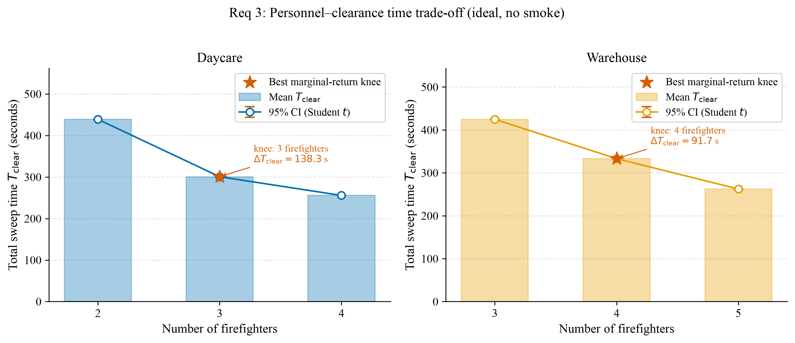
Requirement 3 personnel–time trade-off under the ideal condition. Stars mark the crew size that realises the largest one-firefighter reduction $ΔT_{clear}=T_{clear}(m−1)−T_{clear}(m)$: daycare $m=3$ ($138.3 s$), warehouse $m=4$ ($91.7 s$).
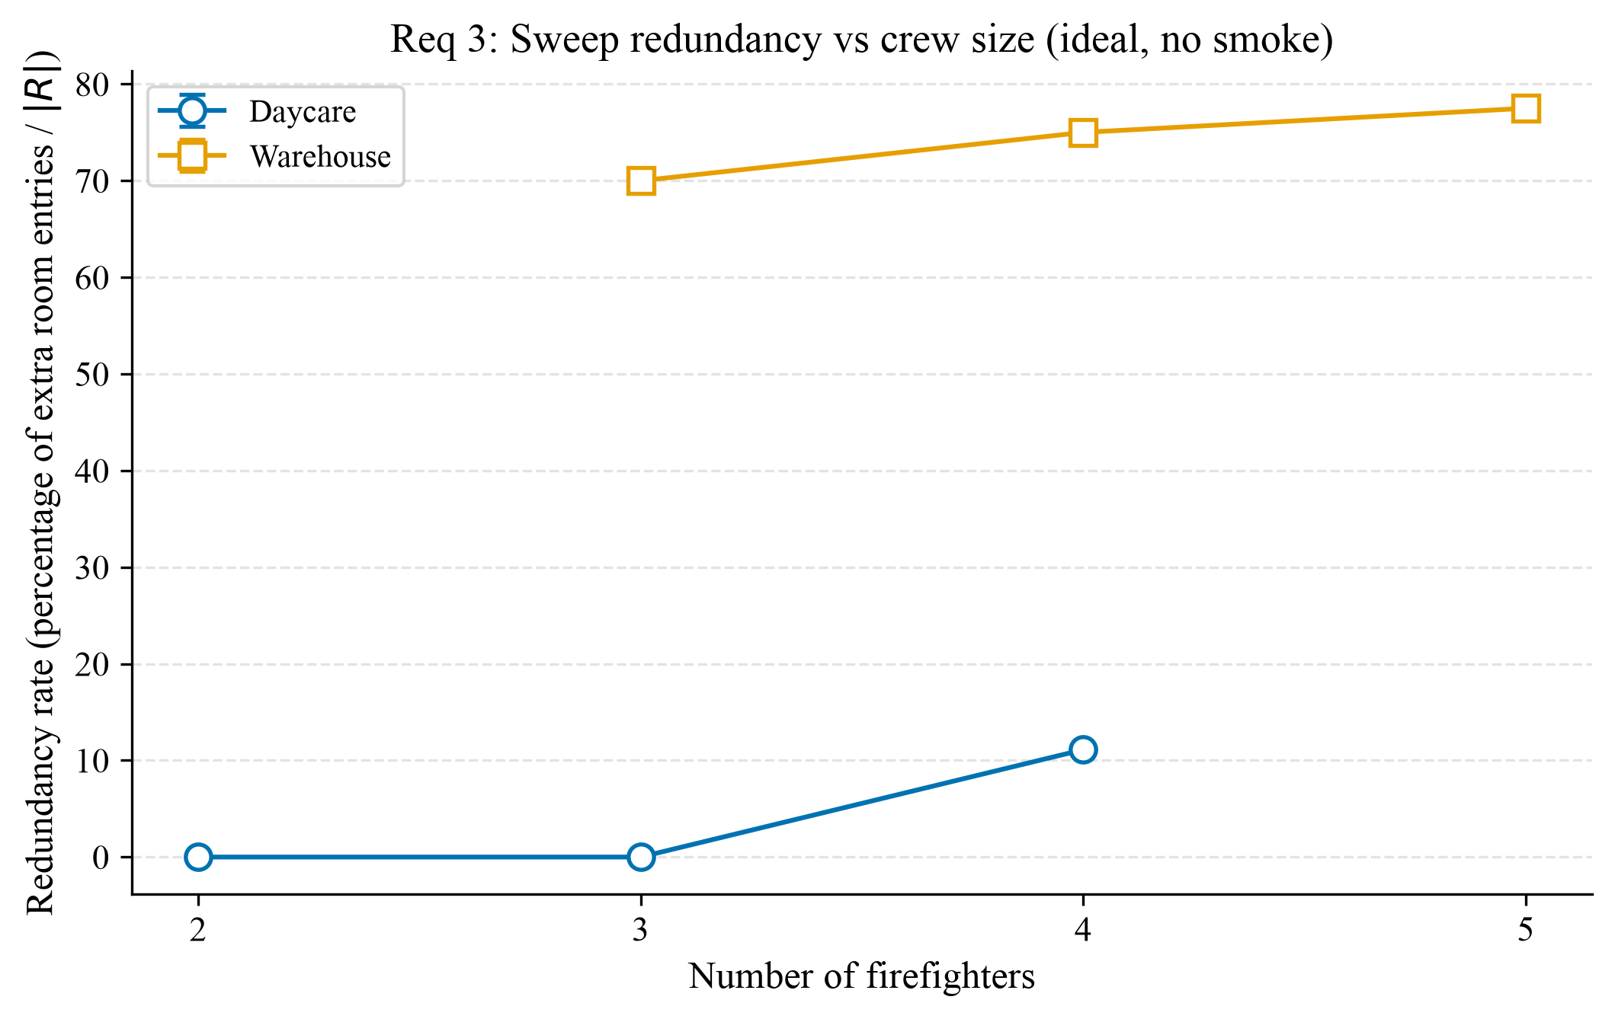
Sweep redundancy $ρ$ (percent extra searchable entries per $|R|$) versus crew size, ideal condition. Tree-like daycares stay near zero until the fourth firefighter; the warehouse grid induces $70$–$78\%$ extra bay entries as more agents share aisles.

Recommendation (no hazard).
Send three firefighters to the daycare template and four to the warehouse template if the objective is elapsed sweep time per additional person. A fourth daycare firefighter still helps ($−45 s$) but is the first crew size at which $ρ$ becomes positive ($0.111$).

GAT-PPO on the Figure 1 office
The scoring planner is a kinematic FSM: travel uses $v_{h}$ and $v_{r}$, and a room tag costs $t_{sw}+t_{tag}=25 s$ after the access edge. GAT-PPO instead acts on the unweighted office graph. Each agent, at every discrete graph step, either stays (the stay action is the only way to tag the current searchable node) or walks one incident edge. Team reward is
$$R=10 Δ|R_{tagged}|−0.5−2 1_{redundant}+50 1_{all clear},$$
with an additional $−15$ if a firefighter occupies a burning node (disabled in the office pre-train). The actor-critic is a two-layer GAT ($4$ heads, hidden width $64$, residual LayerNorm) with masked softmax over $1+\text{deg}(u)$ actions and attentional critic pooling. We train parameter-shared PPO for $200$ episodes, $γ=0.99$, GAE $λ=0.95$, clip $0.2$, entropy bonus $0.01$, two agents, no fire (src/rl/checkpoints/gat_ppo_office.pt).
Because one graph step is not one second, we compare full-clearance rate and rooms tagged, not $T_{clear}$ in seconds. Evaluation uses the same checkpoint with two decoding modes, $N=30$ each, episode seeds $1000+i$ (greedy) and $2000+i$ (stochastic), and a matching Torch RNG seed so the CSV is reproducible (Table 2, results/rl_office_eval.csv).
Office $m=2$, ideal (no smoke). Planner row from experiment_summary.csv; GAT-PPO from rl_office_eval.csv, $N=30$. Rooms and steps for GAT-PPO are sample means with 95% $t$ intervals. Planner steps are kinematic seconds, not graph hops.
Policy | Full clear | Rooms tagged | Length | Return
Scoring planner | $30/30$ | $6.00$ | $135 s$ | —
GAT-PPO greedy | $0/30$ | $2.00$ | $80.0$ hops | $−172.0$
GAT-PPO stochastic | $20/30$ | $5.60 [5.37,5.83]$ | $59.3 [52.2,66.5]$ hops | $18.7 [−2.4,39.9]$
Greedy $argmax$ decoding collapses: every trial hits the $80$-step cap with exactly two rooms tagged and return $−172$. The trained categorical still places mass on exploratory hops; sampling that distribution fully clears $20/30$ trials and tags $5.60$ rooms on average (Figure 5). Among successful stochastic rollouts, the shortest recorded full clear in this evaluation used seed $2014$ and $29$ graph steps (Figure 4). Boxplots of length and return (Figure 6) show that stochastic decoding both shortens the typical episode relative to the greedy timeout and yields a return whose $95\%$ interval still covers zero—the policy is useful but not a substitute for the $135 s$ FSM on this small tree.
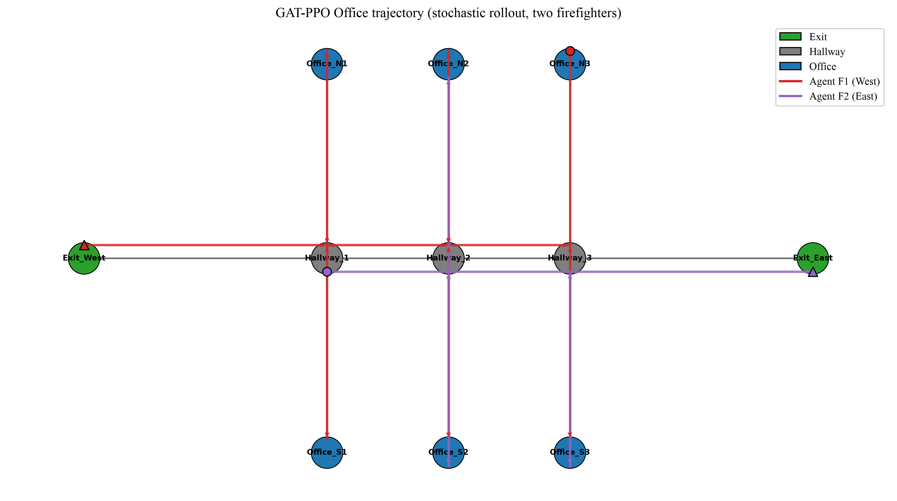
GAT-PPO stochastic rollout on Figure 1 (seed $2014$): both agents start at the west/east exits (triangles) and finish at the marked discs after tagging all six offices in $29$ graph steps. Stay actions appear as overlapping vertices rather than hallway backtracks.
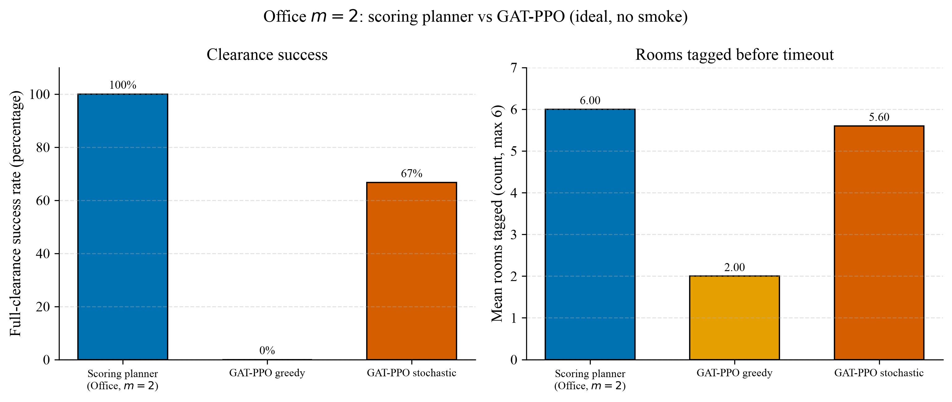
Office $m=2$, ideal condition: full-clearance rate and mean rooms tagged. The scoring planner is $30/30$ and $6/6$. GAT-PPO greedy is $0/30$; stochastic decoding is $20/30$ with mean $5.60$ rooms. Source: experiment_summary.csv and rl_office_eval.csv.
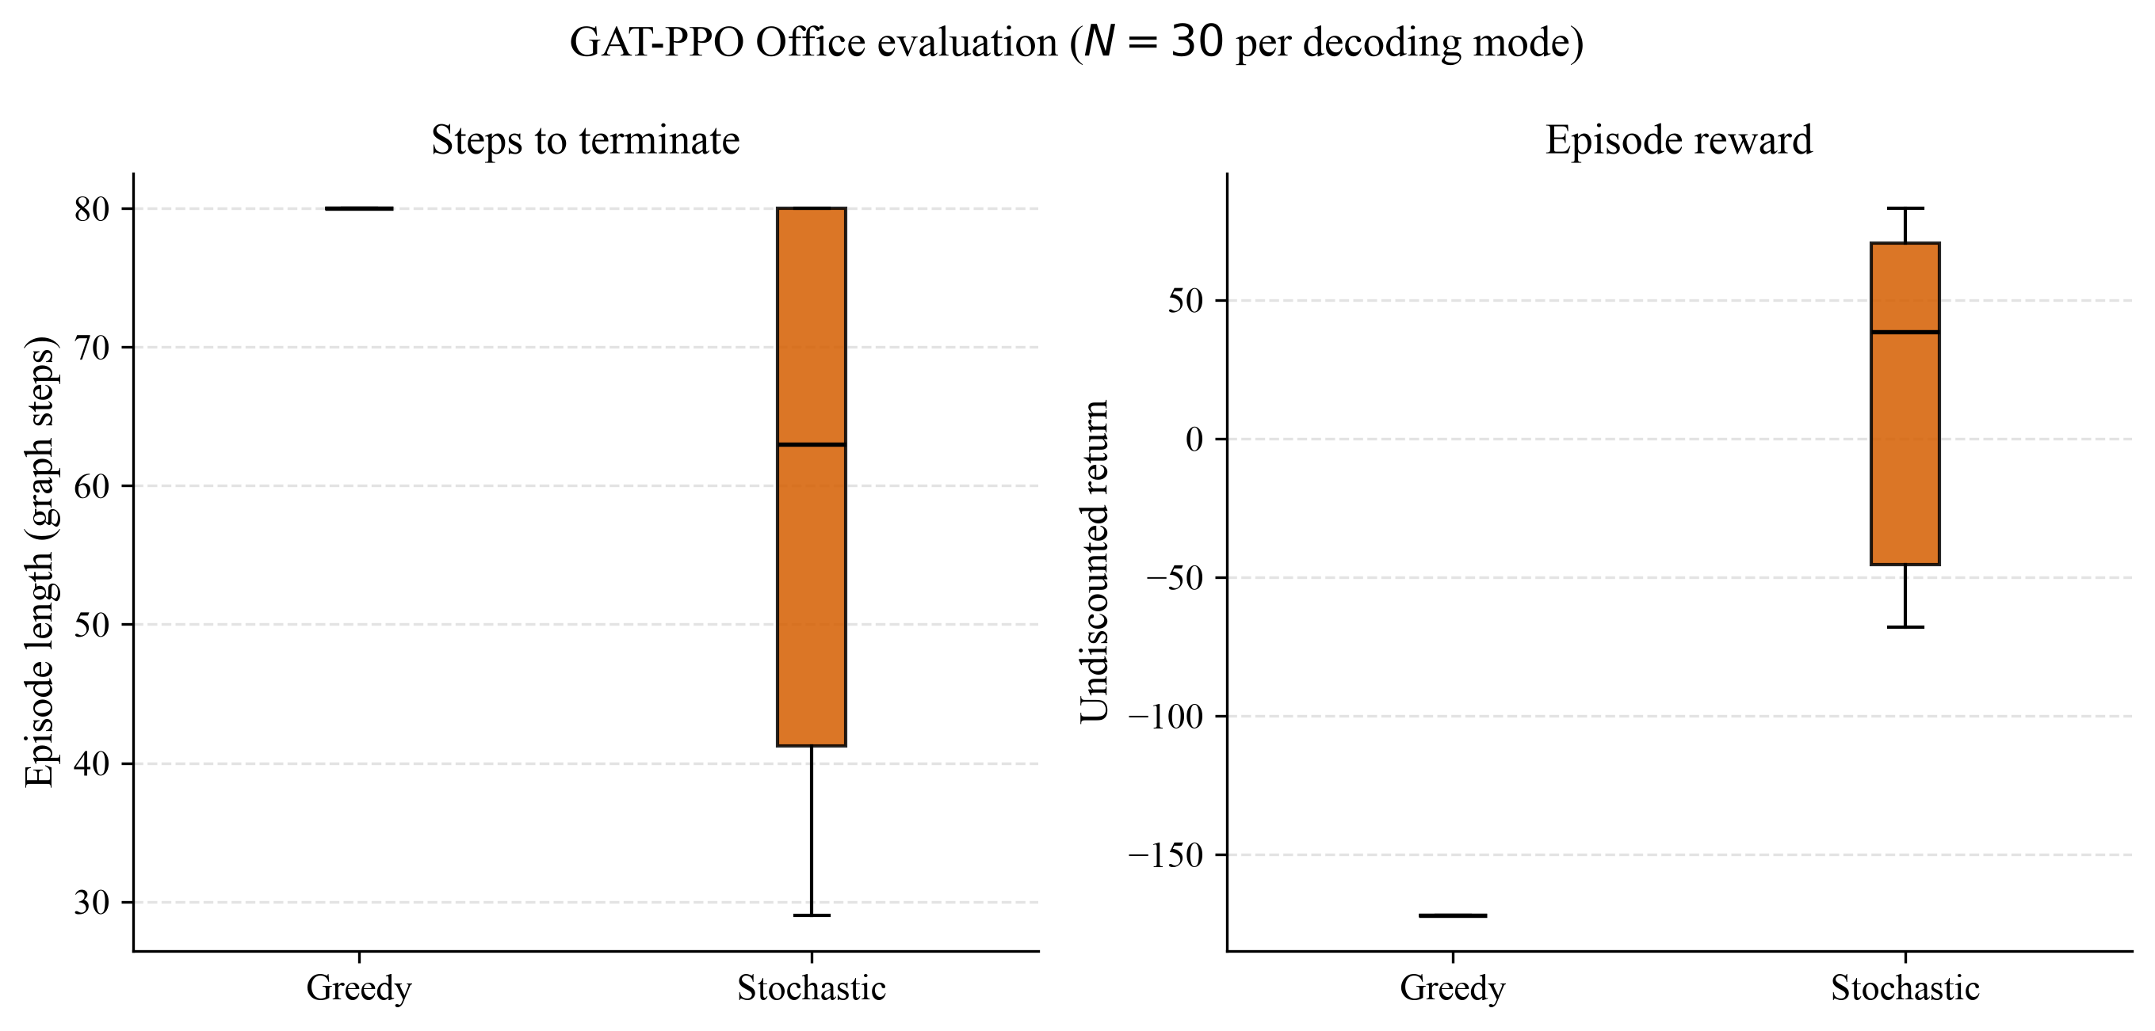
GAT-PPO Office evaluation, $N=30$ per decoding mode. Greedy decoding is degenerate (exactly $80$ hops, return $−172$). Stochastic decoding has mean length $59.3$ hops and mean return $18.7$.

Recommendation (learned policy).
Use the scoring planner for contest-ready $T_{clear}$ in seconds. Use stochastic GAT-PPO only as a graph covering prior: it can finish the six-room office in a majority of sampled trials, but greedy inference is currently unsafe (stay bias), and the hop clock is not a fireground timeline.

Real-World Hazards & Sensor Technology Integration

Fire and smoke on the graph
Let $k(u)$ be the number of burning neighbours of $u$. Ignition of a cold node in one discrete hazard step occurs with
$$P_{spread}(u)=1−(1−p_{0})^{k(u)}, p_{0}=0.08$$
in the Monte Carlo engine. Smoke advances by a multi-source Dijkstra cutoff of length $v_{smoke}Δt$ with $v_{smoke}=1.5 v_{fire}$ and $v_{fire}=0.45 m/s$. Density $σ(u)∈[0,1]$ yields speed multiplier $\text{max}(0.15,1−0.4σ(u))$ and visibility $\text{max}(0.10,1−0.8σ(u))$. Fully involved nodes are impassable.
Each smoke trial draws a uniform ignition node from rooms, bays, and hallways (exits excluded) and a distinct RNG seed $2025+{10}^{5}s+{10}^{3}m+100⋅1_{smoke}+run_id$.

What the 210 smoke trials actually show
Full-building clearance success was $0/210$. On the small office and daycare graphs, fire cuts the unique hallway spine; agents deadlock after tagging only a few rooms. Warehouse trials last longer (median abort $≈182$–$192 s$) and salvage more bays, but five runs hit the 5000-step cap ($T_{clear}$ recorded as $10 000 s$). Those abort clocks are not sweep times; we therefore report salvage $η$ and median abort time, not mean $T_{clear}$, for smoke (Table 3).
Dynamic smoke ($p_{0}=0.08$). Salvage $η$ is a 95% $t$-interval over $N=30$. Median abort time excludes the interpretation of timeouts as completed sweeps. Source: experiment_summary.csv.
Scenario | $m$ | Full clear | $η$ mean [95% CI] | Med. abort (s) | Med. rooms tagged
Office | 2 | $0/30$ | $0.200 [0.130,0.270]$ | 42.0 | 1
Daycare | 2 | $0/30$ | $0.158 [0.130,0.186]$ | 50.5 | 2
Daycare | 3 | $0/30$ | $0.197 [0.169,0.225]$ | 46.0 | 3
Daycare | 4 | $0/30$ | $0.267 [0.241,0.293]$ | 56.5 | 4
Warehouse | 3 | $0/30$ | $0.322 [0.285,0.358]$ | 182.0 | 12.5
Warehouse | 4 | $0/30$ | $0.403 [0.363,0.444]$ | 182.0 | 15.0
Warehouse | 5 | $0/30$ | $0.532 [0.476,0.589]$ | 192.0 | 21.5
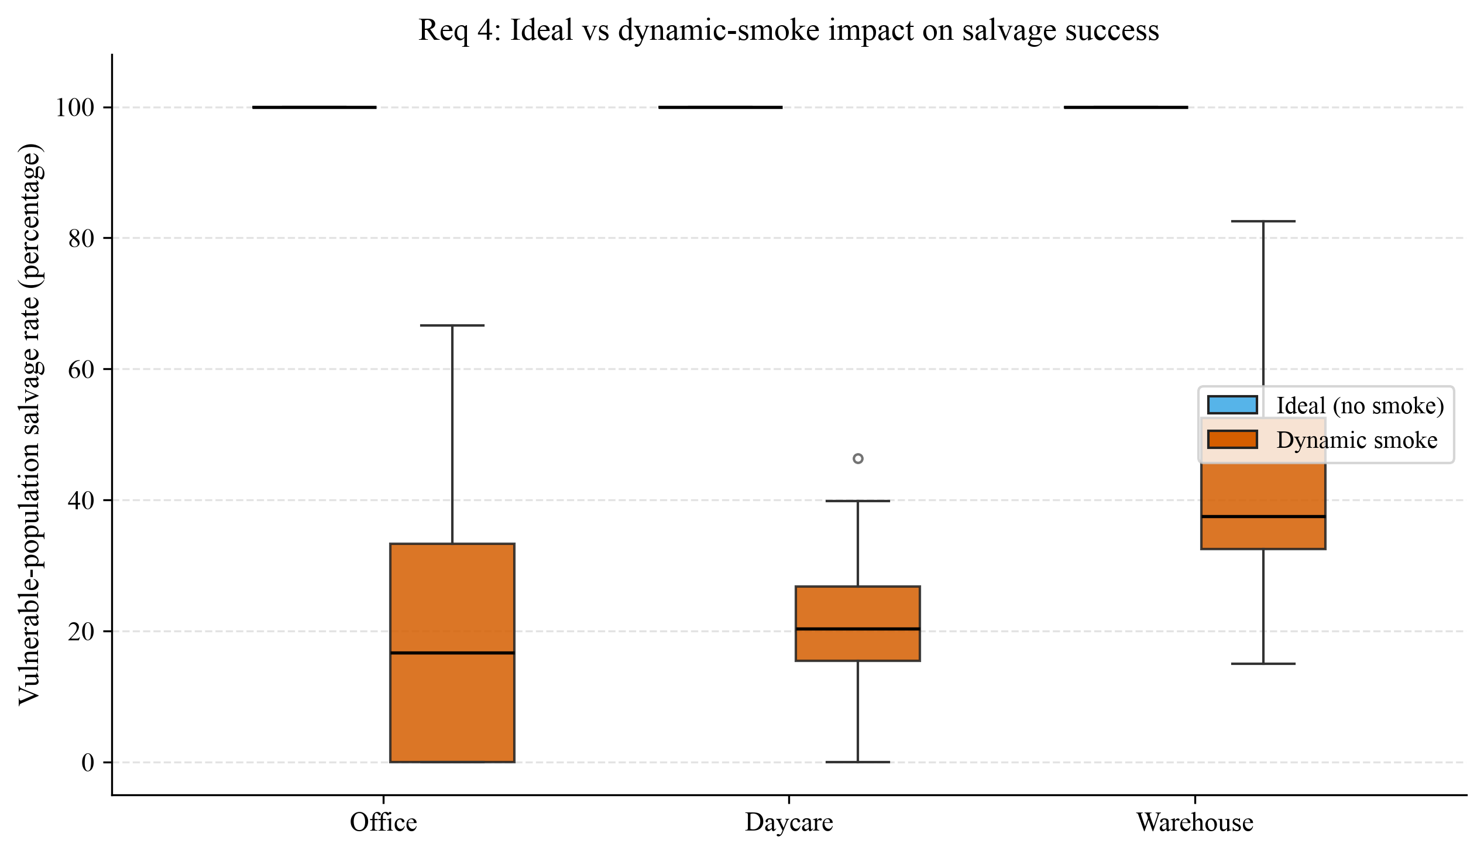
Requirement 4: distribution of vulnerable-population salvage $η$ (percentage) under ideal versus dynamic-smoke conditions, pooling crew sizes within each building. Ideal mass sits at $100\%$; smoke mass is strictly below, with the warehouse retaining the highest median salvage.
Crew size still has a monotone effect inside the hazard: daycare salvage rises $15.8\%→19.7\%→26.7\%$ for $m=2,3,4$; warehouse $32.2\%→40.3\%→53.2\%$ for $m=3,4,5$. Extra agents tag more high-$v(r)$ rooms before the graph disconnects; they do not restore full clearance at this $p_{0}$.

Sensor technology as model inputs
We do not simulate proprietary hardware. We specify how three sensor classes would enter [eq:score] without changing the planner API.
- Door tags / NFC “cleared” cards. Already modelled as $t_{tag}=5 s$. A digital tag that broadcasts to all radios sets the shared tagged-set instantly, which is our current information assumption.
- Thermal or through-smoke cameras. Reduce $t_{sw}$ and raise visibility; equivalently increase $M(a,r)$ for rooms already viewed from the hallway, or lower $h(r)$ when the camera reports a cold empty volume.
- Heat/CO detectors and helmet-mounted lidar. Provide an estimate of $k(u)$ and $σ(u)$ ahead of physical arrival, which is exactly the field $h(r)$ already subtracted in [eq:score]. A more conservative $w_{hazard}$ is then a policy choice, not a new algorithm.
The Monte Carlo says that without such lookahead, $p_{0}=0.08$ on a single-spine building is operationally unsurvivable as a full primary search. Sensors matter because they either slow effective spread (earlier isolation) or let agents skip already-scanned volumes.

Sensitivity & Robustness Analysis

Crew size (ideal)
Figure 2 is the principal sensitivity of $T_{clear}$ to $m$. Marginal returns diminish: daycare savings $138.3 s$ then $45.0 s$; warehouse $91.7 s$ then $70.7 s$. The recommendation in Section 3 is this discrete derivative, not a continuous EOQ formula.

Hazard on/off
Switching from clear to smoke is a binary stress test. Full-clearance rate drops from $1$ to $0$ in every building at $p_{0}=0.08$. The robust ranking of buildings by salvage under smoke is warehouse $>$ daycare $≈$ office, consistent with extra exits and grid connectivity. $η$ intervals in Table 3 do not overlap the ideal value $1$, so the hazard effect is not a sampling artefact.

Determinism and confidence intervals
With fire off, 30 seeds produce bit-identical $T_{clear}$. Reporting a 95% CI is then a formality (width $0$). With fire on, $η$ has genuine dispersion driven by the random ignition node; office salvage 95% CI is $[0.130,0.270]$. Warehouse mean abort time is not robust: two to five timeouts inflate the mean into the hundreds of seconds with a CI that even crosses zero if timeouts are naively included. Robust summaries are the median abort and $η$, as in Table 3.

Algorithmic robustness
Tabu tenure $3$ and momentum were introduced to kill edge-reversal cycles on loopy graphs. On the office tree they leave the Split-Half column order unchanged ($N_{1}→S_{1}→N_{2}$) and keep $T_{clear}=135 s$. We did not sweep $w_{tabu}$ or $p_{0}$ in the 420-run design; those are the natural next one-factor sensitivities. Lowering $p_{0}$ would be required before claiming a positive full-clearance probability under smoke.

Limitations
- Civilians, debris, and hose lines are absent.
- $p_{0}=0.08$ is a harsh stress test, not a calibrated ISO fire curve.
- Warehouse redundancy $ρ≈0.7$ shows aisle contention that a partition-first (non-greedy) dispatcher might cut.
- Step cap of 5000 (warehouse, $Δt=2 s$) censors a few smoke runs.
- GAT-PPO is pretrained only on the office, without fire, for $200$ episodes. Greedy decoding fails ($0/30$ full clears); we did not train daycare or warehouse policies.

Conclusions
For the Figure 1 office, two firefighters and Split-Half geometry give an analytical $145 s$ bound and a $135 s$ operational sweep. For scaled buildings without fire, three daycare firefighters and four warehouse firefighters maximise one-person time savings. Under the implemented spreading hazard, complete clearance is not achieved; adding people still raises vulnerability-weighted salvage, especially in the warehouse. Sensors should be wired into $h(r)$ and $t_{sw}$, not treated as a separate narrative layer. A 200-episode GAT-PPO office policy clears $20/30$ stochastic trials and $0/30$ greedy trials; it is a learned covering heuristic, not a replacement for the timed scoring planner.
9 F. Glover, “Tabu search—Part I,” ORSA Journal on Computing, vol. 1, no. 3, pp. 190–206, 1990.
National Fire Protection Association, NFPA 1620: Standard for Pre-Incident Planning, Quincy, MA.
S. Ko, T. Krishnamurthy, and H. Hamacher, “Dispatching of fire engines with stochastic travel times,” related covering models in emergency logistics (see also standard shortest-path search on graphs).
J. Schulman, F. Wolski, P. Dhariwal, A. Radford, and O. Klimov, “Proximal policy optimization algorithms,” arXiv:1707.06347, 2017.
P. Veličković, G. Cucurull, A. Casanova, A. Romero, P. Liò, and Y. Bengio, “Graph attention networks,” in ICLR, 2018.
Team computational archive: results/experiment_summary.csv (420 runs), results/rl_office_eval.csv ($N=30$ greedy and $N=30$ stochastic GAT-PPO office evaluations), and paper_figures/ (planner and RL plots generated from those CSVs).

AI use disclosure (COMAP policy)
Portions of the code (graph layouts, hazard stepper, scoring planner, Monte Carlo driver, GAT-PPO stack, and figure scripts) were drafted with a coding assistant. Every numerical value in Tables 1–3 and in the GAT-PPO Table 2, as well as every plot under paper_figures/, was produced by executing that code on the repository, not by the assistant inventing spreadsheet entries. Prompt logs suitable for the official AI disclosure form live in prompts/cursor_log.md.

Reproduction commands
PYTHONPATH=. python experiments/run_sweep_experiments.py
PYTHONPATH=. python src/utils/plot_figures.py
PYTHONPATH=. python src/rl/train.py
PYTHONPATH=. python src/utils/plot_rl_figures.py
pdflatex paper/himcm_paper.tex

