Component architecture

|  |
| --- |
| Move  Move down  Health  Transform  MeshCollider  MeshRenderer  Health  Ability Component Interface  AI Component Interface  Physics Component Interface  Status Component Interface  Pickup Component Interface  owns  Actor  ActorComponent |

UML diagrams

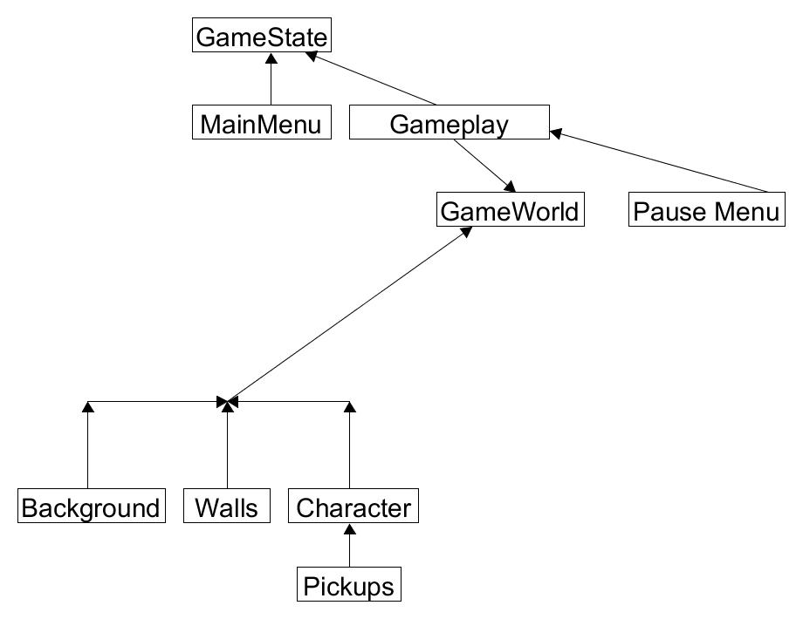

Description of main loop

Start() function:

* Call Generate()
* Call Draw()

Generate() function:

* Set up wall positions

Draw() function:

* Draw UI components
* Draw environment (Backgrounds, walls)
* Draw Player character

Update() function:

* Call Generate()
* Call Draw()
* Call Input()

Input() function:

* Take player inputs