# Segmentation

## What is segmentation?

**Seg·men·tat·ion**

***Noun***

*Biology*

The subdivision of an organism or of an organ into more or less equivalent parts

In image processing ‘segmentation’ separates one area of an image from another; this can be applied to medical images acquired from μCT, MRI or similar capture methods to define distinct areas of anatomy in a sample.

## How is it carried out?

There are a variety of ways that segmentation can be carried out, using a variety of image processing methods, amongst the most popular are:

Manual segmentation: Using various paintbrush tools to define by hand which pixels/voxels belong to your region of interest and which do not

This method is possible with almost all pieces of segmentation and image processing software. Amira and 3DSlicer provide specialist tools for this task, including thresholding paintbrushes that prevent the user from including voxels of insufficient or excessive intensity.

Manual segmentation allows the greatest degree of user control, but is extremely time consuming (hours to days) and is highly susceptible to human error and interpersonal inconsistency.

Semi-automatic segmentation: Coupling human decision-making with computer algorithms

Many pieces of software offer semi-automatic segmentation, using a wide variety of methods. The most successful of these is ITK Snap which uses a snake algorithm for region filling coupled with intensity thresholding or edge detection.

Semi-automatic segmentation is a lot less time consuming that manual segmentation (minutes to hours depending on the quality of the dataset and the experience of the user). The results and the ease of acquiring them is largely dependent on the data input (Is the contrast sufficient? Are the edges well defined? Are there significant changes in texture? Is there excessive noise?) and the familiarity of the user with their dataset and with the segmentation process.

There is often a need for some manual clean-up after semi-automatic segmentation.

Automatic segmentation: Segmentation carried out unsupervised by computer processes

So far as we know this hasn’t been successfully achieved by any group. If it became possible it would be an extremely useful tool for interactive analysis of visual data.

## What is it useful for?

We have two main aims for segmentation: Atlas creation and Image analysis

Atlas creation

One of our primary aims from segmentation is to create an embryo atlas, similar to that created by Wong et al. (1)

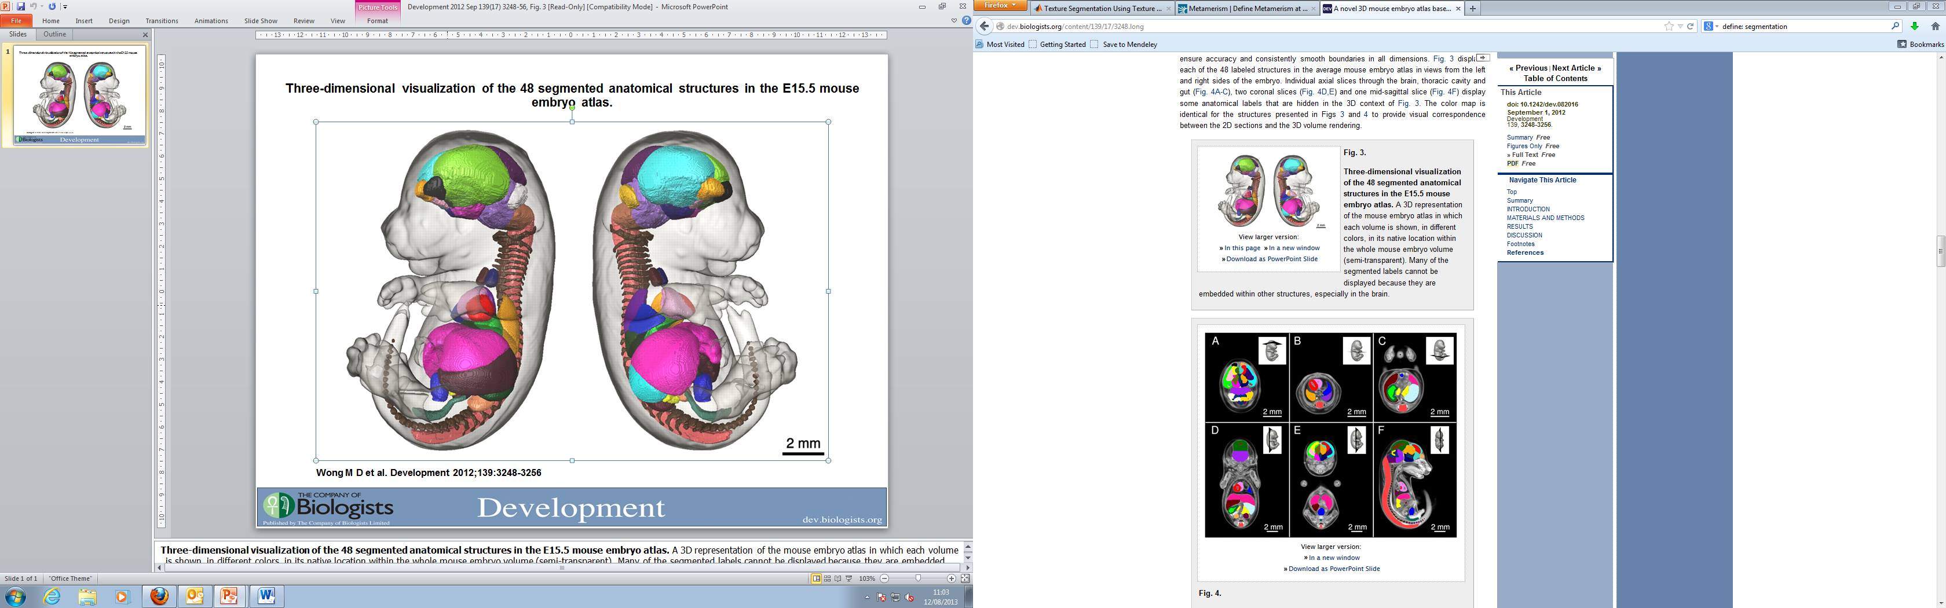

Image analysis

Image analysis – volume metrics - phenotyping

## Our Achievements

So far we’ve achieved segmentation of the liver, heart and lungs of a variety of E14.5 mouse embryo specimens in ITK Snap. We’ve used this data to obtain volume metrics for these organs and should be able to use these to quantify isotropic and anisotropic shrinking in embryos prepared for image capture. We can now also qualitatively compare embryos between specimens and compare these with their equivalents in MRI imaged embryos – which should not have undergone any shrinking.

# Bibliography

1. *A novel 3D mouse embryo atlas based on micro-CT.* **Michael D. Wong, Adrienne E. Dorr, Jonathon R. Walls, Jason P. Lerch, R. Mark Henkelman.** s.l. : Development, 2012, Vol. 139.