



E-PROJECT DOCUMENTATION

***Team Members:***

* Muhammad Hasnain Siddique
* Asad Mahmood
* Abdul Aziz

­

**ACKNOWLEDGEMENT**

I would like to acknowledge all those who have given me moral support and helped in making the project a success.

I wish to express my gratitude to e-Project Team at Head Office who guided and helped me. Also, I would like to express my gratitude to all the staff members of my center for not only providing me opportunity to work with them on this project, but also for their support and encouragement throughout the process.

I also express my sincere gratitude to e-Project Team from Aptech Head Office and my project guide at the organization for his valuable guidance and support for completion of this project.

**Table of Content**

|  |  |
| --- | --- |
| Content | Page No. |
| Introduction ---------------------------------------------------------------------------- | **03** |
| Requirement Specification ---------------------------------------------------------- | **04** |
| Descriptions of All Pages ------------------------------------------------------------ | **05** |
| Site Map -------------------------------------------------------------------------------- | **07** |
| Home Page------------------------------------------------------------------------------ | **08** |
| Market - -------------------------------------------------------------------------------- | **12** |
| About Us -------------------------------------------------------------------------------- | **16** |
| Contact Us ------------------------------------------------------------------------------ | **20** |

**INTRODUCTION**

This is a e-commerce site about a local stationery shop, whose business going really prospering so, they decided to take this business online, rather just go modern like the world, taking everything online these days.

Here you can find all sorts products such as: room decorations, greeting cards, dolls, office files, hand bags, wallets and cosmetics.

**REQUIREMENT SPECIFICATION**

**►non-Financial:**

* The dealer alone can manage the details of the products, employees and as well he can check the details of the orders, stock details, feedbacks and FAQs from the customers.
* The employee will only be able to change his/her password, and check and update the details of the orders and the delivery reports
* The details of the products, employees, orders, delivery/dispatching details and as well that of the customers, are needed to be maintained using the help of the database.
* Also, the customer should be able to check the details of the order that he/she has placed.
* An advanced search option so as to fetch the details with an ease is to be implemented.
* The registered customers should alone be able to manage his/her account, orders placed by them and can check the details of the products while the non registered customers can only be able to check or fetch the details of the products and register with the site.
* The application should be automated, so that the details like the number of products that are available with them, dispatched details like when the product has been dispatched, the payment details, and the delivery details can be attained at an ease.
* The details of the payments at the time of placing an order should be captured in details based on the type of payment/dispatch that the customer is willing to have like the detailed description of the payments (credit card details if the payment is through the credit card, and cheque details if the payment is through cheque.
* The customer can only be able to cancel the order provided that the product is not dispatched from the dealer’s premises.

**►Financial:**

* For the customers who have placed an order for which the payment type is either through cheque or through credit card, only after the clearance of the payment the products will be dispatched.
* If the order placed is through VPP, the customer is needed to make the payment at the time of delivery at their premises.
* If the customer is not satisfied with the product, then he can either place a request for replacing the product or he can return the product, so that he/she can get the payment back, provided the product is returned with in the week days time from the time of the delivery of the product at the customer’s premises.

***Functional Requirements: –***

* Maintaining the details of the Employees, product details, stock details, order, and delivery details of the products and that of the customers are to be maintained with the help of the database.
* There should be separate login for Admin, Employees and for the customer.

**Descriptions of All Pages**

**Home**

Starting with the home page, cuz that’s where it all starts  
so at the top there’s the navigation bar, having a logo and pages links.

Following is a normal landing page with a background image and some text and a button leading to the store page. Below it is a little feature content section containing: Quality Products, Free Shipping and 100% money back. Below it is just another extra section just to make the page feel it has some content cuz I couldn’t of anything else to add so I added some text, a background image of fixed attachment so it looks good and another button leading to store page and then below it is a useful section of “need help?” well, not so useful.. it just leads you to the contact page.. well! After that is just a footer having other page’s links and social media icons leading to nowhere and below it just the generic copy right line.  
that’s all for the home page

**Store**

Now for the store page, at the top it’s the same navigation bar, it’ll appear in like every page.

Well, now at the top is the search bar, it works really well, just search for anything! And it’ll get the all matching results else it’ll just say “nothing found” which is pretty obvious huh… well! Moving on below are all the products on this site, they’re categorized as: room decorations, greeting cards, dolls, office files, hand bags, wallets and cosmetics. Just click/tap on any product to check it’s details and maybe even buy! If you click on “add to cart”, you’ll be redirected to the login page, you MUST login if you wish to add a product in the cart.

**Contact Us**

On this page, there really isn’t much is there, just some contact info and a contact form, fill it up and send a nice message, I’ll read it!

**Login/Register**

Now this page here is pretty important isn’t it, now this page is two important section and you guessed it right! It’s “Register” and “Login”.

First at the register one, write your username, email and a **strong** password and when you click/tap on “sign up” it’ll send a verification link on the email address you submitted, and when you click on that link, it’ll direct you to the “verify” page (I’m not gonna make a different section on this doc for the “verify” page), it’ll show “account verified” and a button below leading you to the login page again, though if you alter the link it’ll show an error message on the verify page, so don’t do that and when you have gotten back to the login page after verifying your email, you can simply login with the same email and password and then you’ll be redirected to the home page.

After logging in you’ll get more links on your navigation bar such as: my orders, my account, cart and logout(didn’t need to mention this one, huh)

**My Orders**

This page will be pretty empty, since you probably haven’t even added anything to your cart yet. Ah well, after adding to cart and placing an order, you’d see your orders here with order number, product image, unit price, total price, product status and courier number(it’ll appear after it’s been dispatched).

**My Account**

This page has almost to nothing, you can just change your password here….

**Cart**

This isn’t really a page itself, it’s just a sidebar, which appears when you clicked on it.

It’ll show the products you’ve added to your cart, they’d be aligned vertically here, you can update the quantity of that product of simply remove it from your cart, you can see the total price at the bottom above the “place order” button, and after you’ve gotten you want to buy in your cart, you can place the order.

After placing the order, your selected products will be found in the “my orders” page.

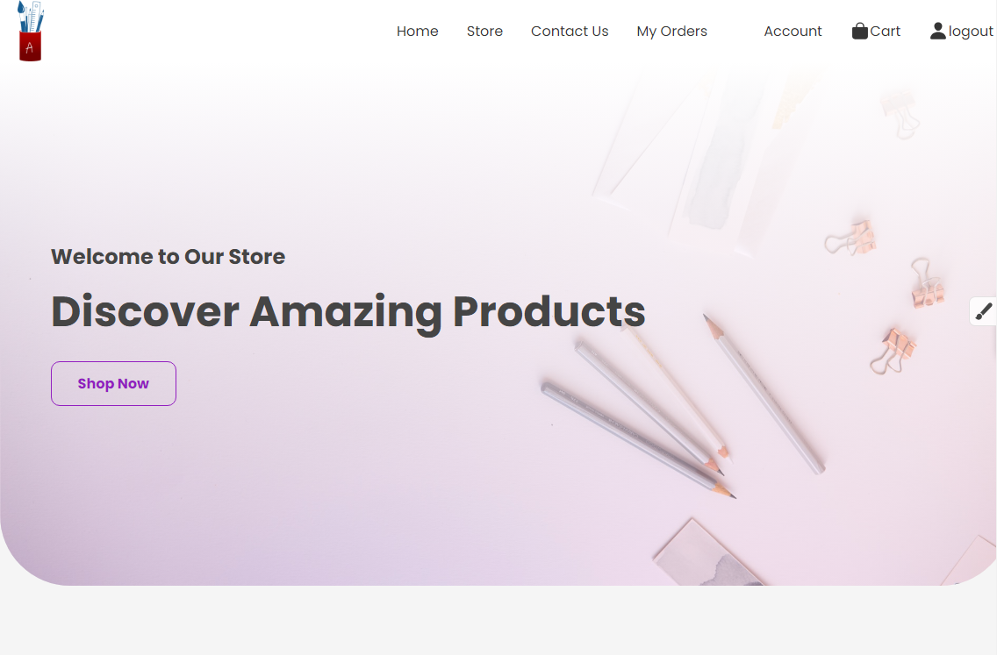

Home

ScreenShots

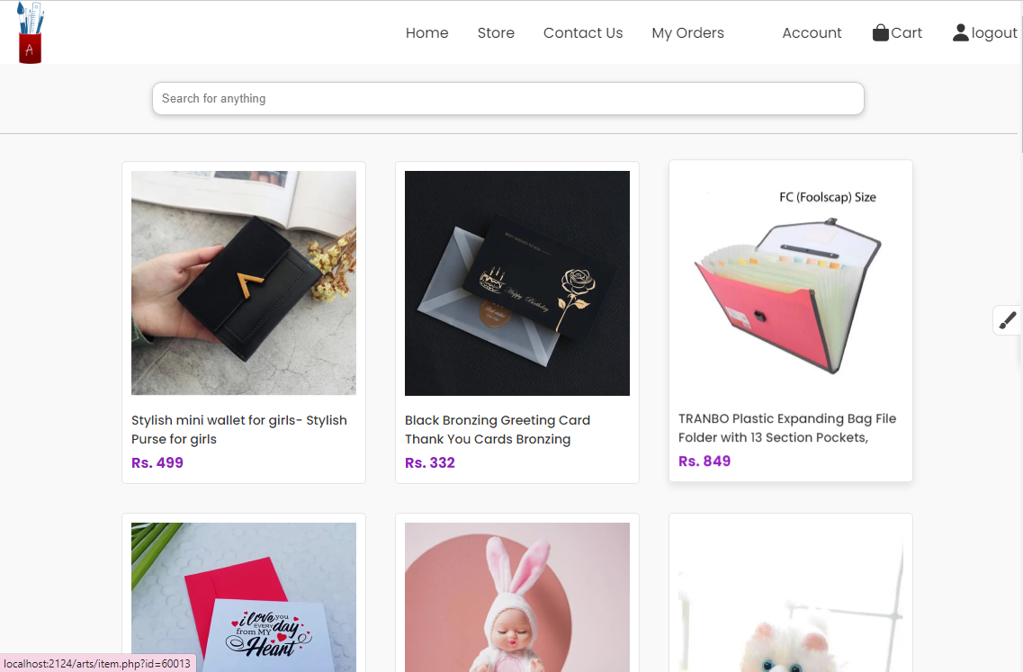

Store

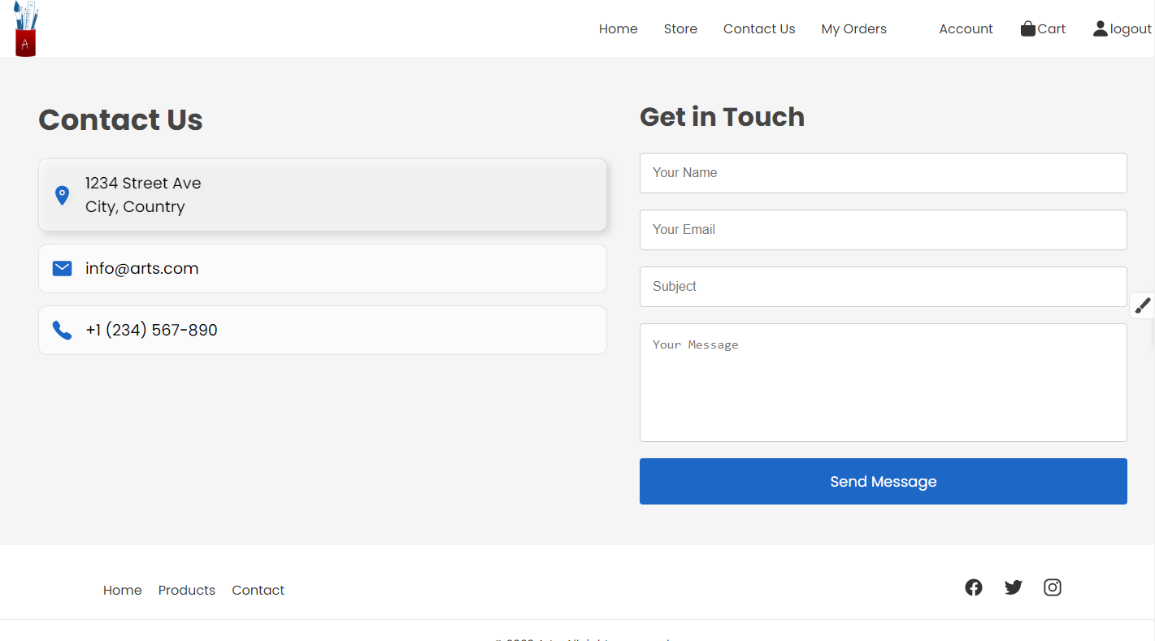

Contact Us

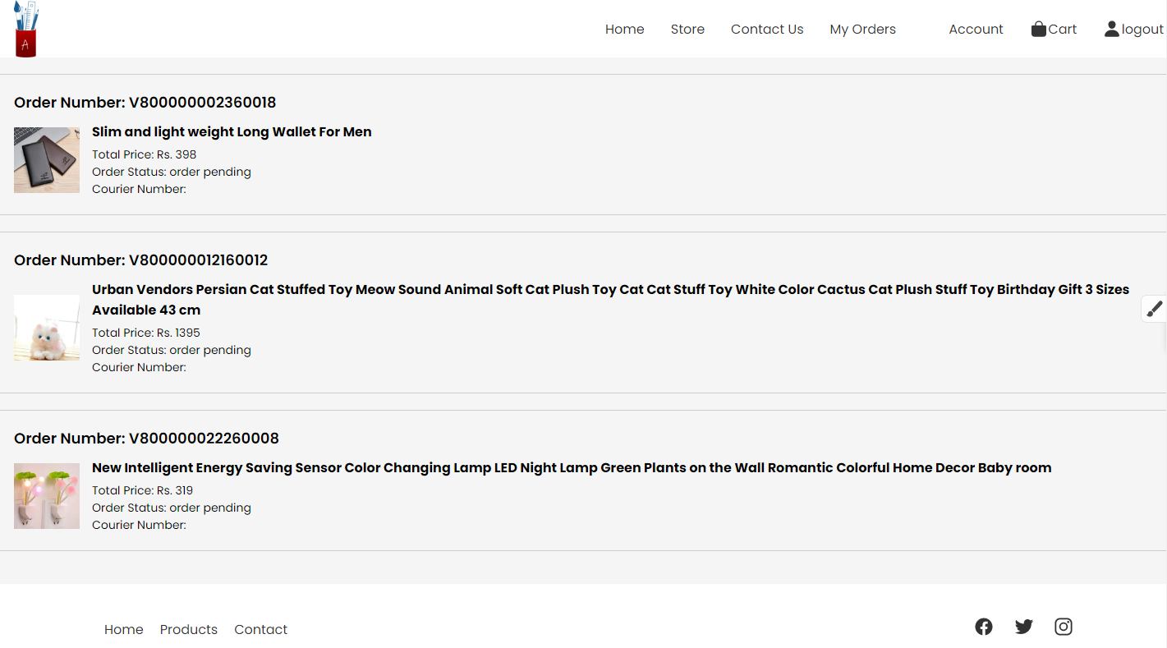

My Orders

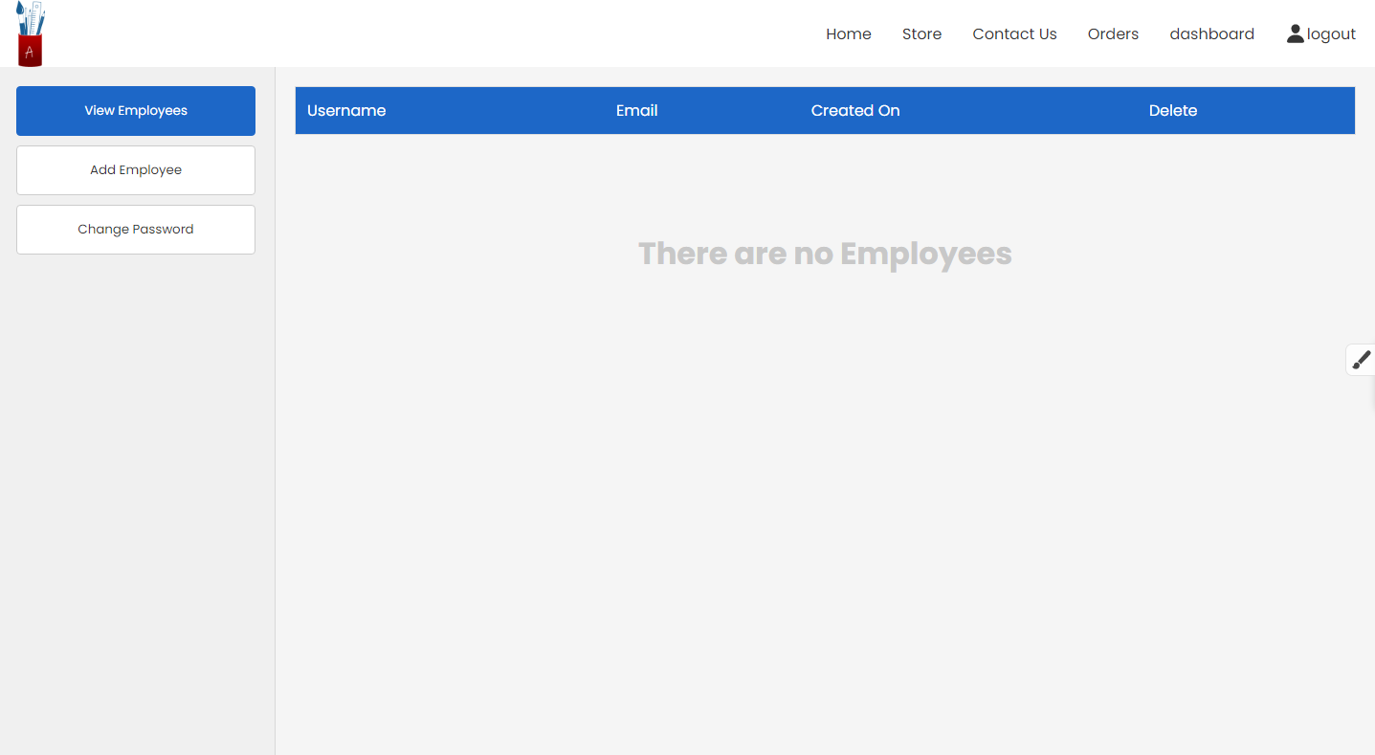

Dashboard

**Backend Explanation:**

**Email registration:**

After submitting the form of valid credentials the page reloads again and send the information to the mailing page, first it checks if the email already exists in the database or not, if it does, it redirects you back to the login page with a notification “a user has already been registered with this email address”, else if it it doesn’t exists, it then generates a random token of 32 characters and inserts the data in the database in the “accounts” table as: (username, email, password, type(default “customer”), verify (default 0), verification_token) after inserting the data in the database, it then sends a url to your email address(using phpMailer), the url includes the verify page, account id and the verification_token, and after clicking on the verification link, and arriving at the verify page, it checks if the verification token and id are the same, if they are, they verify column in the accounts table is set to 1 from 0, after that you can login with that email address and password.

**Adding to Cart & placing an order:**

You can’t add any item to cart unless you’re logged in, after logging in you can add items to your cart, as you click on add to cart, it just adds foreign keys to the cart table, one product foreign key and the customer foreign key.

After you place the order, it gets all the customer_id associated with the current customer from the cart table, and adds them to the orders table and removing all the items from the cart table which had the current customer’s id.

This Concludes The Documentation of E-Project