

**Design Document for:**

# Name of Game

**One Liner, i.e. The Ultimate Racing Game**

“Something funny here!”™

All work Copyright ©2017 by Group Name

Written by Group Name

Version # 1.00

Friday, October 14, 2022

Table of Contents

Name of Game 1

Game Overview 4

Common Questions 4

What is the game? 4

What is the target audience? 4

Why create this game? 4

Where does the game take place? 4

What do I control? 4

How many characters do I control? 4

What is the main focus? 4

What’s different? 4

Feature Set 5

General Features 5

Gameplay 5

Flowcharts 5

Storyboards 6

Controls 6

Single-Player Game 7

Overview 7

Single Player Game Detail #1 7

Single Player Game Detail #2 7

Story 7

Hours of Gameplay 7

Victory Conditions 7

Artificial Intelligence 8

AI Algorithms 8

AI Diagrams 8

The Game World 9

Overview 9

World Feature #1 9

World Feature #2 9

The Physical World 9

Overview 9

Key Locations 9

Travel 9

Scale 9

Objects 9

Weather 9

Day and Night 9

Time 10

Camera 10

Overview 10

Camera Detail #1 10

Camera Detail #2 10

Game Engine 10

Overview 10

Game Engine Detail #1 10

Water 10

Collision Detection 10

The World Layout 11

Overview 11

World Layout Detail #1 11

World Layout Detail #2 11

Game Characters 12

Overview 12

Creating a Character 12

Enemies and Monsters 12

User Interface 13

Overview 13

User Interface Detail #1 13

User Interface Detail #2 13

Weapons 14

Overview 14

Weapons Details #1 14

Weapons Details #2 14

Musical Scores and Sound Effects 15

Overview 15

Red Book Audio 15

3D Sound 15

Sound Design 15

# Game Overview

## Common Questions

Name; creature survivors

### What is the game?

The game is a survival shooter with the goal being for the player to outlast enemies for as long as they can. Various rewards with be available along the way based on player performance (i.e. time survived, enemies killed).

### What is the target audience?

The target audience is all ages and demographics, specifically those who enjoy the following game categories:

* Horror
* First/Third Person Shooter
* Survival

### Why create this game?

The top-down survival genre is unique, and usually associated with titles more commonly considered to be arcade-like. With the genre only hosting a small number of commercial success’, making a title of this type seemed like a fantastic challenge with fun and enjoyable gameplay for all.

### Where does the game take place?

This game takes place in a post-apocalyptic Griffith University campus.

### What do I control?

The player controls the one character throughout the entire game, through both the actions of movement and shooting.

### How many characters do I control?

The player controls the one character throughout the entire game, through both the actions of movement and shooting.

### What is the main focus?

As mentioned, the goal of the game is for the player to survive the longest they possibly can while faced with the challenge of spawning enemies. The groups of enemies each have various attributes, applying different types and amounts of damage to the player. The victory condition within the game is to survive (for as long as possible). Therefore, success is achievable by every player as they set the goal for themselves.

### What’s different?

Many of the commercially successful titles within this genre are based on performance and score, or reaching a very specific objective. This game pays tribute to many older arcade games where the player sets the goal, this being beating their previous time or score record. Placing the victory condition in the players hands provides high replayability and enjoyment for all.

# Feature Set

## General Features

* Huge world
* Slime and mutant enemies
* 3D Graphics
* 32-bit color

## Gameplay

* Mouse & Keyboard Control
* Shooting
* Health Pickup
* Speed Pickup
* Melee enemy
* Ranged Enemy
* Bomb/Explosive Enemy
* Flying Enemy
* Boss Enemy
* Large Environment
* AI Pathfinding
* Time
* Score

## Flowcharts

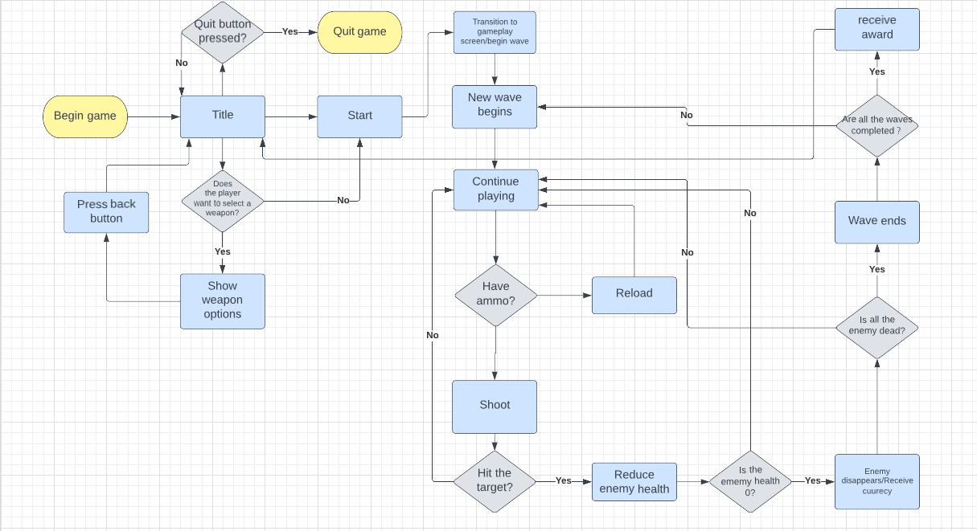

## Storyboards

TITLE

START

START

QUIT

TIME/SCORE

## Controls

* Mouse & Keyboard Control

# 

# Single-Player Game

## Overview

The game is a survival shooter with the goal being for the player to outlast enemies for as long as they can. Various rewards with be available along the way based on player performance (i.e., time survived, enemies killed).

## Control Overview

The player controls the one character throughout the entire game, through both the actions of movement and shooting.

## Enemies/Objectives

Many enemies will be constantly spawning throughout gameplay, make sure to kill them for big rewards! The win condition is set by you, the player. Will you beat your high score?

## Story

Years after strange creatures have emerged from large rifts torn open in the world causing devastation worldwide. Only few are left with hopes to survive. You are safe during the day, but when night falls, you must hold your ground and survive. Taking shelter in a large Griffith University building you setup your defenses and hold your weapon close as the sound of destruction comes closer. Will you be able to hold off the horde of monsters until morning?

## Hours of Gameplay

The gameplay hours depend on how good a player may be at the game, the longer you survive, the longer a game session is expected to last for. Given the open-ended victory condition, this provides the player endless replayability as no run should be the same.

## Victory Conditions

A player wins the game by surviving if they can. The win condition is set by the player, this could be done through achieving a higher score than a previous run or surviving for a longer duration. This type of gameplay allows for high replayability and ensure people of all ages or demographics can have fun while in game.

# Artificial Intelligence

## AI Algorithms

* NavMesh waypoint AI
* FSM AI

## AI Diagrams

FMS Of slime

# The Game World

## Overview

The creature was summoned in the Griffith university terrain to destroy the nation and one brave student tries to eliminate them with a gun in his hand. The student gets point for each enemies killed and gets a speed boost on the ground every set interval in the middle of the terrain.

## World Feature #1

The players get to experience the wild escape from creatures and pleasure of eliminating them to compete with the scores. The enemies have points ranged from 30 – 150, 30 being mummy, slime. 40 is bat and ghost. 150 is the golem with the highest health.

## World Feature #2

The players get to see how much time they can survive by looking at the time from unique enemies they face in the world.

## The Physical World

### Overview

The player finds themselves placed in a room at Griffith University.

### Key Locations

* A room at Griffith University.

### Travel

The player will travel by running around the game world.

### Scale

Within a top-down survival game, scale is important. Too big and the player will be too easy for the player to navigate through enemies. Therefore this world will be kept to a relatively small scale to ensure a challenge for every player.

### Objects

Various obstacles can be found throughout the room which the player will have to avoid to prevent being cornered by enemies.

### Weather

Weather is a clear night.

### Day and Night

The game will be played out during the night at Griffith University.

### 

### Time

Time will be used in order to keep time score within the game, game night/daytime does not change.

## Camera

### Overview

The camera will work by tracking the player wherever they may move.

### Position

The camera will not change positions under any circumstance.

### Movement

The camera may drag behind player to gain a sense of motion.

## Game Engine

### Overview

Unity has been the chosen game engine for the project, as it is one of the more commonly used engines for indie games.

### Components

The game engine keeps track of everything from the player and gunfire to enemy pathfinding and attacking.

### Bullets

The game handles bullets extremely well in engine. A lot of action is happening on screen and bullets that may misfire or miss their target and tracked and removed on time to keep the game running smoothly.

### Collision Detection

Enemies come in all shapes and sizes and collision detection for these is handled in the engine very well. This is done with various colliders in engine.

# The World Layout

## Overview

The player is playable within a room on the Griffith University campus. Within this rooms, there are many obstacles and enemies.

## Enemies

* Various enemies will spawn throughout the map, keep a lookout for these as they do bite!

## Obstacles

* Various obstacles are present throughout the play area, be sure to avoid these.

# Game Characters

## Overview

The main character is a survivor of the apocalypse at Griffith University, good luck surviving!

## Creating a Character

There is no character customization in this title.

## Enemies and Monsters

Enemies are mutant monsters, consisting of bats, slimes, ghosts, and others.

# User Interface

## Overview

The user interface will house a variety of elements to assist the player whilst in game.

## User Interface Detail #1

* The player health bar will always be visible to the player while in game.

## User Interface Detail #2

* Score and timer will be available for the player to see throughout a run, this can be used to keep track of how the player is doing in game.

# Weapons

## Overview

* Only 1 weapon is used throughout the game.

# Musical Scores and Sound Effects

## Overview

This should probably be broken down into two sections but I think you get the point.

## Red Book Audio

If you are using Red Book then describe what your plan is here. If not, what are you using?

## 3D Sound

Talk about what sort of sound APIs you are going to use or not use as the case may be.

## Sound Design

Take a shot at what you are going to do for sound design at this early stage. Hey, good to let your reader know what you are thinking.