Tizen Setup Flow

URL setup for Samsung Tizen 6.5 and Tizen 7.0
- Click the Home button on the Samsung remote.
​
IMAGE
- On the menu on your display, select Custom App.
​
If you do not see the Custom App option when pressing the Home button, your panel is set to load MagicInfo as opposed to the LFD Launcher. You need to follow some more steps as described here to load the Custom App to continue the next steps. Click here to go to the bottom of the page and see the guide How to switch from MagicINFO to URL Launcher or Custom App
​
- Select Install Web App and type in the URL below, which leads you to the TomorrowOS Tizen Player app.
https://tmr.sh/tizen
​
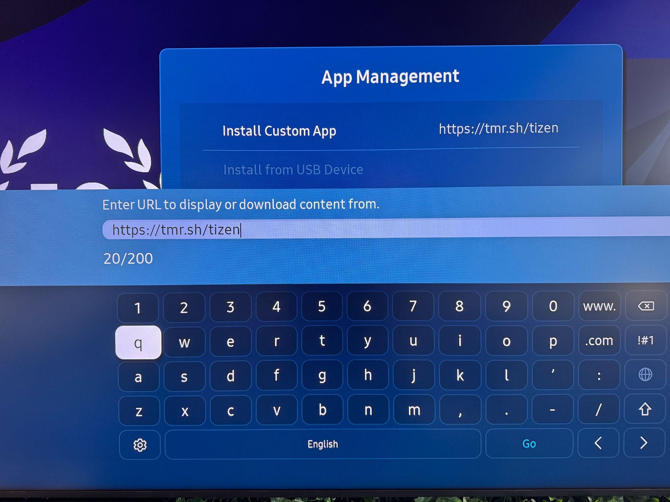
- The TomorrowOS Tizen run time will install, and then boot-up automatically.
​
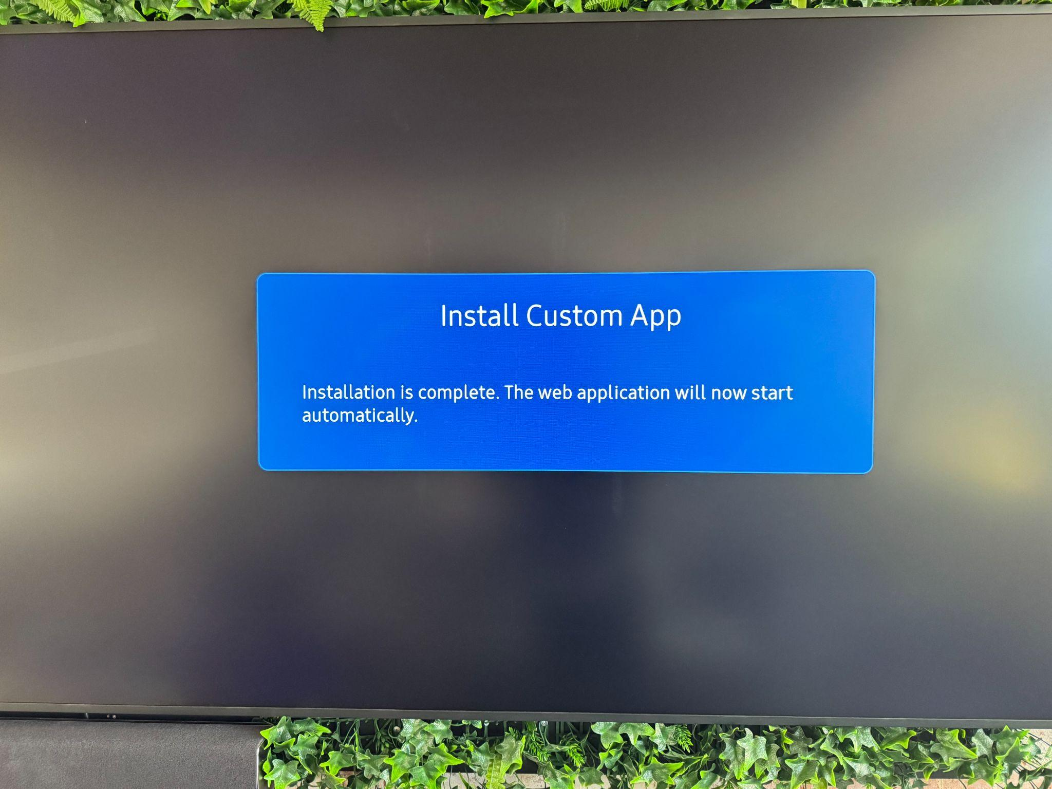
- Follow the steps of setup and select the orientation of the display.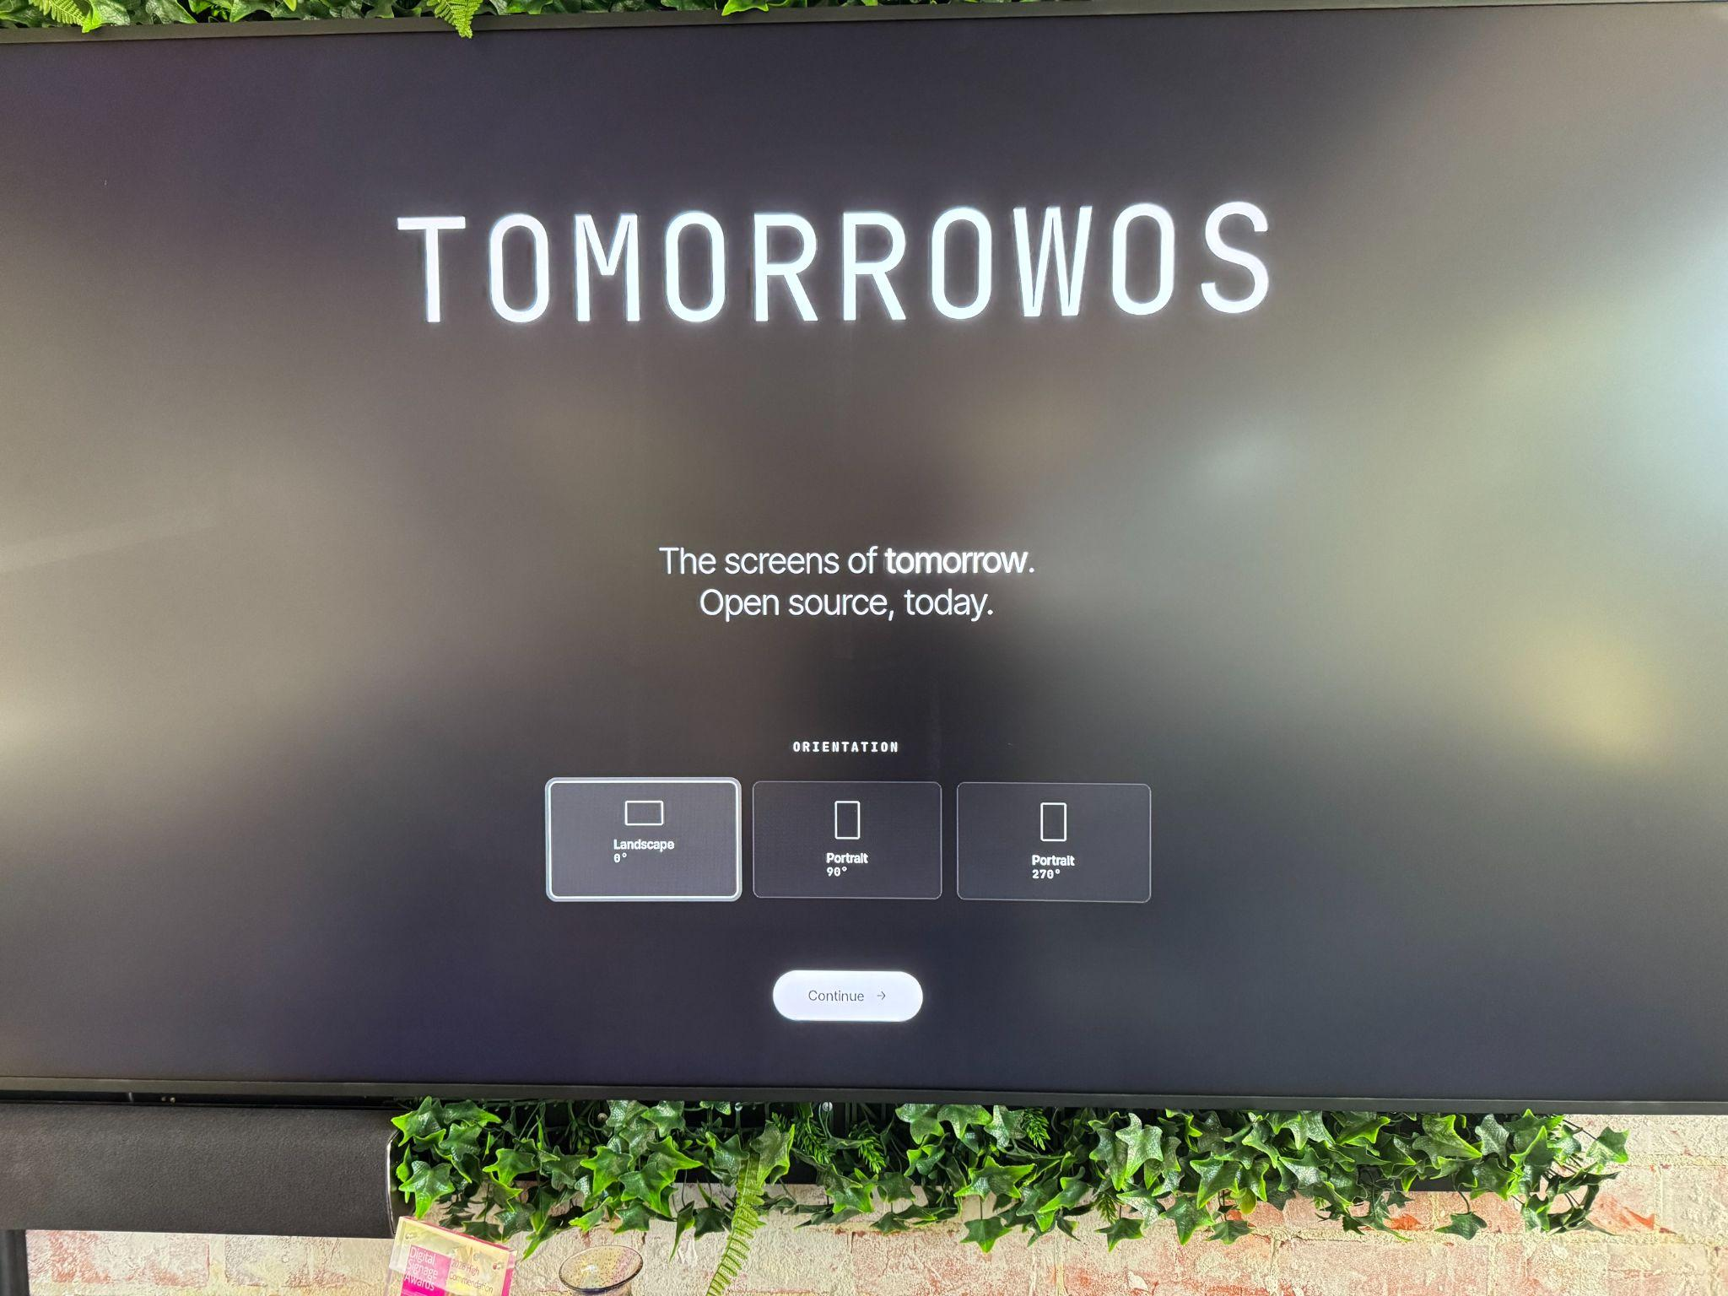
- Add your CMS URL, i.e your Replit built published CMS or custom domain that is hosting your TOmorrowOS build.
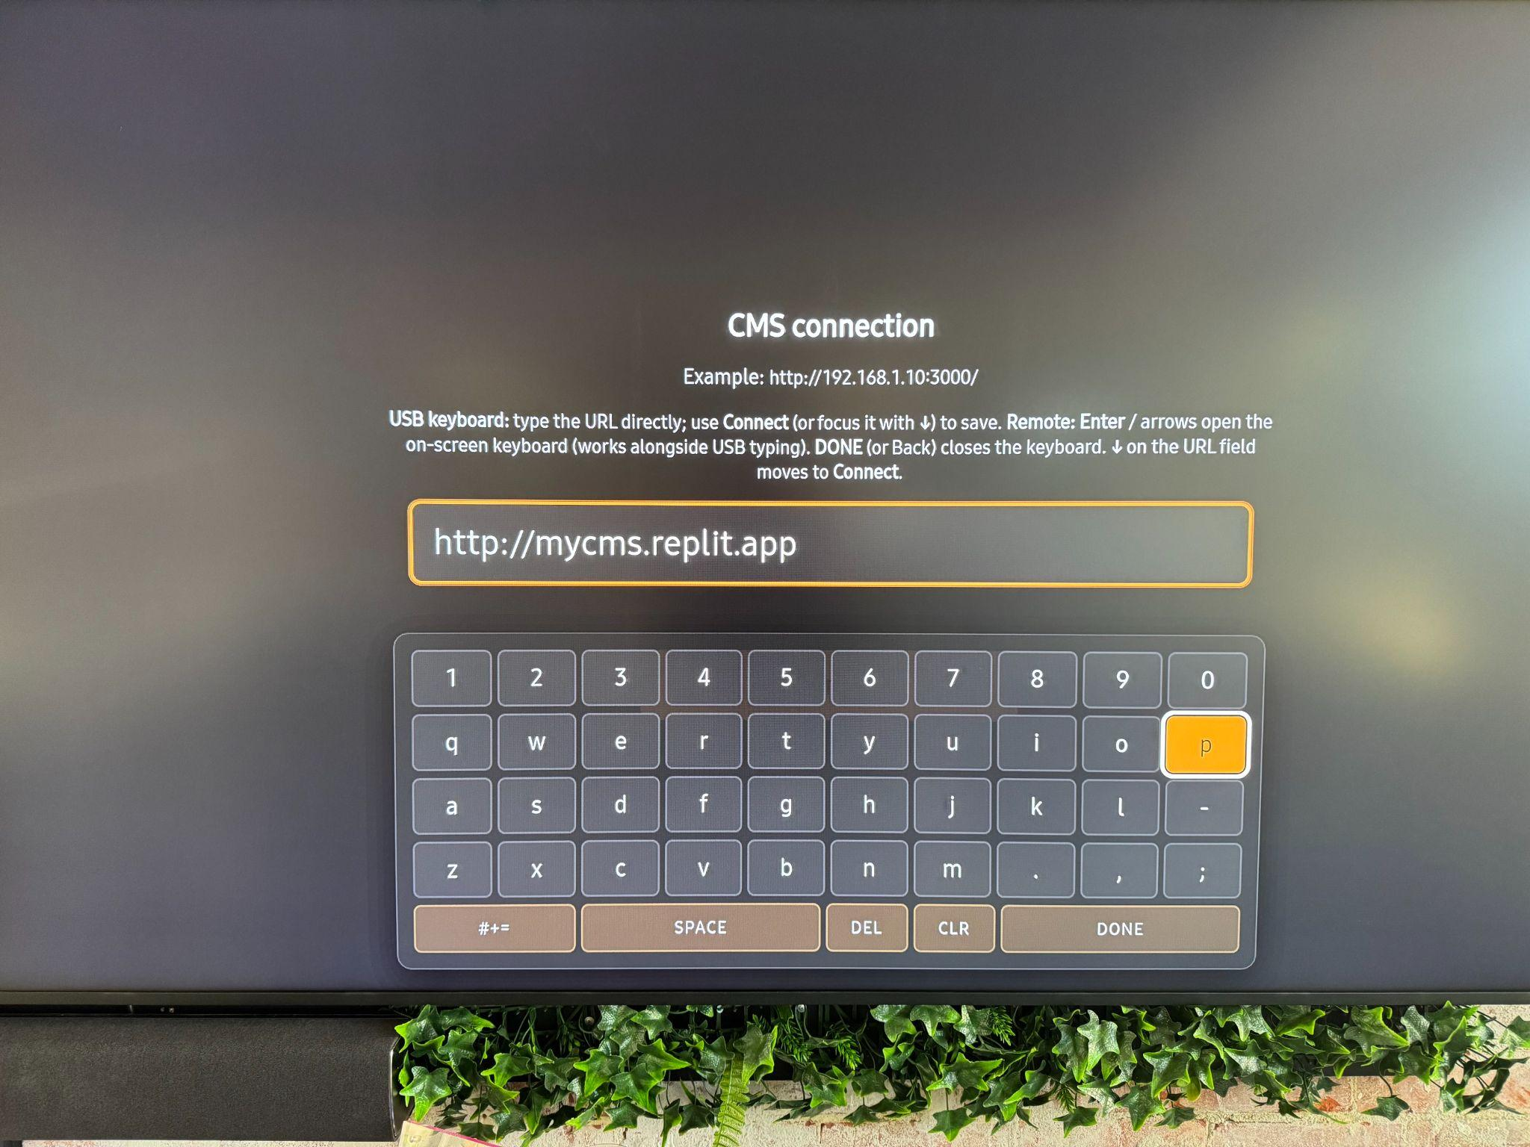
- You will will land on a page with a 6 digit code for you to safely and securely connect your device and begin to publish content. You can now pair your screen and begin publishing content with ScreenCloud.
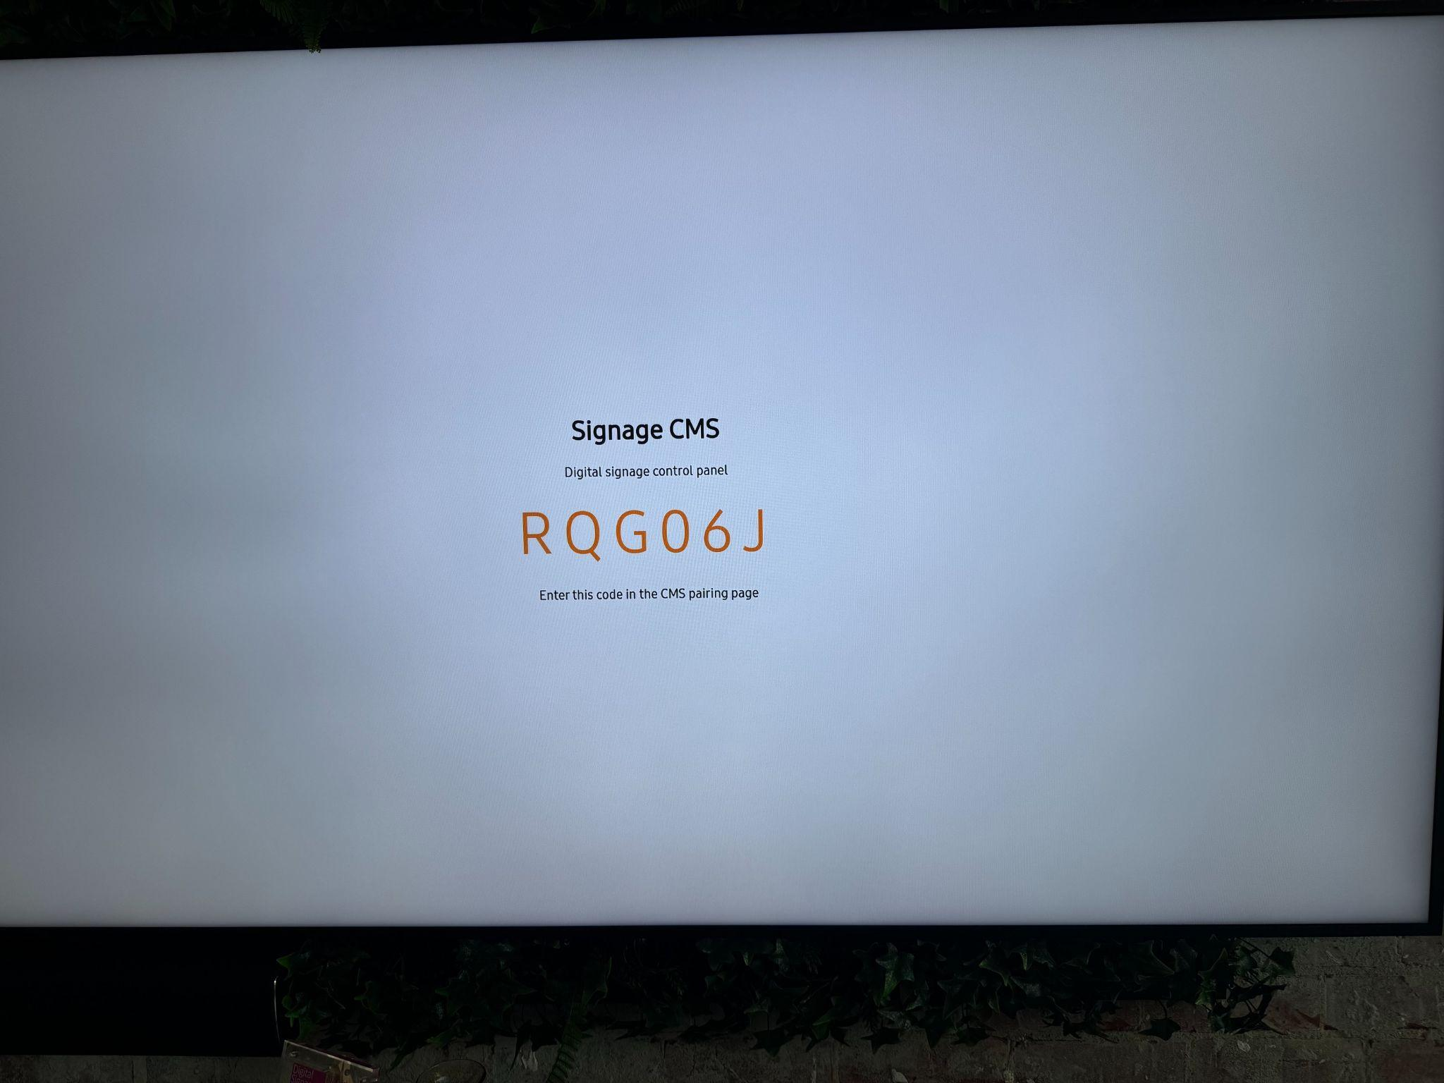
- Add this code into your dashboard and your screen will automatically connect and show a splash screen and show as connected in your CMS sample dashboard.
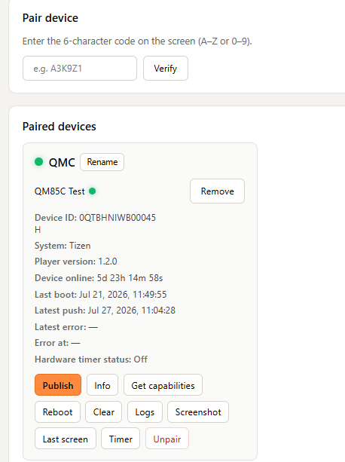

Switch from Magic Info to URL Launcher

How to switch from MagicINFO to URL Launcher or Custom App
Please follow the steps below to switch the Samsung Tizen Display from MagicInfo mode to URL Launcher or Custom App mode.
- Use the Source button to change to HDMI​
- When switched, select on the Menu button
​
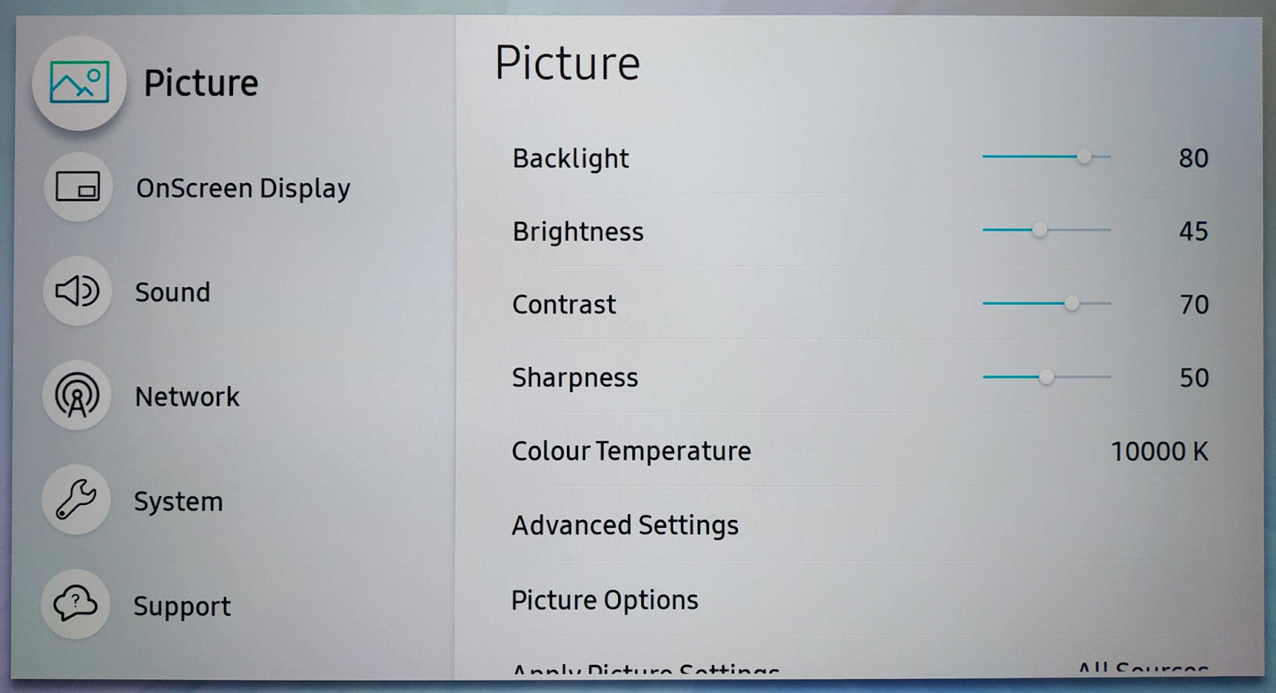
- Now select the System option and scroll down to locate and select the Play via option
​
​For Tizen 6.5 and above
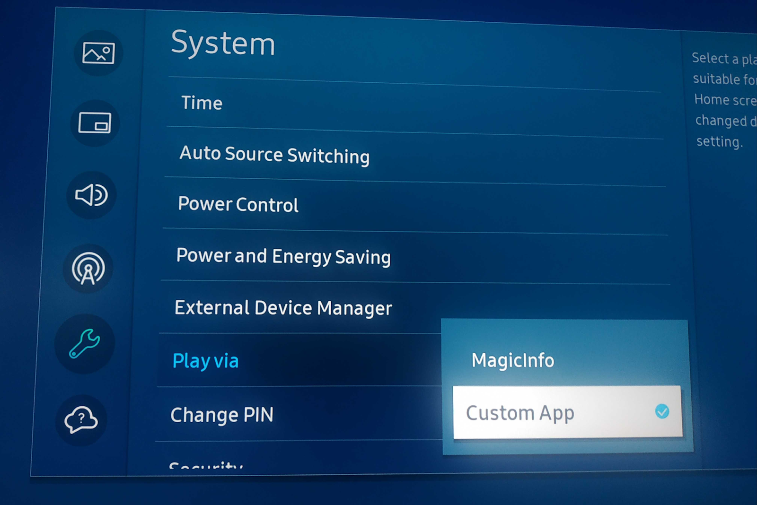
- Once stored, if you restart the panel, The URL Launcher or Custom App will load instead of the MagicInfo.

Install TomorrowOS on Samsung Tizen
Install the TomorrowOS Runtime on a supported Samsung commercial signage display running Tizen 6.5 or Tizen 7.0.

Before you begin
You will need:
- A supported Samsung commercial signage display
- The Samsung remote
- An active internet connection
- Your published CMS URL
- Access to your CMS from a computer or mobile device
- Approximately 10 minutes

Confirm compatibility
Before continuing, check that the display model, Tizen version and firmware are supported by TomorrowOS.
Button: Check Samsung compatibility
This guide is for supported commercial signage displays. It does not apply to Samsung consumer televisions.

1. Choose your starting point

New or factory-reset display
Complete the Samsung display initial setup first.
During setup:
- Select the language.
- Connect the display to the internet.
- Select the physical screen orientation.
- Confirm the local date and time.
- Complete the remaining Samsung setup prompts.
Then continue to Set Play via to Custom App.

Display already configured
Continue directly to the next step.

2. Set Play via to Custom App
TomorrowOS must be selected as the application the display launches.
Using the Samsung remote:
- Open Menu.
- Select System.
- Select Play via.
- Select Custom App.
[IMAGE — SYSTEM → PLAY VIA → CUSTOM APP]

Custom App is already selected
Continue to Step 3.

Custom App is not available
The display may currently be configured to launch MagicINFO.
Follow the section:
Switch from MagicINFO to Custom App

3. Open Custom App
Press Home on the Samsung remote.
Select:
Custom App
Depending on the model and firmware, the option may appear inside App Management.
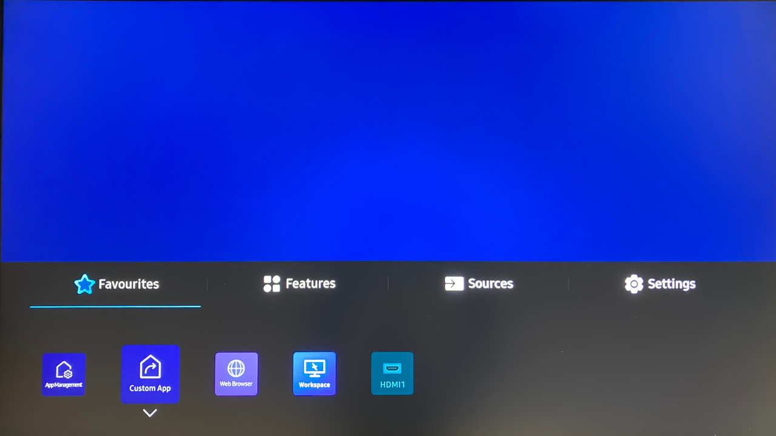

4. Install the TomorrowOS Runtime
Inside Custom App or App Management, select:
Install Custom App
Some supported firmware may label this option Install Web App.
Enter this address exactly:
https://tmr.sh/tizen
Then confirm the installation.
Important
- Enter the full address.
- Do not add spaces.
- Do not turn off or restart the display during installation.

Expected result
The display downloads the TomorrowOS Runtime and launches it when installation is complete.

5. Select the screen orientation
When the TomorrowOS Runtime opens, select the option matching the physical installation:
- Landscape
- Portrait clockwise
- Portrait counter-clockwise
Choose the physical orientation of the display. This can be changed later if required.

6. Connect the Runtime to your CMS
The TomorrowOS Runtime will ask for your CMS address.
Enter the public HTTPS URL copied after publishing your CMS.
Example:
http://mycms.replit.app

Use
- Your published Replit CMS URL, or
- Your connected custom domain

Do not use
- The Replit project editor URL
- A temporary preview URL
- A Supabase URL
- A Cloudinary URL
- An admin or settings page inside the CMS
Help link: Where do I find my CMS URL?

7. Wait for the pairing code
After the CMS URL is accepted, a pairing code will appear on the display.

8. Pair the screen in your CMS
This action takes place inside your published CMS, not on the TomorrowOS guide.
On your computer or mobile device:
- Open your published CMS.
- Select Pair a device.
- Enter the pairing code shown on the Samsung display.
- Select Connect.
- Wait for the screen to appear in the device list.

Expected result
The screen appears in your CMS as connected or online, and the player leaves the pairing screen.
Button: Open my CMS
TomorrowOS.org does not enter or verify the pairing code for you. Pairing is completed inside your owned and operated CMS.

9. Confirm the installation
Before continuing, confirm:
- The display appears online in the CMS.
- The pairing screen has closed.
- The expected starter or assigned content appears.
- No installation or connection error is visible.

Final restart test
Reboot the Samsung display. Click reboot in the devices card in your CMS
Confirm that:
- The display starts normally.
- The TomorrowOS Runtime launches again.
- The screen reconnects to the CMS.
- Assigned content or splash screen resumes.
This restart test should be mandatory before considering the installation complete.

Completion action
I have confirmed the screen reboots and reconnects

10. Create and deploy content
In your CMS:
- Create a playlist.
- Upload or create content.
- Adjust the schedule.
- Save it.
- Assign it to the Samsung screen.
- Confirm it appears on the display.
Link: View the content deployment guide

Switch from MagicINFO to Custom App

When to use this section
Follow these steps when Custom App does not appear after pressing Home.

1. Leave MagicINFO
Use the Source button and temporarily switch to an available input, such as HDMI.
The purpose of this step is to leave MagicINFO so the Samsung system menu can be opened.

2. Open the Samsung menu
Press Menu on the remote.
Select:
System

3. Change Play via
Select:
Play via
Then select:
Custom App

4. Restart the display
Turn the display off and on again.
After restarting:
- Press Home.
- Confirm Custom App is now available.
- Return to Step 3 of the main guide.

Troubleshooting section to add

I cannot see Custom App
- Confirm Play via is set to Custom App.
- Restart the display after changing the setting.
- Confirm the panel is a supported commercial signage model.
Action: View MagicINFO switching steps

The installation URL does not load
- Confirm the display is connected to the internet.
- Re-enter https://tmr.sh/tizen exactly.
- Confirm the display date and time are correct.
- Restart the display and try again.

The CMS URL is rejected
- Use the public published CMS address.
- Confirm it begins with https://.
- Do not use the Replit editor or preview address.
- Open the CMS URL on another device to confirm it loads.

No pairing code appears
- Confirm the CMS URL is correct.
- Confirm the published CMS is currently available.
- Restart the TomorrowOS Runtime.
- Check for an error message on screen.

The CMS does not accept the code
- Enter the code exactly as shown.
- Confirm you are pairing inside the same CMS address entered on the screen.
- Generate or display a new code only through the approved player reset process.

The screen pairs but shows no content
Pairing and content assignment are separate steps.
- Confirm the screen appears online.
- Confirm a playlist or content item is assigned.
- Confirm the schedule is currently active.

